Supplementary material
A sensitivity analysis was conducted to replicate the main analysis among all treated patients with intermediate/poor risk. There were 423 patients in the nivolumab plus ipilimumab arm and 416 patients in the sunitinib arm. The observed trends in all treated patients with intermediate/poor risk were generally consistent with those observed in the all treated population.

Proportion of patients experiencing grade 3/4 AEs for nivolumab plus ipilimumab and sunitinib among all treated patients with intermediate/poor risk
The proportion of all treated patients with intermediate/poor risk who experienced all-cause grade 3/4 AEs and treatment-related grade 3/4 AEs among patients at risk are presented in Figures 1c and 1d, respectively. In both treatment arms, there was an overall decreasing trend in the proportion of patients, although the monthly proportions fluctuated. Nivolumab plus ipilimumab combination therapy was generally associated with lower proportions of patients who experienced all-cause grade 3/4 AEs and treatment-related grade 3/4 AEs compared with sunitinib monotherapy over the assessment period. The highest proportion of patients treated with sunitinib monotherapy who experienced all-cause grade 3/4 AEs occurred at month 1 (38%), while those treated with nivolumab plus ipilimumab combination therapy experienced all-cause grade 3/4 AEs at the highest rate at month 3 (23%). By month 12, the proportion of patients who experienced all-cause grade 3/4 AEs fell from 23% to 7% (relative Δ = 70%) for nivolumab plus ipilimumab combination therapy. For the remaining months within the 42-month study period, the proportion of patients who experienced all-cause grade 3/4 AEs stayed relatively constant, ranging from 0%-9%. In the sunitinib monotherapy arm, the proportion of patients who experienced all-cause grade 3/4 AEs decreased from 38% to 14% (relative Δ = 63%) at month 12, and fluctuated between 3%-21% for the rest of the assessed study period (Figure 1c). The proportion of intermediate/poor-risk patients who experienced treatment-related grade 3/4 AEs is similar to those who experienced AEs of any cause (Figure 1d).

Per-patient AE costs for nivolumab plus ipilimumab and sunitinib among all treated patients with intermediate/poor risk
With regards to per-patient costs, compared with patients who received sunitinib, patients treated with nivolumab plus ipilimumab combination therapy had 27% lower per-patient all-cause grade 3/4 AE costs during all assessment periods, with costs of $19,600 vs. $27,017 over 42 months (Figure 2b). At each assessment period over the first three years, the cost differences between the two arms increased and were statistically significant (all p < 0.05). Compared with patients who received sunitinib, patients treated with nivolumab plus ipilimumab combination therapy had significantly lower per-patient treatment-related grade 3/4 AE costs during all assessment periods. The cost was 45% lower for patients treated with nivolumab plus ipilimumab over 42 months: $9,777 vs. $17,876 (Figure 2b).

Temporal trends of AE costs associated with nivolumab plus ipilimumab and sunitinib among all treated patients with intermediate/poor risk
Although monthly costs fluctuated, both treatment arms experienced an overall decreasing trend in monthly all-cause grade 3/4 AE costs per patient throughout the 42-month study period (Figures 3e). Nivolumab plus ipilimumab combination therapy was generally associated with lower monthly all-cause AE costs per patient compared to sunitinib monotherapy over the assessment period. Specifically, the highest monthly cost for nivolumab plus ipilimumab combination therapy occurred at month 3 ($4,234 per patient). By month 12, the average monthly all-cause AE cost per patient fell by 81% to $787 for nivolumab plus ipilimumab combination therapy. For the remaining months within the assessed study period, monthly all-cause AE costs stayed relatively constant, ranging from $0-$1,492. In the sunitinib monotherapy arm, the highest monthly all-cause grade 3/4 AE cost was $6,136 at month 1, which was more than twice as high as the first month cost in the nivolumab plus ipilimumab combination therapy arm ($2,479). The all-cause AE cost decreased by 58% to $2,607 at month 2 and ranged from $379-$3,732 for the rest of the assessed study period. Cumulative monthly all-cause grade 3/4 AE costs per patient were almost twice as high with sunitinib treatment compared with nivolumab plus ipilimumab treatment ($74,146 vs. $38,131; Figure 3f). The monthly temporal trends for treatment-related grade 3/4 AE costs per patient were similar to those observed for all-cause AEs among all treated patients with intermediate/poor-risk aRCC (Figures 3g and 3h).

Top grade 3/4 AE categories driving the difference in AE costs between treatment arms among all treated patients with intermediate/poor risk
In the nivolumab plus ipilimumab arm, the top three AE categories contributing to per-patient all-cause grade 3/4 AE costs over 42 months were laboratory investigations ($3,728), metabolism and nutrition disorders ($2,505), and general disorders and administration site conditions ($1,556; Supplementary Figure 1b). Similarly, for patients in the sunitinib arm, laboratory investigations ($6,381), blood and lymphatic system disorders ($4,076), and general disorders and administration site conditions ($2,926) were the top three AE categories contributing to per-patient all-cause grade 3/4 AE costs over 42 months. In both arms, laboratory investigations was also the top AE category contributing to per-patient treatment-related grade 3/4 AE costs over 42 months for all treated patients with intermediate/poor risk (Supplementary Figure 1b).
Among all-cause grade 3/4 AEs, the top three AE categories contributing to the largest cost differences between sunitinib and nivolumab plus ipilimumab were blood and lymphatic system disorders ($4,076 vs. $1,213, Δ = $2,863), laboratory investigations ($6,381 vs. $3,728, Δ = $2,653), and vascular disorders ($1,722 vs. $349, Δ = $1,373). The same top three categories drove the difference in AE costs for treatment-related grade 3/4 AEs.

Supplementary figure

Supplementary figure 1. Per-patient all-cause and treatment-related grade 3/4 AE costs over 42 months^{[1−3]}
(a) Grade 3/4 AE costs, all treated population; (b) Grade 3/4 AE costs, all treated patients with intermediate/poor risk.
a) 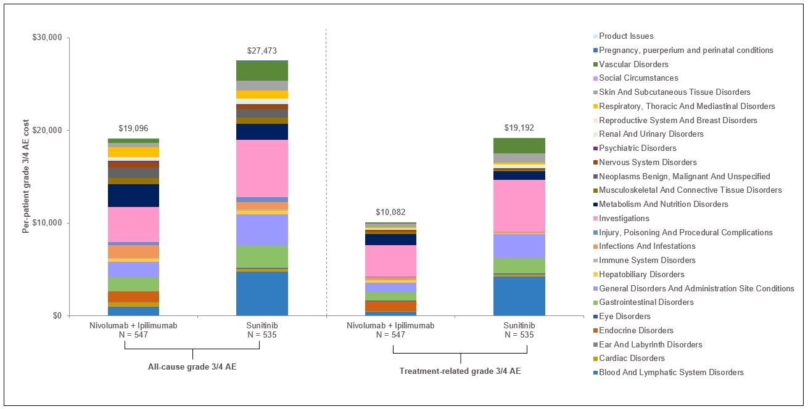

b)
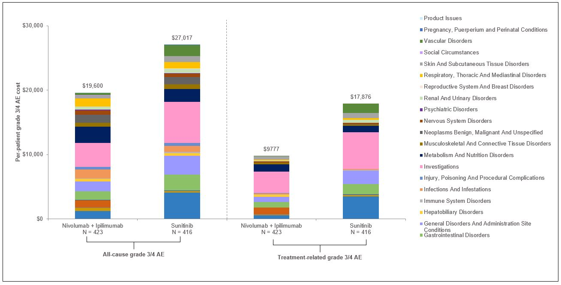

Abbreviations: AE: adverse event; aRCC: advanced or metastatic renal cell carcinoma.
Notes:
[1] Analyses were conducted in patients with aRCC in the all treated population (Supplementary Figure 1a) and all treated patients with intermediate/poor risk (Supplementary Figure 1b) who received at least one dose of the study drug in CheckMate 214.
[2] Per-patient AE costs for each AE category over 42 months were calculated by summing grade 3/4 AE costs within each AE category over 42 months.
[3] Legends for all-cause and treatment-related AEs with per-patient AE costs less than or equal to $100 for the 42-month period are not shown. Among patients experiencing all-cause and treatment-related AEs in the all treated population, this includes ear and labyrinth disorders, eye disorders, reproductive system and breast disorders, social circumstances, pregnancy, puerperium and perinatal conditions, and product issues. Among patients experiencing all-cause and treatment-related AEs in the intermediate/poor-risk population, this includes ear and labyrinth disorders, eye disorders, reproductive system and breast disorders, social circumstances, pregnancy, puerperium and perinatal conditions, and product issues.

