Supplementary materials
Determination of favipiravir in human plasma using homogeneous liquid-liquid microextraction followed by HPLC/UV

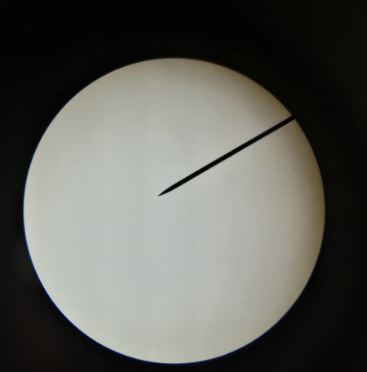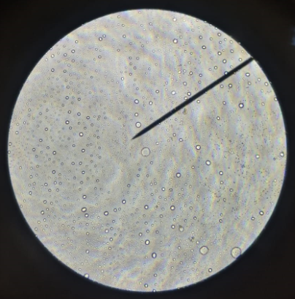
Figure S1: Light microscope images of SULLME using acetonitrile (left) and THF (right)

Figure S2: Effect of sugar type on the extraction efficiency of SULLME of favipiravir.

Figure S3: Chromatogram of blank plasma showing no interfering peaks at the retention periods of favipiravir and propranolol. Chromatographic conditions: Column: Thermo Hypersil ODS C₁₈ (250 mm × 4.6 mm, 5 µm) at 30°C, Mobile phase: acetonitrile: phosphate buffer (50mM, pH 2.5) (40:60, v/v), Elution: Isocratic, Detection: UV at 323 nm, Flow rate: 1 mL/min, Injection volume: 5 µL.

Table S1: Comparison between the developed method and the reference LLE HPLC/UV method.
Parameter | Comparison with reference method
 | SULLME HPLC/UV |  |  | Reference Method
 | Added  (µg/mL) | Found*  (µg/mL) | %Found | Added  (µg/mL) | Found  (µg/mL) | %Found
 | 40.00 | 42.43 | 106.09 | 40.00 | 43.38 | 108.46
 | 40.00 | 41.63 | 104.07 | 40.00 | 43.34 | 108.36
 | 40.00 | 41.91 | 104.77 | 40.00 | 41.72 | 104.31
Mean |  |  | 104.98 |  |  | 107.04
% RSD |  |  | 0.97 |  |  | 2.21
t-test** |  |  | 0.27
F-test** |  |  | 0.31
*Average of triplicate determinations for each concentration
** p-values at 95% confidence level (α=0.05)

