Supplementary Data
Design, Synthesis and SAR Studies of Novel Spirochromanone hydrochloride Analogues as Anticancer Agents
Surendar Chitti^{a#}, Sravani Pulya^{b#}, Adinarayana Nandikollaª, Tarun Kumar Patel^{b}, Banoth Karan Kumar^{c}, Sankaranarayanan Murugesan^{c}, Balaram Ghosh^{b,}∗, and Kondapalli Venkata Gowri Chandra Sekharª∗
ªDepartment of Chemistry, Birla Institute of Technology and Science, Pilani, Hyderabad Campus, Jawahar Nagar, Hyderabad – 500 078, Telangana, India.
^{b}Epigenetic Research Laboratory, Department of Pharmacy, Birla Institute of Technology and Science, Pilani, Hyderabad Campus, Jawahar Nagar, Hyderabad – 500 078, Telangana, India.
^{c}Department of Pharmacy, Birla Institute of Technology and Science, Pilani Campus, Vidya vihar, Pilani–333031, Rajasthan, India.
# equal contribution

Table of Contents Page No.
- Chemistry Experimental Procedures S03 – S05

- Materials and Methods – Biological Studies S05 – S08

- Materials and Methods - In-silico Studies S08 – S10

- ¹H NMR spectral data for Csp series compounds S11 – S24

- ¹³C NMR spectral data for Csp series compounds S25 – S42

- ESI MS spectral data for Csp series compounds S43 – S58
- References S59 – S60

1. Experimental
1.1. Chemistry
All the reagents were procured from commercial available sources and used with further purification wherever necessary. All reactions were monitored by thin layer chromatography (TLC) performed on E-Merck 0.25 mm pre-coated silica gel aluminum plates (60 F254) using mixture of pet ether and ethyl acetate. Visualization of the spots on TLC was achieved by exposure to UV light. Column chromatography was performed using silica gel (Acme, 100-200mesh). Solvents were dried and purified by distillation prior to use. Solvents for chromatography (pet ether and ethyl acetate) were distilled prior to use. Evaporations were carried out under reduced pressure using vacuum rotary evaporator. ¹H and ¹³C NMR spectra were recorded on Bruker (400 MHz for ¹H, 101 MHz for ¹³C), DMSO-d₆. Chemical shifts have been expressed in parts per million (δ) relative to tetramethylsilane (δ = 0.0) as an internal standard and coupling constants (J) in Hertz. Low-resolution mass spectra (ESI-MS) were recorded on LC/MS-2020 Agilent.
1.2 General procedure for synthesis of tert-butyl 7-bromo-4-oxospiro-[chroman-2,4'-piperidine]-1'-carboxylate (3):
To a stirred solution of 5-bromo-2-hydroxyacetophenone (10.0 g, 0.047 mol) in 150 ml of anhydrous MeOH were added N-Boc-4-piperidone (11.0 g, 0.56 mol) and pyrrolidine (5.7 mL, 0.70 mol) at ambient temperature. The reaction mixture was stirred under reflux at 70°C for about 14 h. The reaction progress was monitored by TLC and on completion, as indicated by TLC, the reaction mixture was concentrated under reduced pressure, diluted with 100 ml water and the product was extracted with ethyl acetate (4 x 100 mL). The organic layer was dried over anhydrous Na₂SO₄ and crude product was purified by column chromatography (silica gel 100-200 mesh, n-Hexanes / EtOAc 20%) to yield 13.5 g (75%) of pale yellow solid. Recorded m.p: 112-114°C (Lit. m.p 112-115) [1].
¹HNMR (400 MHz, DMSO-d₆): δ 7.63 (d, J = 8.3 Hz, 1H), 7.40 (d, J = 2.1 Hz, 1H), 7.26 (dd, J = 8.4, 2.1 Hz, 1H), 3.73 (d, J = 11.3 Hz, 2H), 3.14-3.12 (bs, 2H), 2.87 (s, 2H), 1.90 (d, J = 13.1 Hz, 2H). 1.67-1.60 (m, 2H), 1.29 (s, 9H). ESI MS (m/z): calcd. For C₁₈H₂₂BrNO_{4,} 395.07, found 397.1 [M + H]⁺.

1.3 Synthesis of tert-butyl 7-(4-formylphenyl)-4-oxospiro[chroman-2,4'-piperidine]-1'-carboxylate (5):
To a stirred solution of tert-butyl 7-bromo-4-oxospiro-[chroman-2,4'-piperidine]-1'-carboxylate (13.5 g, 34.0 mmol) in 1,4-dioxane, 4-(4,4,5,5-tetramethyl-1,3,2-dioxaborolan-2-yl)-benzaldehyde (7.90 g, 34.0 mmol) and 2M Na₂CO₃ (31.2 mL, 68.0 mmol) were added and the reaction mixture was purged with argon for 5 min. followed by addition of Pd(dppf)Cl₂ (913 mg, 1.25 mmol) again deoxygenated with argon for another 5 min. The resulting reaction mixture was heated to 100 °C for 16 h under argon atmosphere, and later the reaction mixture is cooled to room temperature and filtered through celite-pad. The filtrate was concentrated under reduced pressure and the crude product was purified by column chromatography (silica gel 100-200 mesh, n-Hexanes / EtOAc 60%) to yield 6.80 g (63%) of yellow solid.
¹HNMR (400 MHz, DMSO-d₆): δ9.89 (s, 1H), 7.99-7.95 (m, 3H), 7.92 (d, J = 4.0 Hz, 2H), 7.83 (d, J = 8.0 Hz, 1H), 7.56 (d, J = 1.6 Hz, 1H), 3.73 (d, J = 12.1 Hz, 2H), 3.18-3.15 (bs, 2H), 2.88 (s, 2H), 1.91 (d, J = 13.2 Hz, 2H). 1.69-1.61 (m, 2H), 1.40 (s, 9H). ESI MS (m/z): calcd. For C₂₃H₂₅NO₅S, 421.51, found 422.1 [M + H]⁺ .
1.4 General procedure for synthesis of tert-butyl 7-(4-((amino)-methyl)-phenyl)-4-oxospiro-[chroman-2,4'-piperidine]-1'-carboxylate (6)
To a stirred suspension of tert-butyl 7-(4-formylphenyl)-4-oxospiro-[chroman-2,4'-piperidine]-1'-carboxylate (1.18 mmol) in methanol (10.0 mL), was added acetic acid (0.1 mmol) and corresponding amine (1.17 mmol) at 0°C and resultant mixture was heated to room temperature for 6 h. Sodium cyanoborohydride (2.34 mmol) was added to the above reaction mixture and further stirred for 2 h. The reaction progress was monitored by TLC; after completion of reaction, as indicated by TLC, the reaction mixture was diluted with dichloromethane and organic layers were washed with saturated NaHCO₃, brine, dried over anhydrous Na₂SO₄ and evaporated under reduced pressure. The resultant residue was purified by column chromatography (silica gel 100-200 mesh, dichloromethane / methanol 5%) to yield corresponding reductive amination compounds.

1.5 General procedure for synthesis of 7-(4-(amino)-methyl)-phenyl)-spiro-[chroman-2,4'-piperidin]-4-one hydrochloride analogues (Csp 1-18)
To a stirred suspension of tert-butyl 7-(4-(amino)-methyl)-phenyl)-4-oxospiro-[chroman-2,4'-piperidine]-1'-carboxylate (0.10 mmol) in 2,2,2-trifluoroethanol (5.0 mL), was added TMS-Cl (1.01 mmol) at 0°C and resultant mixture was heated to room temperature for 2 h. The reaction progress was monitored by TLC; after completion of reaction, as indicated by TLC, the reaction mixture was diluted with dichloromethane and organic layers were washed with saturated NaHCO₃, brine, dried over anhydrous Na₂SO₄ and evaporated under reduced pressure. The resultant residue was purified by column chromatography (silica gel 100-200 mesh, dichloromethane / methanol to yield title compounds Csp 1-18.

2. Biology Experimental procedures
Cell culture: Two different cell lines were used for the determination of anticancer activity of the novel compounds synthesized. MCF 7 (human breast cancer cell line), B16F10 (Murine melanoma cell line) and HEK-293 (Human embryonic kidney cell line) were purchased from National Centre for Cell Science (NCCS), Pune, India. B16F10, MCF 7 and HEK-293 cell lines were cultured in DMEM (high glucose media: AL007S, Dulbecco’s modified eagle medium) with 10% fetal bovine serum (FBS) and 1% antibiotic (Pen strep: A001) and were incubated at 37 °C and 5% CO₂ atmosphere. Dulbecco's phosphate buffered saline (PBS), foetal bovine serum (FBS), antibiotic solution 100× liquid with 10,000 U penicillin and 10 mg streptomycin/ml, trypsin, 3-(4,5-dimethylthiazol-2-yl)-2,5-diphenyl tetrazolium bromide (MTT) was supplied by Himedia, Laboratories Pvt. Ltd., (Mumbai, India). The absorbance for MTT assay was measured using a microplate reader (Spectramax™, Molecular Devices).

2.1 Chemicals and reagents
The compounds were dissolved in DMSO stock solution and were stored in -20°C. DAPI (4′,6-diamidino-2- phenylindole) and acridine orange, Propidium Iodide and RNase were purchased from Sigma-Aldrich. TACs Annexin-V/FITC – PI assay kit was purchased from Bio-legend and was used as per the protocol given.
2.2 MTT Assay
As per the protocol, 96 well plate was seeded with 100 µL/well of cell suspension with the cell density of 1× 10⁴ per well and were incubated for overnight. Subsequently, the medium was aspirated, and the cells were treated with the synthesized novel compounds along with BG-45 as positive control at a concentration of 100 µM and 10 µM in 150 µL of their respective media in duplicate and further incubated for 48 h. Following incubation, the culture medium was aspirated and subsequently, 50µl of 5mg/ml concentrated solution of MTT (3-(4,5-dimethylthiazol-2-yl)-2,5-diphenyltetrazolium bromide) in phenol red free DMEM media was prepared and added in each well and further incubated for 3h for the formation of formazan crystals that are formed as a result of cellular enzymatic activity. Subsequently, 150 µl of DMSO was added to the culture after aspirating media in the wells to dissolve the formazan crystals and the absorbance was measured using multi-well plate reader Spectramax (Molecular Devices, USA) at two different wavelengths of 570 nm and 650 nm. The % cell viability was calculated as a fraction of absorbance obtained from the treated cells from the absorbance of untreated control cells. The same procedure was followed for all the three cell lines.
For the IC₅₀ measurement of all the compounds in the series along with BG-45, the same procedure was followed as described above. The DMSO solutions of the selected compounds were prepared and they were further diluted to 200 µM, 100 µM, 50 µM, 25 µM, 12.5 µM, 6.25 µM, 3.125 µM, 1.562 µM and 0.781 µM with the DMEM complete media for the determination of IC₅₀ values along with a blank control containing DMSO in medium and BG-45 as positive control and were incubated for 48h. The experiment was repeated following the same protocol on all the 3 cell lines and the cell viability was measured by MTT assay as discussed. IC₅₀ determination was also performed for the selected compounds to evaluate their cytotoxicity using Human embryonic kidney (HEK-293) cell line sub-cultured in DMEM. Cytotoxicity assay was performed to study their selectivity over cancer cell lines. The DMSO solutions of the selected compounds were prepared and they were further diluted to1 mM, 500 μM, 250 μM, 125 μM, 62.5 μM, 31.25 μM, 15.62 μM and 7.81 μM with the DMEM complete media for the determination of IC₅₀ values along with a blank control containing DMSO in medium and were incubated for 72 h. [2]

2.3 Nuclear staining assay
The nuclear staining assay were performed to investigate the status of nuclear disintegration of cancerous cells after treatment of Csp 12 and BG-45 using as positive control by staining with DAPI and acridine orange. For nuclear staining, B16F10 murine melanoma cells were plated in flat bottom 12 well plate and allow to grow 24 h, and then they were treated with the Csp 12 (9.81 µM) and BG-45 (34.59 µM) at the indicated concentration and incubated for 48 h. After 48 h of the treatment, control and compounds Csp 12 and BG-45 treated group were fixed with 4% paraformaldehyde solution, thereafter both control and compound treated cells were stained with DAPI and acridine orange. The nuclear staining of both control and treated cells was visualized under fluorescence microscope (Leica microsystems, Germany) on 20x Magnification.
2.4 Apoptosis assay
B16F10 cells were seeded with the cell density of 0.5×10⁶/well in 12 well tissue culture plates and left overnight. Next day cells were treated with Csp 12 (9.81 µM) and BG-45 (34.59 µM) for 48h and the cells were incubated at 37°C in CO₂ incubator to assess the apoptosis. The study was carried out as per the manufacturer’s protocol (BioLegend, US). The cells were washed with ice cold PBS, trypsinized and centrifuged to get cell pellet. The pellet was resuspended in 100 µL reagent containing Annexin-V buffer, FITC (1µL) and PI (10 µL) and kept for incubation for 30 min at room temperature. Annexin-V binding buffer, 1X (400 µl) was added to each sample and characterized by flow cytometer (BDAriaTM III). The cells with no treatment were considered as controls. FITC versus PI with quadrant gating was done as dot plot which represents (Q1 – Necrotic cells, Q2 - late apoptosis, Q3 – Live cells, Q4 – early apoptotic cells). To determine the extent of apoptosis, early and late apoptotic events were taken [3].
2.5 Cell cycle analysis
The cell cycle analysis was performed by using flow cytometry. The cells B16F10 cells were seeded with density of 0.5×10⁶ cells per well. After overnight incubation, Csp 12 (9.81 µM) and BG-45 (34.59 µM) were added to cells and incubated for another 48 h. Then the cells were harvested with trypsin and the cell pellet was washed with ice cold PBS. The cells were fixed with 70% ethanol by dropwise addition into the cell suspension under gentle vortex. The clumping of cell was avoided and single cell fixation was visualized under microscope for cross-verification. The samples were kept in -20°C for overnight. The next day fixed samples were centrifuged at 1000 rpm, 4° C for 7 min to obtain cell pellet. Finally, the cells were re-suspended in 500 µL of PI and RNAse staining solution. The staining solution was prepared by addition of 20 % w/v RNAse and 2% w/v PI in 0.1% v/v of Triton X-100 solution in PBS. The samples were incubated in dark for 30 min at room temperature and analysed by flow cytometry (BDAriaTM III). The dot plot of PI width against PI area was recorded and histogram of PI area on X axis and cell count on Y axis was plotted. The percentage of cells in each phase of the cell cycle was evaluated using the FCS express software [3].

3. Materials and Methods for Molecular docking studies
3.1 In-silico prediction of ADME parameters
The ADME parameters of the titled compounds were in silico predicted using Qikprop module of Schrodinger. The diverse parameters predicted were molecular weight (M.Wt.), total solvent accessible surface area (SASA), number of hydrogen bond donor (HBD), number of hydrogen bond acceptor (HBA), octanol / water partition coefficient (log P), aqueous solubility (Log S), predicted apparent Caco-2 cell permeability in nm/sec (P Caco) and number of rotatable bonds (Rot). [4,5]
3.2 Molecular docking study
Molecular docking study was carried out using Schrodinger software [6] (Version 2019-1, Schrodinger) installed on Intel Xenon W 3565 processor and Ubuntu enterprise version 14.04 as an operating system. The selected target protein structure was retrieved from RCSB protein data bank (www.rcsb.org) [7]. Targeted ligands were drawn using ChemDraw 18.0 software. The docking protocol was well established and validated [8-10].
3.3 Ligand preparation
The ligands used as an input for docking study was sketched using ChemDraw software and cleaned up the structures for bond alignment, ligands incorporated into the workstation, the energy was minimized using OPLS3e force field in Ligprep [11] (Version 2019-1, Schrodinger). This minimization helps to assign bond orders, the addition of hydrogens to the ligands, and conversion of 2D to 3D structure for further docking studies. The generated output file (best conformations of the ligands) was further used for docking studies.
3.4 Protein preparation
Protein was retrieved from RCSB site (https://www.rcsb.org/structure/1M17, https://www.rcsb.org/structure/2fb8) [12,13]. Protein was prepared using protein preparation wizard [14,15] (Version 2019-1, Schrodinger). Hydrogen atoms were added to the proteins and charges were assigned. Generated Het states using Epik at pH 7.0 ±2.0. Pre-processed the protein and refined, modified the protein by analyzing the workspace, water molecules, and other heteroatoms were examined, non-significant atoms were excluded from the crystal structure of protein. Finally, the protein was minimized using OPLS3e force filed.
3.5 Receptor grid generation
A grid was created by considering the co-crystallized ligands present in the active site of Epidermal Growth Factor Receptor (EGFR) Kinase domain alone and in complex with 4-anilinoquinazoline inhibitor (PDB-1M17). By picking the inhibitory ligands (X-ray native poses of the ligands in the protein), the centroid of the ligand was selected to create a grid box around it, and the Vander Waals radius of receptor atoms was scaled to 1.00 Å with a partial atomic charge of 0.25.
3.6 Docking validation
The most straightforward way of validating the accuracy of specified parameters for docking study is to re-dock the co-crystallized ligand back into the binding site of the protein and calculate the root mean square deviation (RMSD) value between the crystallographic orientation and the docked pose. RMSD calculation is a convenient method to use in order to follow how much a structure has diverged from its initial geometry. The lower the RMSD value between the docked pose to that of its crystallographic orientation is an indication of the suitability of the docking protocol. Therefore, prior to screening of all the ligands, the co-crystal structures of PDB-1M17 and 2FB8 was chosen and re-docked back into the same active site. The RMSD value between the crystallographic orientation and the best-docked pose was generated. The RMSD value of the selected target was found to be 1.6Å for the selected target. The lower RMSD value indicates that the docking protocol could be reliable for the final docking studies of the test compounds against the selected target.
3.7 Docking and analysis
Molecular docking was performed using the above-prepared ligands and proteins as input. The results of the docking study was analyzed with the help of XP Visualizer (Version 2019-1, Schrodinger). Docking studies of the designed and synthesized molecules were performed using Glide module [15] in Schrodinger. All docking calculations were performed using Extra Precision (XP) mode. A scaling factor of 0.8 and partial atomic charge of less than 0.15 was applied to the atoms of the protein. Glide docking score was used to determine the best-docked confirmation from the output. The interactions of these docked conformations were investigated further using XP visualizer.

4. ¹H NMR spectra of Csp series compounds
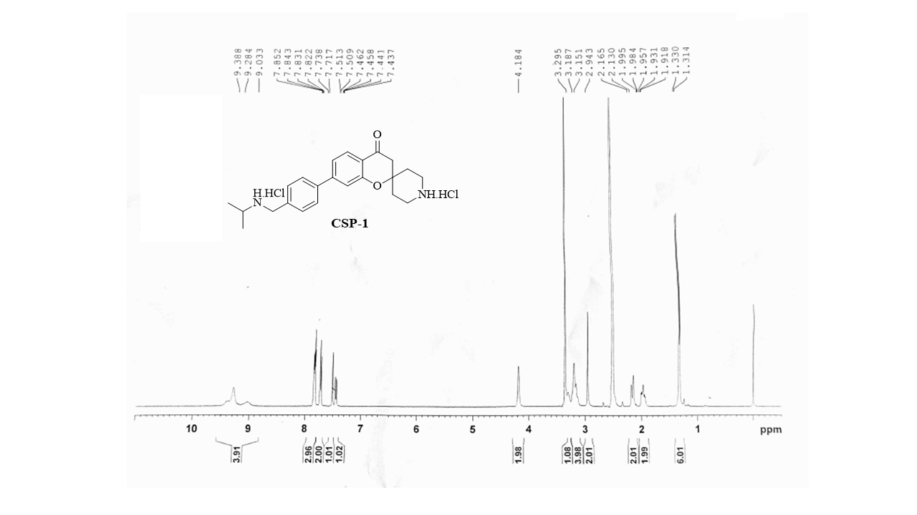

¹H NMR spectrum of compound Csp 1
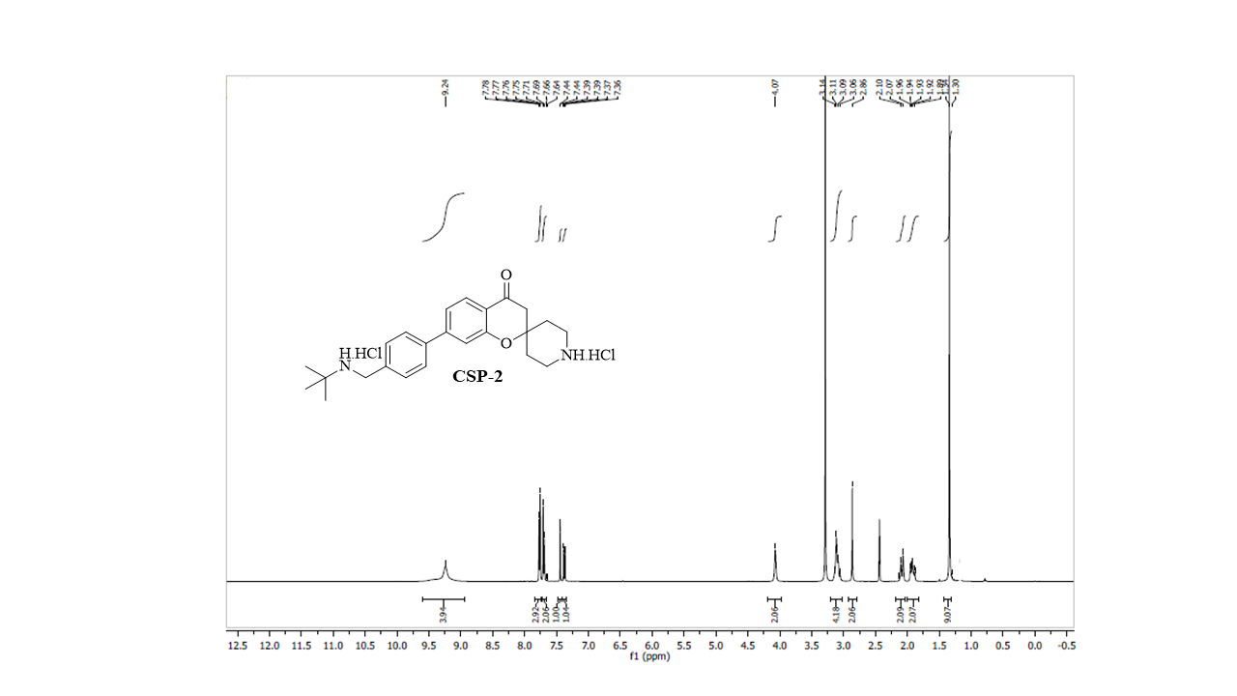
¹H NMR spectrum of compound Csp 2
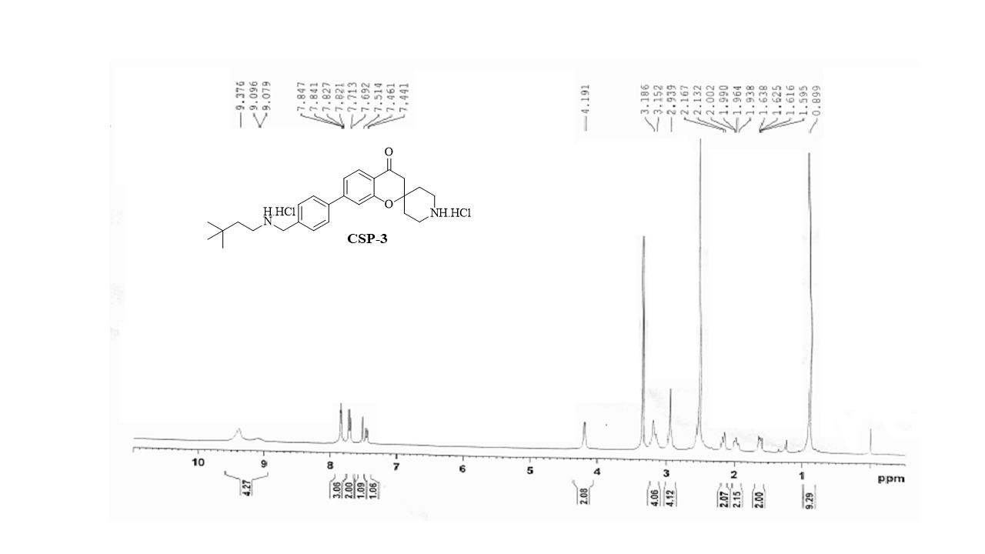
¹H NMR spectrum of compound Csp 3

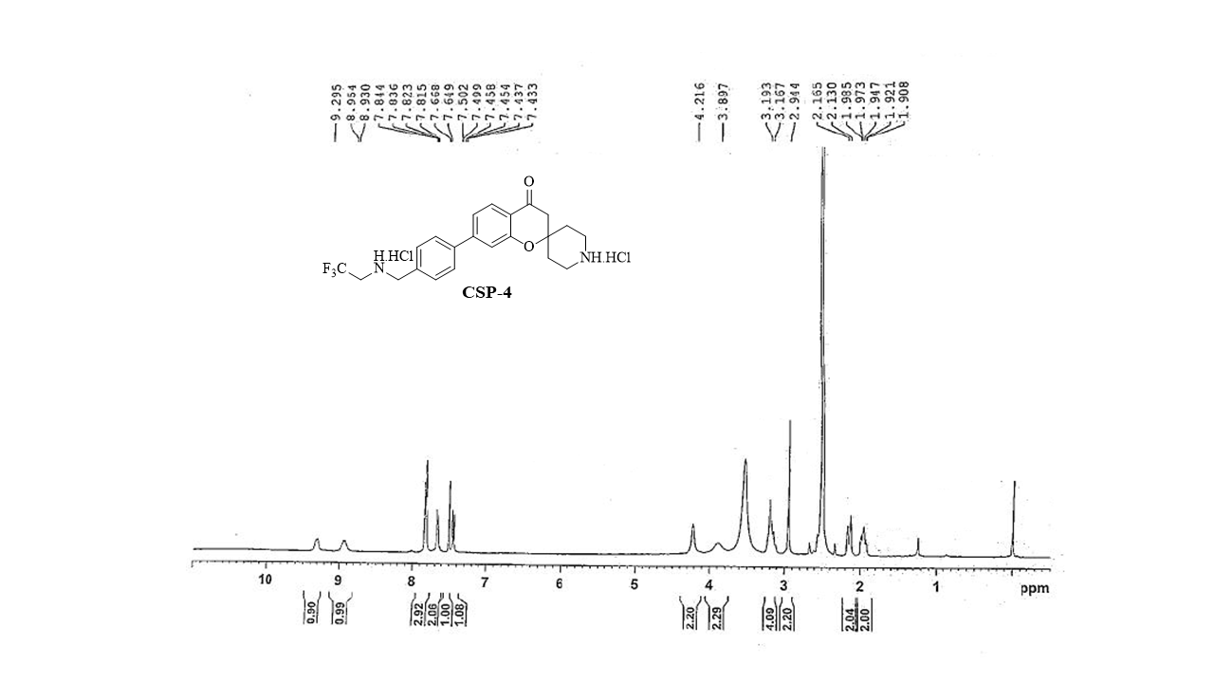
¹H NMR spectrum of compound Csp 4
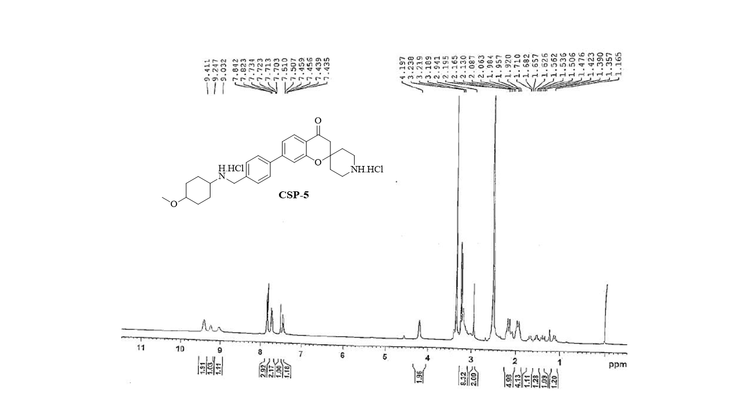
¹H NMR spectrum of compound Csp 5
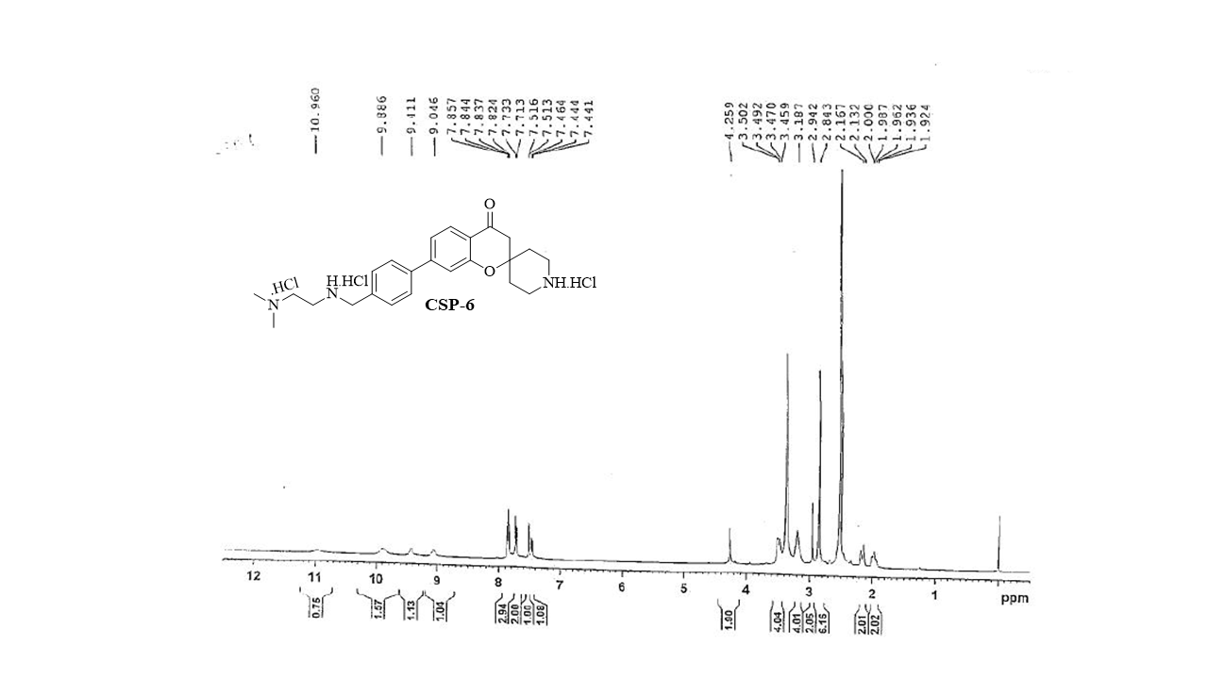
¹H NMR spectrum of compound Csp 6
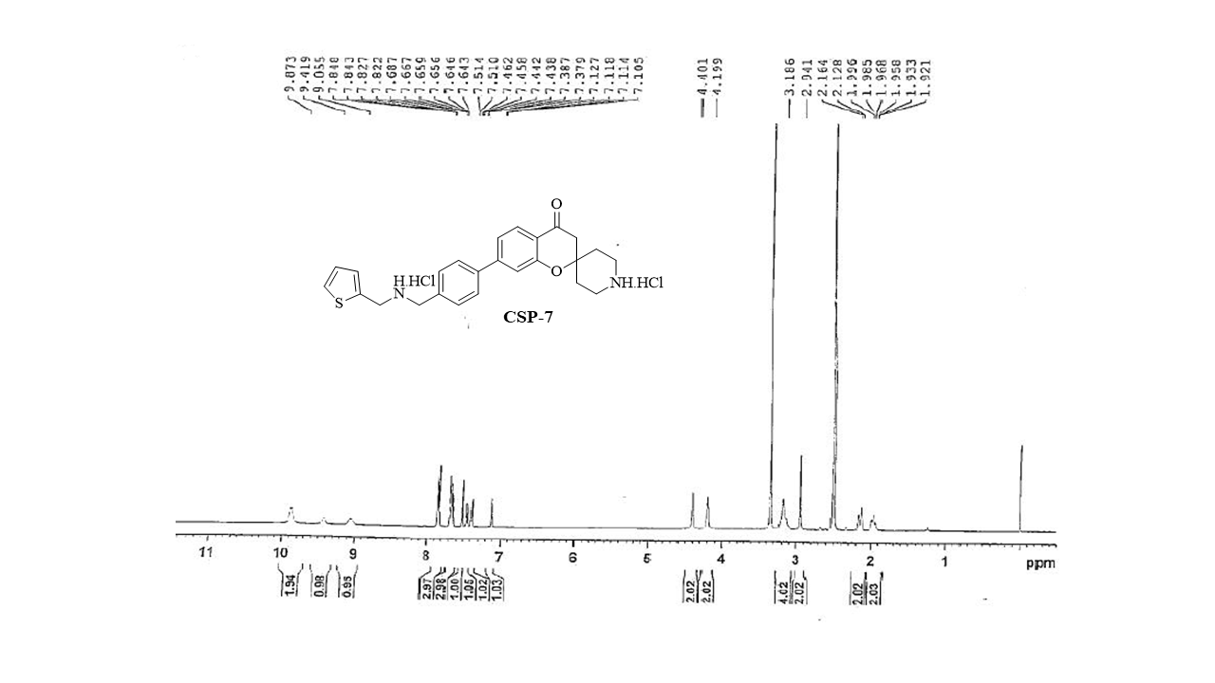
¹H NMR spectrum of compound Csp 7

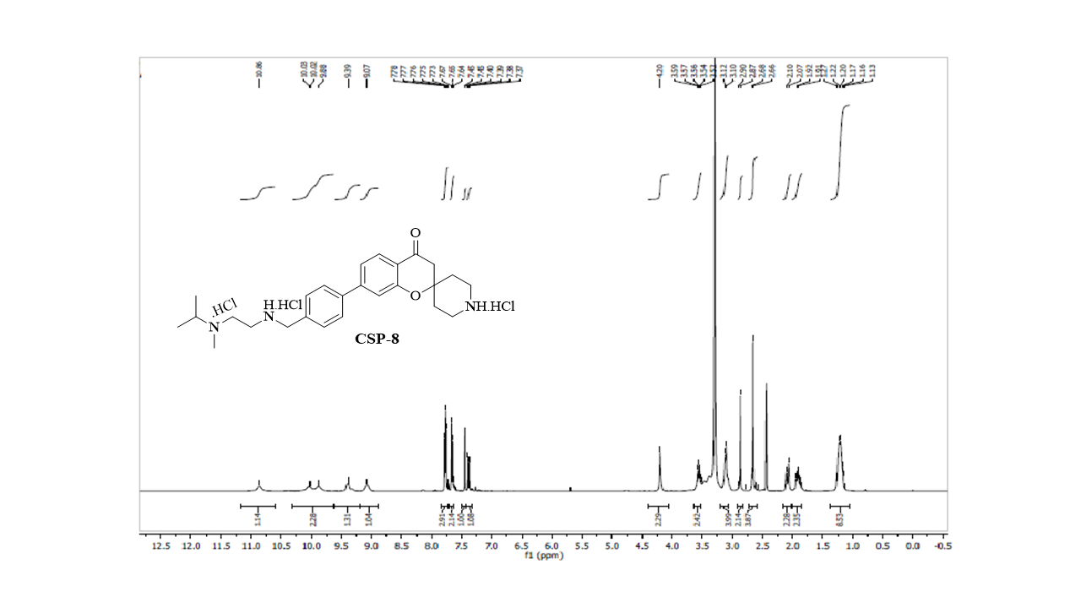¹H-NMR spectrum of compound Csp 8
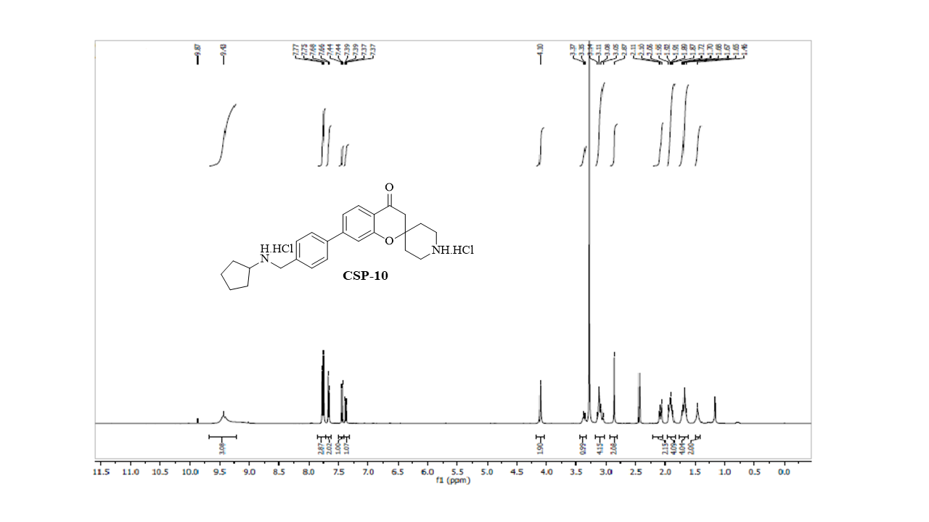

¹H-NMR spectrum of compound Csp 10
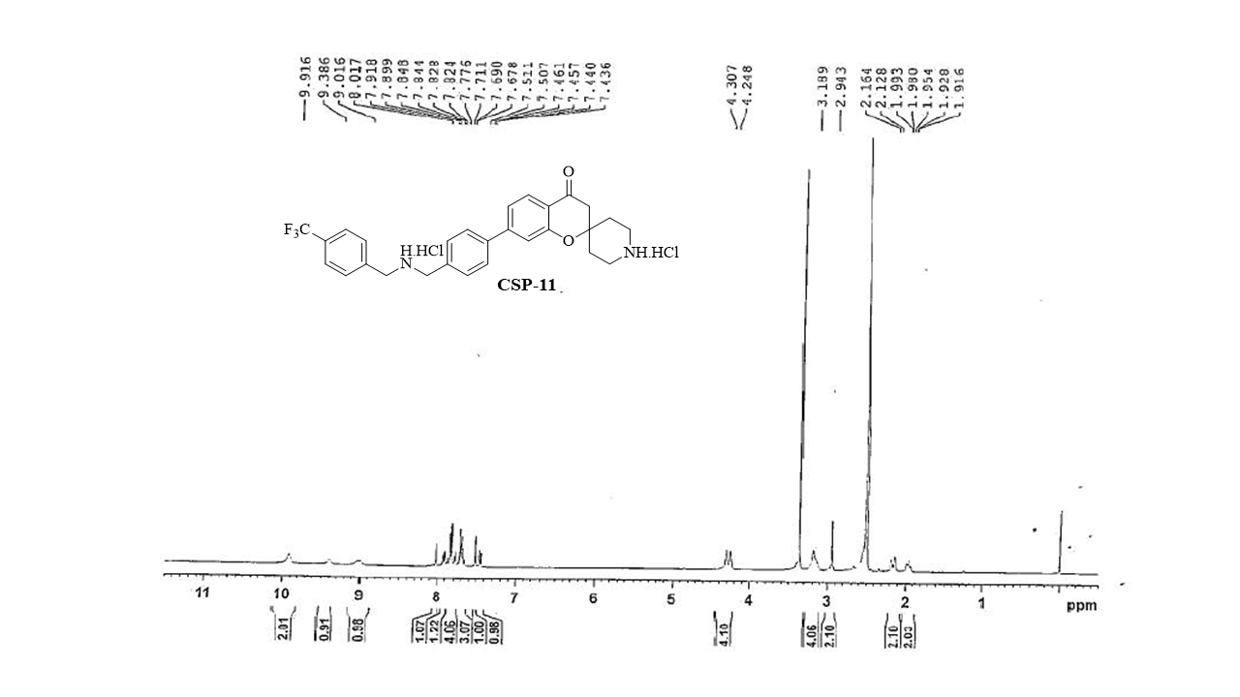
¹H-NMR spectrum of compound Csp 11
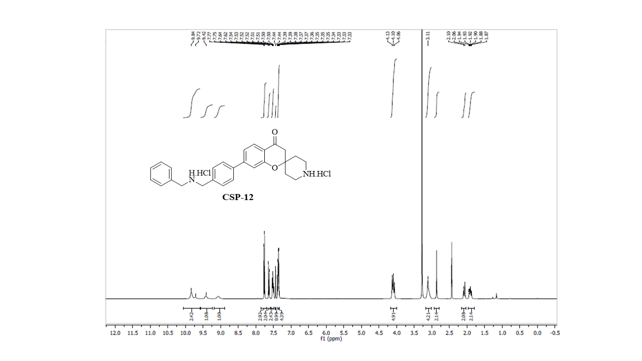
¹H-NMR spectrum of compound Csp 12
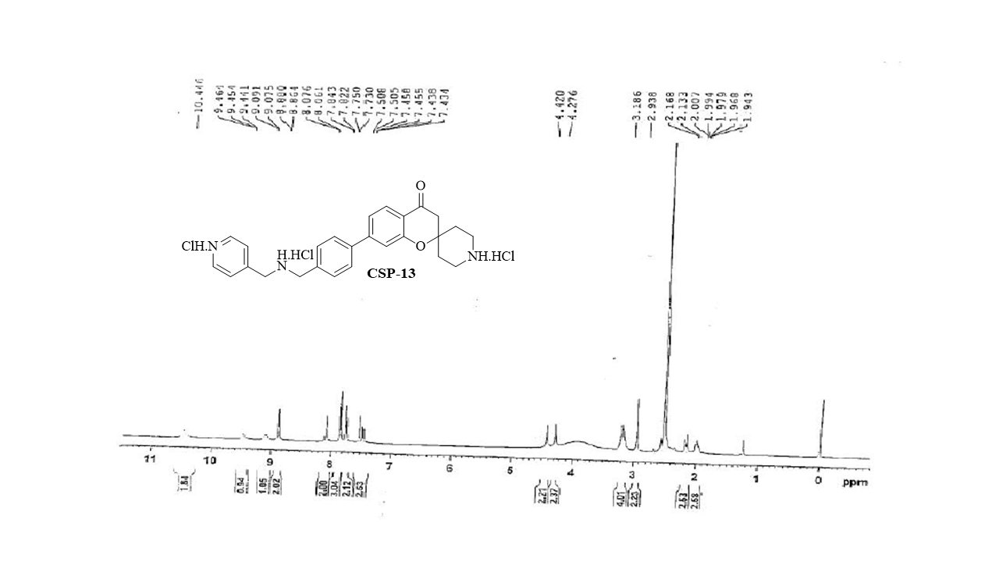
¹H-NMR spectrum of compound Csp 13
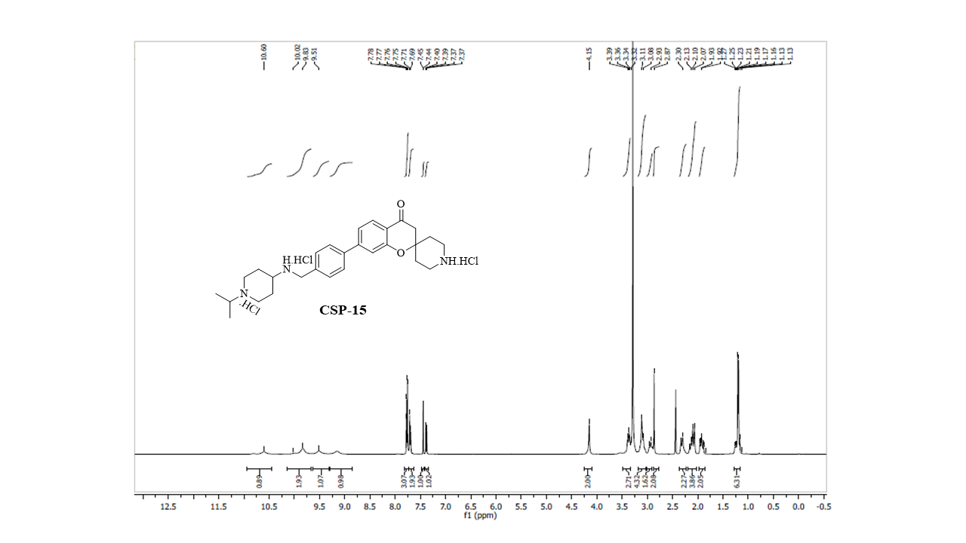
¹H-NMR spectrum of compound Csp 15

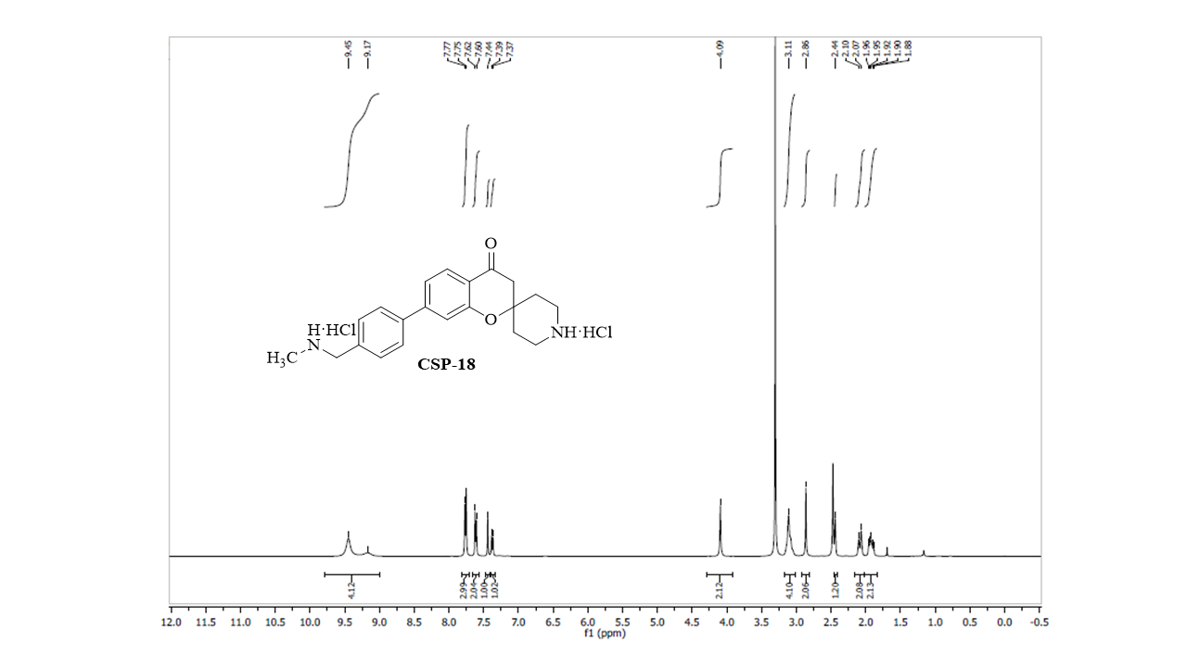
¹H-NMR spectrum of compound Csp 18

5. ¹³C NMR spectra of Csp series compounds

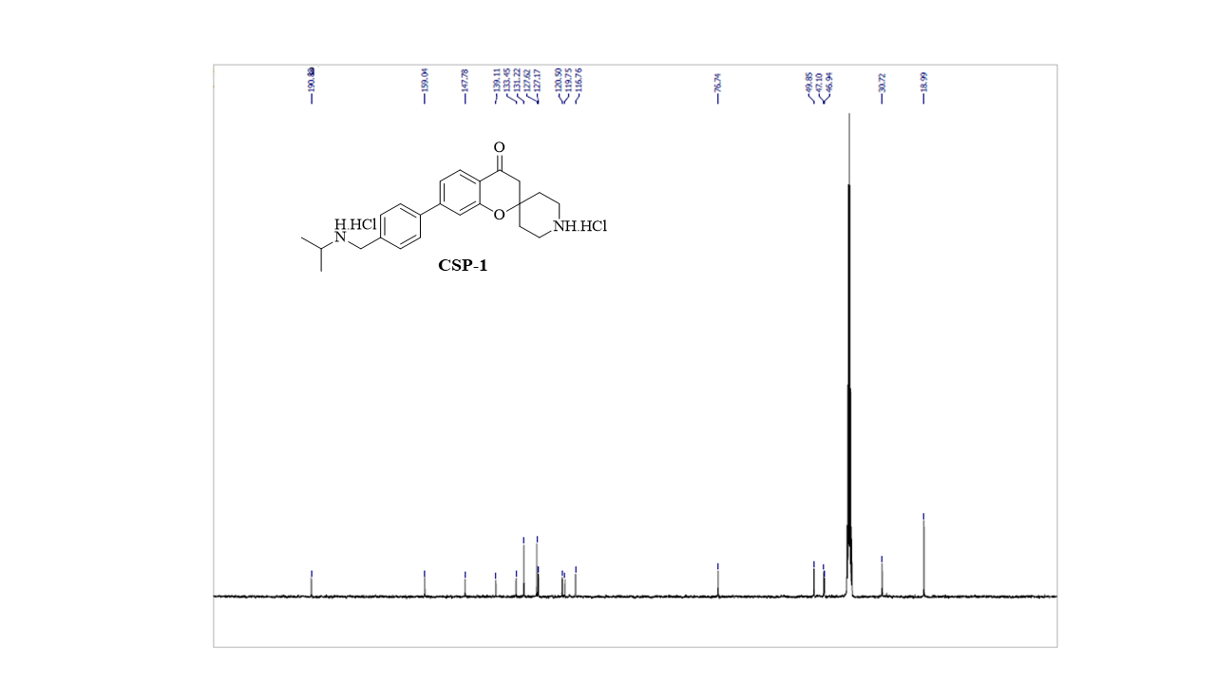¹³C NMR spectrum of compound Csp 1
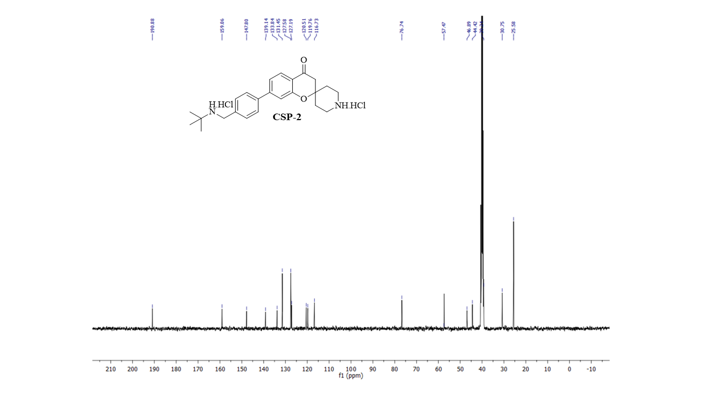¹³C NMR spectrum of compound Csp 2
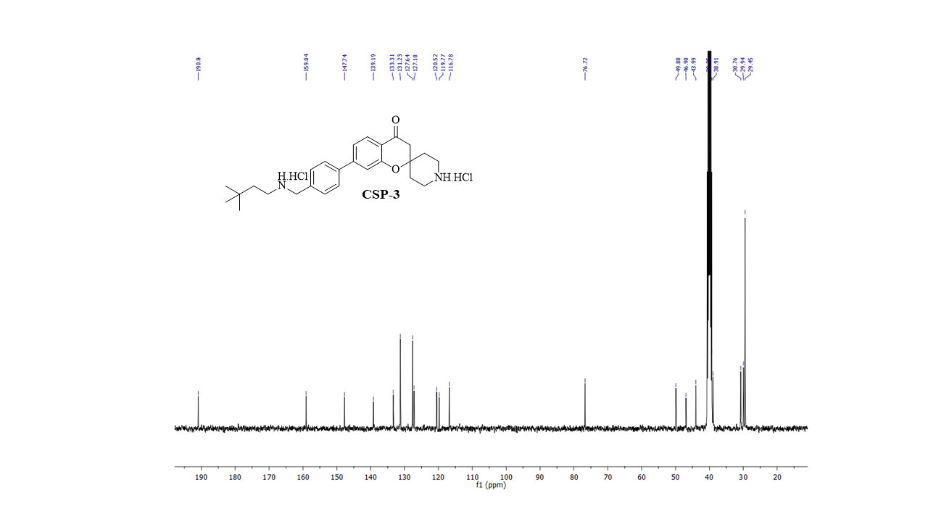¹³C NMR spectrum of compound Csp 3
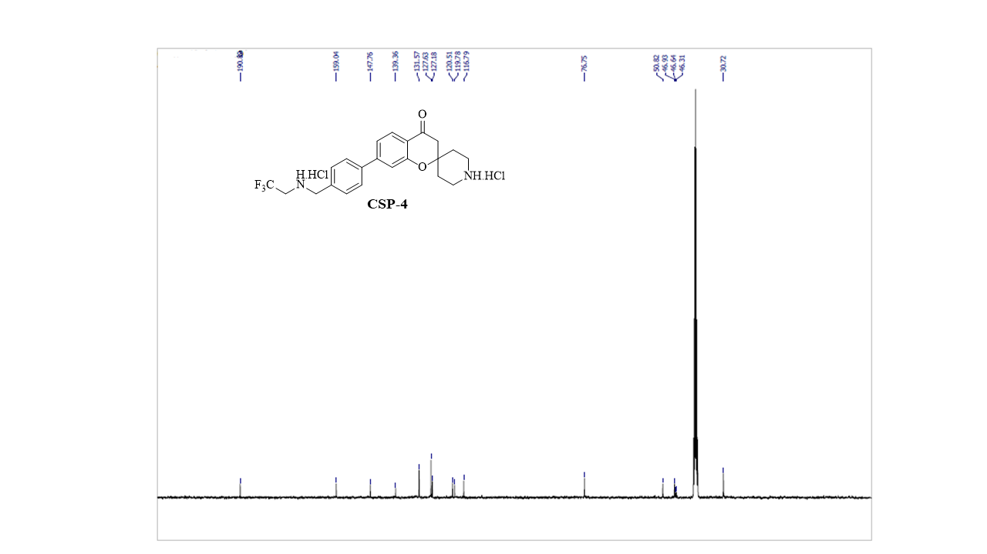¹³C NMR spectrum of compound Csp 4

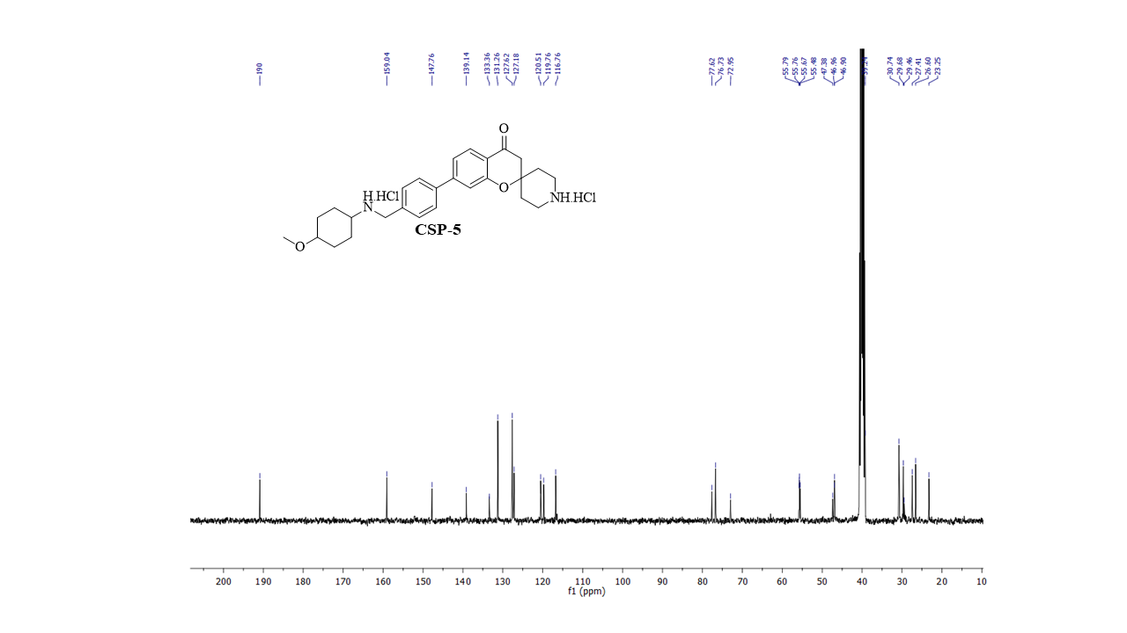¹³C NMR spectrum of compound Csp 5
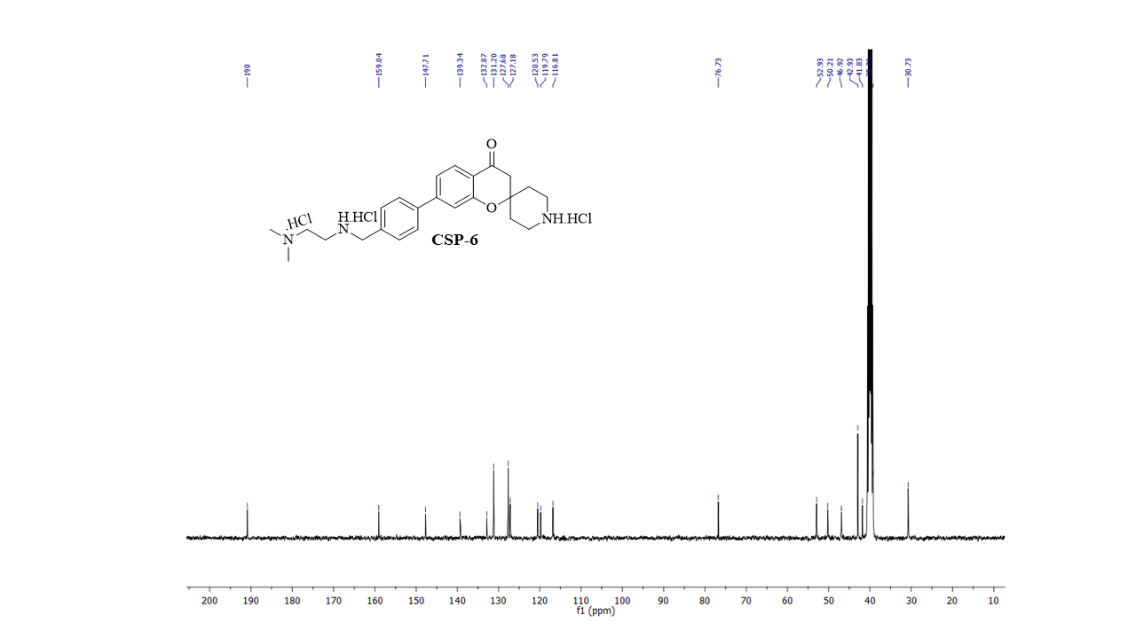¹³C NMR spectrum of compound Csp 6
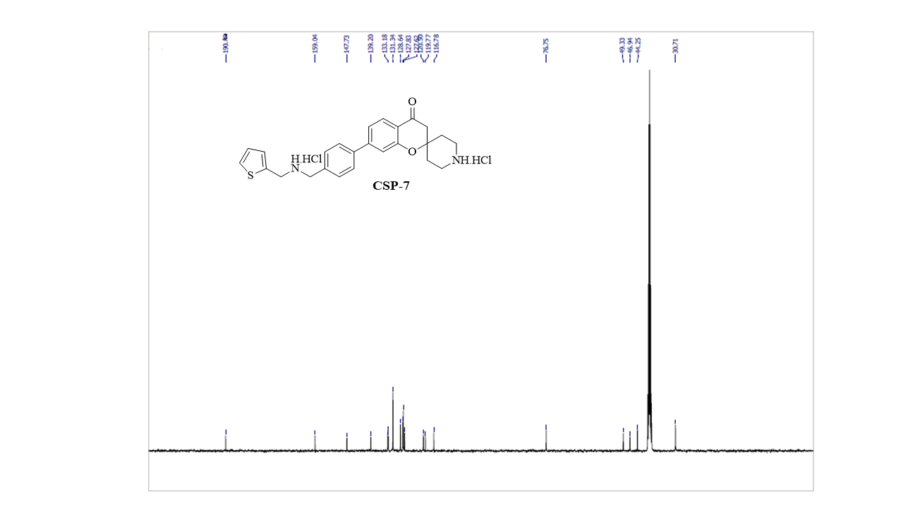

¹³C NMR spectrum of compound Csp 7
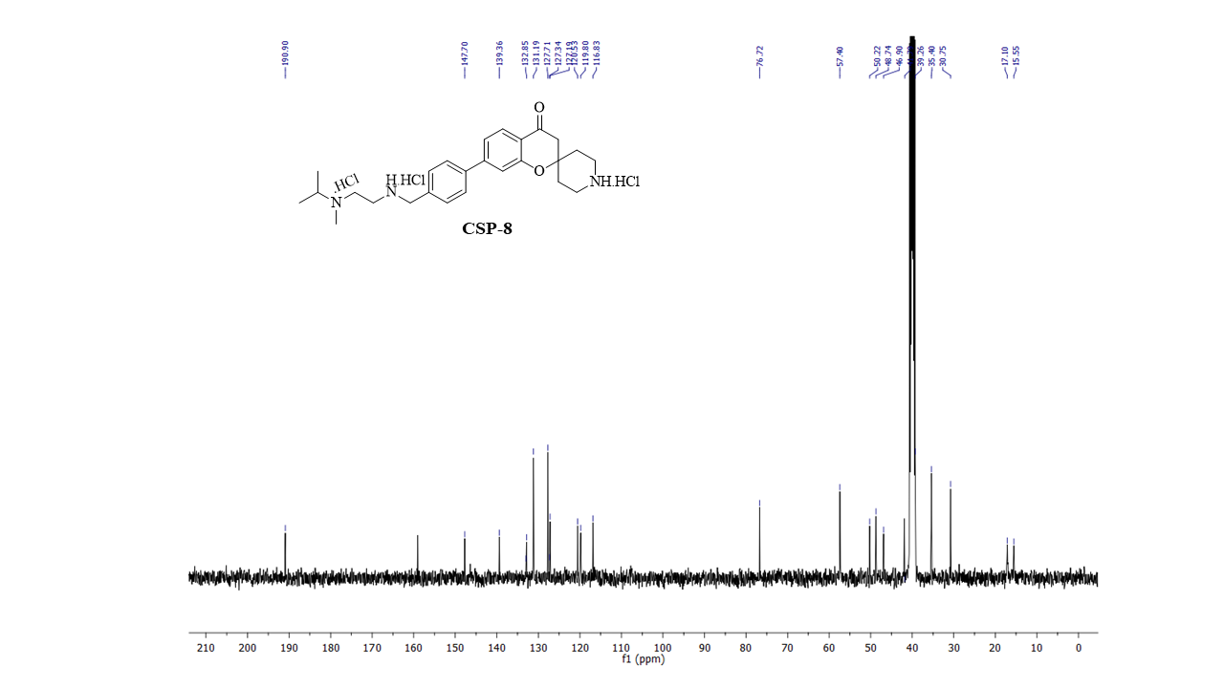¹³C NMR spectrum of compound Csp 8
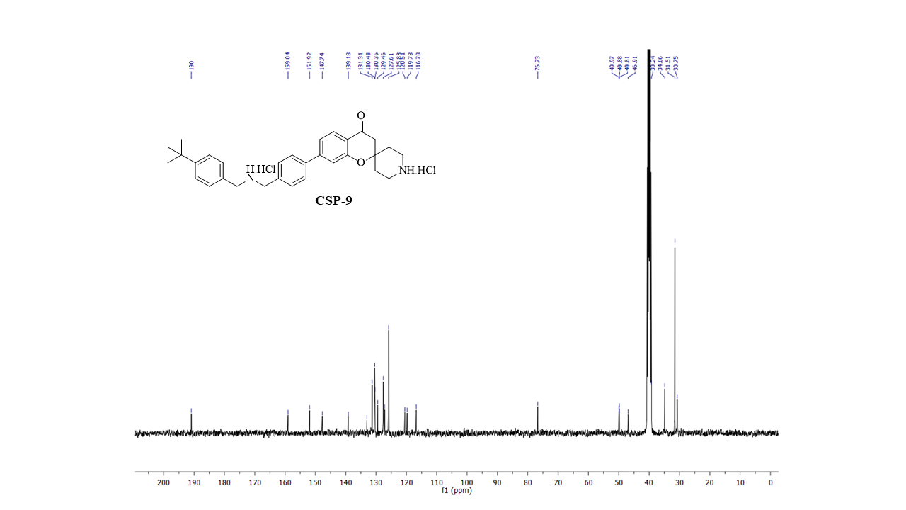¹³C NMR spectrum of compound Csp 9
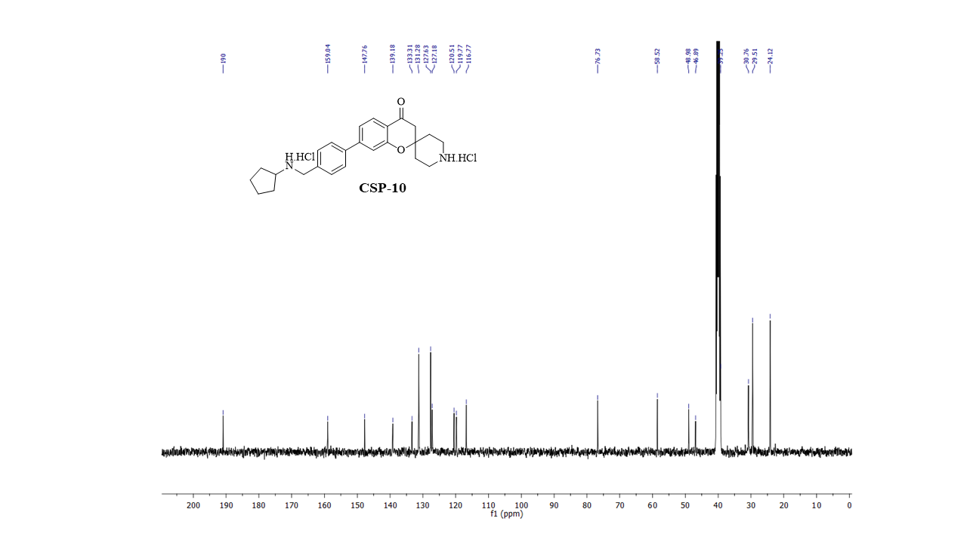¹³C NMR spectrum of compound Csp 10

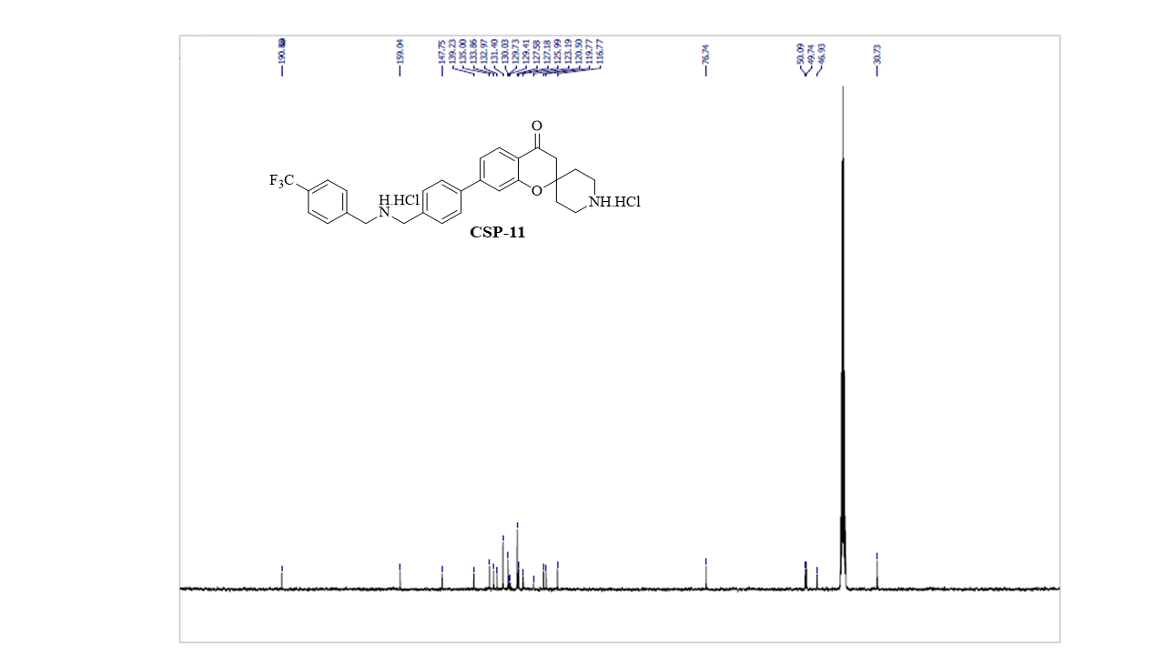¹³C NMR spectrum of compound Csp 11

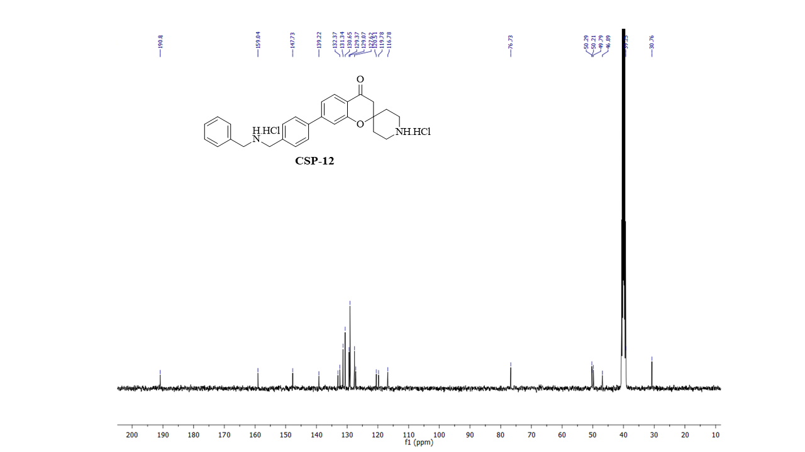
¹³C NMR spectrum of compound Csp 12

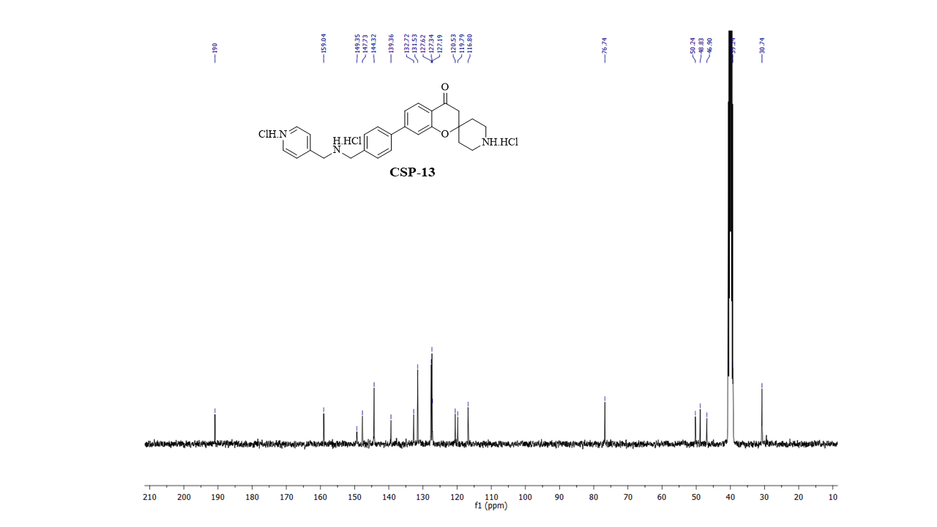
¹³C NMR spectrum of compound Csp 13

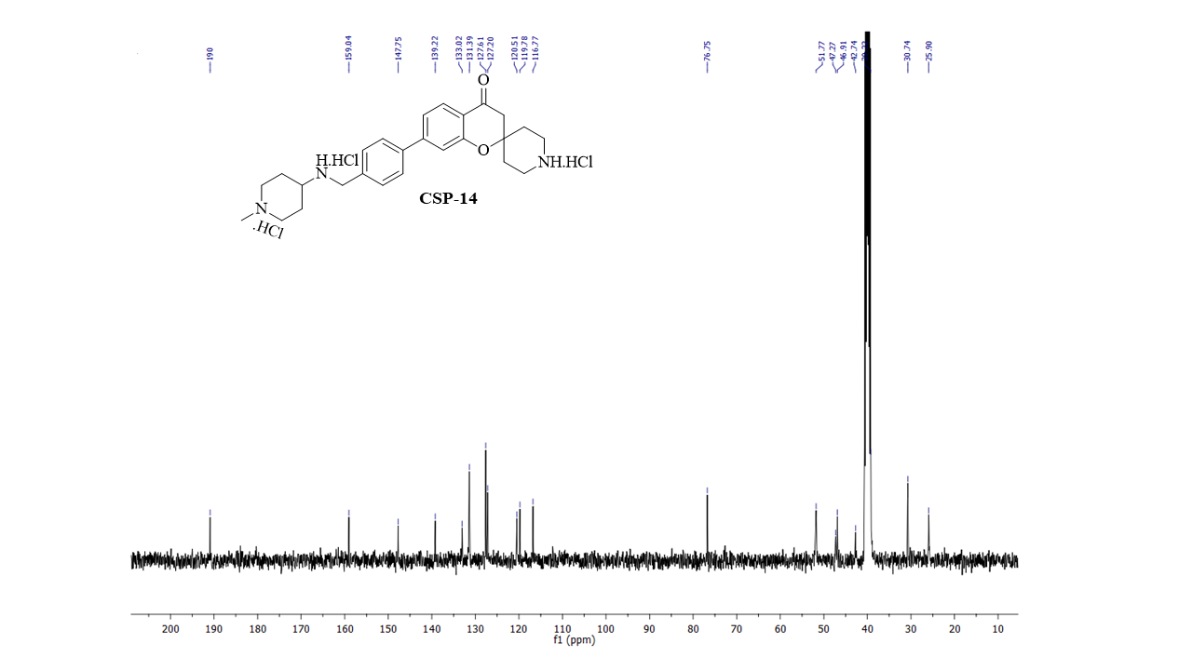¹³C NMR spectrum of compound Csp 14

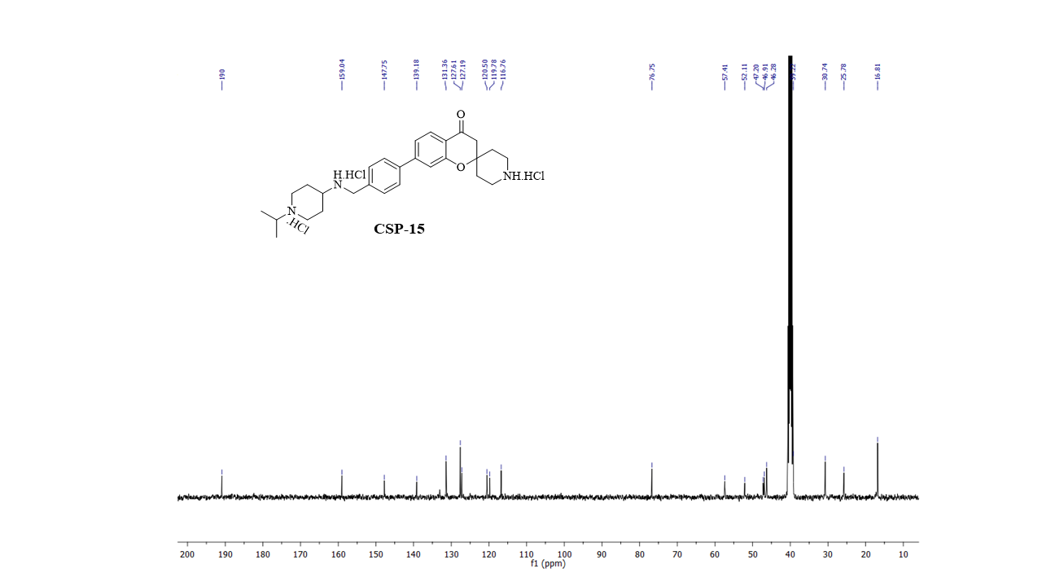
¹³C NMR spectrum of compound Csp 15

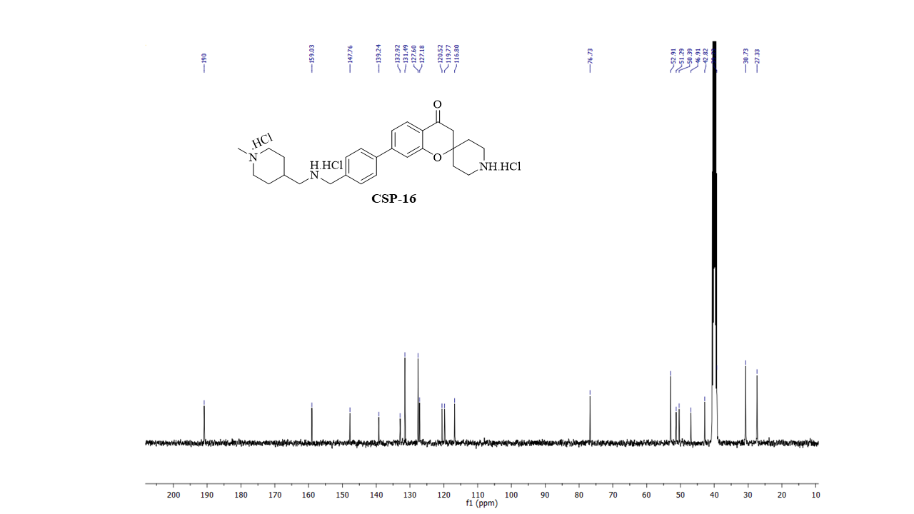¹³C NMR spectrum of compound Csp 16

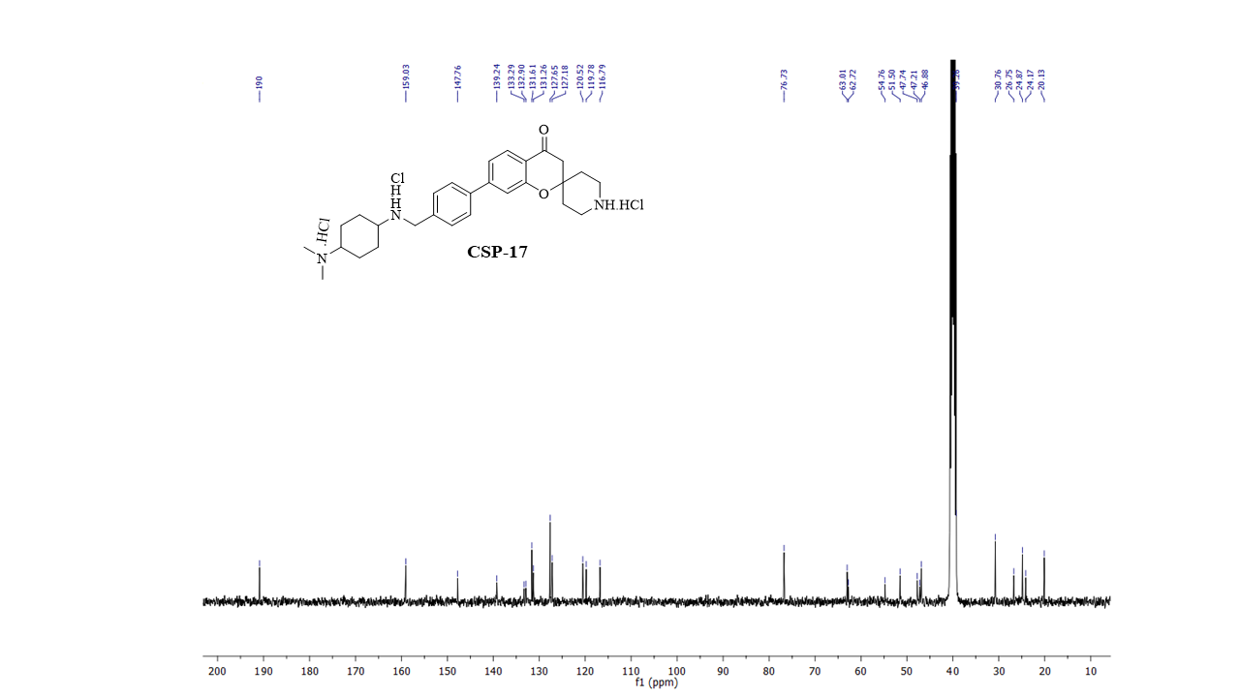
¹³C NMR spectrum of compound Csp 17

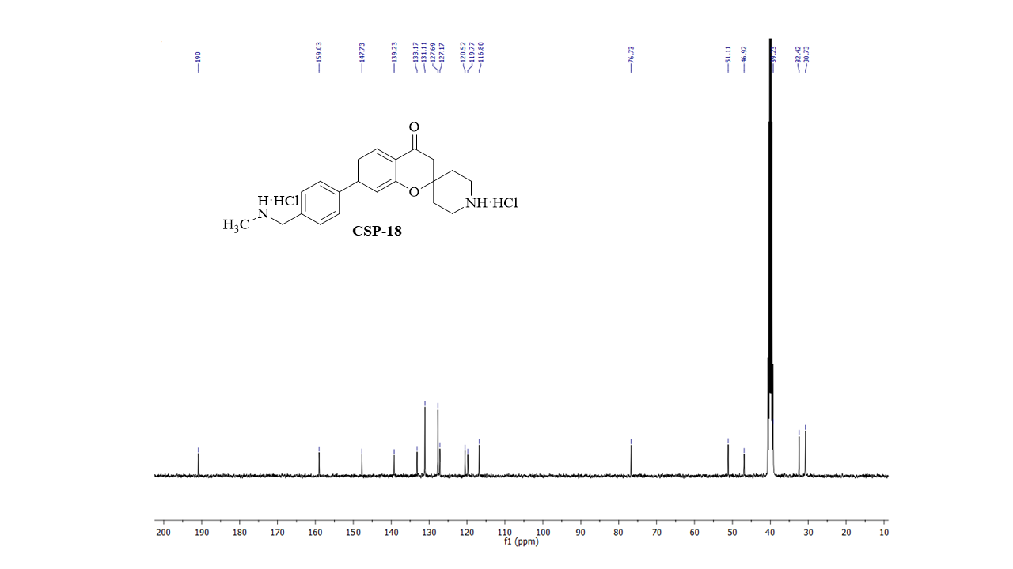¹³C NMR spectrum of compound Csp 18

6. ESI MS spectra of Csp series compounds
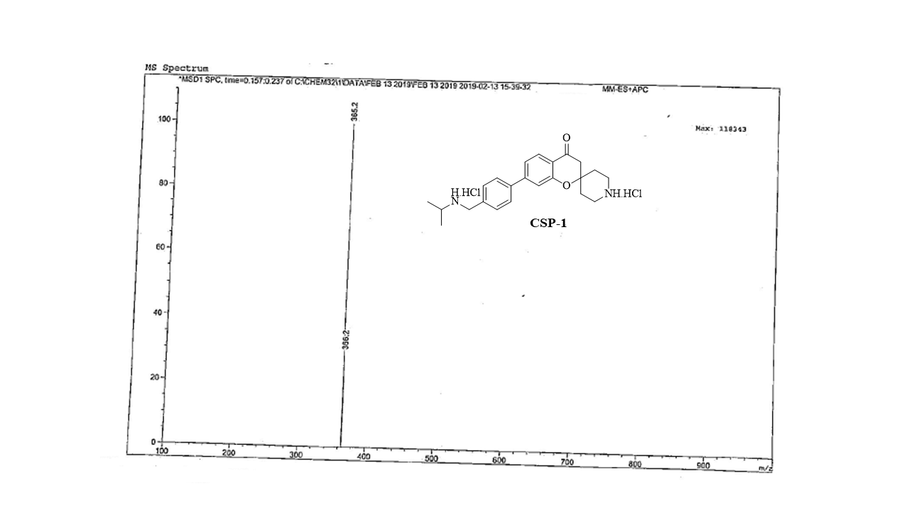ESI MS spectrum of compound Csp 1

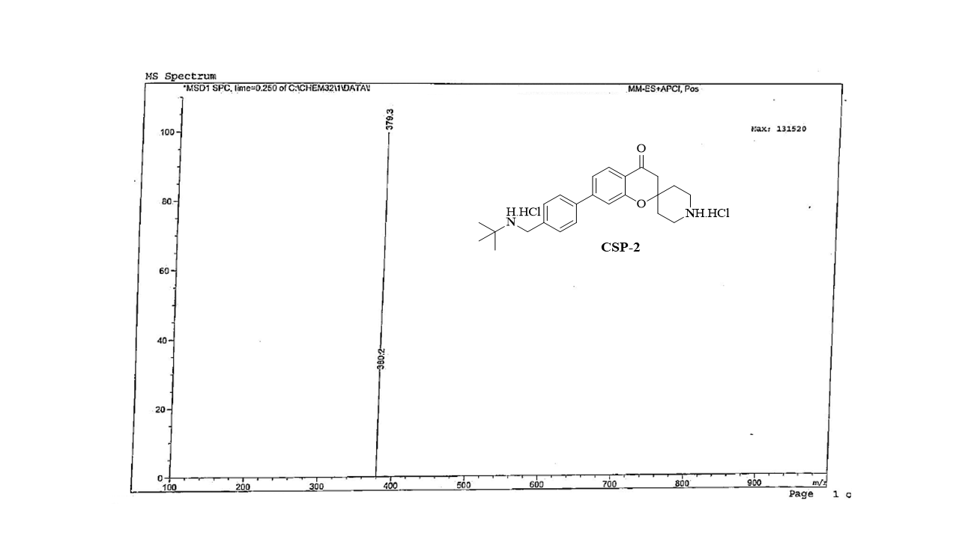ESI MS spectrum of compound Csp 2
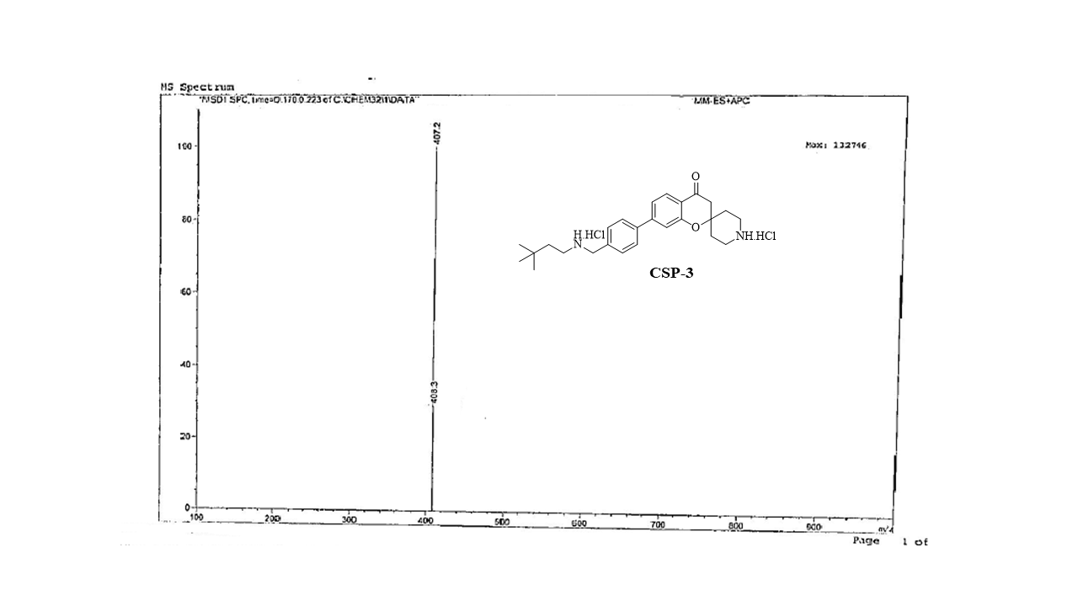 ESI MS spectrum of compound Csp 3

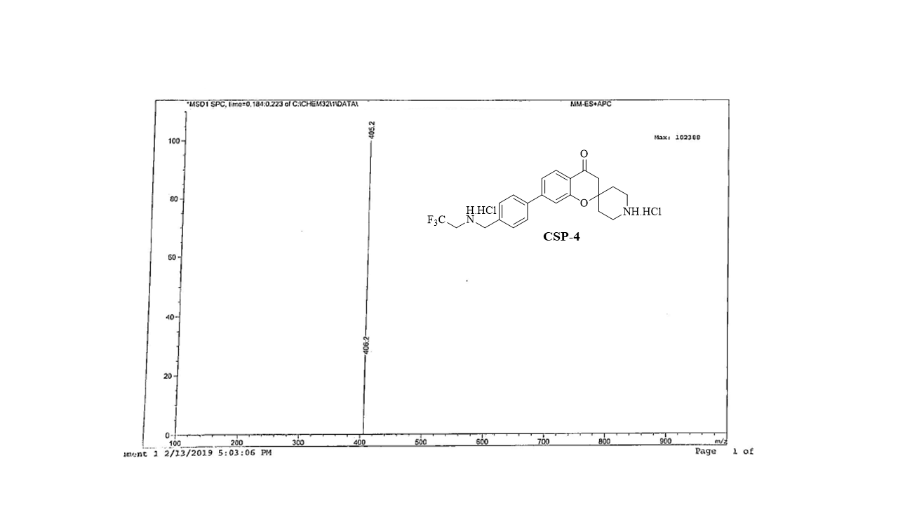ESI MS spectrum of compound Csp 4 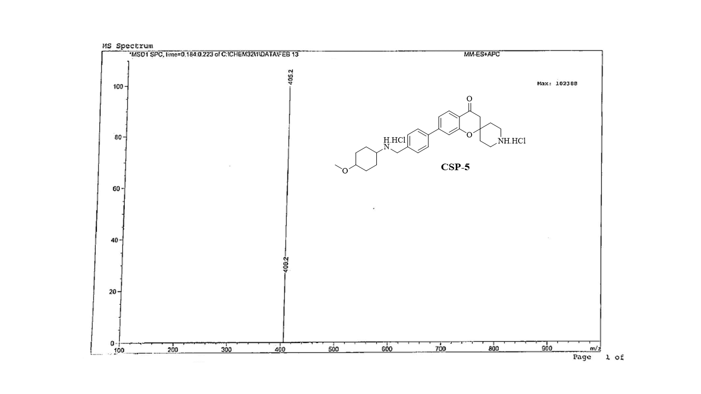
ESI MS spectrum of compound Csp 5
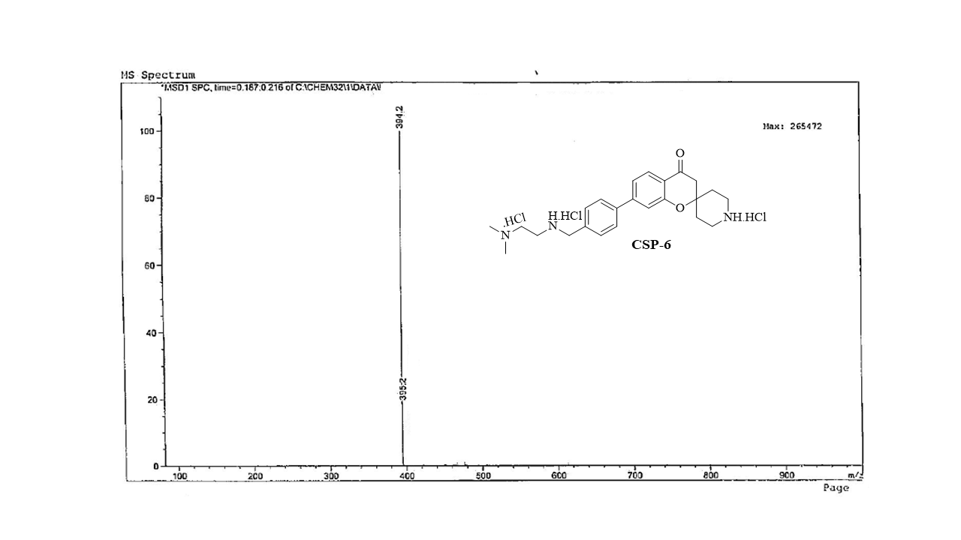 ESI MS spectrum of compound Csp 6
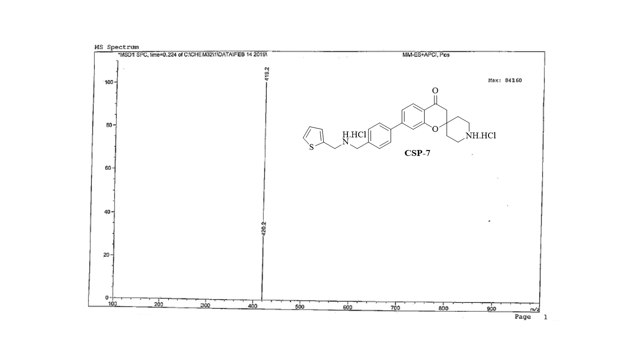 ESI MS spectrum of compound Csp 7
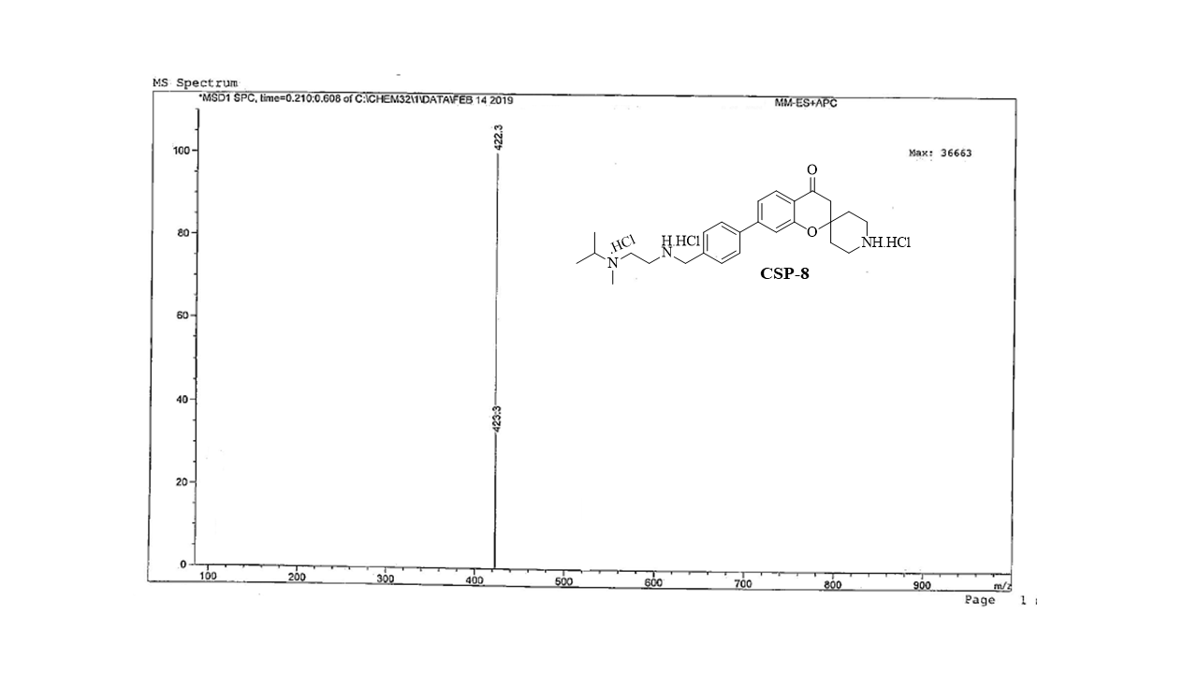ESI MS spectrum of compound Csp 8
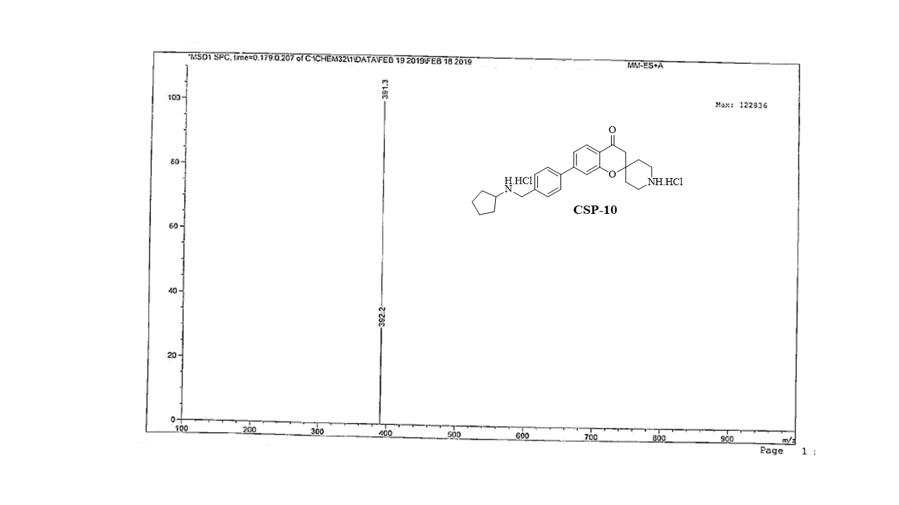ESI MS spectrum of compound Csp 10
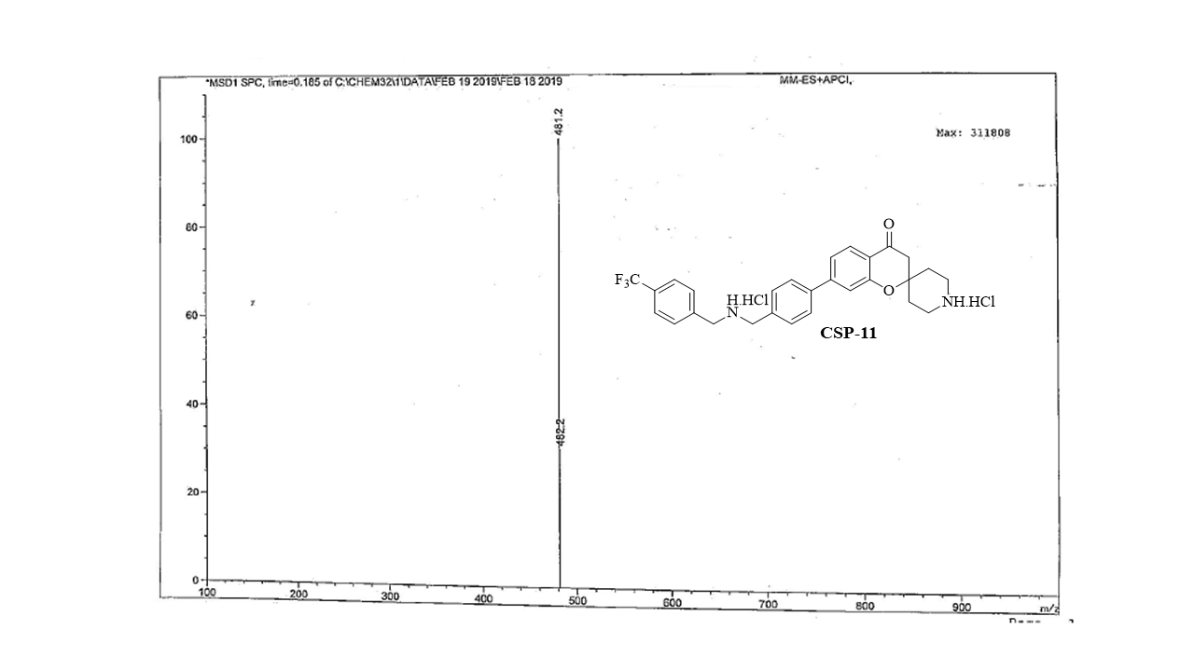 ESI MS spectrum of compound Csp 11

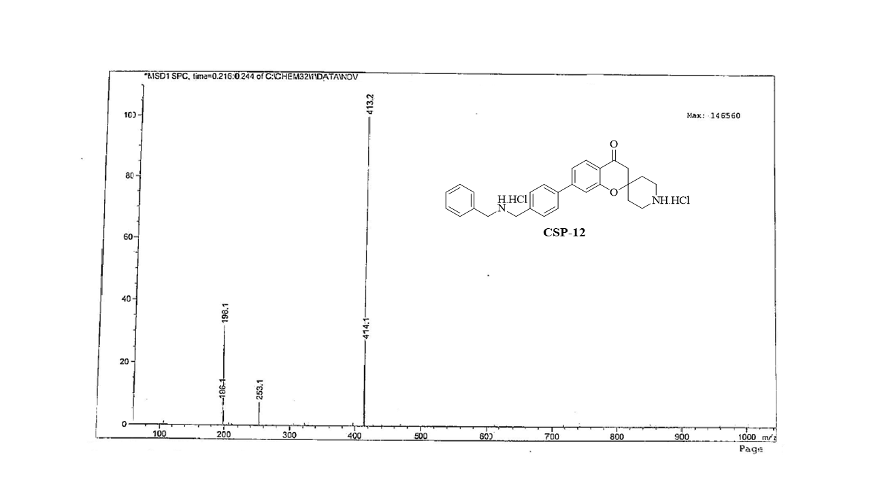ESI MS spectrum of compound Csp 12
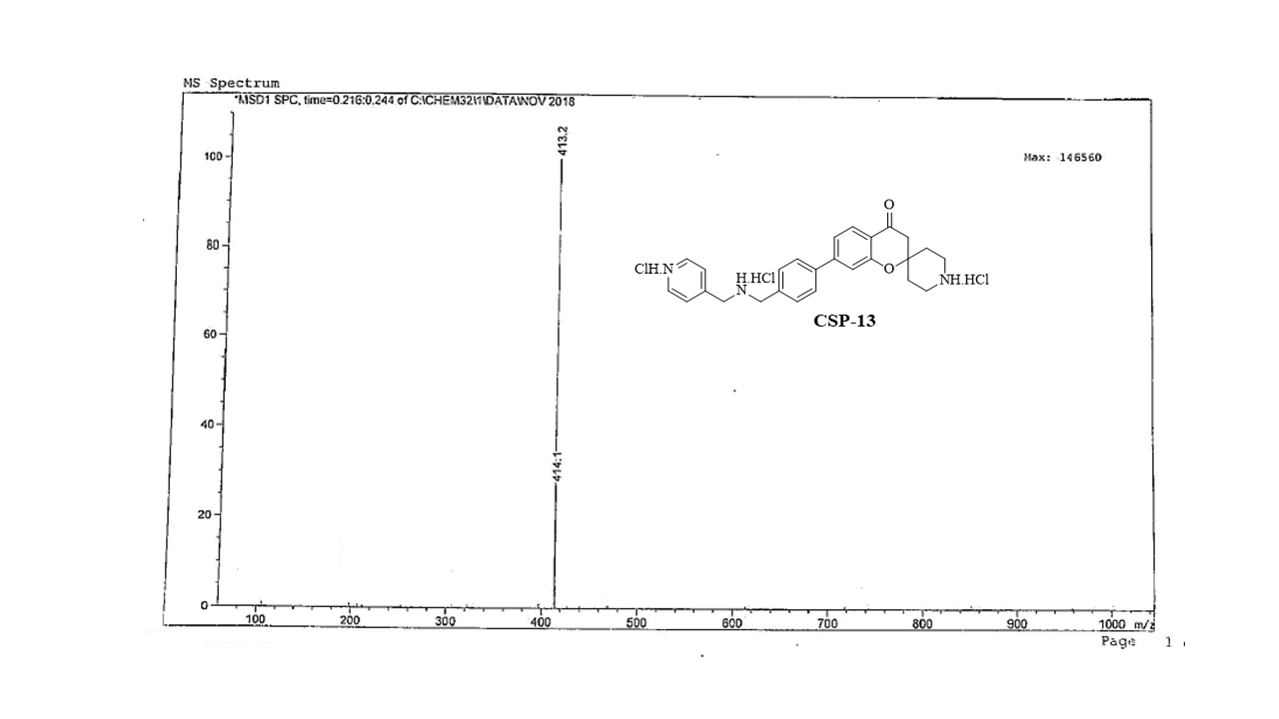ESI MS spectrum of compound Csp 13

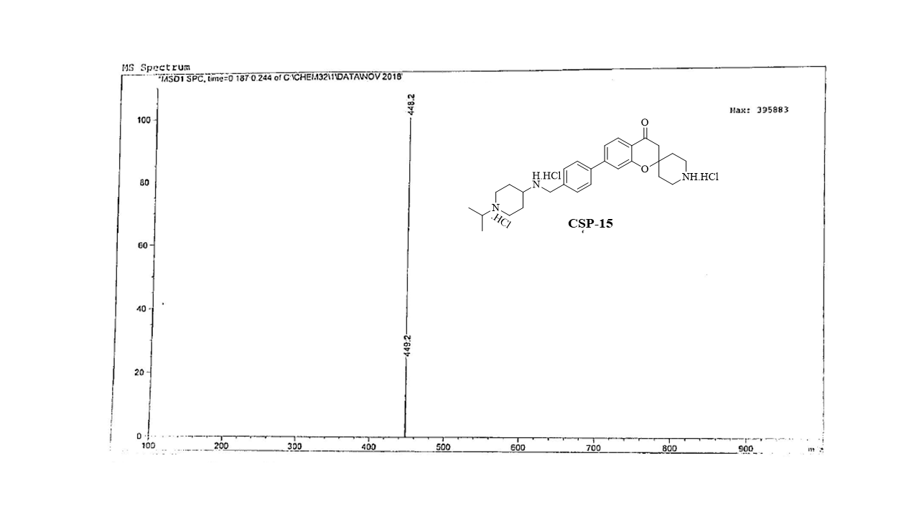ESI MS spectrum of compound Csp 15
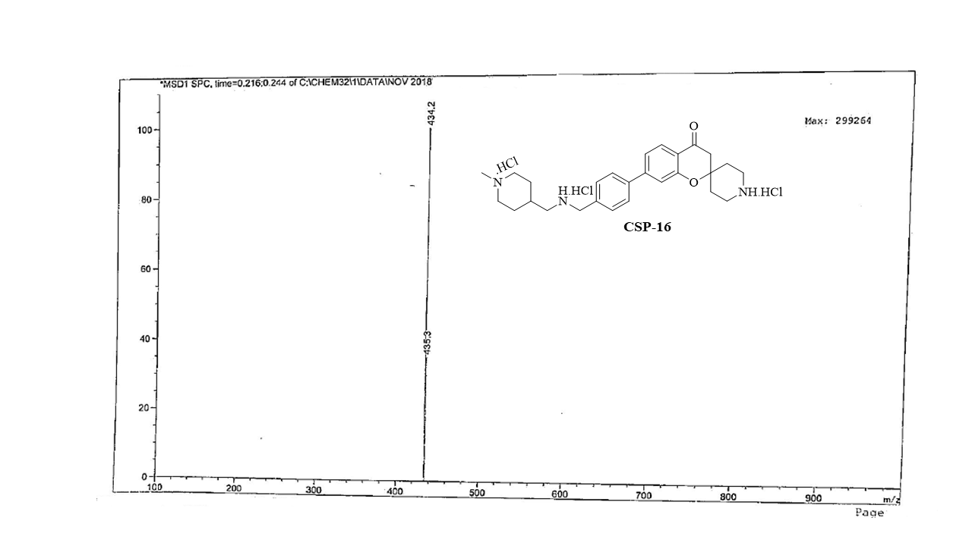 ESI MS spectrum of compound Csp 16

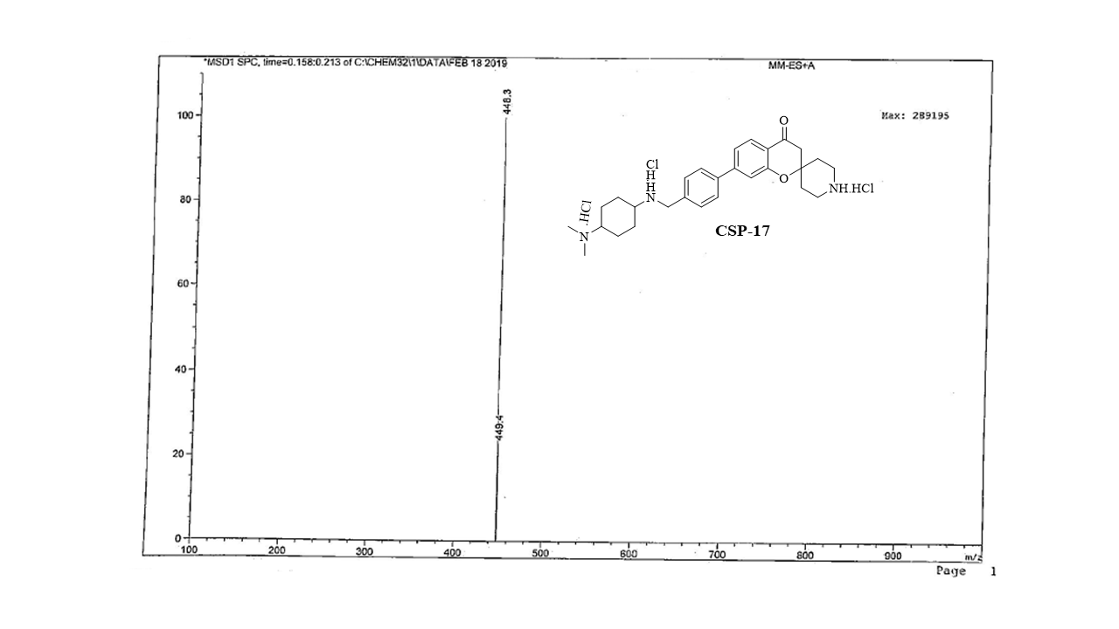ESI MS spectrum of compound Csp 17
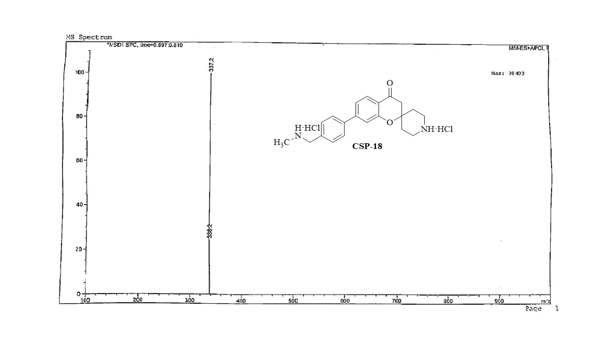ESI MS spectrum of compound Csp 18

References:
1. Reiche HDE, De DDE. International Publication Number. 2007(May), WO2007054580A1 (2007).
2. Hamoud MMS, Pulya S, Osman NA, et al. Design, synthesis, and biological evaluation of novel nicotinamide derivatives as potential histone deacetylase-3 inhibitors. New J. Chem. [Internet]. 44(23), 9671–9683 (2020). Available from: http://dx.doi.org/10.1039/D0NJ01274B.
3. Trivedi P, Adhikari N, Amin SA, et al. Design, synthesis, biological evaluation and molecular docking study of arylcarboxamido piperidine and piperazine-based hydroxamates as potential HDAC8 inhibitors with promising anticancer activity. Eur. J. Pharm. Sci. [Internet]. 138, 105046 (2019). Available from: https://www.sciencedirect.com/science/article/pii/S0928098719303100.
4. Schrödinger Release 2019-1: QikProp, Schrödinger, LLC, New York, NY, 2019. .
5. Q.U. M. QikProp Descriptors and Properties PISA. , 2–4 (2015).
6. Schrödinger Release 2019-1: Maestro, Schrödinger, LLC, New York, NY, 2019. .
7. Burley SK, Berman HM, Bhikadiya C, et al. RCSB Protein Data Bank: biological macromolecular structures enabling research and education in fundamental biology, biomedicine, biotechnology and energy. Nucleic Acids Res. [Internet]. 47(D1), D464–D474 (2019). Available from: https://doi.org/10.1093/nar/gky1004.
8. Singireddi S, Nandikolla A, Amaroju S, et al. Discovery of 1,2,3-triazole based quinoxaline-1,4-di-N-oxide derivatives as potential anti-tubercular agents. Bioorg. Chem. 100, 103955 (2020).
9. Moorthiamma G saraty, Raja KK, Sankaranarayanan M, Banoth KK, Rajagopal G, Thirunavukkarasu S. Synthesis, biological evaluation, molecular docking, molecular dynamics and DFT studies of quinoline-fluoroproline amide hybrids. J. Mol. Struct. [Internet]. 1217, 128360 (2020). Available from: http://www.sciencedirect.com/science/article/pii/S0022286020306852.
10. Ganesan MS, Raja KK, Narasimhan K, Murugesan S, Kumar BK. Design, synthesis, α-amylase inhibition and in silico docking study of novel quinoline bearing proline derivatives. J. Mol. Struct. [Internet]. 1208, 127873 (2020). Available from: https://www.sciencedirect.com/science/article/pii/S0022286020301976.
11. Schrödinger Release 2019-1: LigPrep, Schrödinger, LLC, New York, NY, 2019. .
12. Stamos J, Sliwkowski MX, Eigenbrot C. Structure of the Epidermal Growth Factor Receptor Kinase Domain Alone and in Complex with a 4-Anilinoquinazoline Inhibitor*. J. Biol. Chem. [Internet]. 277(48), 46265–46272 (2002). Available from: https://www.sciencedirect.com/science/article/pii/S002192581933234X.
13. King AJ, Patrick DR, Batorsky RS, et al. Demonstration of a Genetic Therapeutic Index for Tumors Expressing Oncogenic BRAF by the Kinase Inhibitor SB-590885. Cancer Res. [Internet]. 66(23), 11100–11105 (2006). Available from: http://cancerres.aacrjournals.org/content/66/23/11100.abstract.
14. Schrödinger Release 2019-1: Schrödinger Suite 2019-1 Protein Preparation Wizard; Epik, Schrödinger, LLC, New York, NY, 2019. .
15. Friesner RA, Banks JL, Murphy RB, et al. Glide: A New Approach for Rapid, Accurate Docking and Scoring. 1. Method and Assessment of Docking Accuracy. J. Med. Chem. [Internet]. 47(7), 1739–1749 (2004). Available from: https://doi.org/10.1021/jm0306430.

∗ Corresponding author Tel:+91 40 66303639; E-mail: balaram@hyderabad.bits-pilani.ac.in
∗ Corresponding author Tel:+91 40 66303527; E-mail: kvgc@hyderabad.bits-pilani.ac.in; kvgcs.bits@gmail.com

