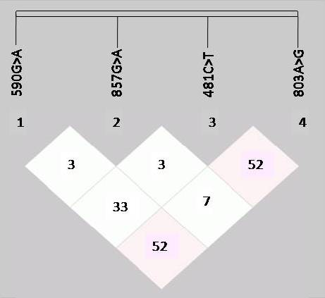
Supplementary Fig. 1: Showing pairwise linkage disequilibrium (D′) between the four variants of NAT2 gene, wherein pink shows the average LD and white depicts the minimum LD between the polymorphic sites.

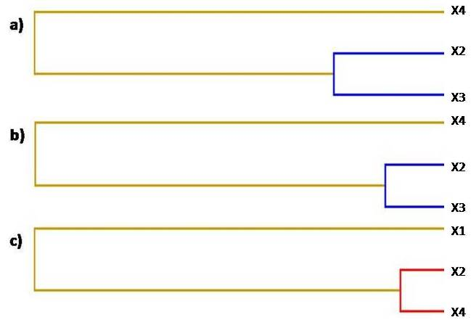
Supplementary Fig. 2: The multifactor dimensionality reduction (MDR) interaction dendrogram a) overall, b) smokers, and c) non-smokers.(Note: X1- NAT2*6 590G>A, X2- NAT2*7 857G>A, X3- NAT2*5 481C>T, X4- NAT2*5 803A>G)

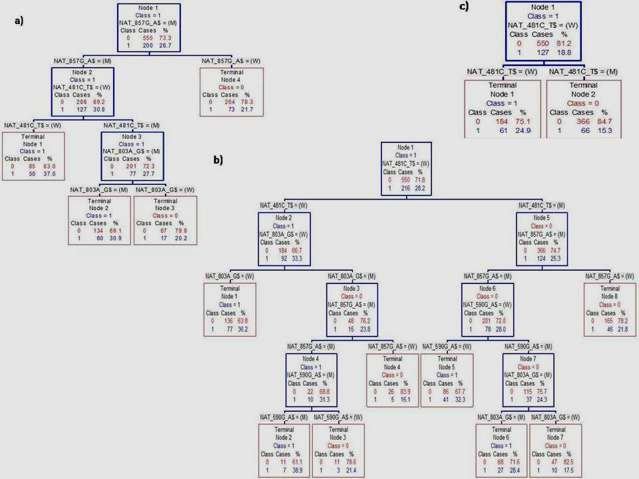
Supplementary Fig. 3: CART analysis in polymorphic NAT2 on basis of histology, a) ADCC, b) SQCC, and c) SCLC. W= homozygous wild type genotype, M = heterozygous + homozygous variant genotype

