Cost-Effectiveness of Brentuximab Vedotin for the Treatment of Cutaneous T-cell Lymphoma: Appendix

Table A1. Clinical Inputs.
Parametric Curves | Input | Source | Scenario Analysis
OS
BV | Same as PC | Assumption | 1. OS benefit for BV:  a. 2-months  b. 4-months  c. 9.5-months
PC | Log-logistic | ¹ | 2. Log-normal (PC)
alloSCT | Log-normal | ² | 3. Weibull (alloSCT)
PFS
BV | Weibull | ¹ | 4. Exponential (BV and PC)
PC | Weibull | ¹
alloSCT | Gompertz | ²
Time on treatment
BV | Actual data | ¹
PC | Actual data | ¹
Time of treatment before alloSCT eligibility | 18 weeks* (i.e. 6 cycles of BV) | Expert opinion | 5. Timing of alloSCT: a. 12-weeks  b. 24-weeks
Responders eligible for alloSCT | 40% | Expert opinion | 6. 20% of responders eligible for alloSCT
Subsequent therapy: Proportion treated |  | EU PROCLIPI data on file
Subsequent therapy: Time on treatment (weeks)
Gemcitabine | 16.0 | ³
CHOP | 9.0 | Expert opinion
Other mono chemotherapy | 24.0 | ⁴
TSEB | 47.8 | ⁵
Background mortality | England and Wales’ life tables 2014–2016 | ⁶
Abbreviations: BEX, bexarotene; BV, brentuximab vedotin; CHOP, cyclophosphamide, doxorubicin, vincristine, prednisone; MTX, methotrexate; OS, overall survival; PC, physician’s choice; PFS, progression-free survival; TSEB, total skin electron beam therapy.
*Expert opinion provided the number of cycles, which was translated into weeks

Table A2. Cost Inputs.
Cost category | Unit cost | Cycle cost | Source | Scenario Analysis
Drug costs
BV | £2,500.00 | £2,500.00 | MIMS ⁷
MTX | £1.44 | £0.51 | MIMS ⁸
BEX | £937.50 | £459.38 | MIMS ⁹
alloSCT | £96,956 | -- | ¹⁰ | 7. £65,154 (NHS Reference costs)
Subsequent therapy
Gemcitabine | 200 mg: £30.93  1000 mg: £154.62  2000 mg: £324.00 | £694.76 | Unit costs: MIMS ¹¹  Dosing: LCA SACT ¹²
CHOP | -- | £97.54 | Unit costs: MIMS ¹³⁻¹⁶  Dosing: LCA SACT ¹⁷
Cyclophosphamide | 50 mg: £139.00 | £13.44
Hydroxydaunorubicin | 10 ml: £18.54  50 ml: £92.70  200 ml: £391.40 | £61.80
Oncovin (vincristine) | 1 ml: £67.35  2 ml: £133.30  5 ml: £329.50 | £13.38
Prednisolone | 1 mg: £0.37  5 mg: £0.47  25 mg: £75.00 | £8.93
Other mono chemotherapy* | -- | £151.29 | Unit costs: MIMS¹⁸  Dosing: LCA SACT
TSEB | -- | £72.67 | Unit costs: NHS Reference Costs ¹⁹  Dosing: Guys Hospital
Administration costs
BV | -- | £58.00 | ^{19,20}
MTX | -- | £0 | Assumption
BEX | -- | £0 | Assumption
Gemcitabine | -- | £130.49 | ^{19,20}
CHOP | -- | £173.99 | LCA SCAT ¹⁷
Other mono chemotherapy* | -- | £164.64 | LCA SCAT ²¹
Adverse event costs
BV | -- | £4.97 | ¹⁹
PC | -- | £5.99 | ¹⁹
Resource use costs |  |  |  | 8. See Table A3
Pre-progression | -- | £388.63 | Expert opinion
Post-progression | -- | £904.45 | Expert opinion
End-stage care (specific to advanced CTCL) | -- | £2,094.92 | Expert opinion
End-stage care (generic oncology disease) | -- | £286.48 | ²²
Indirect costs
Pre-progression | -- | £62.72 | Average number of hospital visits/week: assumption  Costs: ²³⁻²⁶
Post-progression | -- | £199.76
End-stage care | -- | £288.02
Abbreviations: BEX, bexarotene; BV, brentuximab vedotin; LCA, London Cancer Alliance; MTX, methotrexate; PAS, patient access scheme; SACT, systemic anti-cancer therapy.
Notes: *Other mono chemotherapy includes doxorubicin (all formulations) and chlorambucil.

Additional details on drug costs and administration costs
Model costs for each drug were estimated based on weight or body surface area as follows:
- The cycle cost of BV is estimated based on a dose of 1.8 mg/kg during a 21-day treatment cycle with a relative dose intensity of 95%.^{1,27}
- The cycle cost of MTX is estimated based on a dose of 23.44 mg during a 7-day treatment cycle. ^{1,27}
- The cycle cost of BEX is estimated based on a dose of 300 mg/m2 during a 1-day treatment cycle with a relative dose intensity of 90%.^{1,27}
- The cycle cost of gemcitabine is estimated based on a dose of 3000 mg/m2 during a 28-day treatment cycle.¹²
- The cycle cost of CHOP is estimated based on the dose of the component therapies (Cyclophosphamide: 750 mg/m2; Hydroxydaunorubicin: 50 mg/m2; Oncovin (vincristine): 1.4 mg/m2; Prednisolone: 100 mg) during a 21-day treatment cycle.¹⁷
- The cost of 2 weeks on TSEB therapy is spread over the average duration of response of 11 months.

Administration unit costs are estimated from NHS reference costs 2016/17. All IV therapies, including BV, are costed as simple therapies with the exceptions of doxorubicin (costed as complex chemotherapy), and CHOP, for which each of the three IV therapies is costed as simple chemotherapy, with no cost assumed for prednisolone. For oral therapies, the administrative cost for chlorambucil includes costs for oral dispensing; however, the oral dispensing cost is not included for MTX or BEX.

Table A3: Resource utilization.
 | Base case |  | Scenario Analysis: 9. Lower-range resource utilization
 | % Patients | Frequency per week | % Patients | Frequency per week
End-stage care
Hospital outpatient
Clinical nurse specialist | 100 | 2.25 | 100 | 1.63
Dermatologist visit | 100 | 0.17 | 100 | 0.17
Psychologist | 50 | 0.25 | 5 | 0.25
Home visit
District nurse visit | 100 | 2.63 | 100 | 2.63
Macmillan nurse/social services | 100 | 1 | 100 | 0.5
Palliative care support team | 100 | 2 | 100 | 0.5
Dressings
Meptiel dressings | 25 | 7 (x3) | 12.5 | 7 (x3)
Mepilex large sheet dressings | 25 | 7 (x2) | 12.5 | 7 (x2)
Mepilex heels | 25 | 7 (x2) | 12.5 | 7 (x2)
Elasticated garments | 25 | 1 (x3) | 12.5 | 1 (x3)
Medium Allevyn | 75 | 7 | 75 | 7
Pre-progression / Post -progression
District nurse visit | 100 | 2.6 | 100 | 0.25
Dressings - localised coverage | 60 | 7 (x7) | 37.5 | 7 (x7)

Table A4. Utility inputs.
Health State | Utility | Source | Scenario Analysis
Progression free |  |  | Scenario 9: Predicted utilities²⁷
BV | 0.69 | Averaged observed utilities for BV and PC ²⁷ | 0.68
PC | 0.69 |  | 0.64
Progressive disease | 0.64 |  | 0.61
End stage care | 0.38 | ²⁸
alloSCT: 0-14 days | 0.42 | ²⁹
alloSCT: 14 days -3 months | 0.60 | ²⁹
alloSCT: >3 months | 0.77 | ²⁹
Adverse Event | Disutility | Source | Scenario 10: Disutilities from literature
Blood and lymphatic system disorders | 0 | Assumption | -0.10 ³⁰
Gastrointestinal disorders | 0 | Assumption | -0.10 ³¹
General disorders and administration site conditions | 0 | Assumption | -0.07 ³²
Multiorgan failure | 0 | Assumption | -0.20 ³⁰
Infections and infestations | 0 | Assumption | -0.14 ³³
Septicemia | 0 | Assumption | -0.20 ³⁰
Peripheral neuropathy | 0 | Assumption | -0.11 ²⁸
Skin and subcutaneous tissue disorders | 0 | Assumption | -0.03 ³²
Investigations | 0 | Assumption
Hypertriglyceridemia | 0 | Assumption
Abbreviations: alloSCT, allogenic stem cell transplant; BV, brentuximab vedotin; PC, physician’s choice.

References:

1. Horwitz SM, Scarisbrick JJ, Dummer R, et al: Updated Analyses of the International, Open-Label, Randomized, Phase 3 Alcanza Study: Longer-Term Evidence for Superiority of Brentuximab Vedotin Versus Methotrexate or Bexarotene for CD30-Positive Cutaneous T-Cell Lymphoma (CTCL), Am Soc Hematology, 2017
2. Palanicawandar R, Morris S, Lozano-Cerrada S, et al: Allogeneic Stem Cell Transplantation for Advanced Cutaneous T-Cell Lymphoma with Minimal-Intensity Conditioning, European Organisation for Research and Treatment of Cancer, 2017
3. Duvic M, Tetzlaff MT, Gangar P, et al: Results of a Phase II Trial of Brentuximab Vedotin for CD30+ Cutaneous T-Cell Lymphoma and Lymphomatoid Papulosis. J Clin Oncol 33:3759-65, 2015
4. Dummer R, Quaglino P, Becker JC, et al: Prospective international multicenter phase II trial of intravenous pegylated liposomal doxorubicin monochemotherapy in patients with stage IIB, IVA, or IVB advanced mycosis fungoides: final results from EORTC 21012. J Clin Oncol 30:4091-7, 2012
5. Morris S, Scarisbrick J, Frew J, et al: The Results of Low-Dose Total Skin Electron Beam Radiation Therapy (TSEB) in Patients With Mycosis Fungoides From the UK Cutaneous Lymphoma Group. Int J Radiat Oncol Biol Phys 99:627-633, 2017
6. Office for National Statistics: National life tables, UK: 2014 to 2016. Statistical bulletin, 2017
7. Monthly Index of Medical Specialities (MIMS): Brentuximab vedotin - Adcetris, 2018
8. Monthly Index of Medical Specialities (MIMS): Methotrexate, 2018
9. Monthly Index of Medical Specialities (MIMS): Bexarotene - Targretin, 2018
10. Debals-Gonthier M, Siani C, Faucher C, et al: Cost-effectiveness analysis of haploidentical vs matched unrelated allogeneic hematopoietic stem cells transplantation in patients older than 55 years. Bone Marrow Transplantation, 2018
11. Monthly Index of Medical Specialities (MIMS): Gemcitabine, 2018
12. London Cancer Alliance: LCA skin SACT protocols - non melanoma - Gemcitabine, 2015
13. Monthly Index of Medical Specialities (MIMS): Cyclophosphamide, 2018
14. Monthly Index of Medical Specialities (MIMS): Doxorubicin hydrochlor - Doxorubicin, 2018
15. Monthly Index of Medical Specialities (MIMS): Oncovin - Vincristine (Vincristine sulf.) 2018
16. Monthly Index of Medical Specialities (MIMS): Prednisolone, 2018
17. London Cancer Alliance: LCA skin SACT protocols - non melanoma - CHOP +/- Rituximab, 2015
18. Monthly Index of Medical Specialities (MIMS): Caelyx - Doxorubicin hydrochlor in pegylated liposomes, 2018
19. National Health Service (NHS): NHS reference costs 2015 to 2016, in Health Do (ed). London, UK, 2016
20. Department of Health: Reference costs guidance 2015-16, 2016
21. London Cancer Alliance: LCA skin SACT protocols - non melanoma - Pegylated Liposomal Doxorubicin (Caelyx), 2015
22. Round J, Jones L, Morris S: Estimating the cost of caring for people with cancer at the end of life: A modelling study. Palliat Med 29:899-907, 2015
23. Office for National Statistics (ONS): EARN01: Average Weekly Earnings. 2018. ,
24. Macmillan: The hidden cost of hospital car parking, 2013
25. The AA: Motoring Costs 2014, 2014
26. Roberts A, Blunt I, Bardsley M: Focus On: Distance from home to emergency care, Evidence for better health care: Nuffield Trust, 2014
27. Prince HM, Kim YH, Horwitz SM, et al: Brentuximab vedotin or physician's choice in CD30-positive cutaneous T-cell lymphoma (ALCANZA): an international, open-label, randomised, phase 3, multicentre trial. Lancet 390:555-566, 2017
28. Swinburn P, Shingler S, Acaster S, et al: Health utilities in relation to treatment response and adverse events in relapsed/refractory Hodgkin lymphoma and systemic anaplastic large cell lymphoma. Leukemia & Lymphoma 56:1839-1845, 2015
29. van Agthoven M, Vellenga E, Fibbe WE, et al: Cost analysis and quality of life assessment comparing patients undergoing autologous peripheral blood stem cell transplantation or autologous bone marrow transplantation for refractory or relapsed non-Hodgkin's lymphoma or Hodgkin's disease: a prospective randomised trial. European Journal of Cancer 37:1781-1789, 2001
30. Beusterien KM, Davies J, Leach M, et al: Population preference values for treatment outcomes in chronic lymphocytic leukaemia: a cross-sectional utility study. Health Qual Life Outcomes 8:50, 2010
31. Lloyd A, Nafees B, Narewska J, et al: Health state utilities for metastatic breast cancer. Br J Cancer 95:683-90, 2006
32. Nafees B, Stafford M, Gavriel S, et al: Health state utilities for non small cell lung cancer. Health Qual Life Outcomes 6:84, 2008
33. Brown RE, Hutton J, Burrell A: Cost effectiveness of treatment options in advanced breast cancer in the UK. Pharmacoeconomics 19:1091-102, 2001

Figures

Figure A1. Probabilistic sensitivity analysis scatterplot.
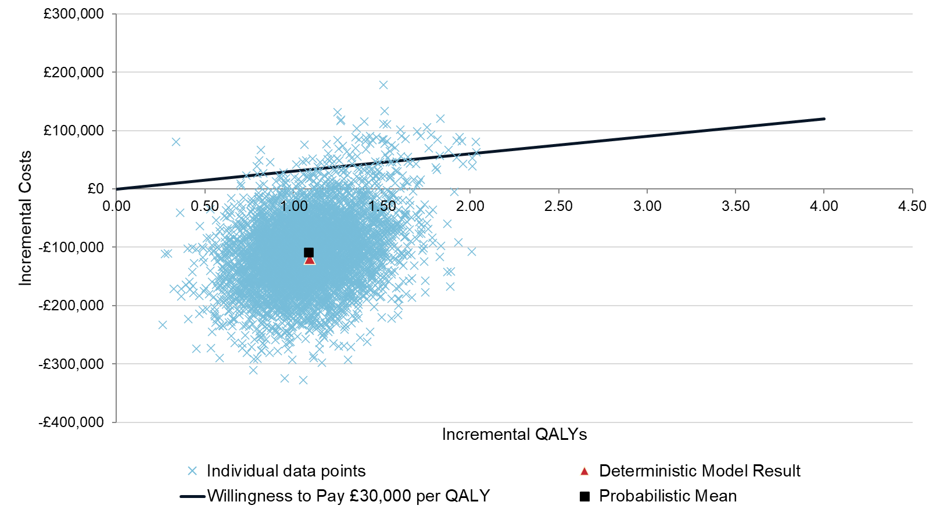
Abbreviations: QALY, quality adjusted life year.

