Supplementary materials
Figure S1. OS of breast cancer patients grouped by RanBP9 expression

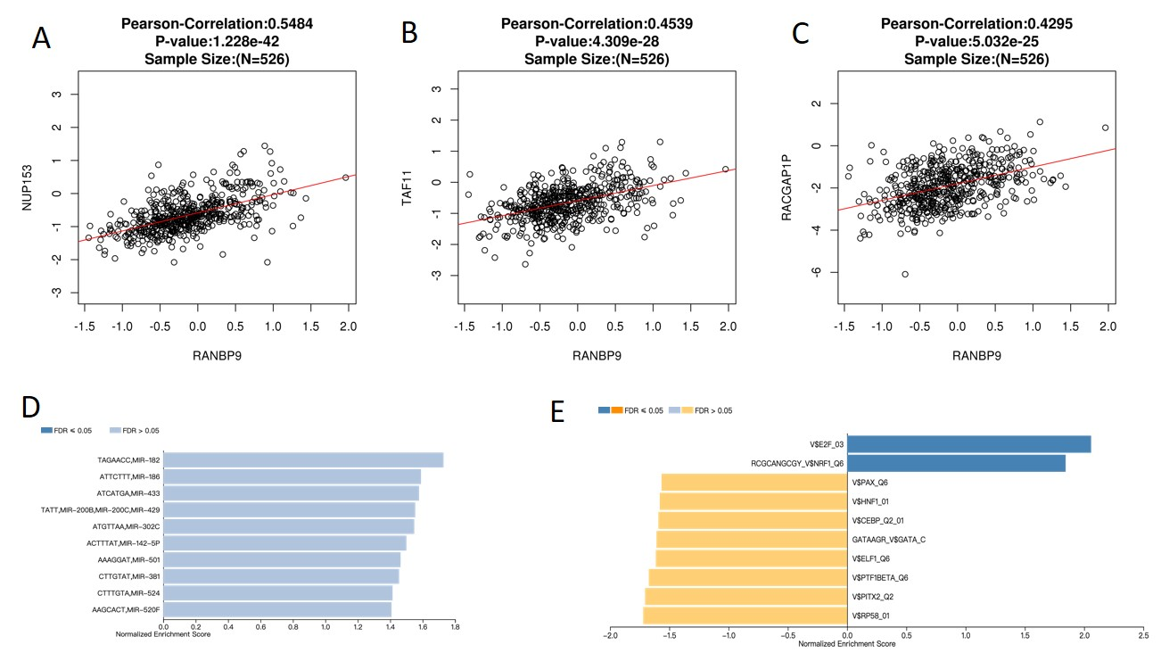

Figure S2. Gene expression correlation analysis of RanBP9 functional networks in BRCA (LinkedOmics)
(A-C) The scatter plot shows Pearson correlation of RanBP9 expression with expression of NUP153, TAF11, and RACGAP1P. (D) miRNA-target networks of RanBP9. (E) Transcription factor-target networks of RanBP9.

