Future Virology
Efficacy of chloroquine and hydroxychloroquine for the treatment of hospitalized COVID-19 patients: A meta-analysis
Jiawen Deng^{a*}, Fangwen Zhou^{a*}, Kiyan Heybati^{a,b}, Saif Aliª, Qi Kang Zuo^{c,d}, Wenteng Houª, Thanansayan Dhivagaran^{a,e}, Harikrishnaa Ba Ramarajuª, Oswin Changª, Chi Yi Wongª, Zachary Silver^{f}

Affiliation
ªFaculty of Health Sciences, McMaster University, ON, Canada
^{b}Mayo Clinic Alix School of Medicine, Rochester, MN, USA
^{c}Department of Anesthesiology, Rutgers, New Jersey Medical School, Newark, NJ, USA
^{d}Faculty of Science, McGill University, Montreal, QC, Canada
^{e}Integrated Biomedical Engineering & Health Sciences Program (iBioMed), McMaster University, Hamilton, ON, Canada
^{f}Faculty of Science, Carleton University, ON, Canada

Supplemental Materials

Table of Contents
Table S1 | PRISMA 2020 checklist |  | 4
Table S2 | MEDLINE search strategy |  | 7
Table S3 | EMBASE search strategy |  | 7
Table S4 | PubMed search strategy |  | 8
Table S5 | CNKI search strategy |  | 8
Table S6 | Wanfang search strategy |  | 8
Table S7 | Wanfang Med Online search strategy |  | 9
Table S8 | SinoMed search strategy |  | 9
Table S9 | CQVIP search strategy |  | 10
Table S10 | Characteristics of included studies and patients |  | 11
Table S11 | Risk of bias, randomized controlled trials (RoB2) |  | 22
Table S12 | Risk of bias, observational studies (ROBINS-I) |  | 22
Figure S1 | Forest plot for subgroup analysis by study design, time to negative conversion of SARS-CoV-2 tests |  | 26
Figure S2 | Forest plot for subgroup analysis by imputed versus non-imputed studies, time to negative conversion of SARS-CoV-2 tests |  | 26
Figure S3 | Forest plot for subgroup analysis by regimen, incidence of negative test conversion at day 7 |  | 27
Figure S4 | Forest plot for subgroup analysis by regimen, incidence of negative test conversion at day 14 |  | 27
Figure S5 | Forest plot for subgroup analysis by study design, incidence of negative test conversion at day 7 |  | 28
Figure S6 | Forest plot for subgroup analysis by study design, incidence of negative test conversion at day 14 |  | 28
Figure S7 | Forest plot for subgroup analysis by study design, length of stay |  | 29
Figure S8 | Forest plot for subgroup analysis by risk of bias ratings, length of stay |  | 30
Figure S9 | Forest plot for subgroup analysis by imputed versus non-imputed studies, length of stay |  | 31
Figure S10 | Forest plot for subgroup analysis by study design, mortality |  | 32
Figure S11 | Forest plot for subgroup analysis by risk of bias ratings, mortality |  | 33
Figure S12 | Forest plot for subgroup analysis by study design, time to fever resolution | 34
Figure S13 | Forest plot for subgroup analysis by imputed versus non-imputed studies, time to fever resolution | 34
Figure S14 | Forest plot for subgroup analysis by study design, incidence of mechanical ventilation | 35
Figure S15 | Forest plot for subgroup analysis by risk of bias ratings, incidence of mechanical ventilation | 36
Figure S16 | Forest plot for subgroup analysis by study design, incidence of adverse events | 37
Figure S17 | Forest plot for subgroup analysis by risk of bias ratings, incidence of adverse events | 37
Figure S18 | Forest plot for subgroup analysis by study design, incidence of QT prolongations | 38
Figure S19 | Forest plot for subgroup analysis by risk of bias ratings, incidence of QT prolongations | 38
Figure S20 | Bubble plot for meta-regression of cumulative chloroquine base dose, incidence of adverse events | 39
Table S13 | P-values for meta-regression analyses | 40
Figure S21 | Funnel plot, incidence of mechanical ventilation | 41
Figure S22 | Forest plot for trim-and-fill analysis, incidence of mechanical ventilation | 42
Figure S23 | Funnel plot, time to negative conversion of SARS-CoV-2 tests | 43
Figure S24 | Funnel plot, incidence of negative test conversion at day 7 | 43
Figure S25 | Funnel plot, incidence of negative test conversion at day 14 | 44
Figure S26 | Funnel plot, length of stay | 44
Figure S27 | Funnel plot, mortality | 45
Figure S28 | Funnel plot, time to fever resolution | 45
Figure S29 | Funnel plot, incidence of mechanical ventilation | 46
Figure S30 | Funnel plot, incidence of adverse events | 46
Figure S31 | Funnel plot, incidence of severe adverse events | 47
Figure S32 | Funnel plot, incidence of QT prolongations | 47
 | Supplementary References | 48

Table S1 PRISMA 2020 checklist [1]
Section and Topic | Item # | Checklist item | Location where item is reported
TITLE
Title | 1 | Identify the report as a systematic review. | Title Page
ABSTRACT
Abstract | 2 | See the PRISMA 2020 for Abstracts checklist. | p.1
INTRODUCTION
Rationale | 3 | Describe the rationale for the review in the context of existing knowledge. | p.2-3
Objectives | 4 | Provide an explicit statement of the objective(s) or question(s) the review addresses. | p.3
METHODS
Eligibility criteria | 5 | Specify the inclusion and exclusion criteria for the review and how studies were grouped for the syntheses. | p.4
Information sources | 6 | Specify all databases, registers, websites, organisations, reference lists and other sources searched or consulted to identify studies. Specify the date when each source was last searched or consulted. | p.3-4
Search strategy | 7 | Present the full search strategies for all databases, registers and websites, including any filters and limits used. | Table S2-S9
Selection process | 8 | Specify the methods used to decide whether a study met the inclusion criteria of the review, including how many reviewers screened each record and each report retrieved, whether they worked independently, and if applicable, details of automation tools used in the process. | p.4
Data collection process | 9 | Specify the methods used to collect data from reports, including how many reviewers collected data from each report, whether they worked independently, any processes for obtaining or confirming data from study investigators, and if applicable, details of automation tools used in the process. | p.4
Data items | 10a | List and define all outcomes for which data were sought. Specify whether all results that were compatible with each outcome domain in each study were sought (e.g. for all measures, time points, analyses), and if not, the methods used to decide which results to collect. | p.4, PROSPERO Registration
 | 10b | List and define all other variables for which data were sought (e.g. participant and intervention characteristics, funding sources). Describe any assumptions made about any missing or unclear information.
Study risk of bias assessment | 11 | Specify the methods used to assess risk of bias in the included studies, including details of the tool(s) used, how many reviewers assessed each study and whether they worked independently, and if applicable, details of automation tools used in the process. | p.4-5
Effect measures | 12 | Specify for each outcome the effect measure(s) (e.g. risk ratio, mean difference) used in the synthesis or presentation of results. | p.5
Synthesis methods | 13a | Describe the processes used to decide which studies were eligible for each synthesis (e.g. tabulating the study intervention characteristics and comparing against the planned groups for each synthesis (item #5)). | p.5
 | 13b | Describe any methods required to prepare the data for presentation or synthesis, such as handling of missing summary statistics, or data conversions. | p.5
 | 13c | Describe any methods used to tabulate or visually display results of individual studies and syntheses. | p.5
 | 13d | Describe any methods used to synthesize results and provide a rationale for the choice(s). If meta-analysis was performed, describe the model(s), method(s) to identify the presence and extent of statistical heterogeneity, and software package(s) used. | p.5-6
 | 13e | Describe any methods used to explore possible causes of heterogeneity among study results (e.g. subgroup analysis, meta-regression). | p.6
 | 13f | Describe any sensitivity analyses conducted to assess robustness of the synthesized results. | p.6
Reporting bias assessment | 14 | Describe any methods used to assess risk of bias due to missing results in a synthesis (arising from reporting biases). | p.5-6
Certainty assessment | 15 | Describe any methods used to assess certainty (or confidence) in the body of evidence for an outcome. | p.5
RESULTS
Study selection | 16a | Describe the results of the search and selection process, from the number of records identified in the search to the number of studies included in the review, ideally using a flow diagram. | p.6, Figure 1
 | 16b | Cite studies that might appear to meet the inclusion criteria, but which were excluded, and explain why they were excluded. | p.6, Figure 1
Study characteristics | 17 | Cite each included study and present its characteristics. | p.6, Table S10
Risk of bias in studies | 18 | Present assessments of risk of bias for each included study. | p.6-7, Figure 2, Table S11-S12
Results of individual studies | 19 | For all outcomes, present, for each study: (a) summary statistics for each group (where appropriate) and (b) an effect estimate and its precision (e.g. confidence/credible interval), ideally using structured tables or plots. | Figure 3-8
Results of syntheses | 20a | For each synthesis, briefly summarise the characteristics and risk of bias among contributing studies. | p.6-10
 | 20b | Present results of all statistical syntheses conducted. If meta-analysis was done, present for each the summary estimate and its precision (e.g. confidence/credible interval) and measures of statistical heterogeneity. If comparing groups, describe the direction of the effect. | p.6-10, Figure 3-8
 | 20c | Present results of all investigations of possible causes of heterogeneity among study results. | p.6-10
 | 20d | Present results of all sensitivity analyses conducted to assess the robustness of the synthesized results. | p.6-10
Reporting biases | 21 | Present assessments of risk of bias due to missing results (arising from reporting biases) for each synthesis assessed. | p.9-10
Certainty of evidence | 22 | Present assessments of certainty (or confidence) in the body of evidence for each outcome assessed. | Table 1
DISCUSSION
Discussion | 23a | Provide a general interpretation of the results in the context of other evidence. | p.10-12
 | 23b | Discuss any limitations of the evidence included in the review. | p.12-13
 | 23c | Discuss any limitations of the review processes used. | p.12-13
 | 23d | Discuss implications of the results for practice, policy, and future research. | p.10-12
OTHER INFORMATION
Registration and protocol | 24a | Provide registration information for the review, including register name and registration number, or state that the review was not registered. | p.3
 | 24b | Indicate where the review protocol can be accessed, or state that a protocol was not prepared. | p.3
 | 24c | Describe and explain any amendments to information provided at registration or in the protocol. | p.3-6
Support | 25 | Describe sources of financial or non-financial support for the review, and the role of the funders or sponsors in the review. | Title Page
Competing interests | 26 | Declare any competing interests of review authors. | Title Page
Availability of data, code and other materials | 27 | Report which of the following are publicly available and where they can be found: template data collection forms; data extracted from included studies; data used for all analyses; analytic code; any other materials used in the review. | Title Page

Table S2 MEDLINE search strategy
Line Number | Search Phrase | Results
1 | ((("Corona virinae" or "corona virus" or Coronavirinae or coronavirus or COVID or nCoV or hCoV) adj4 ("19" or "2019" or novel or new)) or (("Corona virinae" or "corona virus" or Coronavirinae or coronavirus or COVID or nCoV or hCoV) and (wuhan or china or chinese or hubei)) or "COVID-19" or "Corona virinae19" or "Corona virinae2019" or "corona virus19" or "corona virus2019" or Coronavirinae19 or Coronavirinae2019 or coronavirus19 or coronavirus2019 or COVID19 or COVID2019 or nCOV19 or nCOV2019 or "SARS Corona virus 2" or "SARS Coronavirus 2" or "SARS-COV-2" or "Severe Acute Respiratory Syndrome Corona virus 2" or "Severe Acute Respiratory Syndrome Coronavirus 2" or sarscov*).ti,ab,hw,kw,mp. or (Severe Acute Respiratory Syndrome Coronavirus 2 or COVID-19 or COVID-19 drug treatment or COVID-19 serotherapy or COVID-19 diagnostic testing or COVID-19 vaccine or spike glycoprotein, COVID-19 virus).os,ps,rs,ox,px,rx,nm | 128,433
2 | (hydrocloroquin* or hydrochloroquin* or hydroxychloroquin* or choloroquin* or ercoquin* or oxychloroquin* or quensyl or Plaquenil or hydroquin or axemal or dolquine or quinoric).mp. | 8,213
3 | chloroquine/ or hydroxychloroquine/ | 18,638
4 | HCQ*.mp. | 1,567
5 | or/2-4 | 22,382
6 | 1 and 5 | 2,768
7 | limit 6 to yr="2020-Current" | 2,768

Table S3 EMBASE search strategy
Line Number | Search Phrase | Results
1 | ((("Corona virinae" or "corona virus" or Coronavirinae or coronavirus or COVID or nCoV or hCoV) adj4 ("19" or "2019" or novel or new)) or (("Corona virinae" or "corona virus" or Coronavirinae or coronavirus or COVID or nCoV or hCoV) and (wuhan or china or chinese or hubei)) or "COVID-19" or "Corona virinae19" or "Corona virinae2019" or "corona virus19" or "corona virus2019" or Coronavirinae19 or Coronavirinae2019 or coronavirus19 or coronavirus2019 or COVID19 or COVID2019 or nCOV19 or nCOV2019 or "SARS Corona virus 2" or "SARS Coronavirus 2" or "SARS-COV-2" or "Severe Acute Respiratory Syndrome Corona virus 2" or "Severe Acute Respiratory Syndrome Coronavirus 2" or sarscov*).ti,ab,hw,kw,mp. | 127,691
2 | (hydrocloroquin* or hydrochloroquin* or hydroxychloroquin* or choloroquin* or ercoquin* or oxychloroquin* or quensyl or Plaquenil or hydroquin or axemal or dolquine or quinoric).mp. | 30,415
3 | chloroquine/ or hydroxychloroquine/ | 62,881
4 | HCQ*.mp. | 3,045
5 | or/2-4 | 64,559
6 | 1 and 5 | 4,484
7 | limit 6 to yr="2020-Current" | 4,473

Table S4 PubMed search strategy
Line Number | Search Phrase
1 | ("COVID-19"[Supplementary Concept] OR "severe acute respiratory syndrome coronavirus 2"[Supplementary Concept] OR "COVID-19"[Title/Abstract] OR "COVID19"[Title/Abstract] OR "COVID2019"[Title/Abstract] OR "COVID-2019"[Title/Abstract] OR "SARS-CoV-2"[Title/Abstract] OR "SARSCoV2"[Title/Abstract] OR "sars coronavirus 2"[Title/Abstract] OR "2019-nCoV"[Title/Abstract] OR "2019nCoV"[Title/Abstract] OR "nCoV2019"[Title/Abstract] OR "nCoV-2019"[Title/Abstract] OR (("Wuhan"[Title/Abstract] OR "Hubei"[Title/Abstract]) AND "coronavirus*"[Title/Abstract])) AND ("hydroxychloroquin*" OR "hydrochloroquin*" OR "hydroxychloroquin*" OR "choloroquin*" OR "ercoquin*" OR "oxychloroquin*" OR "quensyl" OR "plaquenil" OR "hydroquin" OR "axemal" OR "dolquine" OR "quinoric")
Search Date Range Restriction: 2020-2021

Table S5 CNKI search strategy
Line Number | Search Phrase
1 | (SU=('疫情'+'新冠'+'冠状'+'武汉'+'COVID-19' + '2019-nCoV' + 'coronavirus' + '2019nCoV' + 'SARS-CoV-2'+'COVID19'+'COVID'+'SARS-CoV'+'SARS') OR TI=('疫情'+'新冠'+'冠状'+'武汉'+'COVID-19' + '2019-nCoV' + 'coronavirus' + '2019nCoV' + 'SARS-CoV-2'+'COVID19'+'COVID'+'SARS-CoV'+'SARS') OR KY=('疫情'+'新冠'+'冠状'+'武汉'+'COVID-19' + '2019-nCoV' + 'coronavirus' + '2019nCoV' + 'SARS-CoV-2'+'COVID19'+'COVID'+'SARS-CoV'+'SARS')) AND (SU=('羟氯喹'+'氯喹'+'HCQ'+'Hydroxychloroquine'+'Chloroquine'+'羟基氯喹'+'Plaquenil'+'赛能'+'纷乐') OR TI=('羟氯喹'+'氯喹'+'HCQ'+'Hydroxychloroquine'+'Chloroquine'+'羟基氯喹'+'Plaquenil'+'赛能'+'纷乐') OR KY=('羟氯喹'+'氯喹'+'HCQ'+'Hydroxychloroquine'+'Chloroquine'+'羟基氯喹'+'Plaquenil'+'赛能'+'纷乐'))
Search Date Range Restriction: 1/1/2020-4/26/2021

Table S6 Wanfang search strategy
Line Number | Search Phrase
1 | (主题:("疫情"OR"新冠"OR"冠状"OR"武汉"OR"COVID-19" OR "2019-nCoV" OR "coronavirus" OR "2019nCoV" OR "SARS-CoV-2" OR "COVID19" OR "COVID" OR "SARS-CoV" OR "SARS") OR 题名或关键词:("疫情"OR"新冠"OR"冠状"OR"武汉"OR"COVID-19" OR "2019-nCoV" OR "coronavirus" OR "2019nCoV" OR "SARS-CoV-2" OR "COVID19" OR "COVID" OR "SARS-CoV" OR "SARS")) AND (主题:("羟氯喹" OR "氯喹" OR "HCQ" OR "Hydroxychloroquine" OR "Chloroquine" OR "羟基氯喹" OR "Plaquenil" OR "赛能" OR "纷乐") OR 题名或关键词:("羟氯喹" OR "氯喹" OR "HCQ" OR "Hydroxychloroquine" OR "Chloroquine" OR "羟基氯喹" OR "Plaquenil" OR "赛能" OR "纷乐"))
Search Date Range Restriction: 1/1/2020-4/26/2021
Table S7 Wanfang Med Online search strategy
Line Number | Search Phrase
1 | (TI=(疫情 OR 新冠 OR 冠状 OR 武汉 OR COVID-19 OR 2019-nCoV OR coronavirus OR 2019nCoV OR SARS-CoV-2 OR COVID19 OR COVID OR SARS-CoV OR SARS) OR KW=(疫情 OR 新冠 OR 冠状 OR 武汉 OR COVID-19 OR 2019-nCoV OR coronavirus OR 2019nCoV OR SARS-CoV-2 OR COVID19 OR COVID OR SARS-CoV OR SARS)) AND (TI=(羟氯喹 OR 氯喹 OR HCQ OR Hydroxychloroquine OR Chloroquine OR 羟基氯喹 OR Plaquenil OR 赛能 OR 纷乐) OR KW=(羟氯喹 OR 氯喹 OR HCQ OR Hydroxychloroquine OR Chloroquine OR 羟基氯喹 OR Plaquenil OR 赛能 OR 纷乐))
Search Date Range Restriction: 1/1/2020-4/26/2021

Table S8 SinoMed search strategy
Line Number | Search Phrase
1 | (("疫情"[常用字段:智能] OR "新冠"[常用字段:智能] OR "冠状"[常用字段:智能] OR "武汉"[常用字段:智能] OR "COVID-19"[常用字段:智能] OR "2019-nCoV"[常用字段:智能] OR "coronavirus"[常用字段:智能] OR "2019nCoV"[常用字段:智能] OR "SARS-CoV-2"[常用字段:智能] OR "COVID19"[常用字段:智能] OR "COVID"[常用字段:智能] OR "SARS-CoV"[常用字段:智能] OR "SARS"[常用字段:智能]) OR ("疫情"[全部字段:智能] OR "新冠"[全部字段:智能] OR "冠状"[全部字段:智能] OR "武汉"[全部字段:智能] OR "COVID-19"[全部字段:智能] OR "2019-nCoV"[全部字段:智能] OR "coronavirus"[全部字段:智能] OR "2019nCoV"[全部字段:智能] OR "SARS-CoV-2"[全部字段:智能] OR "COVID19"[全部字段:智能] OR "COVID"[全部字段:智能] OR "SARS-CoV"[全部字段:智能] OR "SARS"[全部字段:智能]) OR ("疫情"[标题:智能] OR "新冠"[标题:智能] OR "冠状"[标题:智能] OR "武汉"[标题:智能] OR "COVID-19"[标题:智能] OR "2019-nCoV"[标题:智能] OR "coronavirus"[标题:智能] OR "2019nCoV"[标题:智能] OR "SARS-CoV-2"[标题:智能] OR "COVID19"[标题:智能] OR "COVID"[标题:智能] OR "SARS-CoV"[标题:智能] OR "SARS"[标题:智能])) AND (("羟氯喹"[常用字段:智能] OR "氯喹"[常用字段:智能] OR "HCQ"[常用字段:智能] OR "Hydroxychloroquine"[常用字段:智能] OR "Chloroquine"[常用字段:智能] OR "羟基氯喹"[常用字段:智能] OR "Plaquenil"[常用字段:智能] OR "赛能"[常用字段:智能] OR "纷乐"[常用字段:智能]) OR ("羟氯喹"[全部字段:智能] OR "氯喹"[全部字段:智能] OR "HCQ"[全部字段:智能] OR "Hydroxychloroquine"[全部字段:智能] OR "Chloroquine"[全部字段:智能] OR "羟基氯喹"[全部字段:智能] OR "Plaquenil"[全部字段:智能] OR "赛能"[全部字段:智能] OR "纷乐"[全部字段:智能]) OR ("羟氯喹"[标题:智能] OR "氯喹"[标题:智能] OR "HCQ"[标题:智能] OR "Hydroxychloroquine"[标题:智能] OR "Chloroquine"[标题:智能] OR "羟基氯喹"[标题:智能] OR "Plaquenil"[标题:智能] OR "赛能"[标题:智能] OR "纷乐"[标题:智能]))
Search Date Range Restriction: 1/1/2020-4/26/2021
Table S9 CQVIP search strategy
Line Number | Search Phrase
1 | M=(疫情 OR 新冠 OR 冠状 OR 武汉 OR COVID-19 OR 2019-nCoV OR coronavirus OR 2019nCoV OR SARS-CoV-2 OR COVID19 OR COVID OR SARS-CoV OR SARS) AND M=(羟氯喹 OR 氯喹 OR HCQ OR Hydroxychloroquine OR Chloroquine OR 羟基氯喹 OR Plaquenil OR 赛能 OR 纷乐)
Search Date Range Restriction: 1/1/2020-4/26/2021

Table S10 Characteristics of included studies and patients
Study | Design | Country | Treatment Arms | Treatment Description | Treatment Duration (Days)ª | Sample Size | Patients with Severe Disease  N (%) | F/M | Age^{b}
Abd-Elsalam et al. 2020 | Parallel RCT | Egypt | HCQ | HCQ 400 mg b.i.d. (single loading dose), HCQ 200 mg b.i.d. (maintenance dose) | 15 | 97 | 13 (13.4) | 41/56 | 40.4±18.7 | [2]
 |  |  | SOC | - | - | 97 | 11 (11.3) | 39/58 | 41.1±20.1
Abdulrahman et al. 2021 | Matched Retrospective Cohort | Bahrain | HCQ | HCQ 600 mg b.i.d. (single loading dose), HCQ 400 mg q.d. (maintenance dose) | 5 | 223 | - | 101/122 | 50.5±13.8 | [3]
 |  |  | SOC | - | - | 223 | - | 92/131 | 52.7±14.4
Alghamdi et al. 2021 | Retrospective Cohort | Saudi Arabia | HCQ | HCQ 400 mg b.i.d. (single loading dose), HCQ 200 mg b.i.d. (maintenance dose) | - | 568 | - | 252/316 | - | [4]
 |  |  | SOC | - | - | 207 | - | 116/91 | -
Almazrou et al. 2020 | Retrospective Cohort | Saudi Arabia | HCQ | HCQ 400 mg b.i.d. (single loading dose), HCQ 200 mg b.i.d. (maintenance dose) | - | 95 | - | 22/73 | - | [5]
 |  |  | SOC | - | - | 66 | - | 27/39 | -
Annie et al. 2020 | Matched Retrospective Cohort | United States | HCQ | - | - | 367 | - | 170/197 | 62.3±16 | [6]
 |  |  | SOC | - | - | 367 | - | 172/195 | 61.9±16
 |  |  | HCQ+AZM | - | - | 199 | - | 88/111 | 61±16
 |  |  | SOC | - | - | 199 | - | 90/109 | 60.1±16
Arshad et al. 2020 | Retrospective Cohort | United States | HCQ+AZM | HCQ 400 mg b.i.d. (single loading dose), HCQ 200 mg b.i.d. (maintenance dose); AZM 500 mg q.d. (single loading dose), 250 mg q.d. (maintenance dose) | 5 | 783 | 290 (37) | 380/403 | 62.3±15.9 | [7]
 |  |  | AZM | AZM 500 mg q.d. (single loading dose), AZM 250 mg q.d. (maintenance dose) | 5 | 147 | 19 (12.9) | 85/62 | 63.3±17.3
 |  |  | HCQ | HCQ 400 mg b.i.d. (single loading dose), HCQ 200 mg b.i.d. (maintenance dose) | 5 | 1202 | 243 (20.2) | 568/634 | 63.2±15.6
 |  |  | SOC | - | - | 409 | 62 (15.2) | 210/199 | 68.1±18.9
Awad et al. 2021 | Retrospective Cohort | United States | HCQ | - | - | 188 | 151 (80.3) | 64/124 | 67.3±17.8 | [8]
 |  |  | SOC | - | - | 148 | 63 (42.6) | 63/85 | 62±15.9
Bernardini et al. 2021 | Retrospective Cohort | Italy | HCQ+AZM | HCQ 400 mg b.i.d. (single loading dose), HCQ 200 mg b.i.d. (maintenance dose); AZM 500 mg q.d. (single loading dose), AZM 250 mg q.d. (maintenance dose) | 5 | 53 | - | 16/37 | 67.3±12.2 | [9]
 |  |  | HCQ | HCQ 400 mg b.i.d. (single loading dose), HCQ 200 mg b.i.d. (maintenance dose) | 5 | 40 | - | 11/29 | 66.8±13.6
 |  |  | SOC | - | - | 19 | - | 6/13 | 65.7±12.4
Catteau et al. 2020 | Retrospective Cohort | Belgium | HCQ | HCQ 2400 mg over 5 days | 5 | 4542 | - | - | 66 (54-78) | [10]
 |  |  | SOC | - | - | 3533 | - | - | 77 (63-85)
Cavalcanti et al. 2020 | Parallel RCT | Brazil | HCQ+AZM | HCQ 400 mg b.i.d.; AZM 500 mg q.d. | 7 | 217 | 0 (0) | 94/123 | 49.6±14.2 | [11]
 |  |  | HCQ | HCQ 400 mg b.i.d. | 7 | 221 | 0 (0) | 79/142 | 51.3±14.5
 |  |  | SOC | - | - | 227 | 0 (0) | 104/123 | 49.9±15.1
Chen et al. 2020a | Parallel RCT | China | HCQ | HCQ 400 mg q.d. | 5 | 15 | 0 (0) | 6/9 | 50.5±3.8 | [12]
 |  |  | SOC | - | - | 15 | 0 (0) | 3/12 | 46.7±3.6
Chen et al. 2020b | Parallel RCT | Taiwan | HCQ | HCQ 400 mg q.d. (single loading dose), HCQ 200 mg b.i.d. (maintenance dose) | 7 | 21 | 0 (0) | 10/11 | 33±12 | [13]
 |  |  | SOC | - | - | 12 | 0 (0) | 4/8 | 32.8±8.3
CORIST Collaboration 2020 | Retrospective Cohort | Italy | HCQ | HCQ 400 mg b.i.d. or q.i.d. (single loading dose), HCQ 200 mg b.i.d. (maintenance dose) | 10 | 2634 | 512 (19.4) | 940/1694 | 66 (55-77) | [14]
 |  |  | SOC | - | - | 817 | 140 (17.1) | 361/456 | 73 (58-83)
Dubée et al. 2021 | Parallel RCT | France | HCQ | HCQ 800 mg q.d. (single loading dose), HCQ 400 mg q.d. (maintenance dose) | 9 | 124 | 0 (0) | - | 76 (60-85) | [15]
 |  |  | SOC | - | - | 123 | 0 (0) | - | 78 (57-87)
Gao et al. 2020 | Retrospective Cohort | China | CQ | HCQ 500 mg b.i.d. | 7 | 19 | 1 (5.3) | 9/10 | 32 (22-50) | [16]
 |  |  | SOC | - | - | 59 | 2 (3.4) | 29/30 | 30 (23-45)
Gautret et al. 2020 & 2021 | Prospective Cohort | France | HCQ+AZM | HCQ 200 mg t.i.d.; AZM 500 mg q.d. (single loading dose), AZM 250 mg q.d. (maintenance dose) | 10 | 8 | 1 (12.5) | 3/5 | 53.9±18.8 | [17,18]
 |  |  | HCQ | HCQ 200 mg t.i.d. | 10 | 16 | 2 (12.5) | 9/7 | 55.8±21.2
 |  |  | SOC | - | - | 18 | 2 (11.1) | 11/7 | 37.8±23
Geleris et al. 2020 | Matched Retrospective Cohort | United States | HCQ | HCQ 600 mg b.i.d. (single loading dose), HCQ 400 mg q.d. (maintenance dose) | 5 | 811 | - | 337/474 | - | [19]
 |  |  | SOC | - | - | 274 | - | 113/161 | -
Grimaldi et al. 2020 | Prospective Cohort | France | HCQ | HCQ 400 mg q.d. or HCQ 600 mg q.d. or HCQ 800 mg q.d. (single loading dose), HCQ 400 mg q.d. (maintenance dose) | - | 220 | 220 (100) | 51/169 | 64±10 | [20]
 |  |  | SOC | - | - | 85 | 85 (100) | 21/64 | 63±11
Hraiech et al. 2020 | Retrospective Cohort | France | HCQ+AZM | HCQ 600 mg q.d.; AZM 500 mg (single loading dose), AZM 250 mg q.d. (maintenance dose) | - | 17 | - | 2/15 | 60±17 | [21]
 |  |  | SOC | - | - | 15 | - | 4/11 | 60±16
Huang et al. 2020a | Prospective Cohort | China | CQ | HCQ 500 mg q.d. or HCQ 500 mg b.i.d. | - | 197 | 4 (2) | 101/96 | 43.8±13.1 | [22]
 |  |  | SOC | - | - | 176 | 14 (8) | 97/79 | 45.6±13.5
Huang et al. 2020b | Matched Retrospective Cohort | United States | HCQ+AZM | HCQ 400 mg b.i.d. (single loading dose), HCQ 200 mg b.i.d. (maintenance dose); AZM 500 mg q.d. (single loading dose), AZM 250 mg q.d. (maintenance dose) | 5 | 173 | - | 59/114 | 57±13 | [23]
 |  |  | SOC | - | - | 173 | - | 70/103 | 57±17
Ip et al. 2020 | Retrospective Cohort | United States | HCQ+AZM | - | 5 | 1473 | - | - | - | [24]
 |  |  | AZM | - | - | 256 | - | - | -
 |  |  | HCQ | - | 5 | 441 | - | - | -
 |  |  | SOC | - | - | 342 | - | - | -
Kalligeros et al. 2020 | Matched Retrospective Cohort | United States | HCQ+AZM | HCQ or HCQ+ AZM | 5 | 36 | - | 17/19 | 61 (48.5-67.5) | [25]
 |  |  | SOC | - | - | 72 | - | 34/38 | 56.5 (43-71.5)
Karolyi et al. 2020 | Prospective Cohort | Austria | HCQ | HCQ 400 mg b.i.d. (single loading dose), HCQ 200 mg b.i.d. (maintenance dose) | 6 | 20 | - | 6/14 | 62.5 (46.5-78) | [26]
 |  |  | SOC | - | - | 89 | - | 43/46 | 77 (60-81)
Kelly et al. 2021 | Retrospective Cohort | Ireland | HCQ+AZM | HCQ 400 mg b.i.d. (single loading dose), HCQ 200 mg b.i.d. (maintenance dose); AZM 500 mg q.d. (single loading dose), AZM 250 mg q.d. (maintenance dose) | 5 | 82 | - | 27/55 | 64.8 (29-93) | [27]
 |  |  | SOC | - | - | 52 | - | 24/28 | 68 (21-91)
Kim et al. 2021 | Matched Retrospective Cohort | United States | HCQ (Period 1) | - | - | 192 | - | 83/109 | 61.1±15.8 | [28]
 |  |  | SOC (Period 1) | - | - | 384 | - | 166/218 | 62.8±17.2
 |  |  | HCQ (Period 2) | - | - | 1406 | - | 666/740 | 67.8±15.8
 |  |  | SOC (Period 2) | - | - | 1406 | - | 641/765 | 67.3±17.6
 |  |  | HCQ (Period 3) | - | - | 176 | - | 84/92 | 66.2±16.2
 |  |  | SOC (Period 3) | - | - | 352 | - | 158/194 | 66.3±17.6
Lagier et al. 2020 | Retrospective Cohort | France | HCQ+AZM≥3 days | HCQ 200 mg t.i.d.; AZM 500 mg q.d. (single loading dose), AZM 250 mg q.d. (maintenance dose) | - | 3119 | 80 (2.6) | 1703/1416 | - | [29]
 |  |  | HCQ+AZM<3 days | HCQ 200 mg t.i.d.; AZM 500 mg q.d. (single loading dose), AZM 250 mg q.d. (maintenance dose) | - | 218 | 31 (14.2) | 113/105 | -
 |  |  | AZM | AZM 500 mg q.d. (single loading dose), AZM 250 mg q.d. (maintenance dose) | - | 137 | 21 (15.3) | 73/64 | -
 |  |  | HCQ | HCQ 200 mg t.i.d. | - | 101 | 2 (2) | 54/47 | -
 |  |  | SOC | - | - | 162 | 11 (6.8) | 90/72 | -
Lamback et al. 2021 | Retrospective Cohort | Brazil | HCQ+AZM | HCQ 400 mg b.i.d. (single loading dose), HCQ 400 mg q.d. (maintenance dose); AZM 500 mg q.d. | 5 | 101 | 10 (9.9) | - | - | [30]
 |  |  | SOC | - | - | 92 | 20 (21.7) | - | -
Lammers et al. 2020 | Retrospective Cohort | Netherlands | CQ | CQ 600 mg+300 mg q.d. (single loading dose), CQ 300 mg b.i.d. (maintenance dose) | 5 | 377 | - | 133/244 | 66.4±13.5 | [31]
 |  |  | SOC (CQ Control) | - | - | 155 | - | 77/78 | 71.8±15.3
 |  |  | HCQ | HCQ 400 mg+400 mg (single loading dose), HCQ 200 mg b.i.d. (maintenance dose) | 5 | 189 | - | 66/123 | 64.7±14.5
 |  |  | SOC (HCQ Control) | - | - | 81 | - | 38/43 | 63.9±17.2
Lauriola et al. 2020 | Retrospective Cohort | Italy | HCQ+AZM | HCQ 200 mg t.i.d., AZM 500 mg q.d. | 10 | 297 | - | 99/198 | 70.8±13.6 | [32]
 |  |  | HCQ | HCQ 200 mg t.i.d. | 10 | 17 | - | 9/8 | 76.3±13.1
 |  |  | SOC | - | - | 63 | - | 21/42 | 75.4±11.9
Lecronier et al. 2020 | Retrospective Cohort | France | HCQ | HCQ 200 mg b.i.d. | 5 | 38 | 38 (100) | 7/31 | 59 (53-66) | [33]
 |  |  | SOC | - | - | 22 | 22 (100) | 4/18 | 63 (54-70)
Li et al. 2020 | Prospective Cohort | China | CQ | - | - | 56 | 0 (0) | 24/32 | 46.4±11.3 | [34]
 |  |  | SOC | - | - | 32 | 0 (0) | 15/17 | 46.2±11.2
Lotfy et al. 2021 | Retrospective Cohort | Saudi Arabia | HCQ+AZM | HCQ 400 mg b.i.d. (single loading dose), HCQ 200 mg b.i.d. (maintenance dose); AZM 500 mg q.d. | 6 | 99 | 0 (0) | 21/78 | 55.5±9.8 | [35]
 |  |  | AZM | AZM 500 mg q.d. | 6 | 103 | 0 (0) | 19/84 | 54.6±10.5
Mahale et al. 2020 | Retrospective Cohort | India | HCQ+MP | - | - | 90 | - | - | - | [36]
 |  |  | MP | - | 5 | 9 | - | - | -
 |  |  | HCQ | - | 1 | 12 | - | - | -
 |  |  | SOC | - | - | 23 | - | - | -
Mahévas et al. 2020 | Retrospective Cohort | France | HCQ | HCQ 600 mg q.d. | - | 84 | 84 (100) | 7/77 | 59 (48-67) | [37]
 |  |  | SOC | - | - | 89 | 89 (100) | 22/67 | 62 (54-69)
Mallat et al. 2020 | Retrospective Cohort | United Arab Emirates | HCQ | HCQ 400 mg b.i.d. (single loading dose); HCQ 400 mg q.d. (maintenance dose) | 11 | 23 | 4 (17.4) | 6/17 | 33 (31-48) | [38]
 |  |  | SOC | - | - | 11 | 2 (18.2) | 3/8 | 41 (30-55)
Niwas et al. 2020 | Retrospective Cohort | India | CQ | CQ 500 mg b.i.d. | 7 | 12 | - | 3/9 | 41.3±18 | [39]
 |  |  | SOC | - | - | 17 | - | 3/14 | 47.6±15.3
Paccoud et al. 2020 | Retrospective Cohort | France | HCQ | HCQ 200 mg t.i.d. | 10 | 38 | 10 (26.3) | 21/17 | 67±13.5 | [40]
 |  |  | SOC | - | - | 46 | 9 (19.6) | 31/15 | 64.3±17.9
Pritchard et al. 2020 | Retrospective Cohort | United States | HCQ+AZM | - | - | 115 | - | - | - | [41]
 |  |  | HCQ | - | - | 84 | - | - | -
 |  |  | SOC | - | - | 249 | - | - | -
RECOVERY Trial 2020 | Parallel RCT | United Kingdom | HCQ | HCQ 800 mg b.i.d. (single loading dose), HCQ 400 mg b.i.d. (maintenance dose) | 10 | 1561 | - | 601/960 | 65.2±15.2 | [42]
 |  |  | SOC | - | - | 3155 | - | 1181/1974 | 65.4±15.4
Roomi et al. 2020 | Retrospective Cohort | United States | HCQ | - | - | 144 | - | 10/134 | 63.8 | [43]
 |  |  | SOC | - | - | 32 | - | 75/-43 | 65.9
Rosenberg et al. 2020 | Retrospective Cohort | United States | HCQ+AZM | - | - | 735 | - | 279/456 | 61.4 | [44]
 |  |  | AZM | - | - | 211 | - | 77/134 | 62.5
 |  |  | HCQ | - | - | 271 | - | 113/158 | 65.5
 |  |  | SOC | - | - | 221 | - | 111/110 | 64
Sands et al. 2021 | Retrospective Cohort | United States | HCQ | - | - | 973 | 9 (0.9) | 464/509 | 60.2±16.6 | [45]
 |  |  | SOC | - | - | 696 | 6 (0.9) | 346/350 | 61.3±17.8
Scalese et al. 2020 | Retrospective Cohort | Italy | HCQ | - | - | 118 | - | 78/40 | 63 | [46]
 |  |  | SOC | - | - | 56 | - | 27/29 | 78.5
Self et al. 2020 | Parallel RCT | United States | HCQ | HCQ 400 mg b.i.d. (single loading dose), HCQ 200 mg b.i.d. (maintenance dose) | 5 | 242 | - | 107/135 | 58 (45-69) | [47]
 |  |  | SOC | - | - | 237 | - | 105/132 | 57 (43-68)
Sevilla-Castillo et al. 2021 | Retrospective Cohort | Mexico | CQ+LPV/r | CQ 300 mg b.i.d.; LPV/r 500 mg b.i.d. | - | 17 | 17 (100) | - | - | [48]
 |  |  | LPV/r | LPV/r 500 mg b.i.d. | - | 27 | 27 (100) | - | -
 |  |  | CQ | CQ 300 mg b.i.d. | - | 11 | 11 (100) | - | -
 |  |  | SOC | - | - | 6 | 6 (100) | - | -
Stewart et al. 2021 | Retrospective Cohort | United States | HCQ+AZM | - | - | 4981 | - | 2253/2728 | - | [49]
 |  |  | AZM | - | - | 3588 | - | 1944/1644 | -
 |  |  | HCQ | - | - | 2011 | - | 891/1120 | -
 |  |  | SOC | - | - | 6661 | - | 4009/2652 | -
Tang et al. 2020 | Parallel RCT | China | HCQ | HCQ 1200 q.d. (3 day loading dose), HCQ 800 mg q.d. (maintenance dose) | - | 75 | 1 (1.3) | 33/42 | 48±14.1 | [50]
 |  |  | SOC | - | - | 75 | 1 (1.3) | 35/40 | 44.1±15
Ulrich et al. 2020 | Parallel RCT | United States | HCQ | HCQ 400 mg b.i.d. (single loading dose), HCQ 200 mg q.d. (maintenance dose) | 5 | 67 | - | 22/45 | 66.5±16.4 | [51]
 |  |  | SOC | - | - | 61 | - | 30/31 | 65.8±16
Vernaz et al. 2020 | Retrospective Cohort | Switzerland | HCQ+LPV/r | HCQ 800 mg (single dose); LPV/r 400 mg b.i.d. or 600 mg q.d. | 5 | 158 | - | 101/57 | 62.2±14.8 | [52]
 |  |  | LPV/r | LPV/r 400 mg b.i.d. or LPV/r 600 mg q.d. | 5 | 83 | - | 37/46 | 63.4±17.4
 |  |  | HCQ | HCQ 800 mg (single dose) | - | 93 | - | 38/55 | 66.1±15.8
 |  |  | SOC | - | - | 506 | - | 284/222 | 70.8±20
Yu et al. 2020 | Retrospective Cohort | China | HCQ | HCQ 200 mg b.i.d. | - | 48 | 48 (100) | 16/32 | 68 (60-75) | [53]
 |  |  | SOC | - | - | 502 | 502 (100) | 190/312 | 68 (59-77)

ªPlanned treatment duration is presented unless otherwise specified.
^{b}Age is presented as mean (SD) or median (IQR) unless otherwise specified.
F: Female; M: Male; RCT: Randomized Controlled Trial; HCQ: Hydroxychloroquine; AZM: Azithromycin; CQ: Chloroquine; LPV/r: Lopinavir-Ritonavir Combination Therapy; MP: Methylprednisolone; SOC: Standard of Care; SD: Standard Deviation; IQR: Interquartile Range.
Table S11 Risk of bias, randomized controlled trials (RoB2)
Study | Risk of bias arising from the randomization process | Risk of bias due to deviations from the intended interventions | Risk of bias due to missing outcome data | Risk of bias in measurement of the outcome | Risk of bias in selection of the reported result | Overall risk of bias
Abd-Elsalam et al. 2020 | Some concerns | Some concerns | Low | Low | Low | Some concerns
Cavalcanti et al. 2020 | Low | Some concerns | Low | Low | Low | Some concerns
Chen et al. 2020a | Some concerns | Some concerns | Some concerns | Low | Low | Some concerns
Chen et al. 2020b | Some concerns | Some concerns | Low | Low | Low | Some concerns
Dubée et al. 2021 | Low | Some concerns | Some concerns | Low | Low | Some concerns
RECOVERY Trial 2020 | Low | Some concerns | Low | Low | Low | Some concerns
Self et al. 2020 | Low | Low | Low | Low | Low | Low
Tang et al. 2020 | Low | Some concerns | Low | Low | Low | Some concerns
Ulrich et al. 2020 | Low | Low | Low | Low | Low | Low

Table S12 Risk of bias, observational studies (ROBINS-I)
Study | Bias due to confounding | Bias in selection of participants into the study | Bias in classification of interventions | Bias due to deviations from intended intervention | Bias due to missing data | Bias in measurement of outcomes | Bias in selection of the reported result | Overall risk of bias
Abdulrahman et al. 2021 | Low | Low | Moderate | No information | Low | Low | Moderate | Moderate
Alghamdi et al. 2021 | Serious | Low | Moderate | Serious | Low | Low | Moderate | Serious
Almazrou et al. 2020 | Serious | Low | Serious | Critical | Low | Low | Moderate | Critical
Annie et al. 2020 | Low | Low | Serious | No information | Low | Low | Moderate | Serious
Arshad et al. 2020 | Moderate | Low | Moderate | No information | Low | Low | Moderate | Moderate
Awad et al. 2021 | Moderate | Low | Critical | No information | Moderate | Low | Moderate | Critical
Bernardini et al. 2021 | Serious | Low | Moderate | No information | Low | Low | Moderate | Serious
Catteau et al. 2020 | Moderate | Low | Serious | No information | Low | Low | Moderate | Serious
CORIST Collaboration 2020 | Serious | Low | Serious | No information | Low | Low | Moderate | Serious
Gao et al. 2020 | Serious | Low | Moderate | No information | Low | Low | Moderate | Serious
Gautret et al. 2021 & Gautret et al. 2020 | Critical | Low | Moderate | Moderate | Moderate | Low | No information | Critical
Geleris et al. 2020 | Low | Low | Low | No information | Low | Low | Moderate | Moderate
Grimaldi et al. 2020 | Serious | Low | Serious | No information | Low | Low | Moderate | Serious
Hraiech et al. 2020 | Moderate | Low | Moderate | Low | Moderate | Low | No information | Serious
Huang et al. 2020a | Moderate | Moderate | Serious | No information | Moderate | Moderate | Moderate | Serious
Huang et al. 2020b | Moderate | Low | Low | No information | Low | Low | Moderate | Moderate
Ip et al. 2020 | Serious | Low | Critical | No information | Low | Low | Serious | Critical
Kalligeros et al. 2020 | Moderate | Low | Serious | No information | Low | Low | Moderate | Serious
Karolyi et al. 2020 | Moderate | Low | Moderate | Moderate | Low | Low | No information | Serious
Kelly et al. 2021 | Serious | Low | Moderate | No information | Low | Low | Serious | Serious
Kim et al. 2021 | Moderate | Low | Serious | No information | Low | Low | Moderate | Serious
Lagier et al. 2020 | Serious | Low | Moderate | No information | Moderate | Low | Moderate | Serious
Lamback et al. 2021 | Serious | Low | Moderate | No information | Low | Moderate | Moderate | Serious
Lammers et al. 2020 | Serious | Moderate | Moderate | Critical | Low | Low | No information | Critical
Lauriola et al. 2020 | Serious | No information | Moderate | No information | Low | Low | No information | Critical
Lecronier et al. 2020 | Moderate | Low | Moderate | No information | Low | Low | No information | Serious
Li et al. 2020 | Moderate | Low | Moderate | No information | Moderate | Low | No information | Critical
Lotfy et al. 2021 | Low | Low | Moderate | Low | Low | Low | Serious | Serious
Mahale et al. 2020 | No information | Low | Serious | Low | Low | Low | No information | Critical
Mahévas et al. 2020 | No information | Serious | Moderate | No information | Moderate | Low | No information | Critical
Mallat et al. 2020 | Moderate | Low | Moderate | Low | Low | Low | No information | Serious
Niwas et al. 2020 | Serious | Serious | Moderate | No information | Low | Low | Serious | Critical
Paccoud et al. 2020 | Moderate | Moderate | Moderate | Moderate | Low | Low | No information | Critical
Pritchard et al. 2020 | No information | No information | Serious | No information | Low | Low | No information | No information
Roomi et al. 2020 | Serious | Low | Serious | Low | Serious | Low | No information | Critical
Rosenberg et al. 2020 | Critical | Low | Moderate | No information | Serious | Low | No information | Critical
Sands et al. 2021 | Moderate | Low | Serious | Low | Low | Low | No information | Critical
Scalese et al. 2020 | Low | No information | Serious | No information | Low | Low | No information | No information
Sevilla-Castillo et al. 2021 | Serious | Low | Moderate | Moderate | No information | Low | No information | Critical
Stewart et al. 2021 | Low | Low | Serious | No information | Low | Low | No information | Critical
Vernaz et al. 2020 | Moderate | Low | Serious | Low | Low | Low | No information | Critical
Yu et al. 2020 | Low | Critical | Serious | Moderate | Low | Low | No information | Critical

Figure S1 Forest plot for subgroup analysis by study design, time to negative conversion of SARS-CoV-2 tests  There is no significant difference between the pooled mean differences from randomized studies versus non-randomized studies (P=0.64). | 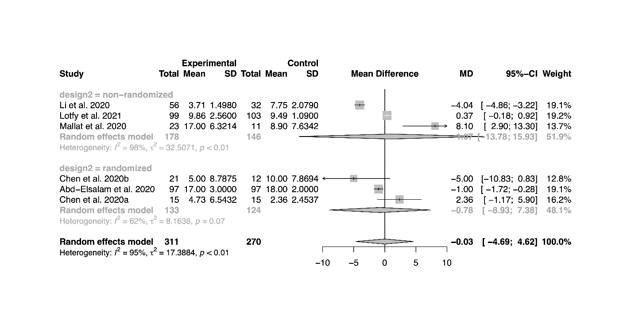
Figure S2 Forest plot for subgroup analysis by imputed versus non-imputed studies, time to negative conversion of SARS-CoV-2 tests  There is no significant difference between the pooled mean differences of imputed versus non-imputed studies (P=0.05). | 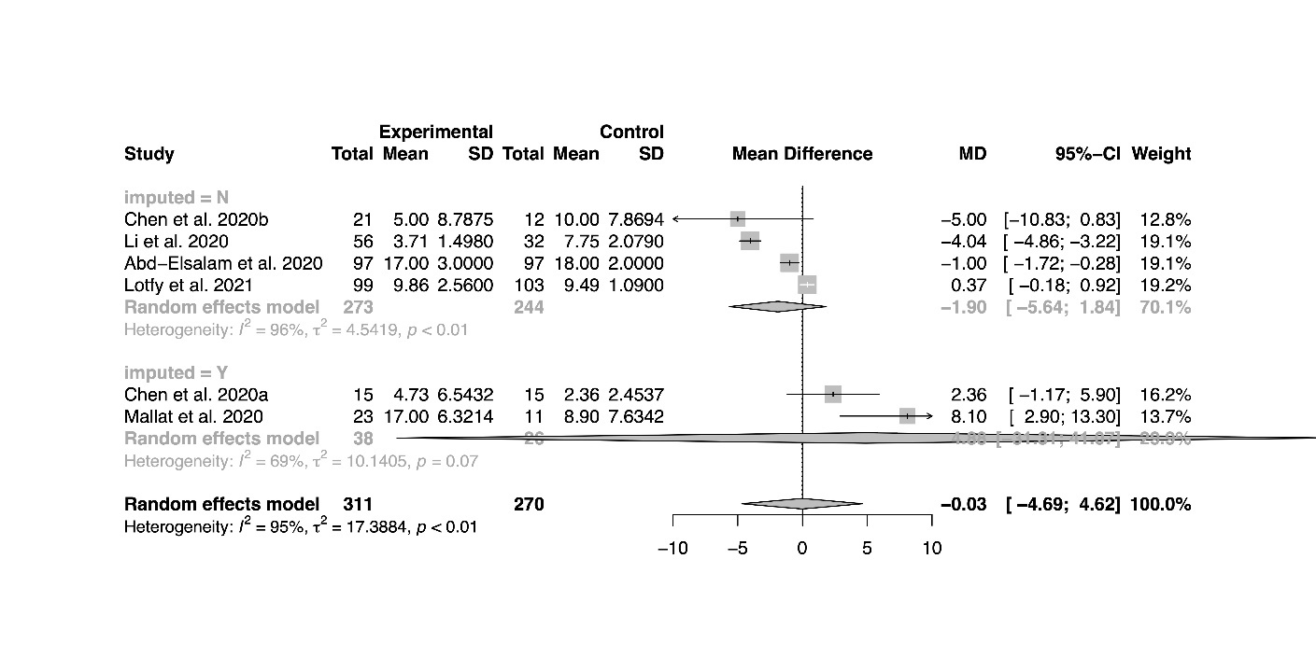
Figure S3 Forest plot for subgroup analysis by regimen, incidence of negative test conversion at day 7  There is no significant difference between different regimen subgroups (P=0.18). | 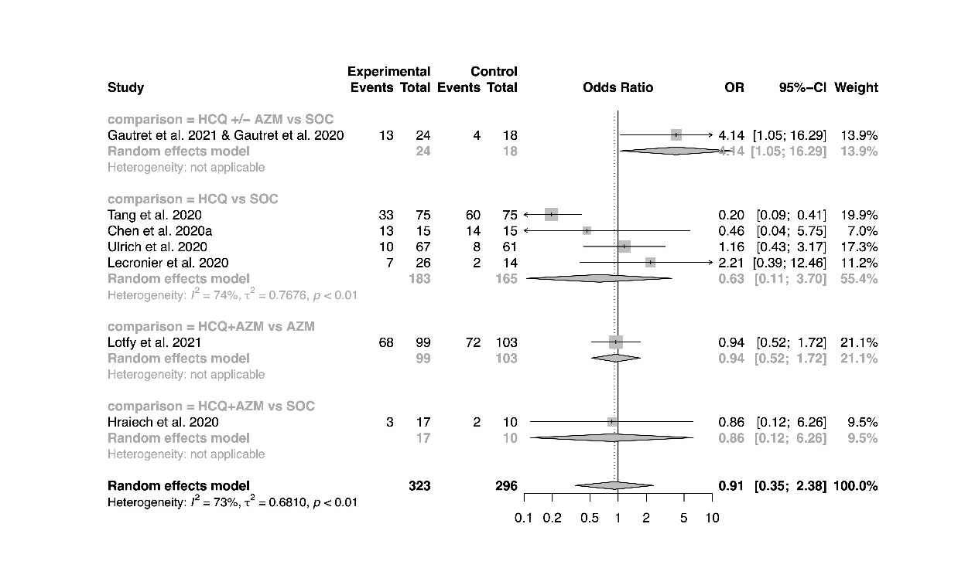
Figure S4 Forest plot for subgroup analysis by regimen, incidence of negative test conversion at day 14

There is no significant difference between different regimen subgroups (P=0.31).
Figure S5 Forest plot for subgroup analysis by study design, incidence of negative test conversion at day 7

There is no significant difference between the pooled odds ratios from randomized studies versus non-randomized studies (P=0.08).
Figure S6 Forest plot for subgroup analysis by study design, incidence of negative test conversion at day 14

There is no significant difference between the pooled odds ratios from randomized studies versus non-randomized studies (P=0.79).
Figure S7 Forest plot for subgroup analysis by study design, length of stay

There is no significant difference between the pooled mean differences from randomized studies versus non-randomized studies (P=0.98).
Figure S8 Forest plot for subgroup analysis by risk of bias ratings, length of stay

There is no significant difference between the pooled mean differences from studies with low/moderate risk of bias versus studies with high risk of bias (P=0.28).
Figure S9 Forest plot for subgroup analysis by imputed versus non-imputed studies, length of stay

There is no significant difference between the pooled mean differences of imputed versus non-imputed studies (P=0.17).
Figure S10 Forest plot for subgroup analysis by study design, mortality

There is no significant difference between the pooled odds ratios from randomized studies versus non-randomized studies (P=0.16).
Figure S11 Forest plot for subgroup analysis by risk of bias ratings, mortality

There is no significant difference between the pooled odds ratios from studies with low/moderate risk of bias versus studies with high risk of bias (P=0.61).
Figure S12 Forest plot for subgroup analysis by study design, time to fever resolution

There is no significant difference between the pooled mean differences from randomized studies versus non-randomized studies (P=0.93).
Figure S13 Forest plot for subgroup analysis by imputed versus non-imputed studies, time to fever resolution

There is no significant difference between the pooled mean differences of imputed versus non-imputed studies (P=0.38).
Figure S14 Forest plot for subgroup analysis by study design, incidence of mechanical ventilation

There is no significant difference between the pooled odds ratios from randomized studies versus non-randomized studies (P=0.39).
Figure S15 Forest plot for subgroup analysis by risk of bias ratings, incidence of mechanical ventilation

There is no significant difference between the pooled odds ratios from studies with low/moderate risk of bias versus studies with high risk of bias (P=0.77).
Figure S16 Forest plot for subgroup analysis by study design, incidence of adverse events

There is no significant difference between the pooled odds ratios from randomized studies versus non-randomized studies (P=0.88).
Figure S17 Forest plot for subgroup analysis by risk of bias ratings, incidence of adverse events

There is no significant difference between the pooled odds ratios from studies with low/moderate risk of bias versus studies with high risk of bias (P=0.74).
Figure S18 Forest plot for subgroup analysis by study design, incidence of QT prolongations

There is no significant difference between the pooled odds ratios from randomized studies versus non-randomized studies (P=0.89).
Figure S19 Forest plot for subgroup analysis by risk of bias ratings, incidence of QT prolongations

There is no significant difference between the pooled odds ratios from studies with low/moderate risk of bias versus studies with high risk of bias (P=0.79).
Figure S20 Bubble plot for meta-regression of cumulative chloroquine base dose, incidence of adverse events  There is significant correlation between the cumulative chloroquine base dose and the treatment effect (P=0.04). | 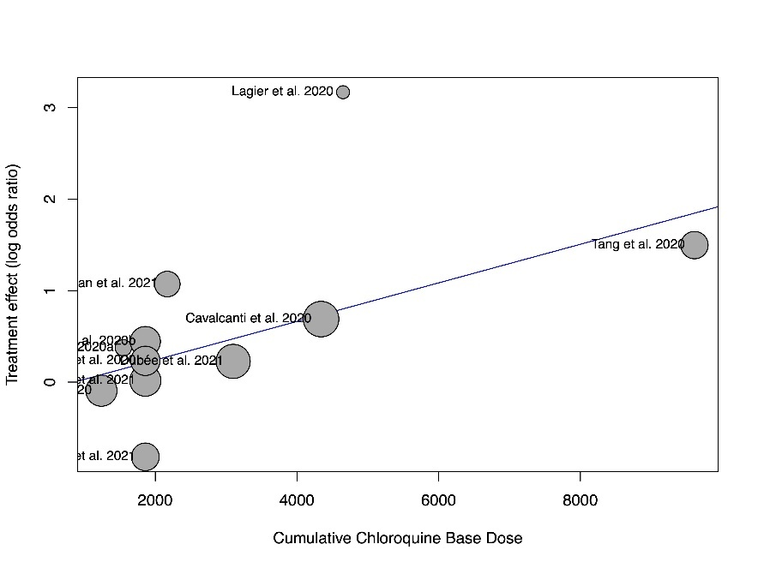

Table S13 P-values for meta-regression analyses
Outcome/Regressor | Cumulative chloroquine base dose | Proportion of severe patients | Time from COVID-19 symptom onset to drug administration/randomization | Follow up durationª
Time to negative conversion of SARS-CoV-2 tests | 0.87 | 0.21 | - | -
Incidence of negative SARS-CoV-2 tests at day 7 | 0.19 | 0.45 | 0.05 | -
Incidence of negative SARS-CoV-2 tests at day 14 | 0.58 | 0.46 | - | -
Length of stay | 0.37 | 0.40 | 0.20 | -
Incidence of mortality | 0.37 | 0.51 | 0.56 | 0.16
Time to fever resolution | - | 0.77 | - | -
Incidence of mechanical ventilation | 0.83 | 0.33 | 0.17 | -
Incidence of adverse events | 0.04^{b} | 0.28 | 0.31 | -
Incidence of severe adverse events | 0.22 | - | - | -
Incidence of QT prolongation | 0.16 | 0.99 | 0.73 | -

“-” indicates that the meta-regression had not been conducted due to insufficient data.
ªMeta-regression by follow up duration was only conducted for the outcome of mortality incidence.
^{b}The results of the meta-regression was significant. The bubble plot for the analysis is shown in Figure S20.
Figure S21 Funnel plot, incidence of mechanical ventilation  There is evidence of small study effects based on visual inspection and Egger’s regression test (P_{Egger}=0.04). | 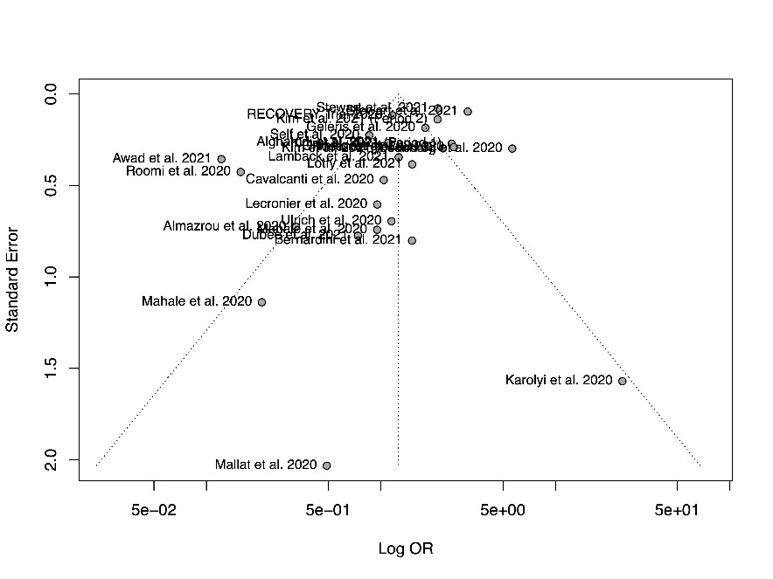
Figure S22 Forest plot for trim-and-fill analysis, incidence of mechanical ventilation
Figure S23 Funnel plot, time to negative conversion of SARS-CoV-2 tests  There is no evidence of small study effects based on visual inspection. | 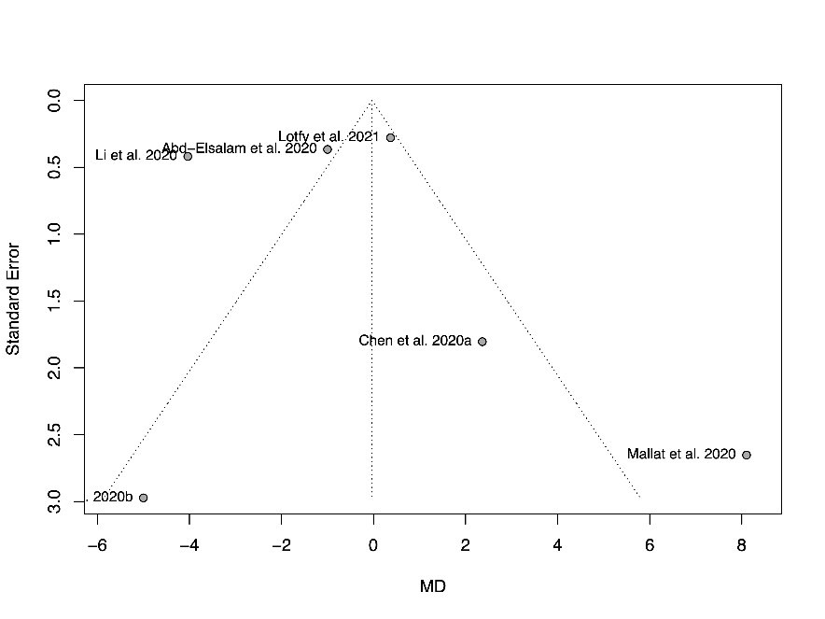
Figure S24 Funnel plot, incidence of negative test conversion at day 7  There is no evidence of small study effects based on visual inspection. | 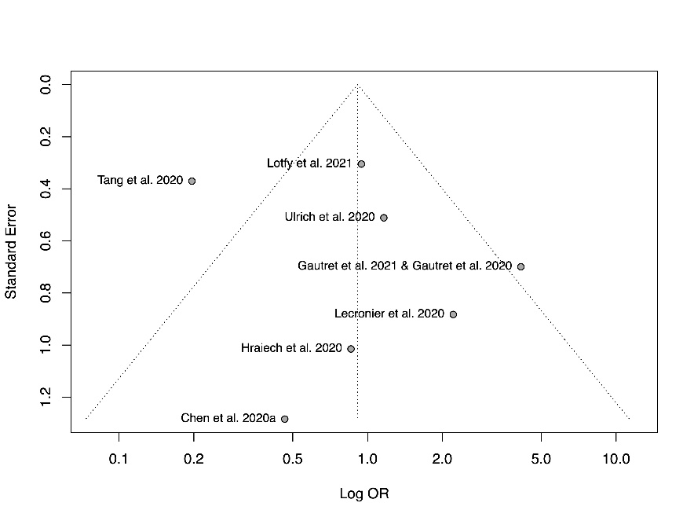
Figure S25 Funnel plot, incidence of negative test conversion at day 14  There is no evidence of small study effects based on visual inspection. | 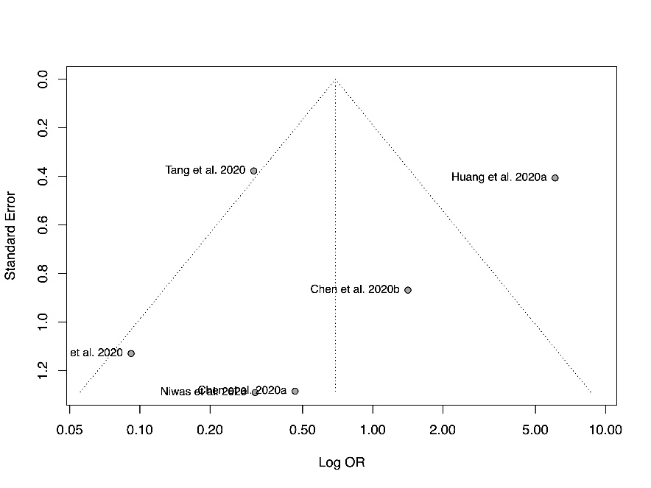
Figure S26 Funnel plot, length of stay  There is no evidence of small study effects based on visual inspection and Egger’s regression test (P_{Egger}=0.26). | 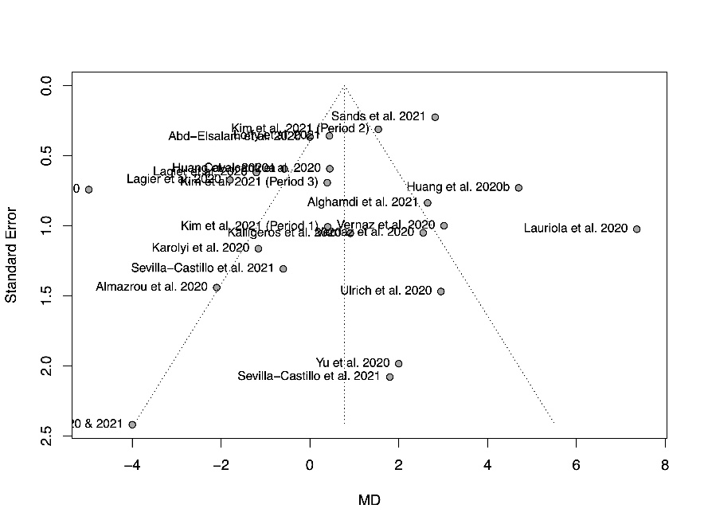
Figure S27 Funnel plot, mortality  There is no evidence of small study effects based on visual inspection and Egger’s regression test (P_{Egger}=0.83). | 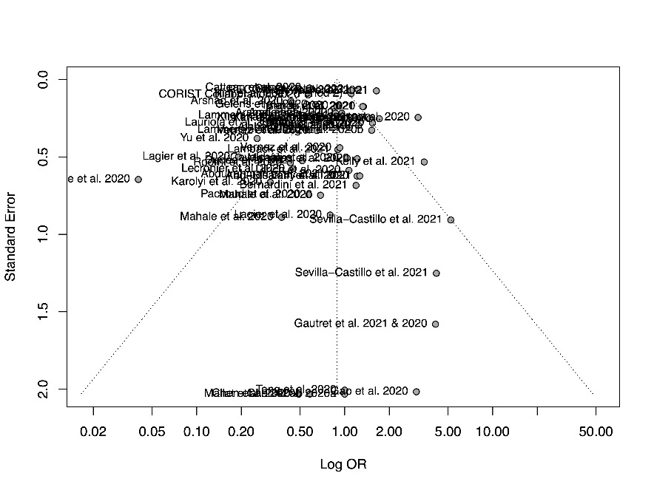
Figure S28 Funnel plot, time to fever resolution  There is no evidence of small study effects based on visual inspection. | 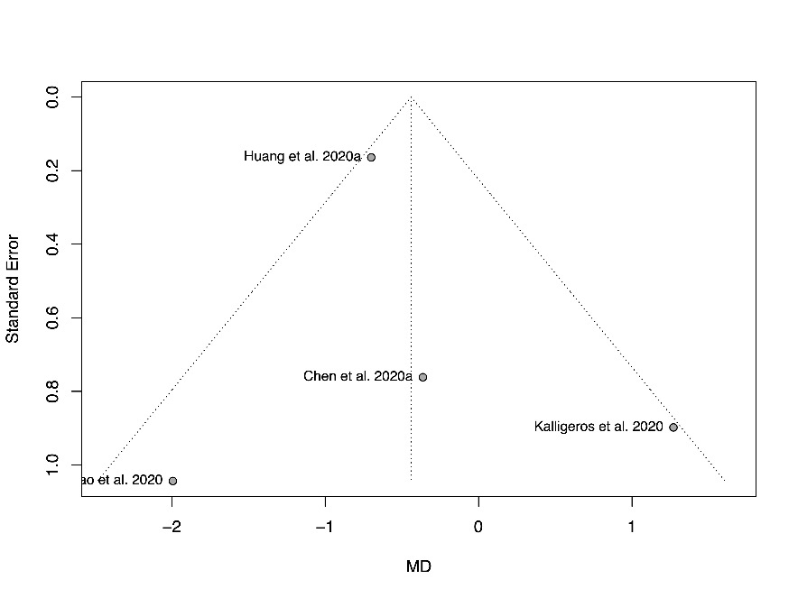
Figure S29 Funnel plot, incidence of mechanical ventilation

There is evidence of small study effects based on visual inspection and Egger’s regression test (P_{Egger}=0.04).
Figure S30 Funnel plot, incidence of adverse events  There is no evidence of small study effects based on visual inspection and Egger’s regression test (P_{Egger}=0.31). | 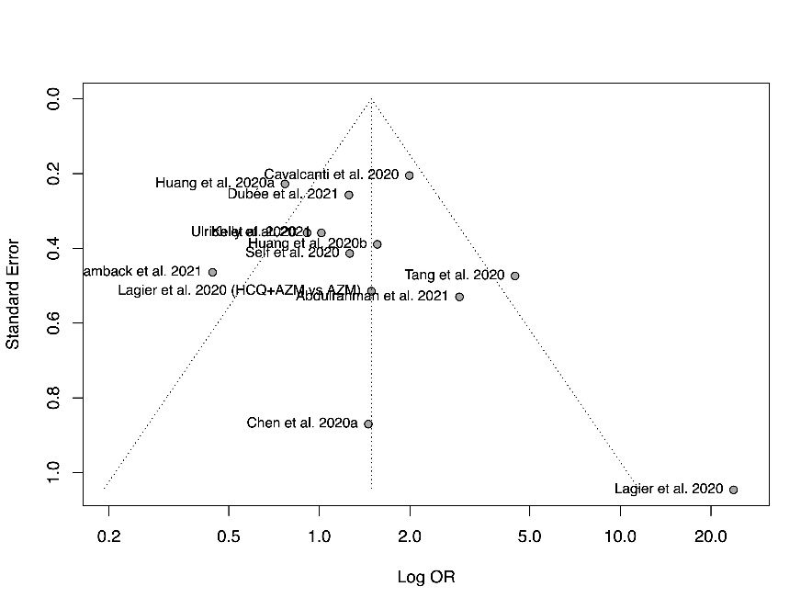
Figure S31 Funnel plot, incidence of severe adverse events  There is no evidence of small study effects based on visual inspection. | 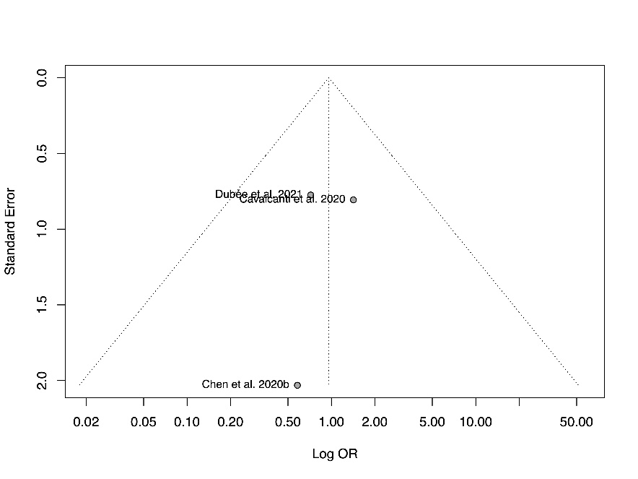
Figure S32 Funnel plot, incidence of QT prolongations  There is no evidence of small study effects based on visual inspection and Egger’s regression test (P_{Egger}=0.23). | 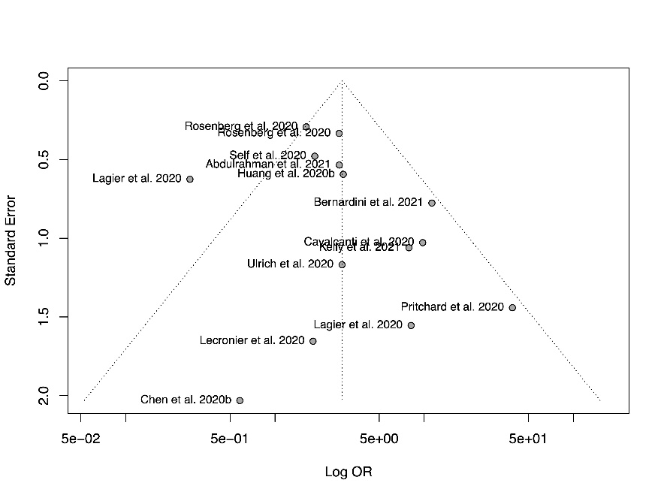

Supplementary References
1. Page MJ, McKenzie JE, Bossuyt PM et al. The PRISMA 2020 statement: an updated guideline for reporting systematic reviews. BMJ, 372, n71 (2021).
2. Abd-Elsalam S, Esmail ES, Khalaf M et al. Hydroxychloroquine in the Treatment of COVID-19: A Multicenter Randomized Controlled Study. Am. J. Trop. Med. Hyg., 103(4), 1635-1639 (2020).
3. Abdulrahman A, AlSayed I, AlMadhi M et al. The Efficacy and Safety of Hydroxychloroquine in Patients with COVID-19: A Multicenter National Retrospective Cohort. Infect Dis Ther, 10(1), 439-455 (2021).
4. Alghamdi S, Barakat B, Berrou I et al. Clinical Efficacy of Hydroxychloroquine in Patients with COVID-19: Findings from an Observational Comparative Study in Saudi Arabia. Antibiotics (Basel), 10(4) (2021).
5. Almazrou SH, Almalki ZS, Alanazi AS, Alqahtani AM, Alghamd SM. Comparing the impact of Hydroxychloroquine based regimens and standard treatment on COVID-19 patient outcomes: A retrospective cohort study. Saudi Pharm J, 28(12), 1877-1882 (2020).
6. Annie FH, Sirbu C, Frazier KR, Broce M, Lucas BD, Jr. Hydroxychloroquine in Hospitalized Patients with COVID-19: Real-World Experience Assessing Mortality. Pharmacotherapy, 40(11), 1072-1081 (2020).
7. Arshad S, Kilgore P, Chaudhry ZS et al. Treatment with hydroxychloroquine, azithromycin, and combination in patients hospitalized with COVID-19. Int. J. Infect. Dis., 97, 396-403 (2020).
8. Awad N, Schiller DS, Fulman M, Chak A. Impact of hydroxychloroquine on disease progression and ICU admissions in patients with SARS-CoV-2 infection. Am. J. Health. Syst. Pharm., 78(8), 689-696 (2021).
9. Bernardini A, Ciconte G, Negro G et al. Assessing QT interval in COVID-19 patients:safety of hydroxychloroquine-azithromycin combination regimen. Int. J. Cardiol., 324, 242-248 (2021).
10. Catteau L, Dauby N, Montourcy M et al. Low-dose hydroxychloroquine therapy and mortality in hospitalised patients with COVID-19: a nationwide observational study of 8075 participants. Int. J. Antimicrob. Agents, 56(4), 106144 (2020).
11. Cavalcanti AB, Zampieri FG, Rosa RG et al. Hydroxychloroquine with or without Azithromycin in Mild-to-Moderate Covid-19. N. Engl. J. Med., 383(21), 2041-2052 (2020).
12. Chen J, Liu D, Liu L et al. [A pilot study of hydroxychloroquine in treatment of patients with moderate COVID-19]. Zhejiang Da Xue Xue Bao Yi Xue Ban, 49(2), 215-219 (2020).
13. Chen C-P, Lin Y-C, Chen T-C et al. A multicenter, randomized, open-label, controlled trial to evaluate the efficacy and tolerability of hydroxychloroquine and a retrospective study in adult patients with mild to moderate coronavirus disease 2019 (COVID-19). PLoS One, 15(12), e0242763 (2020).
14. COVID-19 RISK and Treatments (CORIST) Collaboration. Use of hydroxychloroquine in hospitalised COVID-19 patients is associated with reduced mortality: Findings from the observational multicentre Italian CORIST study. Eur. J. Intern. Med., 82, 38-47 (2020).
15. Dubée V, Roy P-M, Vielle B et al. Hydroxychloroquine in mild-to-moderate COVID-19: a placebo-controlled double blind trial. Clin. Microbiol. Infect., (2021).
16. Gao G, Wang A, Wang S et al. Brief Report: Retrospective Evaluation on the Efficacy of Lopinavir/Ritonavir and Chloroquine to Treat Nonsevere COVID-19 Patients. J. Acquir. Immune Defic. Syndr., 85(2), 239-243 (2020).
17. Gautret P, Hoang VT, Lagier J-C, Raoult D. Effect of hydroxychloroquine and azithromycin as a treatment of COVID-19: results of an open-label non-randomized clinical trial, an update with an intention-to-treat analysis and clinical outcomes. Int. J. Antimicrob. Agents, 57(1), 106239 (2021).
18. Gautret P, Lagier J-C, Parola P et al. Hydroxychloroquine and azithromycin as a treatment of COVID-19: results of an open-label non-randomized clinical trial. Int. J. Antimicrob. Agents, 56(1), 105949 (2020).
19. Geleris J, Sun Y, Platt J et al. Observational Study of Hydroxychloroquine in Hospitalized Patients with Covid-19. N. Engl. J. Med., 382(25), 2411-2418 (2020).
20. Grimaldi D, Aissaoui N, Blonz G et al. Characteristics and outcomes of acute respiratory distress syndrome related to COVID-19 in Belgian and French intensive care units according to antiviral strategies: the COVADIS multicentre observational study. Ann. Intensive Care, 10(1), 131 (2020).
21. Hraiech S, Bourenne J, Kuteifan K et al. Lack of viral clearance by the combination of hydroxychloroquine and azithromycin or lopinavir and ritonavir in SARS-CoV-2-related acute respiratory distress syndrome. Ann. Intensive Care, 10(1), 63 (2020).
22. Huang M, Li M, Xiao F et al. Preliminary evidence from a multicenter prospective observational study of the safety and efficacy of chloroquine for the treatment of COVID-19. National Science Review, 7(9), 1428-1436 (2020).
23. Huang HD, Jneid H, Aziz M et al. Safety and Effectiveness of Hydroxychloroquine and Azithromycin Combination Therapy for Treatment of Hospitalized Patients with COVID-19: A Propensity-Matched Study. Cardiol Ther, 9(2), 523-534 (2020).
24. Ip A, Berry DA, Hansen E et al. Hydroxychloroquine and tocilizumab therapy in COVID-19 patients-An observational study. PLoS One, 15(8), e0237693 (2020).
25. Kalligeros M, Shehadeh F, Atalla E et al. Hydroxychloroquine use in hospitalised patients with COVID-19: An observational matched cohort study. J Glob Antimicrob Resist, 22, 842-844 (2020).
26. Karolyi M, Pawelka E, Mader T et al. Hydroxychloroquine versus lopinavir/ritonavir in severe COVID-19 patients : Results from a real-life patient cohort. Wien. Klin. Wochenschr., 133(7-8), 284-291 (2021).
27. Kelly M, O'Connor R, Townsend L et al. Clinical outcomes and adverse events in patients hospitalised with COVID-19, treated with off-label hydroxychloroquine and azithromycin. Br. J. Clin. Pharmacol., 87(3), 1150-1154 (2021).
28. Kim EJ, Coppa K, Hirsch JS et al. Examination of patient characteristics and hydroxychloroquine use based on the US Food and Drug Administration's recommendation: a cross-sectional analysis in New York. BMJ Open, 11(2), e042965 (2021).
29. Lagier J-C, Million M, Gautret P et al. Outcomes of 3,737 COVID-19 patients treated with hydroxychloroquine/azithromycin and other regimens in Marseille, France: A retrospective analysis. Travel Med. Infect. Dis., 36, 101791 (2020).
30. Lamback EB, Oliveira MAd, Haddad AF et al. Hydroxychloroquine with azithromycin in patients hospitalized for mild and moderate COVID-19. Braz. J. Infect. Dis., 25(2), 101549 (2021).
31. Lammers AJJ, Brohet RM, Theunissen REP et al. Early hydroxychloroquine but not chloroquine use reduces ICU admission in COVID-19 patients. Int. J. Infect. Dis., 101, 283-289 (2020).
32. Lauriola M, Pani A, Ippoliti G et al. Effect of Combination Therapy of Hydroxychloroquine and Azithromycin on Mortality in Patients With COVID-19. Clin. Transl. Sci., 13(6), 1071-1076 (2020).
33. Lecronier M, Beurton A, Burrel S et al. Comparison of hydroxychloroquine, lopinavir/ritonavir, and standard of care in critically ill patients with SARS-CoV-2 pneumonia: an opportunistic retrospective analysis. Crit. Care, 24(1), 418 (2020).
34. Li N, Xie T, Wei XF et al. [Chloroquine phosphate accelerates the conversion of nucleic acid to negative in 88 common COVID⁃19 patients]. The Journal of Practical Medicine, 36(20), 2759-2762 (2020).
35. Lotfy SM, Abbas A, Shouman W. Use of Hydroxychloroquine in Patients with COVID-19: A Retrospective Observational Study. Turk Thorac J, 22(1), 62-66 (2021).
36. Mahale N, Rajhans P, Godavarthy P et al. A Retrospective Observational Study of Hypoxic COVID-19 Patients Treated with Immunomodulatory Drugs in a Tertiary Care Hospital. Indian J. Crit. Care Med., 24(11), 1020-1027 (2020).
37. Mahévas M, Tran V-T, Roumier M et al. Clinical efficacy of hydroxychloroquine in patients with covid-19 pneumonia who require oxygen: observational comparative study using routine care data. BMJ, 369, m1844 (2020).
38. Mallat J, Hamed F, Balkis M et al. Hydroxychloroquine is associated with slower viral clearance in clinical COVID-19 patients with mild to moderate disease. Medicine, 99(52), e23720 (2020).
39. Niwas R, S AS, Garg MK et al. Clinical outcome, viral response and safety profile of chloroquine in COVID-19 patients - initial experience. Adv Respir Med, 88(6), 515-519 (2020).
40. Paccoud O, Tubach F, Baptiste A et al. Compassionate use of hydroxychloroquine in clinical practice for patients with mild to severe Covid-19 in a French university hospital. Clin. Infect. Dis., (2020).
41. Pritchard H, Hiles J, Teresa B et al. 547. A Retrospective Cohort Study of Treatment Patterns and Clinical Outcomes in Patients with COVID-19. Open Forum Infectious Diseases, 7(Supplement_1), S339-S340 (2020).
42. Recovery Collaborative Group, Horby P, Mafham M et al. Effect of Hydroxychloroquine in Hospitalized Patients with Covid-19. N. Engl. J. Med., 383(21), 2030-2040 (2020).
43. Roomi S, Ullah W, Ahmed F et al. Efficacy of Hydroxychloroquine and Tocilizumab in Patients With COVID-19: Single-Center Retrospective Chart Review. J. Med. Internet Res., 22(9), e21758 (2020).
44. Rosenberg ES, Dufort EM, Udo T et al. Association of Treatment With Hydroxychloroquine or Azithromycin With In-Hospital Mortality in Patients With COVID-19 in New York State. JAMA, 323(24), 2493-2502 (2020).
45. Sands K, Wenzel R, McLean L et al. No clinical benefit in mortality associated with hydroxychloroquine treatment in patients with COVID-19. Int. J. Infect. Dis., 104, 34-40 (2021).
46. Scalese GA, Antonacci N, Firenti D et al. Efficacy of hydroxychloroquine in a group of subjects with SARS-CoV 2 infection. Italian Journal of Medicine, 14(S2), 116 (2020).
47. Self WH, Semler MW, Leither LM et al. Effect of Hydroxychloroquine on Clinical Status at 14 Days in Hospitalized Patients With COVID-19: A Randomized Clinical Trial. JAMA, 324(21), 2165-2176 (2020).
48. Sevilla-Castillo F, Roque-Reyes OJ, Romero-Lechuga F et al. Both Chloroquine and Lopinavir/Ritonavir Are Ineffective for COVID-19 Treatment and Combined Worsen the Pathology: A Single-Center Experience with Severely Ill Patients. Biomed Res. Int., 2021, 8821318 (2021).
49. Stewart M, Rodriguez-Watson C, Albayrak A et al. COVID-19 Evidence Accelerator: A parallel analysis to describe the use of Hydroxychloroquine with or without Azithromycin among hospitalized COVID-19 patients. PLoS One, 16(3), e0248128 (2021).
50. Tang W, Cao Z, Han M et al. Hydroxychloroquine in patients with mainly mild to moderate coronavirus disease 2019: open label, randomised controlled trial. BMJ, 369, m1849 (2020).
51. Ulrich RJ, Troxel AB, Carmody E et al. Treating COVID-19 With Hydroxychloroquine (TEACH): A Multicenter, Double-Blind Randomized Controlled Trial in Hospitalized Patients. Open Forum Infect Dis, 7(10), ofaa446 (2020).
52. Vernaz N, Agoritsas T, Calmy A et al. Early experimental COVID-19 therapies: associations with length of hospital stay, mortality and related costs. Swiss Med. Wkly, 150, w20446 (2020).
53. Yu B, Li C, Chen P et al. Low dose of hydroxychloroquine reduces fatality of critically ill patients with COVID-19. Sci. China Life Sci., 63(10), 1515-1521 (2020).

