Supplementary materials
Table 1. Hydrodynamic sizes, polydispersity indexes and zeta potentials of AgNTs, PNTs, ANTs, ENTs and AENTs in water, DMEM and DMEM with 10% FBS.
Environment | Sample | Hydrodynamic size (nm) | Polydispersity index | Zeta potential (mV)
Water | AgNTs | 85.34 | 0.363 | 36.03
 | PNTs | 48.47 | 0.312 | 29.67
 | ANTs | 54.23 | 0.343 | 30.12
 | ENTs | 56.34 | 0.351 | 30.76
 | AENTs | 59.73 | 0.334 | 31.33
DMEM | AgNTs | 711.43 | 0.594 | -5.89
 | PNTs | 327.84 | 0.382 | -6.09
 | ANTs | 344.80 | 0.502 | -6.49
 | ENTs | 269.34 | 0.487 | -6.25
 | AENTs | 276.53 | 0.396 | -6.14
DMEM with 10% FBS | AgNTs | 423.7 | 0.390 | -7.37
 | PNTs | 77.82 | 0.381 | -10.13
 | ANTs | 79.75 | 0.347 | -9.19
 | ENTs | 83.23 | 0.336 | -9.36
 | AENTs | 96.12 | 0.373 | -9.04
AgNTs: silver nanotriangles; PNTs: PEGylated silver nanotriangles; ANTs: AS1411-conjugated PEGylated silver nanotriangles; ENTs: EpDT3-conjugated PEGylated silver nanotriangles; AENTs: AS1411 and EpDT3-conjugated PEGylated silver nanotriangles; DMEM: Dulbecco’s modified Eagle’s medium; FBS: fetal bovine serum.

Calculation of the photothermal conversion efficiency
The photothermal conversion efficiency of AgNTs was determined according to a previous method [1]. The formula is given as following:
$\text{η=}\frac{\text{hs}（{\text{T}}_{\text{Max}}\text{-}{\text{T}}_{\text{Surr}}）\text{-}{\text{Q}}_{\text{Dis}}}{\text{I(1-}{\text{10}}^{\text{-}{\text{A}}_{\text{808}}}\text{)}}$ (1)
where T_{Max} and T_{Surr} are the maximum equilibrium temperature and the surrounding temperature, respectively. The temperature change (T_{Max}-T_{Surr}) of the AgNTs solution was 47.3 °C. Q_{Dis} presents the heat dissipated from the light absorbed by the sample cell and it was measured to be approximately 30 mW with a quartz cuvette cell containing pure water. I is the laser power (1 W), and A₈₀₈ is the absorbance (0.33) of the AgNTs solution at 808 nm. In order to determine photothermal conversion efficiency (η), all the parameters in equation (1) are known except heat transfer efficiency (h) and surface area of the container (s). A dimensionless driving force temperature θ and a sample system time constant τ_{s} are introduced to deduce hs. The equations are shown as following:
$\text{θ}\text{=}\frac{\text{T-}{\text{T}}_{\text{Surr}}}{{\text{T}}_{\text{Max}}\text{-}{\text{T}}_{\text{Surr}}}$ (2)
$\text{t=}\text{-}{\text{τ}}_{\text{s}}\text{ln}\text{⁡}\text{(}\text{θ}\text{)}$ (3)
△T (T-T_{Surr}) expresses the temperature change of the AgNTs solution response to 808 nm near-infrared laser (2 W/cm²) with the increase of time (Figure 1A). τ_{s} was calculated to be 109.2 s according to Figure 1(B). hs can be calculated using the following equation:
$\text{hs}\text{=}\frac{\sum_{\text{i}}{{\text{m}}_{\text{i}}}{\text{C}}_{\text{p,i}}}{{\text{τ}}_{\text{s}}}$ (4)
where m is the mass (0.15 g) and Cp is the heat capacity of water (4.2 J/g·°C). Thus, hs was determined to be 5.77 mW/°C and then the heat conversion efficiency (η) of AgNTs was calculated to be 45.7%.

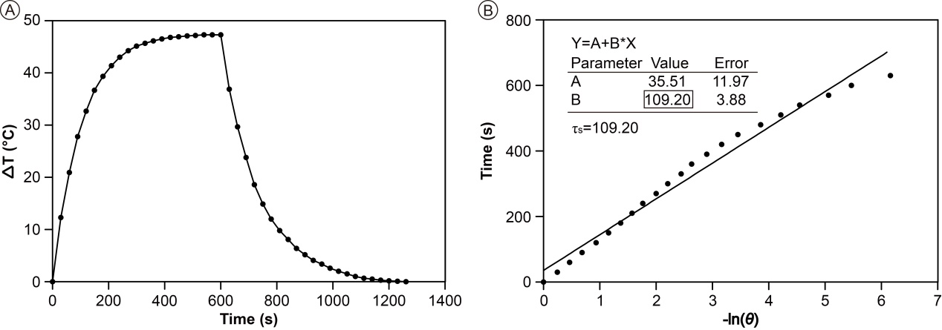
Figure 1. Calculation of the photothermal conversion efficiency. (A) Temperature change of AgNTs solution (10 μg/mL) under 808 nm near-infrared laser irradiation (2 W/cm²), in which the irradiation lasted for 600 s, and then the laser was shut off. (B) Linear time data versus -ln(θ) obtained from the cooling period of Figure 1A.

Table 2. IC₅₀ values of PNTs, ANTs, ENTs and AENTs against MDA-MB-231 cells and breast CSCs
IC₅₀ (μg/mL) | MDA-MB-231 | breast CSCs
PNTs | 116 | 86
ANTs | 71 | 51
ENTs | 108 | 59
AENTs | 64 | 31
IC₅₀: half maximal inhibitory concentration; PNTs: PEGylated silver nanotriangles; ANTs: AS1411-conjugated PEGylated silver nanotriangles; ENTs: EpDT3-conjugated PEGylated silver nanotriangles; AENTs: AS1411 and EpDT3-conjugated PEGylated silver nanotriangles; CSCs: cancer stem cells.

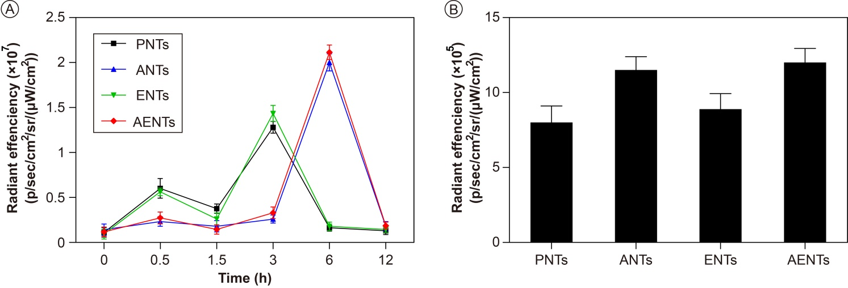
Figure 2. Quantitative analysis of Cy5-labeled PNTs, ANTs, ENTs or AENTs in tumor site and isolated tumors. (A) The fluorescence intensity of Cy5-labeled PNTs, ANTs, ENTs or AENTs in the tumor site at different times after the injection of nanomaterials via the tail vein. (B) The fluorescence intensity of Cy5-labeled PNTs, ANTs, ENTs or AENTs in the isolated tumors.
PNTs: PEGylated silver nanotriangles; ANTs: AS1411-conjugated PEGylated silver nanotriangles; ENTs: EpDT3-conjugated PEGylated silver nanotriangles; AENTs: AS1411 and EpDT3-conjugated PEGylated silver nanotriangles.

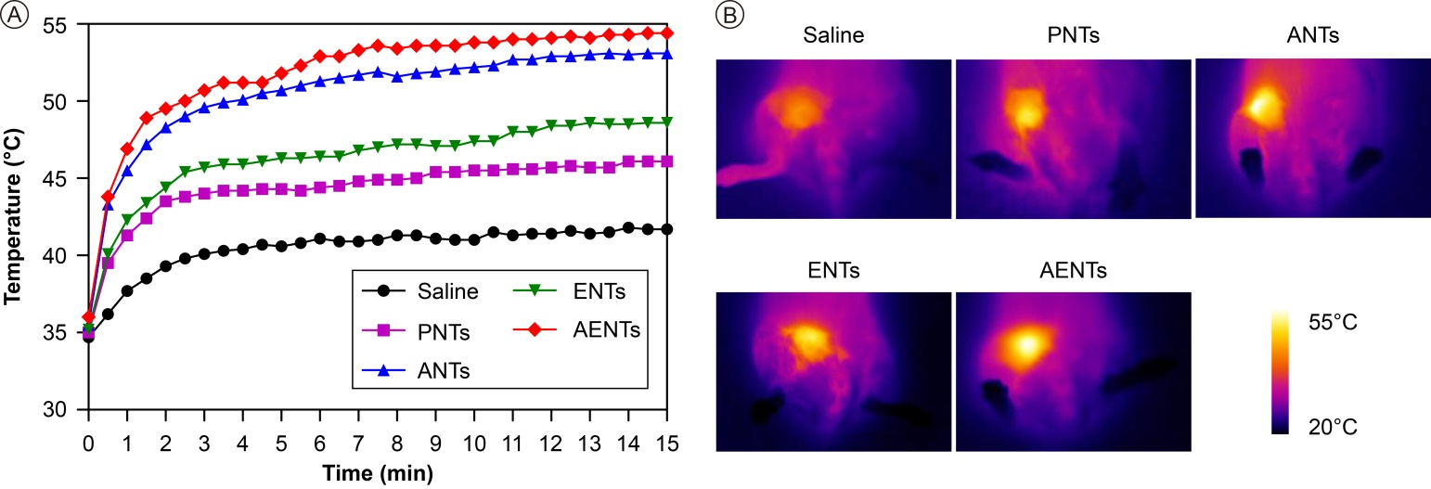
Figure 3. In vivo photothermal conversion effects of PNTs, ANTs, ENTs and AENTs. (A) Temperature changes and (B) infrared thermal images of tumor sites of breast cancer-bearing mice intravenously injected with 150 μL of saline or nanomaterials (PNTs, ANTs, ENTs or AENTs) at a dose of 4 mg/kg under 808 nm NIR laser irradiation (2 W/cm², 15 min).
PNTs: PEGylated silver nanotriangles; ANTs: AS1411-conjugated PEGylated silver nanotriangles; ENTs: EpDT3-conjugated PEGylated silver nanotriangles; AENTs: AS1411 and EpDT3-conjugated PEGylated silver nanotriangles; NIR: near infrared.

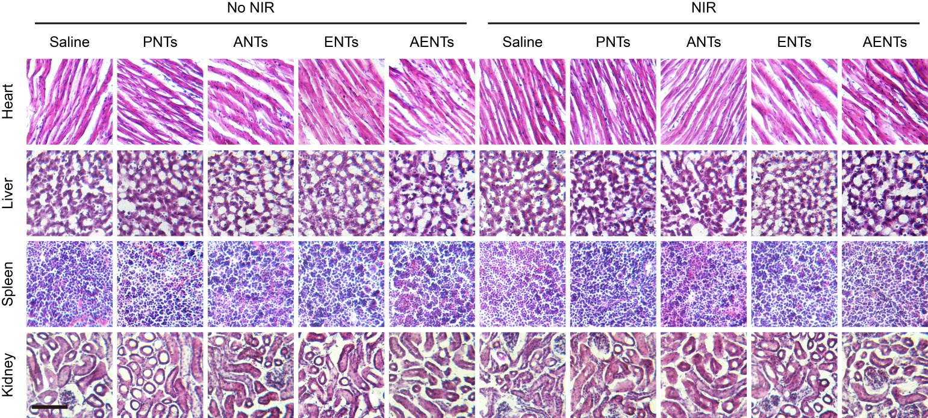
Figure 4. H&E staining images of heart, liver, spleen and kidney of breast cancer-bearing mice treated by intravenous injection of 150 μL of saline or nanomaterials (PNTs, ANTs, ENTs or AENTs) at a dose of 4 mg/kg with or without 808 nm NIR laser irradiation (2 W/cm², 15 min). Scale bar: 100 μm.
PNTs: PEGylated silver nanotriangles; ANTs: AS1411-conjugated PEGylated silver nanotriangles; ENTs: EpDT3-conjugated PEGylated silver nanotriangles; AENTs: AS1411 and EpDT3-conjugated PEGylated silver nanotriangles; NIR: near infrared.

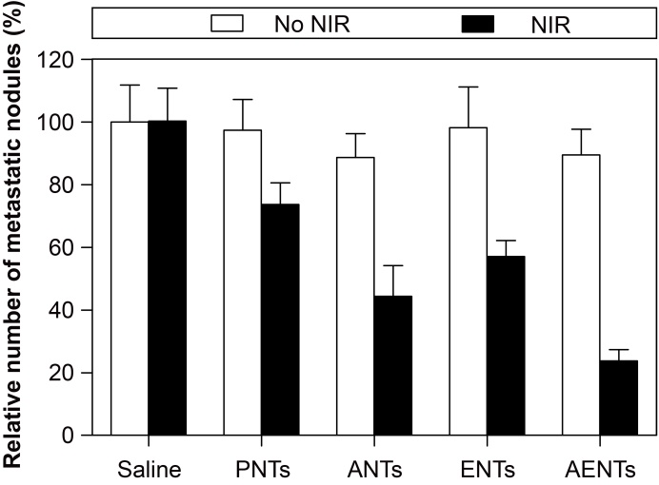
Figure 5. Quantitative analysis of metastatic nodules in lungs of breast cancer-bearing mice treated by intravenous injection of 150 μL of saline or nanomaterials (PNTs, ANTs, ENTs or AENTs) at a dose of 4 mg/kg with or without 808 nm NIR laser irradiation (2 W/cm², 15 min).
PNTs: PEGylated silver nanotriangles; ANTs: AS1411-conjugated PEGylated silver nanotriangles; ENTs: EpDT3-conjugated PEGylated silver nanotriangles; AENTs: AS1411 and EpDT3-conjugated PEGylated silver nanotriangles; NIR: near infrared.

References
- Liu X, Li B, Fu F, et al. Facile synthesis of biocompatible cysteine-coated CuS nanoparticles with high photothermal conversion efficiency for cancer therapy. Dalton. Trans. 43(30), 11709–11715 (2014).

