Supplementary Table S1 – P-scores for overall survival (OS)
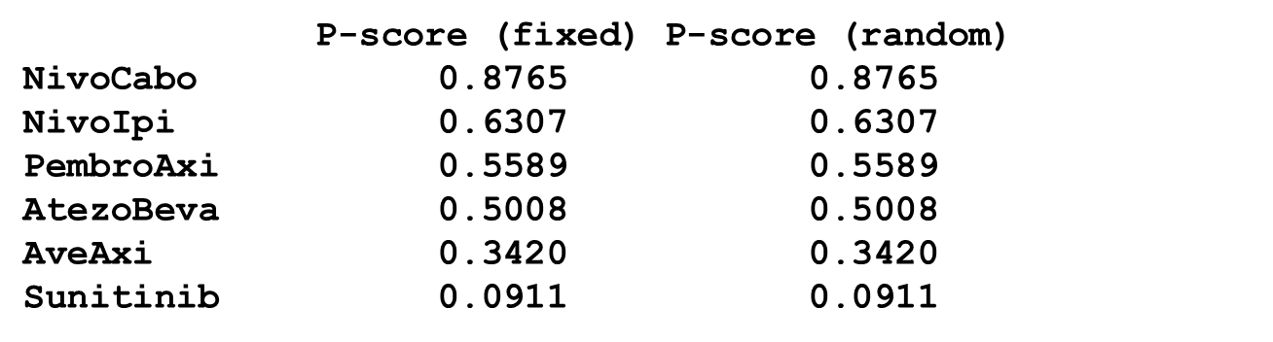

Supplementary Table S2 - Direct and indirect comparisons for progression-free survival
 | Nivolumab + cabozantinib | Nivolumab + ipilimumab | Pembrolizumab + axitinib | Atezolizumab + bevacizumab | Avelumab + axitinib | Sunitinib
Nivolumab + cabozantinib |  | 1.45  (0.69 – 3.07) | 1.29  (0.55 – 3.01) | 1.24  (0.60 – 2.54) | 1.36  (0.60 – 3.07) | 2.38  (1.33 – 4.27)
Nivolumab + ipilimumab | 0.69  (0.33 – 1.46) |  | 0.89  (0.41 – 1.92) | 0.85  (0.45 – 1.60) | 0.93  (0.45 – 1.95) | 1.64  (1.03 – 2.62)
Pembrolizumab + axitinib | 0.78  (0.33 – 1.82) | 1.13  (0.52 – 2.46) |  | 0.96  (0.46 - 2.04) | 1,06  (0.46 – 2.45) | 1.85  (1.00 – 3.44)
Atezolizumab + bevacizumab | 0.81  (0.39 – 1.66) | 1.17  (0.62 – 2.20) | 1.04  (0.49 – 2.20) |  | 1.10  (0.54 – 2.23) | 1.92  (1.26 – 2.93)
Avelumab + axitinib | 0.74  (0.33 – 1.67) | 1.07  (0.51 – 2.24) | 0.95  (0.41 – 2.20) | 0.91  (0.45 – 1.85) |  | 1.75  (0.99 – 3.10)
Sunitinib | 0.42  (0.23 – 0.75) | 0.61  (0.38 – 0.97) | 0.54  (0.29 - 1.00) | 0.52  (0.34 – 0.79) | 0.57  (0.32 – 1.01)
Each cell contains the Hazard Ratio (95% confidence interval) for treatment A (column) vs treatment B (row). Direct comparisons are bold.

Supplementary Table S3– P-scores for progression-free survival (PFS)
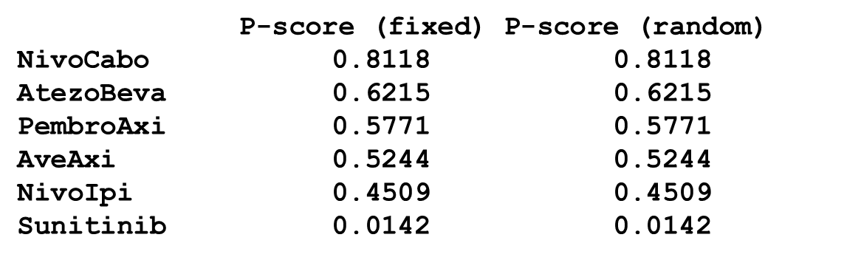

Supplementary Table S4 - Direct and indirect comparisons for objective response rate
 | Nivolumab + cabozantinib | Nivolumab + ipilimumab | Pembrolizumab + axitinib | Atezolizumab + bevacizumab | Avelumab + axitinib | Sunitinib
Nivolumab + cabozantinib |  | 1.15  (0.33 – 4.00) | 0.69  (0.19 – 2.49) | 1.34  (0.37 – 4.89) | 0.72  (0.20 – 2.67) | 0.22  (0.08 – 0.61)
Nivolumab + ipilimumab | 0.87  (0.25 – 3.03) |  | 0.60  (0.20 – 1.79) | 1.17  (0.39 – 3.52) | 0.63  (0.20 – 1.93) | 0.19  (0.09 – 0.41)
Pembrolizumab + axitinib | 1.45  (0.40 – 5.22) | 1.66  (0.56 – 4.95) |  | 1.94  (0.62 – 6.09) | 1.05  (0.33 – 3.33) | 0.32  (0.14 – 0.71)
Atezolizumab + bevacizumab | 0.75  (0.20 – 2.72) | 0.86  (0.28 – 2.59) | 0.52  (0.16 – 1.62) |  | 0.54  (0.17 – 1.74) | 0.17  (0.07 – 0.38)
Avelumab + axitinib | 1.38  (0.37 – 5.13) | 1.59  (0.52 – 4.88) | 0.96  (0.30 – 3.05) | 1.86  (0.57 – 6.00) |  | 0.31  (0.13 – 0.71)
Sunitinib | 4.50  (1.65 – 12.27) | 5.17  (2.46 – 10.86) | 3.11  (1.40 – 6.91) | 6.03  (2.66 – 13.67) | 3.25  (1.40 – 7.53)
Each cell contains the Odds Ratio (95% confidence interval) for treatment A (column) vs treatment B (row). Direct comparisons are bold.

Supplementary Table S5 – P-scores for objective response rate (ORR)
