Supplementary Materials
Study 019 safety and clinical laboratory data
Clinical laboratory data including changes from baseline were summarized by visit and tabulated to show the number of patients and corresponding percentages by severity grade. The clinical significance of abnormal ECG results was determined by the clinician. The hypertension status (normal, prehypertension and hypertension) was derived based on age, sex and height-adjusted systolic blood pressure (SBP) and diastolic blood pressure (DBP) percentile results (hypertensive: ≥95th percentile; pre-hypertensive: 90th to <95th percentile; normal: <90th percentile) for patients aged < 18 years [36]. For patients aged ≥ 18 years, the hypertension status was based on SBP ≥ 140 mmHg or DBP ≥ 90 mmHg (hypertensive), SBP 120–139 mmHg or DBP 80–89 mmHg (pre-hypertensive), or SBP 90–119 mmHg and DBP 60–79 mmHg (normal).
Sensitivity analyses results
Data from the sensitivity analyses, in which the age at diagnosis data from both Study 019 and CINRG DNHS populations were used as the fourth covariate for propensity score matching, are presented in Supplementary Figures 1 and 2, and Supplementary Tables 1 and 2.
Safety results
No clinically meaningful post-baseline trends were observed in the laboratory assessments performed (Supplementary Tables 4–7). The observed elevations in blood pressure during the study were small, not clinically relevant and confounded by concomitant corticosteroid use. There were no other clinically significant differences in vital sign measurements from baseline to the end of study. Clinically significant electrocardiogram (ECG) abnormalities occurred in three patients and were consistent with one patient’s medical history of ventricular hypertrophy and cardiomyopathy in the other two patients.
Supplementary Figure 1. Age at LoA for Study 019 patients with nmDMD who received ataluren 40 mg/kg/day plus SoC in at least Study 019 (N = 59) compared with propensity-score matched patients with DMD receiving SoC alone in the CINRG DNHS (N = 59), using age at diagnosis for both datasets as the fourth covariate for matching, for the sensitivity analysis† of age at LoA.
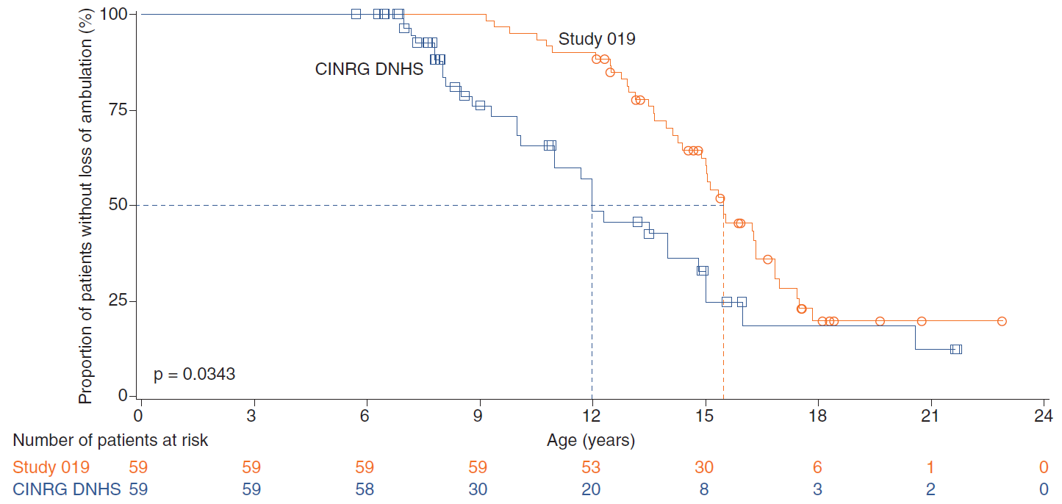
†Since the patients’ age at first symptoms was not captured in Study 019, the patients’ age at diagnosis was used as the fourth covariate for propensity score matching in this sensitivity analysis.
CINRG DNHS: Cooperative International Neuromuscular Research Group Duchenne Natural History Study; LoA: loss of ambulation; SoC: Standard of care

Supplementary Figure 2. Age at (A) predicted FVC <60%, (B) predicted FVC <50%, (C) predicted FVC <30% and (D) FVC <1 L, and (E) the percentage predicted FVC since LoA, for patients with nmDMD who received ataluren 40 mg/kg/day plus SoC in at least Study 019 (all N = 45), compared with propensity-score matched patients with DMD who received SoC alone in the CINRG DNHS (N = 45), using age at diagnosis for both datasets as the fourth covariate for matching†.
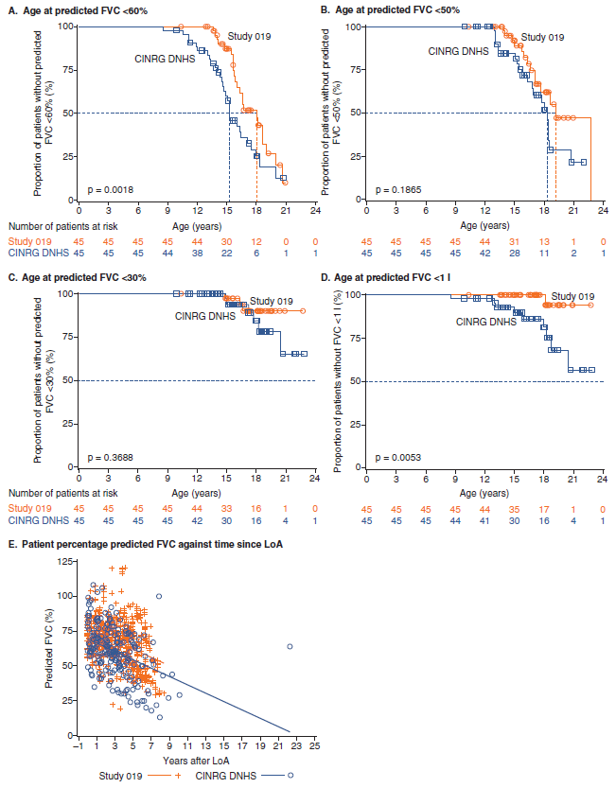

†Since the patients’ age at first symptoms was not captured in Study 019, the patients’ age at diagnosis was used as the fourth covariate for propensity score matching in this sensitivity analysis.
CINRG DNHS: Cooperative International Neuromuscular Research Group Duchenne Natural History Study; FVC: Forced vital capacity; LoA: Loss of ambulation.

Supplementary Table 1. Baseline demographics and disease characteristics for Study 019 patients with nmDMD who received ataluren (40 mg/kg/day) plus SoC in at least Study 019 (N = 59) and for propensity-score matched patients with DMD receiving SoC alone in the CINRG DNHS (N = 59), using age at diagnosis for both datasets as the fourth covariate for matching, for the sensitivity analysis of age at LoA.
 | Study 019  (N = 59) | CINRG DNHS  (N = 59) | P value
Age at diagnosis, years†
Mean (SD) | 3.7 (2.0) | 3.5 (1.6) | 0.4990
Age at corticosteroid initiation, years‡
Mean (SD) | 10.9 (8.1) | 13.4 (11.2) | 0.1784
Deflazacort duration, n (%)§
<1 month | 24 (40.7) | 33 (55.9) | 0.1748
≥1 to <12 months | 1 (1.7) | 0 (0.0)
≥12 months | 34 (57.6) | 26 (44.1)
Other corticosteroid duration, n (%)§
<1 month | 36 (61.0) | 38 (64.4) | 0.6298
≥1 to <12 months | 4 (6.8) | 6 (10.2)
≥12 months | 19 (32.2) | 15 (25.4)
Time to climb four stairs at first assessment, seconds¶
n | 59 | 32
Mean (SD) | 5.3 (6.0) | 6.2 (5.9) | 0.5252
Time to walk/run 10m at first assessment, seconds¶
n | 59 | 33
Mean (SD) | 6.6 (4.3) | 6.8 (2.4) | 0.8193
Time to stand from supine at first assessment, seconds¶
n | 59 | 29
Mean (SD) | 7.9 (8.5) | 5.9 (3.1) | 0.1084
P values were calculated based on a two-sample t-test for continuous variables or a χ² test for categorical variables.
†Since the patients’ age at first symptoms was not captured in Study 019, the patients’ age at diagnosis was used as the fourth covariate for propensity score matching in this sensitivity analysis.
‡Age at initiation of corticosteroid use for steroid-naïve patients (patients who had never used steroids or used steroids after loss of ambulation) in Study 019 was set to 30 years.
§Corticosteroid duration is calculated from starting use of corticosteroid to LoA/censored date.
¶Time to climb four stairs, walk/run 10 m, and stand from supine at first assessment were determined using baseline values from the prior ataluren studies that the patients were enrolled in, i.e., Study 007/007e or Study 004/004e.
CINRG DNHS: Cooperative International Neuromuscular Research Group Duchenne Natural History Study; LoA: Loss of ambulation; SD: standard deviation; SoC: standard of care.

Supplementary Table 2. Baseline demographics and disease characteristics for non-ambulatory Study 019 patients with nmDMD who received ataluren 40 mg/kg/day plus SoC in at least this study (N = 45) and propensity-score matched patients with DMD who received SoC alone in the CINRG DNHS (N = 45), using age at diagnosis for both datasets as the fourth covariate for matching, for the sensitivity analysis of age at decline in respiratory function.
 | Study 019  (N = 45) | CINRG DNHS  (N = 45) | P value
Age at diagnosis, years† |  |  | 0.7481
Mean (SD) | 3.8 (1.8) | 3.6 (2.2)
Age at initiation of corticosteroids, years‡  Mean (SD) | 10.6 (6.9) | 9.1 (6.9) | 0.3152
Deflazacort duration, n (%)§
<1 month | 22 (48.9) | 20 (44.4) | 0.6726
≥1 to <12 months | 0 (0.0) | 0 (0.0)
≥12 months | 23 (51.1) | 25 (55.6)
Other corticosteroid duration, n (%)§ |  |  | 0.9762
<1 month | 26 (57.8) | 25 (55.6)
≥1 to <12 months | 2 (4.4) | 2 (4.4)
≥12 months | 17 (37.8) | 18 (40.0)
Time to climb four stairs at first assessment, seconds¶
n | 45 | 28
Mean (SD) | 7.1 (7.7) | 9.3 (8.6) | 0.2752
Time to walk/run 10m at first assessment, seconds¶
n | 45 | 29
Mean (SD) | 8.2 (5.7) | 7.9 (3.9) | 0.8248
Time to stand from supine at first assessment, seconds¶
n | 45 | 24
Mean (SD) | 12.4 (11.1) | 9.9 (7.1) | 0.2586
P values were calculated based on a two-sample t-test for continuous variables or a χ² test for categorical variables.
†Since the patients’ age at first symptoms was not captured in Study 019, the patients’ age at diagnosis was used as the fourth covariate for propensity score matching in this sensitivity analysis.
‡Age at initiation of corticosteroid use for steroid-naïve patients (patients who had never used steroids or used steroids after loss of ambulation) in Study 019 was set to 30 years.
§Corticosteroid duration is calculated from starting use of corticosteroid to LoA/censored date.
¶Time to climb four stairs, walk/run 10 m, and stand from supine at first assessment were determined using baseline values from the prior ataluren studies that the patients were enrolled in, i.e., Study 007/007e or Study 004/004e.
CINRG DNHS: Cooperative International Neuromuscular Research Group Duchenne Natural History Study; LoA: Loss of ambulation; NA, not available; SD: Standard deviation.

Supplementary Table 3. Treatment-emergent adverse events† experienced by patients in the as-treated population of Study 019 (N = 94).
TEAEs | Corticosteroid use |  | Overall  (N = 94)
 | Yes  (n = 84) | No  (n = 10)
Number of TEAEs† | 1199 | 83 | 1282
Patients with at least one of the following
TEAE | 82 (97.6) | 9 (90.0) | 91 (96.8)
TEAE related to ataluren | 23 (27.4) | 3 (30.0) | 26 (27.7)
TEAE leading to discontinuation of ataluren | 2 (2.4) | 1 (10.0) | 3 (3.2)
SAE | 29 (34.5) | 2 (20.0) | 31 (33.0)
TEAE with maximum severity‡,§
Mild | 21 (25.0) | 2 (20.0) | 23 (24.5)
Moderate | 26 (31.0) | 5 (50.0) | 31 (33.0)
Severe | 34 (40.5) | 1 (10.0) | 35 (37.2)
Life-threatening | 0 (0) | 0 (0) | 0 (0)
Fatal | 1 (1.2) | 1 (10.0) | 2 (2.1)
Patients with at least one of the following‡,¶,#
Infections and infestations‡ | 63 (75.0) | 5 (50.0) | 68 (72.3)
Gastrointestinal disorders‡ | 48 (57.1) | 6 (60.0) | 54 (57.4)
Injury, poisoning and procedural complications‡ | 48 (57.1) | 3 (30.0) | 51 (54.3)
General disorders and administration site conditions‡ | 46 (54.8) | 4 (40.0) | 50 (53.2)
Musculoskeletal and connective tissues disorders‡ | 41 (48.8) | 7 (70.0) | 48 (51.1)
Respiratory, thoracic and mediastinal disorders‡ | 31 (36.9) | 5 (50.0) | 36 (38.3)
Nervous system disorders‡ | 32 (38.1) | 1 (10.0) | 33 (35.1)
Investigations‡ | 17 (20.2) | 4 (40.0) | 21 (22.3)
Cardiac disorders‡ | 16 (19.0) | 2 (20.0) | 18 (19.1)
Skin and subcutaneous tissue disorders‡ | 17 (20.2) | 1 (10.0) | 18 (19.1)
Metabolism and nutrition disorders‡ | 9 (10.7) | 2 (20.0) | 11 (11.7)
Psychiatric disorders‡ | 10 (11.9) | 0 (0) | 10 (10.6)
Renal and urinary disorders‡ | 7 (8.3) | 0 (0) | 7 (7.4)
Surgical and medical procedures‡ | 6 (7.1) | 1 (10.0) | 7 (7.4)
Eye disorders‡ | 6 (7.1) | 0 (0) | 6 (6.4)
Ear and labyrinth disorders‡ | 5 (6.0) | 0 (0) | 5 (5.3)
Vascular disorders‡ | 3 (3.6) | 0 (0) | 3 (3.2)
Endocrine disorders‡ | 2 (2.4) | 0 (0) | 2 (2.1)
Neoplasms benign, malignant and unspecified (including cysts and polyps)‡ | 1 (1.2) | 0 (0) | 1 (1.1)
Reproductive system and breast disorders‡ | 1 (1.2) | 0 (0) | 1 (1.1)
†TEAE is defined as any AE that occurred or worsened in the period extending from the day of a patient’s first dose of ataluren to 6 weeks after the last dose of ataluren in this study.
‡TEAE categories.
§For patients with two or more AEs, the event with the maximum severity was reported. The order of severity is: ‘Mild’, ‘Moderate’, ‘Severe’, ‘Life-threatening’ and ‘Fatal’.
¶AEs were coded using the Medical Dictionary for Regulatory Activities (version 20.1)
#A patient who reported two or more AEs with the same preferred term was counted only once for that term. A patient who reported two or more AEs with different preferred terms within the same organ class was counted only once in the system organ class
AE: adverse events; SAE: serious adverse event; TEAE: treatment-emergent adverse event.
Supplementary Table 4. Lipid profile of patients in the as-treated population of Study 019 (N = 94) at baseline and Week 240.
 | Corticosteroid use
 | Yes (n = 84) |  |  | No (n = 10)
 | Baseline level†
Week 240 level | Low | Normal | High | Low | Normal | High
HDL | n = 25 | n = 25 | n = 25 | n = 2 | n = 2 | n = 2
Low | 0 (0) | 0 (0) | 0 (0) | 0 (0) | 0 (0) | 0 (0)
Normal | 0 (0) | 15 (60.0) | 3 (12.0) | 0 (0) | 2 (100.0) | 0 (0)
High | 0 (0) | 2 (8.0) | 5 (20.0) | 0 (0) | 0 (0) | 0 (0)
LDL | n = 25 | n = 25 | n = 25 | n = 2 | n = 2 | n = 2
Low | 0 (0) | 0 (0) | 0 (0) | 0 (0) | 0 (0) | 0 (0)
Normal | 1 (4.0) | 15 (60.0) | 3 (12.0) | 0 (0) | 2 (100.0) | 0 (0)
High | 0 (0) | 2 (8.0) | 4 (16.0) | 0 (0) | 0 (0) | 0 (0)
Triglycerides | n = 25 | n = 25 | n = 25 | n = 2 | n = 2 | n = 2
Low | 0 (0) | 0 (0) | 0 (0) | 0 (0) | 0 (0) | 0 (0)
Normal | 0 (0) | 15 (60.0) | 3 (12.0) | 0 (0) | 0 (0) | 1 (50.0)
High | 0 (0) | 2 (8.0) | 5 (20.0) | 0 (0) | 0 (0) | 1 (50.0)
Total cholesterol | n = 25 | n = 25 | n = 25 | n = 2 | n = 2 | n = 2
Low | 0 (0) | 0 (0) | 0 (0) | 0 (0) | 0 (0) | 0 (0)
Normal | 0 (0) | 13 (52.0) | 2 (8.0) | 0 (0) | 2 (100.0) | 0 (0)
High | 0 (0) | 4 (16.0) | 6 (24.0) | 0 (0) | 0 (0) | 0 (0)
†Baseline was defined as the last available assessment on or prior to the first dose of study medication.
HDL: high density lipoprotein; LDL: low density lipoprotein.

Supplementary Table 5. Hypertensive status of patients in the as-treated population of Study 019 (N = 94) from baseline to Week 240.
Visit  Hypertension criteria† | Corticosteroid use |  | Overall N = 94
 | Yes (n = 84) | No (n = 10)
Baseline | n = 56 | n = 3 | n = 59
Normal | 37 (66.1) | 2 (66.7) | 39 (66.1)
Pre-hypertensive | 6 (10.7) | 1 (33.3) | 7 (11.9)
Hypertensive | 13 (23.2) | 0 (0) | 13 (22.0)
Week 48 | n = 43 | n = 4 | n = 47
Normal | 28 (65.1) | 4 (100.0) | 32 (68.1)
Pre-hypertensive | 5 (11.6) | 0 (0) | 5 (10.6)
Hypertensive | 10 (23.3) | 0 (0) | 10 (21.3)
Week 96 | n = 36 | n = 3 | n = 39
Normal | 26 (72.2) | 2 (66.7) | 28 (71.8)
Pre-hypertensive | 5 (13.9) | 1 (33.3) | 6 (15.4)
Hypertensive | 5 (13.9) | 0 (0) | 5 (12.8)
Week 144 | n = 37 | n = 2 | n = 39
Normal | 22 (59.5) | 1 (50.0) | 23 (59.0)
Pre-hypertensive | 13 (35.1) | 1 (50.0) | 14 (35.9)
Hypertensive | 2 (5.4) | 0 (0) | 2 (5.1)
Week 192 | n = 34 | n = 2 | n = 36
Normal | 23 (67.6) | 1 (50.0) | 24 (66.7)
Pre-hypertensive | 8 (23.5) | 1 (50.0) | 9 (25.0)
Hypertensive | 3 (8.8) | 0 (0) | 3 (8.3)
Week 240 | n = 17 | n = 1 | n = 18
Normal | 14 (82.4) | 1 (100.0) | 15 (83.3)
Pre-hypertensive | 3 (17.6) | 0 (0) | 3 (16.7)
†For patients aged < 18 years old, the hypertension criteria are based on age, gender and height-adjusted systolic blood pressure (SBP) and diastolic blood pressure (DBP) percentile results (hypertensive: =95th percentile; pre-hypertensive: 90–95th percentile; normal: < 90th percentile). For patients aged ≥ 18 years old, hypertensive: SBP ≥ 140 mmHg or DBP ≥ 90 mmHg; pre-hypertensive: SBP 120–139 mmHg or DBP 80–89 mmHg; normal: SBP 90–119 mmHg and DBP 60–79 mmHg.
DBP: diastolic blood pressure; SBP: systolic blood pressure.
Supplementary Table 6. ECG results of patients of patients in the as-treated population of Study 019 (N = 94) from screening to post-treatment.
Visit | Assessment category | Corticosteroid use |  | Overall N = 94
 |  | Yes n = 84 | No n = 10
Screening
 | Normal | 53 (63.1) | 4 (44.4) | 57 (61.3)
 | Abnormal, not clinically significant† | 31 (36.9) | 5 (55.6) | 36 (38.7)
 | Abnormal, clinically significant† | 0 (0) | 0 (0) | 0 (0)
Week 48
 | Normal | 8 (53.3) | 1 (100.0) | 9 (56.3)
 | Abnormal, not clinically significant† | 7 (46.7) | 0 (0) | 7 (43.8)
 | Abnormal, clinically significant† | 0 (0) | 0 (0) | 0 (0)
Week 240
 | Normal | 7 (70.0) | 2 (100.0) | 9 (75.0)
 | Abnormal, not clinically significant† | 3 (30.0) | 0 (0) | 3 (25.0)
 | Abnormal, clinically significant† | 0 (0) | 0 (0) | 0 (0)
Post-treatment
 | Normal | 1 (50.0) | 1 (100.0) | 2 (66.7)
 | Abnormal, not clinically significant† | 1 (50.0) | 0 (0) | 1 (33.3)
 | Abnormal, clinically significant† | 0 (0) | 0 (0) | 0 (0)
†The clinical significance of abnormal ECG results was determined by the clinician.
Supplementary Table 7. Hepatic and renal abnormalities in patients in the as-treated population of Study 019 (N = 94) from screening to post-treatment.
Parameter criterion†,‡ | Corticosteroid use |  | Overall N = 94
 | Yes n = 84 | No n = 10
Hepatic
Serum total bilirubin
Grade 2 (1.5–3.0 x ULN) | 0 (0) | 1 (10.0) | 1 (1.1)
Serum GGT
Grade 2 (>2.5–5.0 x ULN) | 0 (0) | 1 (10.0) | 1 (1.1)
Renal
Serum cystatin C
>1.33–2.00 mg/L | 1 (1.2) | 0 (0) | 1 (1.1)
Serum BUN
≥1.5–3.0 x ULN | 2 (2.4) | 0 (0) | 2 (2.1)
Urine protein: urine creatine (spot)
>0.40 mg:mg | 36 (42.9) | 7 (70.0) | 43 (45.7)
Urine protein: urine osmolality (spot)
>0.30 mg/L:mOsm/kg | 10 (11.9) | 5 (50.0) | 15 (16.0)
Urine blood (by dipstick)
2+ (small) | 2 (2.4) | 0 (0) | 2 (2.1)
3+ (moderate) | 1 (1.2) | 0 (0) | 1 (1.1)
†Patients with more than one abnormality are counted only once in the worst category.
‡Severity of laboratory abnormalities was graded using CTCAE version 3.0.
CTCAE: common terminology criteria for adverse events; ULN: upper limit of normal.

