Supplementary Material
Supplementary Table 1. ICD-10 morphology codes for NSCLC.
Morphology code  (ICD-O/3) | Type of NSCLC
 | Adenocarcinoma (non-squamous NSCLC)
81403 | Adenocarcinoma UNS
81443 | Enteric adenocarcinoma
82303 | Solid adenocarcinoma with mucin production
82443 | Mixed adenoneuroendocrine carcinoma
82500 | Atypical adenomatous hyperplasia
82502 | Adenocarcinoma in situ, non-mucinous
82503 | Adenocarcinoma, BAC, bronchiolar carcinoma (incl pathologic in situ-variant)
82523 | Bronchio-alveolar carcinoma
82532 | Adenocarcinoma in situ, mucinous
82533 | Adenocarcinoma, mucinous BAC
82543 | Bronchio-alveolar carcinoma, mixed mucinous and non-mucinous
82553 | Adenocarcinoma, mixed with other types of carcinoma incl. squamous cell and small cell carcinoma
82563 | Minimally invasive adenocarcinoma, non-mucinous
82573 | Minimally invasive adenocarcinoma, mucinous
82603 | Papillary adenocarcinoma, NOS
82653 | Micropapillary adenocarcinoma
83103 | Clear cell adenocarcinoma
83333 | Foetal adenocarcinoma
84703 | Mucinous cystadenocarcinoma
84803 | Mucinous adenocarcinoma
84903 | Signet ring cell carcinoma
85503 | Acinar cell carcinoma
85513 | Acinar adenocarcinoma
 | Squamous-cell carcinoma
80523 | Papillary squamous cell carcinoma
80702 | Squamous cell carcinoma in situ
80703 | Squamous cell carcinoma
80713 | Keratinizing squamous cell carcinoma
80723 | Non-keratinizing squamous cell carcinoma
80733 | Squamous cell carcinoma, small cell non-keratinizing
80833 | Basaloid squamous cell carcinoma
80843 | Squamous cell carcinoma, clear cell type
 | NSCLC NOS
80103 | Carcinoma, NOS
80203 | Carcinoma, undifferentiated NOS
80213 | Carcinoma, anaplastic NOS
80463 | Carcinoma, non-small cell unspecified
 | Large cell carcinoma (non-squamous NSCLC)
80123 | Large-cell carcinoma, unspecified
 | Neuroendocrine NSCLC carcinoma (other specified NSCLC carcinoma)
80133 | Large cell neuroendocrine carcinoma
82463 | Neuroendocrine carcinoma, NOS
 | Other miscellaneous NSCLC (other specified NSCLC carcinoma)
80143 | Large cell carcinoma with rhabdoid phenotype
80223 | Sarcomatoid carcinoma, pleomorphic
80233 | NUT carcinoma
80303 | Spindle cell and giant cell carcinoma
80313 | Giant cell carcinoma
80323 | Spindle cell carcinoma, NOS
80333 | Pseudosarcomatous carcinoma
81233 | Basaloid carcinoma
82003 | Adenocystic carcinoma
84303 | Mucoepidermoid carcinoma
85603 | Adenosquamous carcinoma
85623 | Epithelial-myoepithelial carcinoma
89723 | Blastoma, pulmonary (pneumoblastoma)
89803 | Carcinosarcoma, NOS
89823 | Myoepithelial carcinoma
ICD-10: International Classification of Diseases for Oncology, 10th Revision; BAC: Bronchiolo-alveolar; NOS: Not otherwise specified; NSCLC: Non-small cell lung cancer; UNS: Unspecified.
Supplementary Table 2. Initial treatment categories and definitions.
Initial treatment was defined as the first treatment received within 6 months of diagnosis, associated with any other treatment received within a certain time period following first treatment as defined in the table below.
Initial treatment category | Definitions
A. Surgery | Sum of all A sub-groups
A0. Surgery only | Surgery + no SACT or RT within 12 weeks after surgery
A1. Surgery + adjuvant SACT (only) – no RT within 6 months of SACT start | Surgery + identification of SACT only (start) within 84 days (12 weeks) after surgery
A2. Surgery + adjuvant RT (only) – no SACT within 6 months of RT start | Surgery + identification of RT only (start) within 84 days (12 weeks) after surgery
A3. Surgery + adjuvant RT and SACT | Surgery + identification of RT [or SACT] (start) within 84 days (12 weeks) after surgery + identification of SACT [or RT] (start) within 180 days (6 months) after RT [or SACT]
A4. Neoadjuvant SACT + surgery | SACT + identification of surgery within 120 days (4 months) after 1st SACT regimen start + no RT identification prior to surgery  AND:
A4.1 Neoadjuvant SACT + surgery alone | No SACT and RT within 12 weeks (start of SACT) after surgery
A4.2 Neoadjuvant SACT + surgery + adjuvant SACT | SACT only within 12 weeks (start) after surgery, continued SACT regimen
A4.3 Neoadjuvant SACT + surgery + adjuvant RT | RT only within 12 weeks (start) after surgery
A4.4 Neoadjuvant SACT + surgery + adjuvant SACT and RT | SACT and RT within 12 weeks (start) + 3 months (end) after surgery, continued SACT regimen
A5. Neoadjuvant RT + surgery | RT + identification of surgery within 90 days (3 months) after 1st RT treatment start + no SACT identification prior to surgery AND:
A5.1 Neoadjuvant RT + surgery alone | No SACT and RT within 12 weeks after surgery
A5.2 Neoadjuvant RT + surgery + adjuvant SACT | SACT only within 12 weeks after surgery
A5.3 Neoadjuvant RT + surgery + adjuvant RT | RT only within 12 weeks after surgery
A5.4 Neoadjuvant RT + surgery + adjuvant SACT and RT | SACT and RT within 12 weeks (start) + 3 months (end) after surgery
A6. Neoadjuvant SACT and RT + surgery | RT or SACT + identification of surgery within 3 months after start + identification of SACT and RT prior to surgery  Note: Neoadjuvant SACT and RT corresponds to RT within 6 weeks of SACT start (i.e., chemoradiation)
A6.1 Neoadjuvant SACT and RT + surgery alone | No SACT and RT within 12 weeks after surgery
A6.2 Neoadjuvant SACT and RT + surgery + adjuvant SACT | SACT only within 12 weeks (start) after surgery
A6.3 Neoadjuvant SACT and RT + surgery + adjuvant RT | RT only within 12 weeks (start) after surgery
A6.4 Neoadjuvant SACT and RT + surgery + adjuvant SACT and RT | SACT and RT within 12 weeks (start) + 6 months (start) after surgery
B. RT alone | RT + no SACT nor surgery within 90 days (3 months) after RT
C. SACT + RT | Sum of C1, C2, and C3
C1. RT followed by SACT | RT + identification of SACT within 90 days (3 months) after 1st SACT regimen start + no surgery within 6 months after 1st SACT start
C2. SACT followed by RT | SACT + identification of RT within 90 days (3 months) after 1st SACT regimen start + no surgery within 6 months after 1st SACT start
C3. Chemoradiation | SACT or RT + [regimen identified as being a chemoradiation]  OR  [start RT within 6 weeks of SACT] + no surgery within 3 months after chemoradiation
D. SACT alone | SACT + no RT nor surgery within 90 days (3 months) after 1st SACT regimen start
E. Not treated | No SACT, surgery, or RT identified over entire follow-up period
RT: Radiotherapy; SACT: Systemic anticancer therapy.

Supplementary Figure 1. Kaplan-Meier curves for overall survival in patients with NSQ NSCLC by TNM stage and year of diagnosis in Denmark. A) Stage I, B) Stage II, C) Stage IIIA, D) Stage IIIB and E) Stage IV.
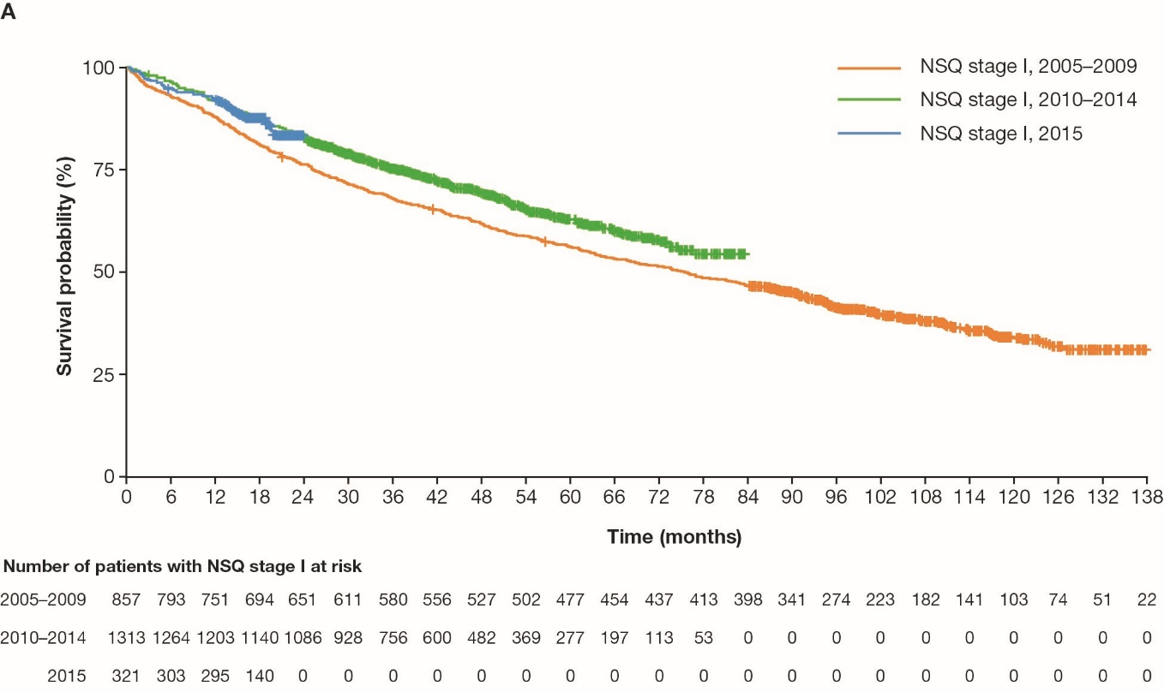
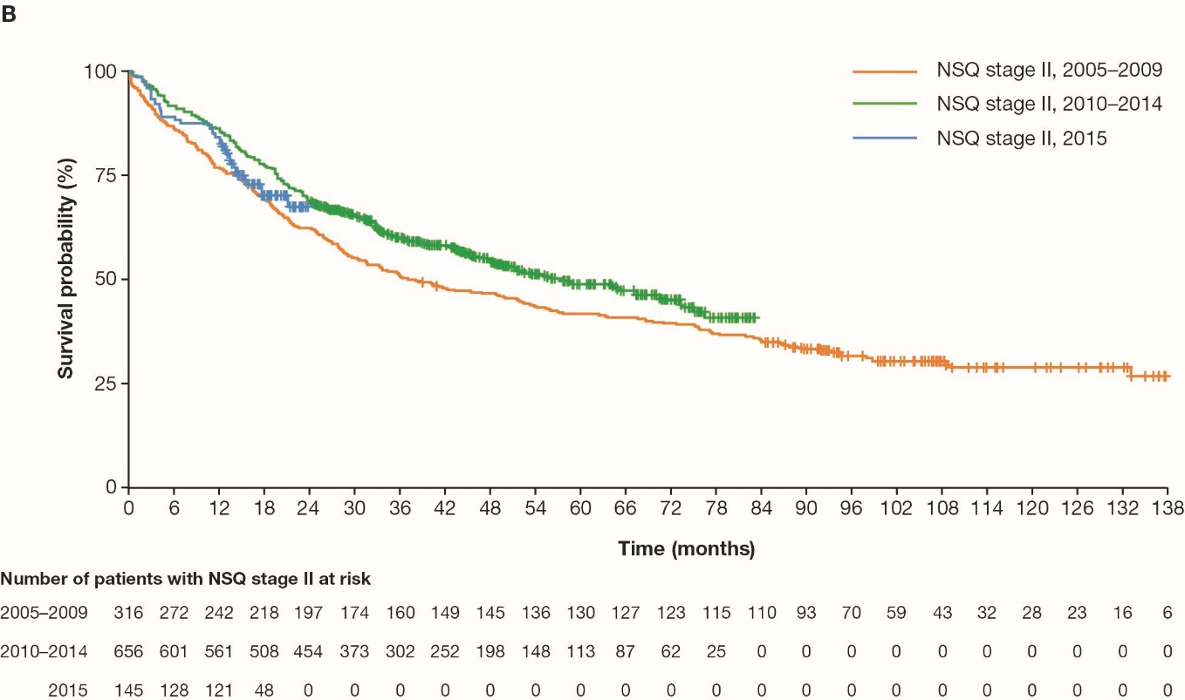
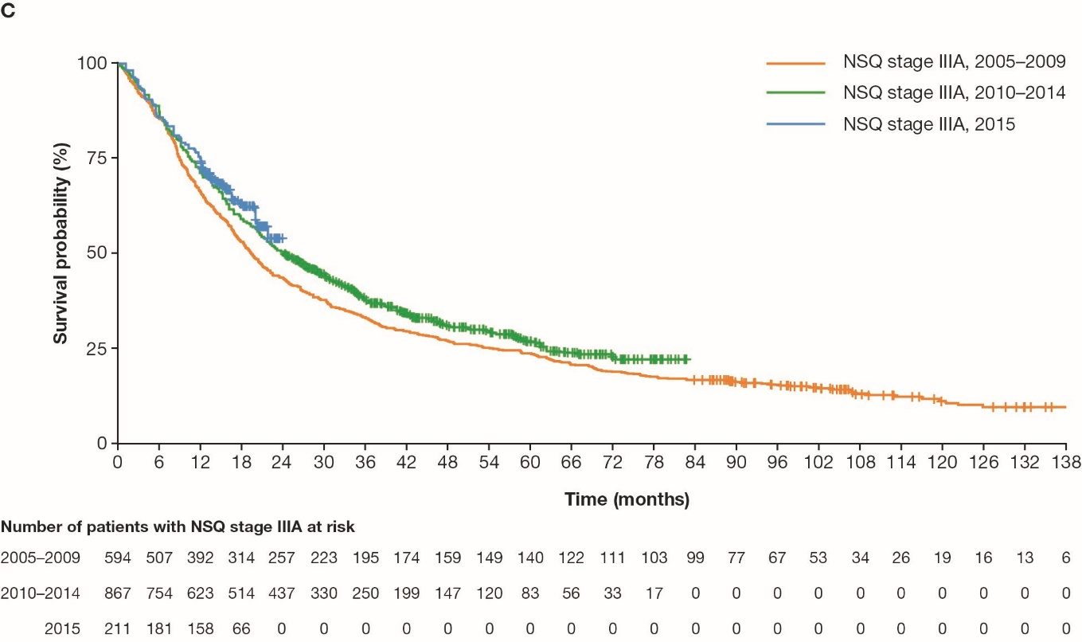
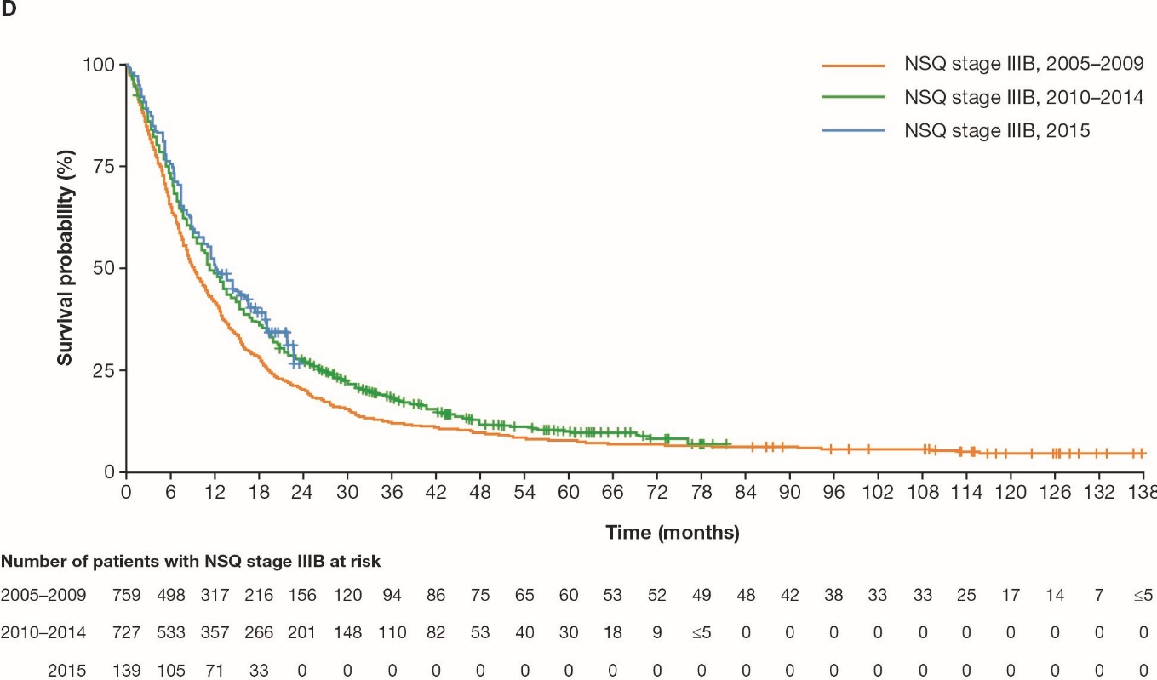
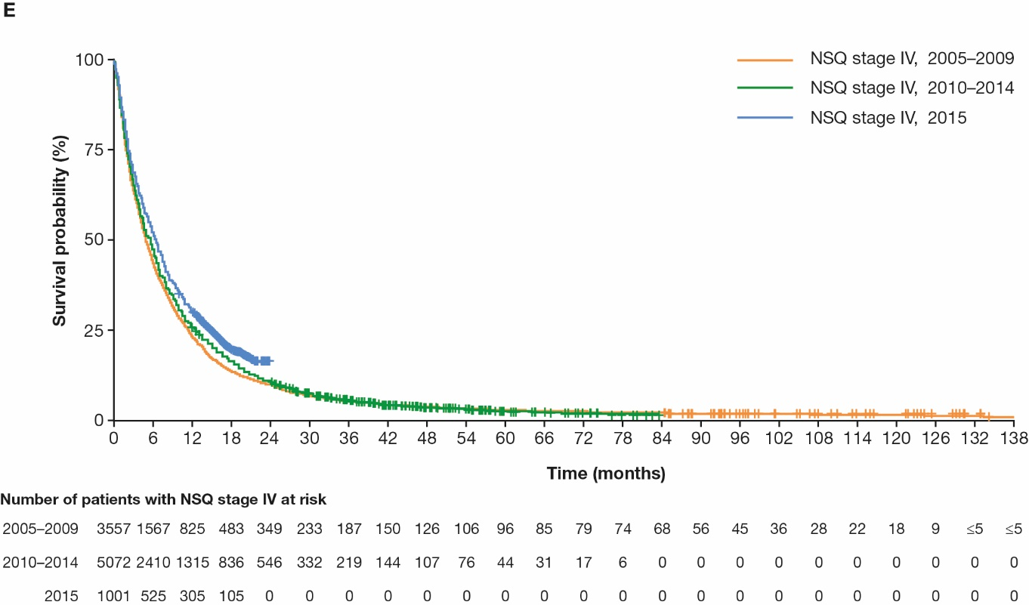Data were truncated at month 138.

Supplementary Figure 2. Kaplan-Meier curves for overall survival in patients with SQ NSCLC by TNM stage and year of diagnosis in Denmark. A) Stage I, B) Stage II, C) Stage IIIA, D) Stage IIIB and E) Stage IV.
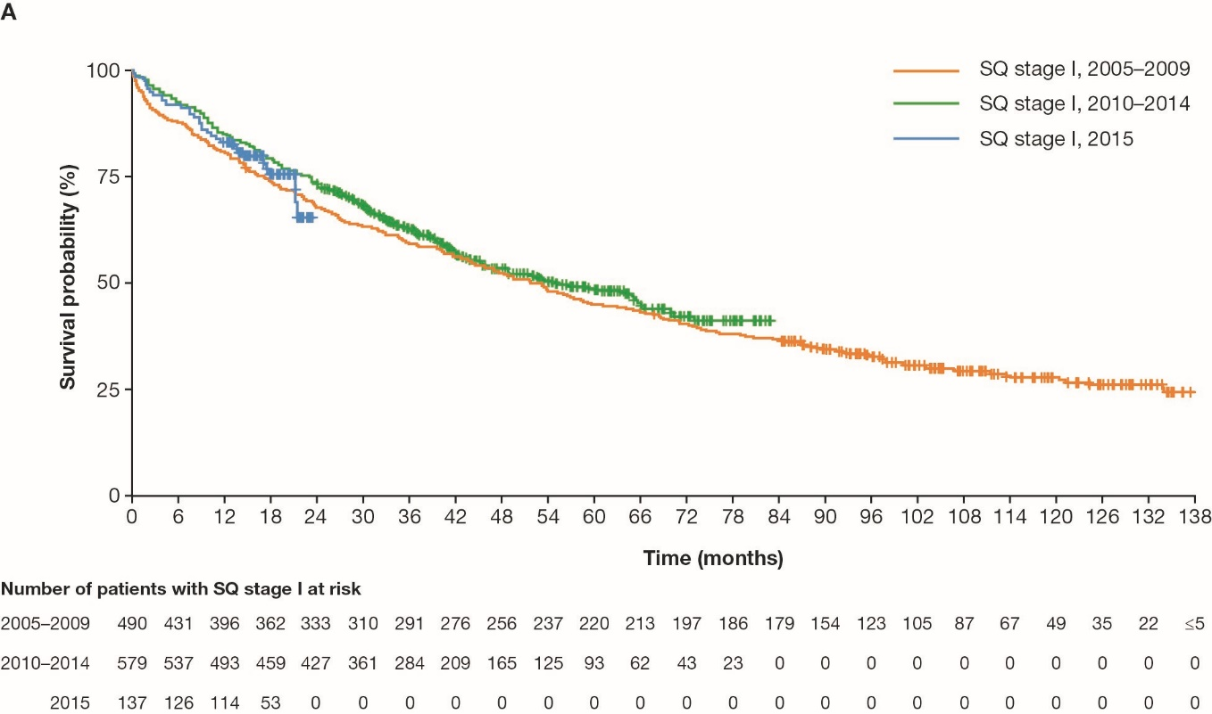
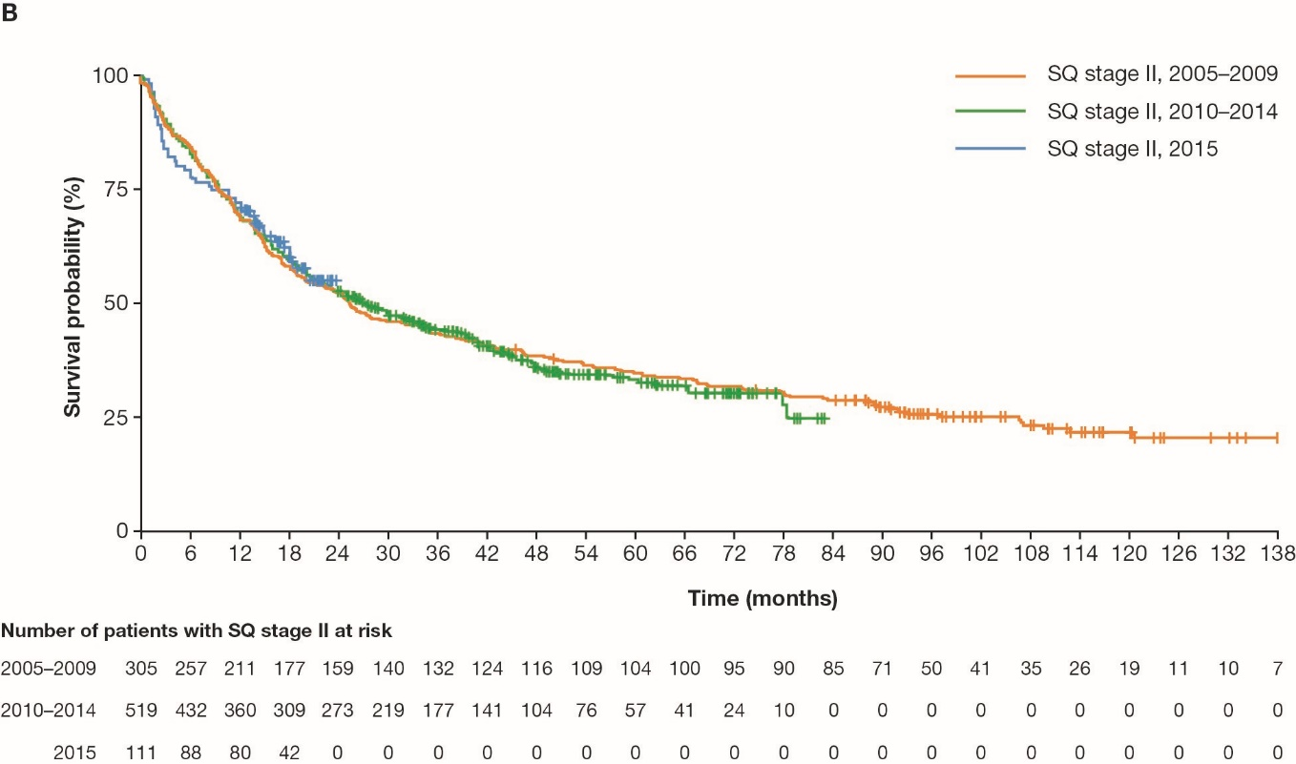

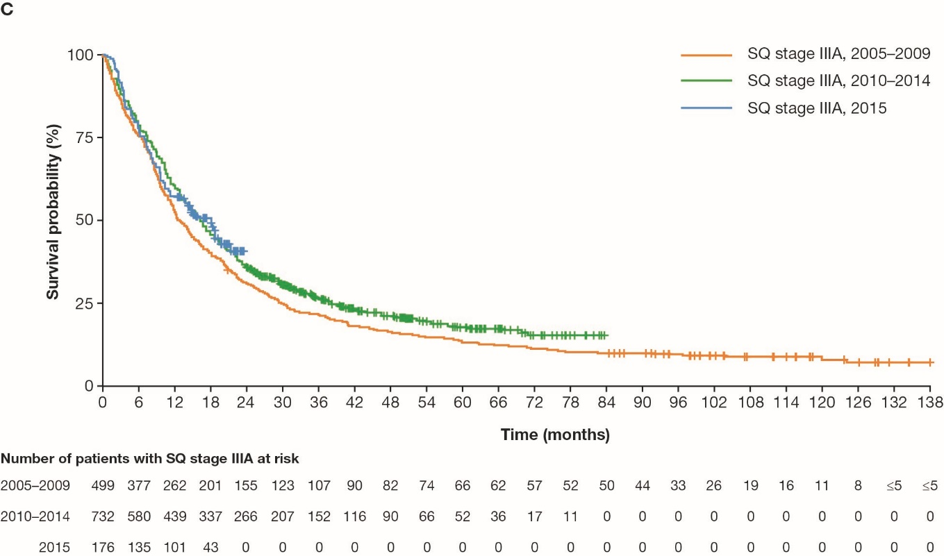
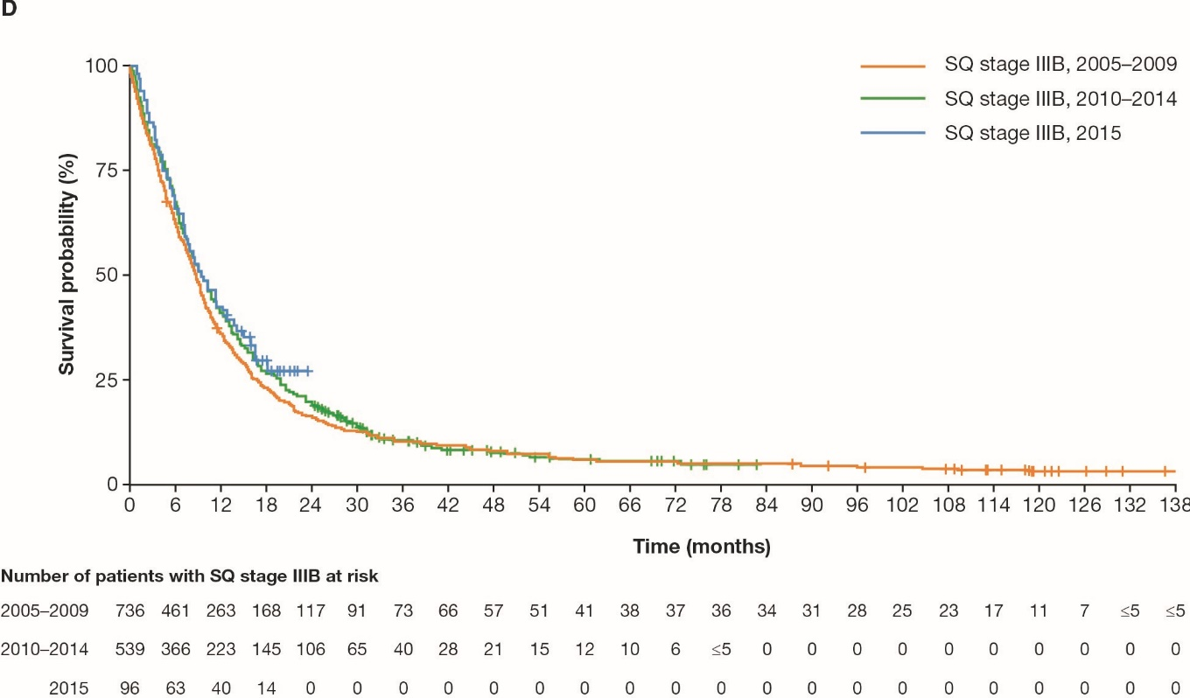
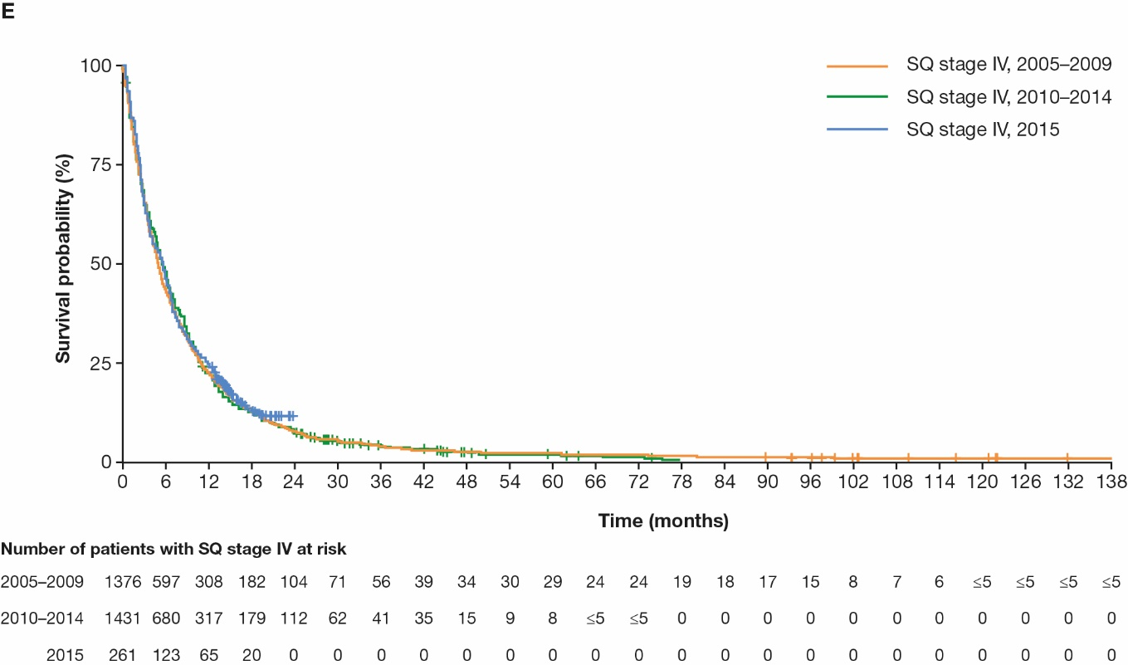 Data were truncated at month 138.

