RT-qPCR information
Experimental design
Experimental group: 35 paired of Papillary thyroid cancer tissue; Control group: 35 paired of normal thyroid tissues.
Sample information
The sample tissues were collected from surgery, immediately frozen, immobilized less than 24 hours, storage at -80℃.
Nucleic acid extraction
Extract the sample RNA with Trizol, and finally add 100µl of RNase-free water to dissolve the RNA.
DNase I digests the DNA in the sample RNA:
Component | dosage
Template (RNA) | 10µg
RNase Inhibitor | 4µl
DNase I buffer | 10µl
DNase I | 10µl
DEPC treats H2O | to 100µl
Mix 37℃ 30min
RNA agarose gel electrophoresis validation
1) Weigh 0.45g of agarose into an Erlenmeyer flask, add 4.5ml of 10×MOPS buffer and 39.5ml of DEPC water to it, and dissolve in a microwave oven.
2) When it is cooled to about 60 degrees Celsius, add 1ml formaldehyde, 5ul GelRed, and shake well (to avoid bubbles). Pour into the gel plate and solidify for 30 minutes.
3) Take 4μl of each RNA sample, add 2μl of 6×RNA electrophoresis loading buffer, mix well, and add all the liquid to the sample well of denaturing gel.
4) Electrophoresis at 120V for 25min. Observe with a gel ultraviolet analyzer, take pictures and save.
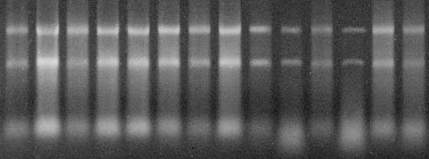
RNA extraction product agarose gel electrophoresis figure
Reverse Transcription
The procedure for reverse transcription of RNA to cDNA is summarized in the following table:
Component | dosage
Template (RNA) | 1µg
Reverse transcription primer T18 (50µM) | 1.0µl
DEPC treats H2O | to 12µl
Mix, 70℃ for 5min, immediately ice bath
5×buffer | 4.0µl
dNTP（10mM） | 1.0µl
RNase Inhibitor（MBI） | 0.5µl
M-MLV | 1.0µl
Make up DEPC water to 20µl
42℃ 60min，70℃ 15min
Chill on ice for 5 minutes

qPCR primers
Primer | sequence (5'to3') | Base number | Product length
GAPDH | F：TGAAGGTCGGAGTCAACGG | 19 | 226bp
 | R：TCCTGGAAGATGGTGATGGG | 20
TFF3 | F：GGGCTGCTGCTTTGACTCCA | 20 | 238bp
 | R：TCGTTAAGACATCAGGCTCCAGAT | 24

qPCR experimental protocol
Take 0.2ml thin-walled PCR tubes and number them respectively. Add dye-containing Premix Taq 12.5ul, 10uM primer mixture 0.75ul to each tube, corresponding cDNA 1ul each, one tube without template is used as a negative control, and each tube is filled with water to 25ul. Summarized as follows:
Component | dosage
Template（cDNA） | 1.0µl
10μM primer F/R | 0.75µl
Premix Taq | 12.5µl
ddH2O | To 25µl
PCR product validation: After mixing, place it in a PCR machine at 95℃ for 5min pre-denaturation, 95℃ 10s→60℃ 30s→72℃ 30s, 40cycles, 4℃ pause. Electrophoresis at 120V voltage for 20min, after the electrophoresis is over, take pictures on the gel UV analyzer
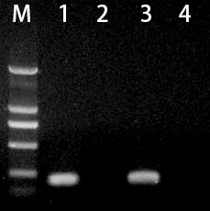
M: DL2000; 1:GAPDH; 2:GAPDH negative control; 3:TFF3; 4:TFF3 negative control;

REAL TIME PCR experiment data: Take Roche 384-well plates and number them respectively. The system is summarized as follows:
Component | dosage
Template（cDNA） | 1.0µl
10μM primer F/R | 0.3µl
Premix Taq | 5µl
EvaGreen | 0.5µl
ddH2O | to 10µl
Mix well and place in a fluorescent quantitative PCR machine.
After 95°C 5min pre-denaturation, 95°C 10s→60°C 30s (fluorescence detection), 40 cycles. Melting curve 65℃-95℃.

GAPDH melting curves
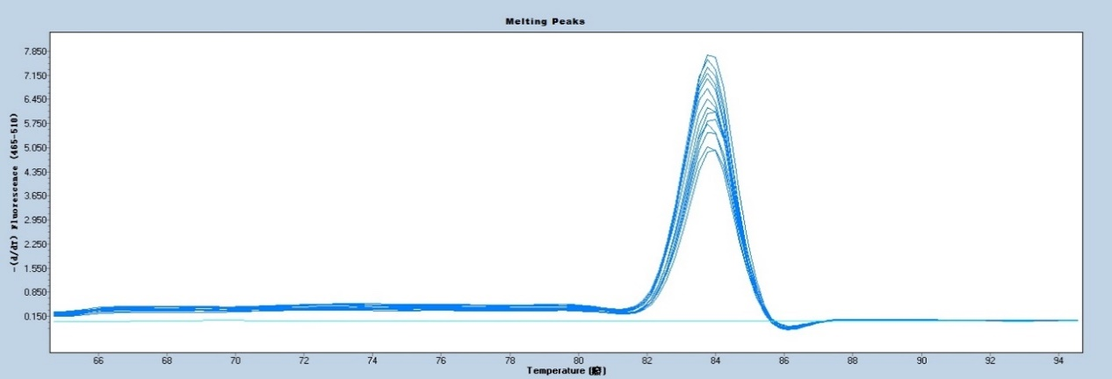
TFF3 melting curves
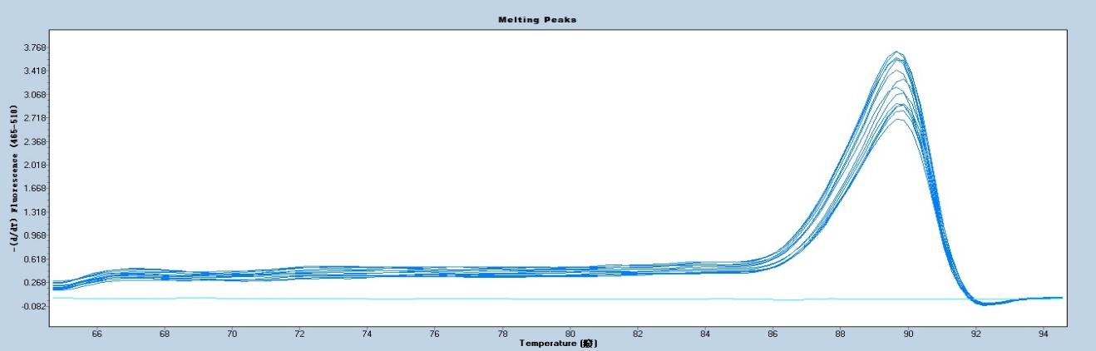

Data analysis: Analyze the results with the relative quantitative 2-ΔΔCT method, subtract the Ct value of the housekeeping gene of each sample from the Ct value of the target gene of each sample to obtain delta Ct; subtract the value of the control group from delta Ct to obtain delta delta Ct. Use 2^{-ΔΔCT} to calculate the expression change of the target gene in each sample. Statistical methods for result significance was used with SPSS version 23.0.

Reagents, consumables and primers used in the experiment
1. Trizol Invitrogen, USA
2. M-MLV reverse transcriptase Bao Bioengineering (Dalian) Co., Ltd.
3. DNase I Fermentas, USA
4. RNase Inhibitor Fermentas, USA
5. 6×Loading Dye Fermentas, USA
6. dNTP(10mM) Bao Biological Engineering (Dalian) Co., Ltd.
7. Premix Taq™ (Ex Taq™ Version 2.0) Bao Biological Engineering (Dalian) Co., Ltd.
8. DL2000 DNA Marker Bao Biological Engineering (Dalian) Co., Ltd.
9. RL 6,000 RNA Marker Fermentas, USA
10. Agarose Biowest, Spain
11. RNase-free H2O Bao Biological Engineering (Dalian) Co., Ltd.
12. EvaGreen Dye Biotium, USA
13. Isopropanol (Analytical Pure) Beijing Chemical Reagent Company
14. Anhydrous ethanol (analytical grade) Beijing Chemical Reagent Company
15. Chloroform (Analytical Pure) Beijing Chemical Reagent Company
16. Formaldehyde (Analytical Pure) Beijing Chemical Reagent Company
17. 50xTAE Bao Biological Engineering (Dalian) Co., Ltd.
18. 10×MOPS Beijing Chemical Reagent Company
19. GelRed American biotium company
20. Real Time PCR 384-well plate Roche, Switzerland
21. 10µl/200µl/1000µl Tips AXYGEN, USA
22. 1.5ml /0.5ml centrifuge tube AXYGEN, USA

Instruments used in the experiment
1. Type 2720 PCR instrument ABI Company, USA
2. system electrophoresis Mupid (Mupid 2plus) electrophoresis tank TAKARA Japan
3. image system (EUV-LDUV) gel imaging system Korea Biotech, Korea
4. Centrifuge (MICRO 17TR) Centrifuge Hanil Corporation, South Korea
5. Ultra-clean workbench Suzhou Purification Company
6. 2.5µl/10µl/100µl/200µl/1000µl pipettes Eppendorf, Germany
7. Eppendorf epMotion 5070 Automatic Dosing Workstation Eppendorf, Germany
8. Autoclave (LS-B50L) Sterilizer Jiangyin Binjiang Company, China
9. Freezer Big (DW-40L262) refrigerator Qingdao Haier Company
10. Mixer vortex (Voltex-Genie2) vortex mixer SI company, USA
11. oven dry(DHG-9240A) Shanghai Yiheng Company
12. Balance (BT-214) balance Denver company, USA
13. Roche LightCycler® 480II real-time fluorescent quantitative PCR system Roche, Switzerland

