Supplemental material
Appendix Table 1. A comparison of standardized mean differences for baseline covariates between matched and unmatched samples.

 | Total Population  (N = 4,490) | DAMA  (N = 2,245) | Routine discharge  (N = 2,245) | Std diff  (Matched  Sample) | Std diff  (Unmatched  Sample)
Age category 1 (18-29) | 1,088 (24.2) | 538 (24.0) | 550 (24.5) | 0.012 | 0.075
Age category 2 (30-39) | 836 (18.6) | 414 (18.4) | 422 (18.8) | 0.009 | 0.152
Age category 3 (40-49) | 999 (22.3) | 498 (22.2) | 501 (22.3) | 0.003 | 0.116
Age category 4 (50-64) | 1,567 (34.9) | 795 (35.4) | 772 (34.4) | 0.021 | 0.031
Female | 1,831 (40.8) | 934 (41.6) | 897 (40.0) | 0.034 | 0.526
Region 1 (East) | 1,548 (34.5) | 754 (33.6) | 794 (35.4) | 0.037 | 0.362
Region 2 (Mid-West) | 964 (21.5) | 489 (21.8) | 475 (21.2) | 0.015 | 0.229
Region 3 (South) | 1,722 (38.4) | 869 (38.7) | 853 (38.0) | 0.015 | 0.077
Region 4 (West) | 256 (5.6) | 133 (5.9) | 123 (5.4) | 0.019 | 0.069
Elixhauser score = 0 | 1,419 (31.6) | 703 (31.3) | 716 (31.9) | 0.012 | 0.325
Elixhauser score = 1 | 1,810 (40.3) | 923 (41.1) | 887 (39.5) | 0.033 | 0.122
Elixhauser score ≥ 2 | 1,261 (28.1) | 619 (27.6) | 642 (28.6) | 0.023 | 0.234
Timing of admission (Weekend) | 1,011 (22.5) | 498 (22.2) | 513 (22.9) | 0.032 | 0.150
Admission year (2007-2009) | 1,165 (26.0) | 598 (26.6) | 567 (25.3) | 0.019 | 0.082
Admission year (2010-2012) | 1,480 (33.0) | 750 (33.4) | 730 (32.5) | 0.046 | 0.047
Admission year (2013-2015) | 1,845 (41.0) | 897 (40.0) | 948 (42.2) | 0.016 | 0.124
Surgery during stay (Yes) | 567 (12.6) | 290 (12.9) | 277 (12.3) | 0.017 | 1.100
Length of stay (Mean ± SD) | 2.27 ± 3.06 | 2.22 ± 3.30 | 2.31 ± 2.78 | 0.030 | 0.202
Index hospitalization cost (Mean ± SD) | 8,010 ± 14626 | 7,598 ± 14595 | 8421 ± 14649 | 0.056 | 0.433
DAMA: discharge against medical advice

Figure S1. Histogram of 30-day healthcare costs for the total matched sample.
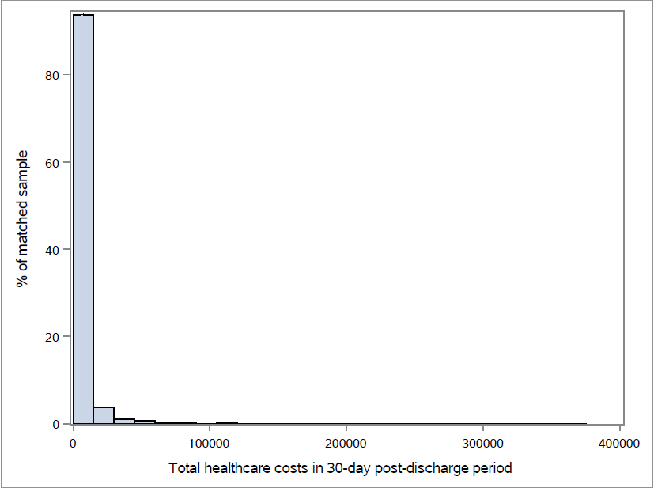

Figure S2. Histogram of 30-day inpatient readmission costs for the total matched sample.
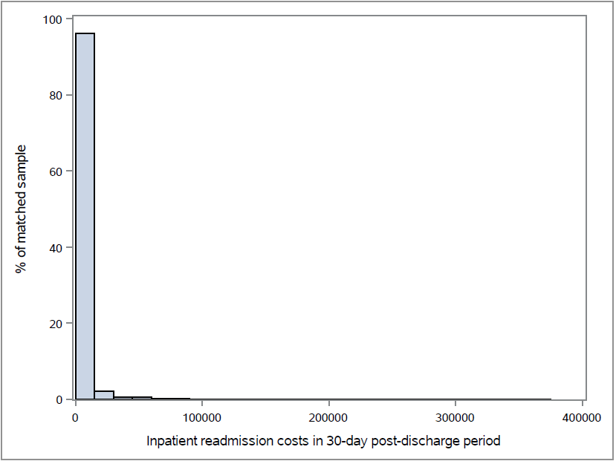

Figure S3. Histogram of 30-day emergency department visit costs for the total matched sample.
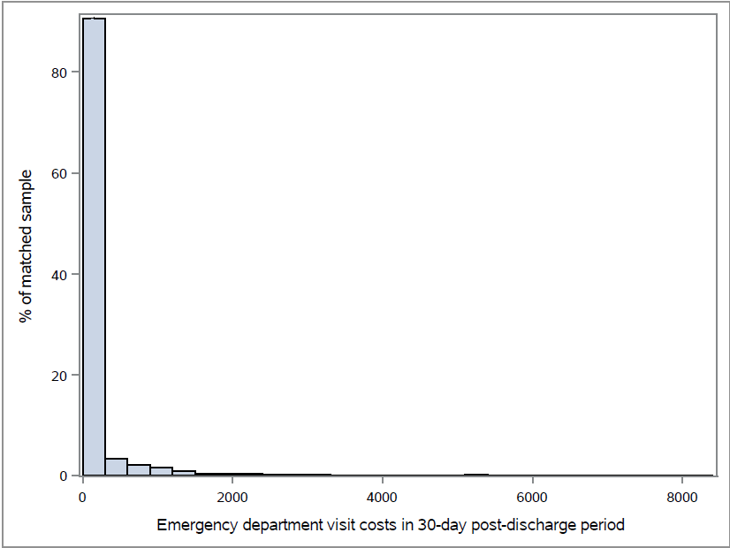

Figure S4. Histogram of 30-day physician office visit costs for the total matched sample.
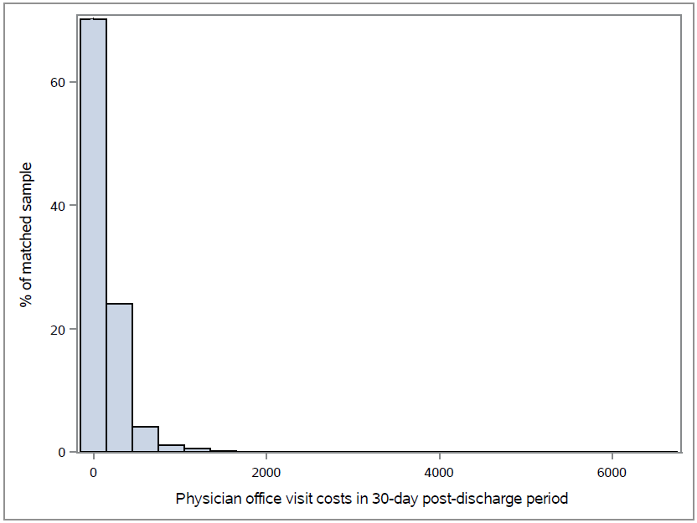

Figure S5. Histogram of 30-day non-physician outpatient encounter costs for the total matched sample.
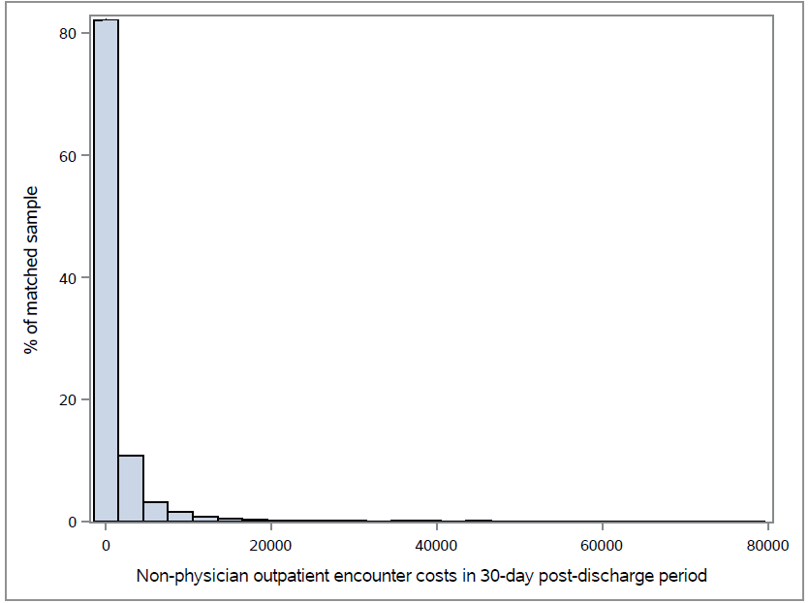

Figure S6. Histogram of 30-day prescription drug fill costs for the total matched sample.
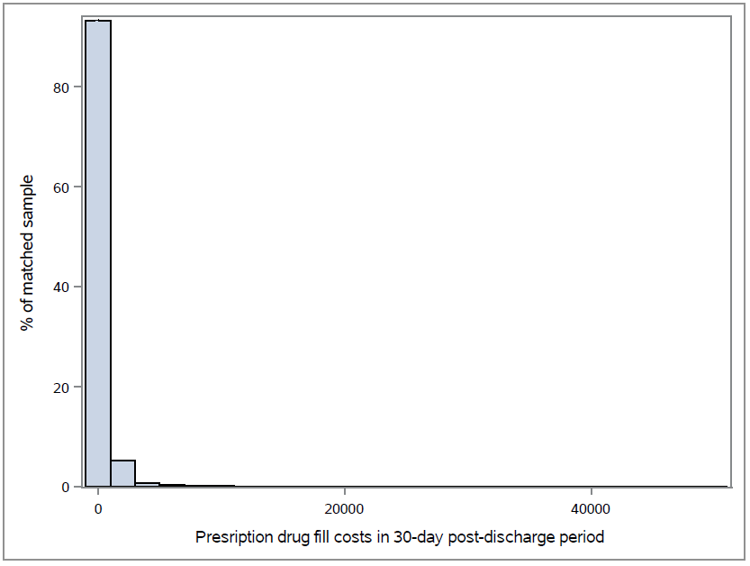

Figure S7. Consort diagram displaying study inclusion and exclusion criteria for the study sample.
*Other hospitalizations include those that resulted in in-hospital deaths, discharge to a short-term hospital, skilled nursing facility, intermediate care facility or any other type of facility
†Continuous eligibility definition: 7 months of continuous medical and prescription drug insurance enrollment (6 months prior through 1-month post index hospitalization)

