A) | B)
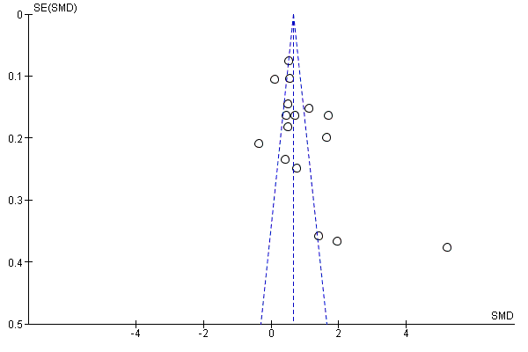 | 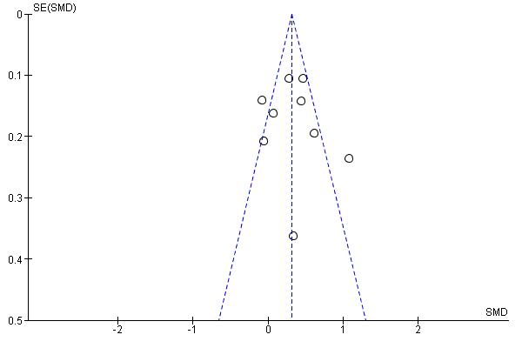
C)
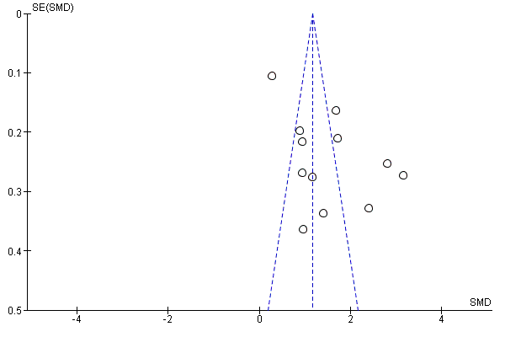

Supplementary Figure 1: Funnel plot of biomarkers and Alzheimer’s Diseases A). Blood neurofilament light as diagnostic biomarker of Alzheimer’s Disease; B). Blood Total-tau as diagnostic biomarker of Alzheimer’s Disease; C). Blood Phosphorylated tau diagnostic biomarker of Alzheimer’s Disease.

