Supplementary Material

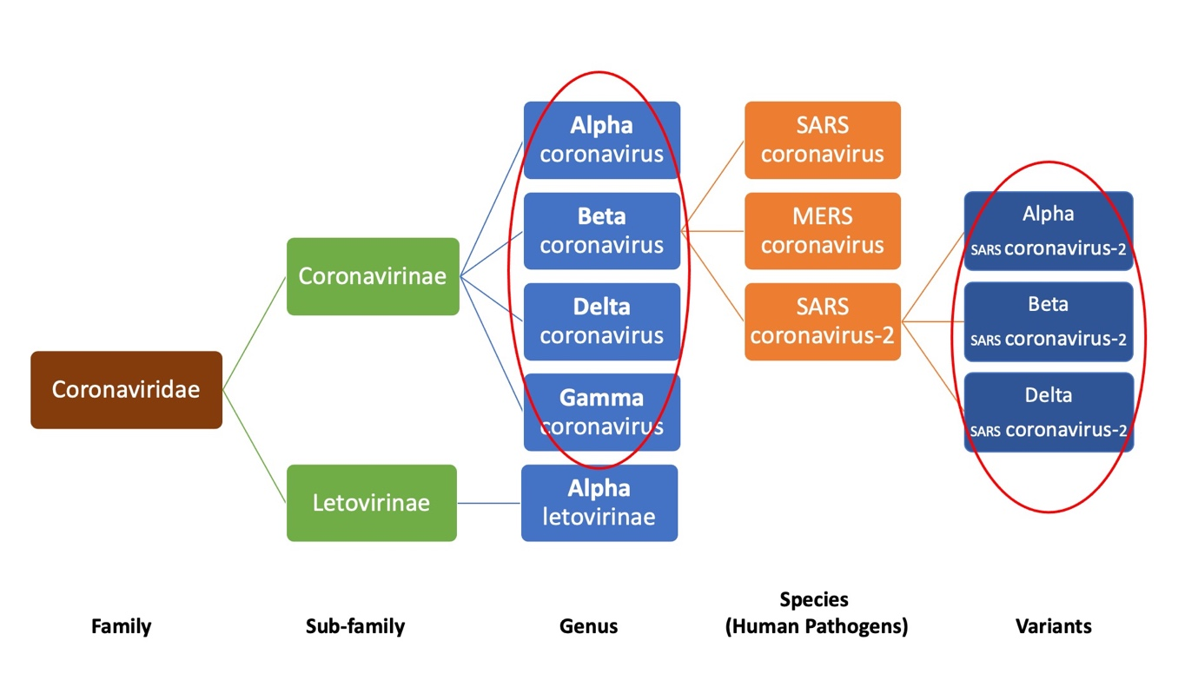
Figure S1: Classification of coronaviruses. Illustration of how the new names of the variants are causing confusion with names assigned to genera in the family Coronaviridae

Table S1: Details of the authorized/approved vaccines against COVID-19
S.No | Name | Vaccine type | Primary developer | Country or Origin | Authorization type
 | Comirnaty (BNT162b2) | mRNA-based vaccine | Pfizer, BioNTech; Fosun Pharma | Multinational | WHO
 | Moderna COVID‑19 Vaccine (mRNA-1273) | mRNA-based vaccine | Moderna, BARDA, NIAID | US | WHO
 | AstraZeneca (AZD1222); aka Vaxzevria and Covishield | Adenovirus vaccine | BARDA, OWS | UK | WHO
 | Sputnik V | Recombinant adenovirus vaccine (rAd26 and rAd5) | Gamaleya Research Institute, Acellena Contract Drug Research and Development | Russia | Various countries*
 | Sputnik Light | Recombinant adenovirus vaccine (rAd26) | Gamaleya Research Institute, Acellena Contract Drug Research and Development | Russia | Various countries*
 | Janssen (JNJ-78436735; Ad26.COV2.S) | Non-replicating viral vector | Janssen Vaccines (Johnson & Johnson) | The Netherlands, US | WHO
 | CoronaVac | Inactivated vaccine (formalin with alum adjuvant) | Sinovac | China | WHO
 | BBIBP-CorV | Inactivated vaccine | Beijing Institute of Biological Products; China National Pharmaceutical Group (Sinopharm) | China | WHO
 | EpiVacCorona | Peptide vaccine | Federal Budgetary Research Institution State Research Center of Virology and Biotechnology | Russia | Various countries*
 | Convidicea (PakVac, Ad5-nCoV) | Recombinant vaccine (adenovirus type 5 vector) | CanSino Biologics | China | Various countries*
 | Covaxin (BBV152) | Inactivated vaccine | Bharat Biotech, ICMR; Ocugen; ViroVax | India | Various countries*
 | WIBP-CorV | Inactivated vaccine | Wuhan Institute of Biological Products; China National Pharmaceutical Group (Sinopharm) | China | China
 | CoviVac | Inactivated vaccine | Chumakov Federal Scientific Center for Research and Development of Immune and Biological Products | Russia | Russia
 | ZF2001 (ZIFIVAX) | Recombinant vaccine | Anhui Zhifei Longcom Biopharmaceutical, Institute of Microbiology of the Chinese Academy of Sciences | China, Uzbekistan | China, Uzbekistan
 | QazVac (QazCovid-in) | Inactivated vaccine | Research Institute for Biological Safety Problems | Kazakhstan | Kazakhstan
 | Unnamed vaccine candidate | Inactivated vaccine | Minhai Biotechnology Co.; Kangtai Biological Products Co. Ltd. | China | China
 | COVIran Barekat | Inactivated vaccine | Shifa Pharmed Industrial Group | Iran | Iran
 | Unnamed vaccine candidate | Inactivated vaccine | Chinese Academy of Medical Sciences, Institute of Medical Biology | China | China
 | Abdala (CIGB 66) | Protein subunit vaccine | Center for Genetic Engineering and Biotechnology | Cuba | Cuba
 | Soberana 02 | Conjugate vaccine | Finlay Institute of Vaccines; Pasteur Institute | Cuba, Iran | Cuba, Iran
 | MVC-COV1901 | Protein subunit vaccine | Medigen Vaccine Biologics Corp.; Dynavax | Taiwan | Taiwan
*The information about different countries could be found on this website which was used for the data in this table (https://www.raps.org/news-and-articles/news-articles/2020/3/covid-19-vaccine-tracker).

