Supplemental Digital Content

Figure A1. Pooled odds ratios and 95% confidence intervals for in-hospital mortality across 1,000 simulations for the Missing at Random (MAR) and Missing Not at Random (MNAR) missing data mechanisms at 10%, 20%, and 30% missing SOFA score variables
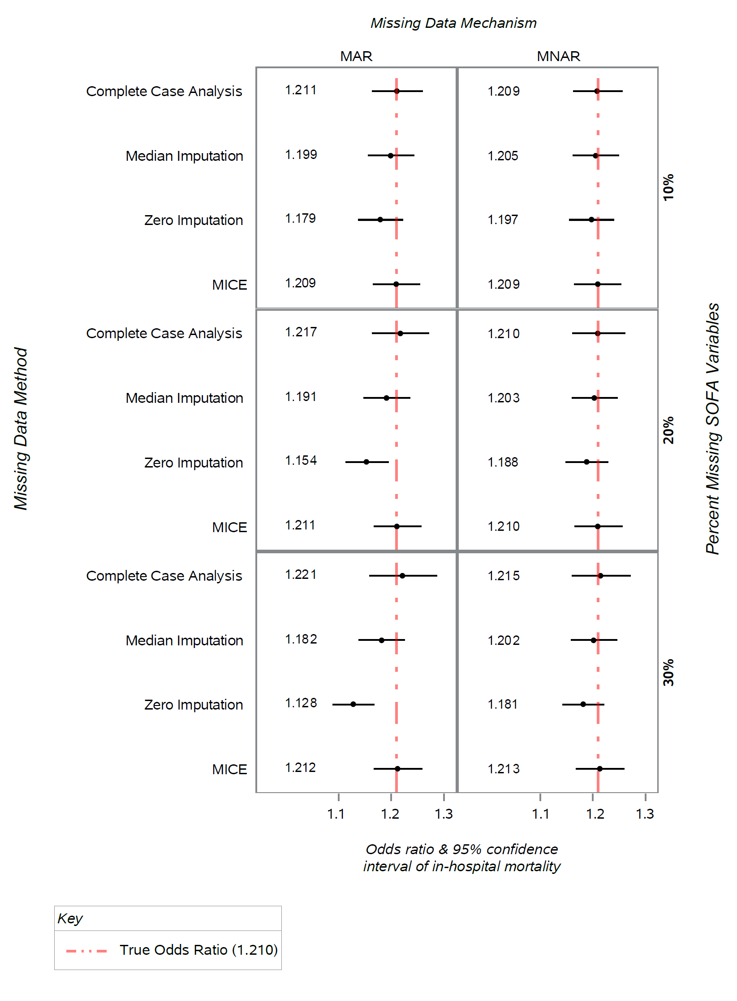
Figure A2. Comparison of relative bias of parameter estimates of the SOFA score among the methods for handling missingness at the composite-level in the logistic regression model predicting Death, with the MAR missing data mechanism
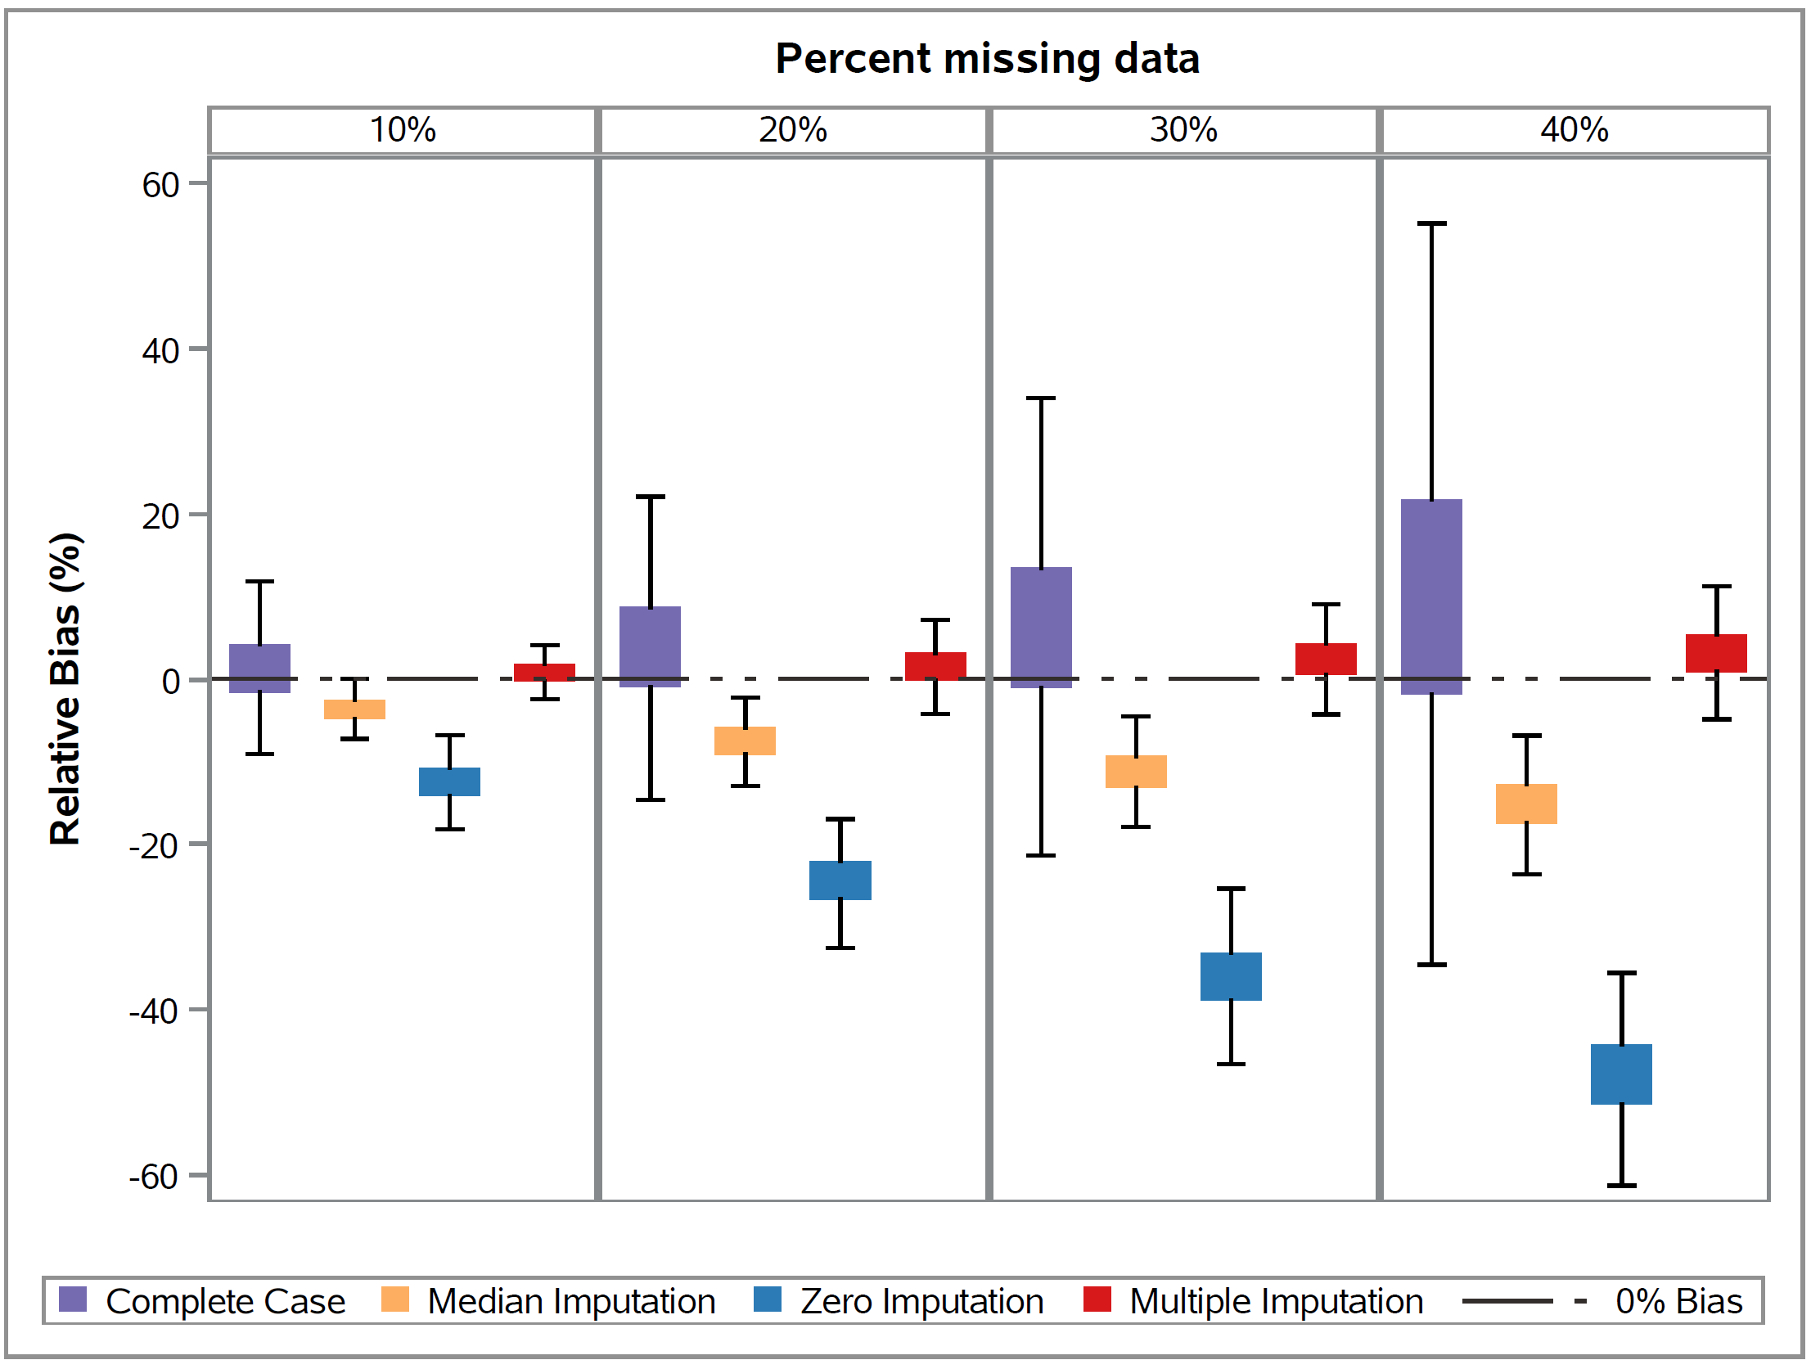

Figure A3. Comparison of relative bias of parameter estimates of the SOFA score among the methods for handling missingness at the composite-level in the logistic regression model predicting Death, with the MNAR missing data mechanism
