Supplementary Materials
Supplemental Methods
Cell Line and Cell Culture
The cytotoxicity of Dox@Rg1 nanoparticles was assessed with MCF-7 tumor cells (human breast cancer cells), 4T1 tumor cells (murine breast cancer cells) and H9c2 cardiomyocytes (rat BDIX heart myoblasts), which were obtained from the American Type Culture Collection (USA). All cells were kept at 37 °C in a 5% CO₂ incubator and cultured in RPMI 1640 culture medium (Gibco) or DMEM culture medium (Gibco) supplemented with 10% fetal bovine serum (Gibco) and 1% penicillin-streptomycin solutions (HyClone).

Reactive oxygen species (ROS) measurements
After a 24 h preculture, the H9c2 cells seed in glass bottom cell culture dishes were incubated with Dox or Dox@Rg1 nanoparticles for 24 h. After the medium discarded, the cells were washed with PBS for three times. After fixed with 4% PFA and washed with PBS, the cells were incubated with ROS specific fluorescent probe dye (DCFH-DA, Nanjing Jiancheng Bioengineering Research Institute, China) at the concentration of 10 μM for 30 min at 37 °C. At last, the cells were washed with PBS and the DCF fluorescence was detected at the excitation and emission wavelengths (ex/em) of 500 nm and 530 nm, respectively.

Mitochondria membrane potential measurements
The H9c2 cells seed in glass bottom cell culture dishes (5,000 cells/well) and incubated with Dox or Dox@Rg1 nanoparticles for 24 h. After the medium discarded, the cells were washed with PBS. Then cells were further fixed with 4% PFA for about 10 min. After the PFA discarded, the cells were washed with PBS. The mitochondrial membrane potential of H9c2 cells and the apoptotic cells were determined using the kit (Beyotime Institute of Biotechnology, China). In brief, the cells were added with 188 μl Annexin V-FITC combination solution and 5 μl Annexin V-FITC. After shaken gently, the cells were next incubated with 2 μl Mito-Tracker Red CMXRos staining solution for about 30 min and 200 μl DAPI for about 10 min. The apoptotic cells, total cell nuclei and mitochondria were labeled with Annexin V-FITC (ex/em: 492/520 nm), DAPI (ex/em: 402/461 nm) and Mito-Tracker Red CMXRos (ex/em: 579/599 nm), respectively. The cells were washed with PBS and analyzed with a fluorescence microscope. The extent of cell apoptosis was defined as the ratio of Annexin-stained positive nuclei to DAPI-stained nuclei. The relative fluorescence intensities of Mito-Tracker Red CMXRos in the obtained images were calculated using the Image J software.

TdT-mediated dUTP nick end-labelling (TUNEL) staining
Cell apoptosis was qualitatively analyzed with the One Step TUNEL Apoptosis Assay Kit (Beyotime Institute of Biotechnology, China). In brief, after incubated with free Dox or Dox@Rg1 nanoparticles (1 μM) for 24 h, the cells were washed with PBS gently for three times. Then the cells were permeabilized with 4% PFA for about 30 min and washed with PBS. The cells were next treated with Enhanced Immunostaining Permeabilization Buffer (Beyotime Institute of Biotechnology, China) for about 5 min and washed with PBS for three times. Then the cells were incubated with TUNEL (ex/em: 450/515 nm) reaction mixture for 60 min at 37 °C and washed with PBS. In addition, the total cell nuclei of cells was labeled with DAPI for 10 min and washed with PBS. The fragmented DNA was coloured green with dUTP (fluorescein-dUTP) and the total nuclei was labeled with DAPI. The cell apoptosis level was defined as the ratio of TUNEL positive nuclei to DAPI-stained nuclei.

Caspase-3 activity determination
The caspase-3 activity of the cells was measured with a Caspase-3 Activity Assay Kit (Beyotime Institute of Biotechnology, China) as follows. The cells were homogenized after the free-Dox or Dox@Rg1 nanoparticles treated for 24 h, and then 50 μl of total protein was loaded and incubated with proper Ac-DEVD-pNA at 37 °C for 90 min. Caspase-3 cleaved pNA from DEVD and the free pNA was quantified with a microplate reader (Epoch BioTek Gene Company Limited) at 405 nm.

Protein extraction and quantification
After treated with free Dox or Dox@Rg1 nanoparticles (1 μM) for 24 h, the culture medium of cells was removed and washed with PBS for three times carefully. The lysate solution (100 μl) with PMSF as protease inhibitor (dilutions of 1:100) was added into each well of the 6-well plate for the cell lysis. After treated for about 30 min, the mixture was collected and centrifuged for 10 min with 12000 rpm/min. At last, the supernatant obtained was the extracted protein, which was quantified by BCA protein assay kit for the Western Blot experiment (Beyotime Institute of Biotechnology, China).

In vivo distribution
Briefly, the dissected tumor and major organ tissues from 4T1 tumor-bearing mice were fixed with 4% PFA and embedded in paraffin. The tissues were sectioned at 4 μm and the slides were fixed and dehydrated. The Dox and Dox@Rg1 nanoparticles distribution in the sliced tissues was detected with a fluorescence microscope (Nikon, Japan). In addition, the sliced tissues were also stained with haematoxylin and eosin (HE) for the morphology observations.

Morphology observations
The heart tissue was cut into the size about 1-2 mm³ and fixed in 2.5% lutaraldehyde for 4 h and 1% osmic acid for 1 h, respectively. The tissue was next dehydrated by ethanol, step by step, at last covered with epoxy resin. Then the sections was cut into approximately 70 nm thick and stained with lead citrate to be observed by a transmission electron microscopy (Hitachi, Japan). The remaining tissue was fixed in 4% PFA solution and carried out the conventional paraffin embedding, which was cut into the sections of 4 μm thickness. The sections was performed for the HE and Masson trichrome staining, and the morphological structure was observed using a microscope (Olympus, Japan). The major organs, such as the liver, kidney and spleen were all also subjected to HE staining.

Supplemental Data
Table S1 Design and results of formula optimization of Dox@Rg1 nanoparticles
Mixing ratio (mDox:mRg1) | Size (nm) | PDI | Kcps | EE%
1:4 | 2554.33±32.36 | 0.54±0.05 | 199.57±36.04 | -----
1:6 | 2832.67±265.85 | 0.30±0.02 | 173.57±9.24 | -----
1:12 | 215.63±8.23 | 0.20±0.05 | 335.70±18.38 | 83.33±0.04

Table S2 The characterization of Dox@Rg1 nanoparticles after different process.
Process | Size (nm) | PDI | Kcps
Mixed | 215.63±8.23 | 0.20±0.05 | 335.70±18.38
lyophilized | 384.63±8.58 | 0.59±0.09 | 327.53±40.88
Ultrasonic | 264.87±9.86 | 0.20±0.05 | 325.67±3.32

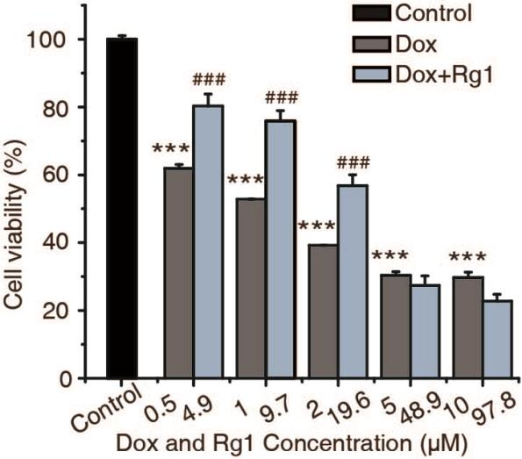

Figure S1 The cell viability of H9c2 cells treated with different concentration of Dox and Rg1 (0.5 μM Dox + 4.9 μM Rg1; 1 μM Dox + 9.7 μM Rg1; 2 μM Dox +19.6 μM Rg1; 5 μM Dox + 48.9 μM Rg1; 10 μM Dox + 97.8 μM Rg1), ***p<0.001, compared with control group; ###p<0.001, compared with Dox treated group.

Figure S2 (A) Fluorescence images of dissected heart tissues from saline-, free Dox or Dox@Rg1 nanoparticles treated 4T1 tumor-bearing mice (red colour=Dox channel). (B) Fluorescence images of dissected tumor tissues from saline, free Dox or Dox@Rg1 nanoparticle treated 4T1 tumor-bearing mice.

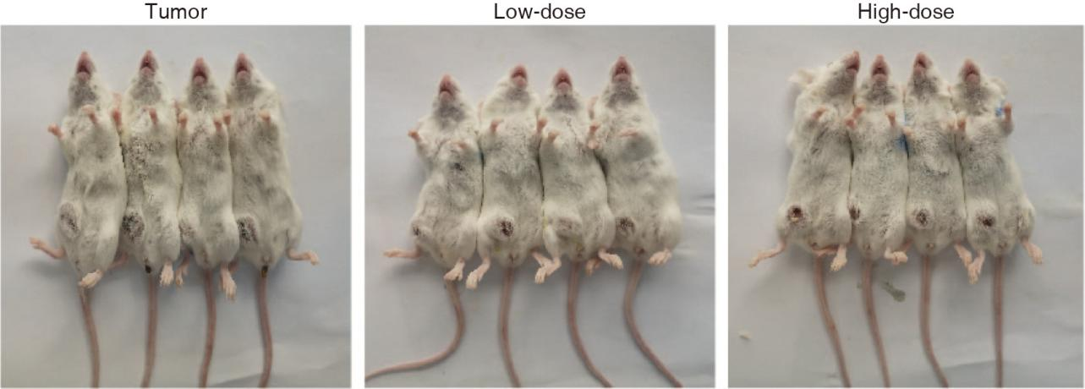
Figure S3 Images of the 4T1 tumor-bearing mice after 15 days post-treatment of Dox@Rg1 nanoparticles.

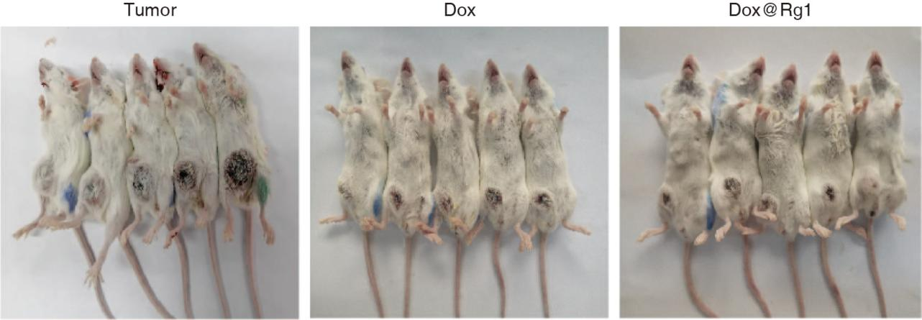
Figure S4 Images of 4T1 tumor-bearing mice after 15 days post-treatment of free Dox and Dox@Rg1 nanoparticles.

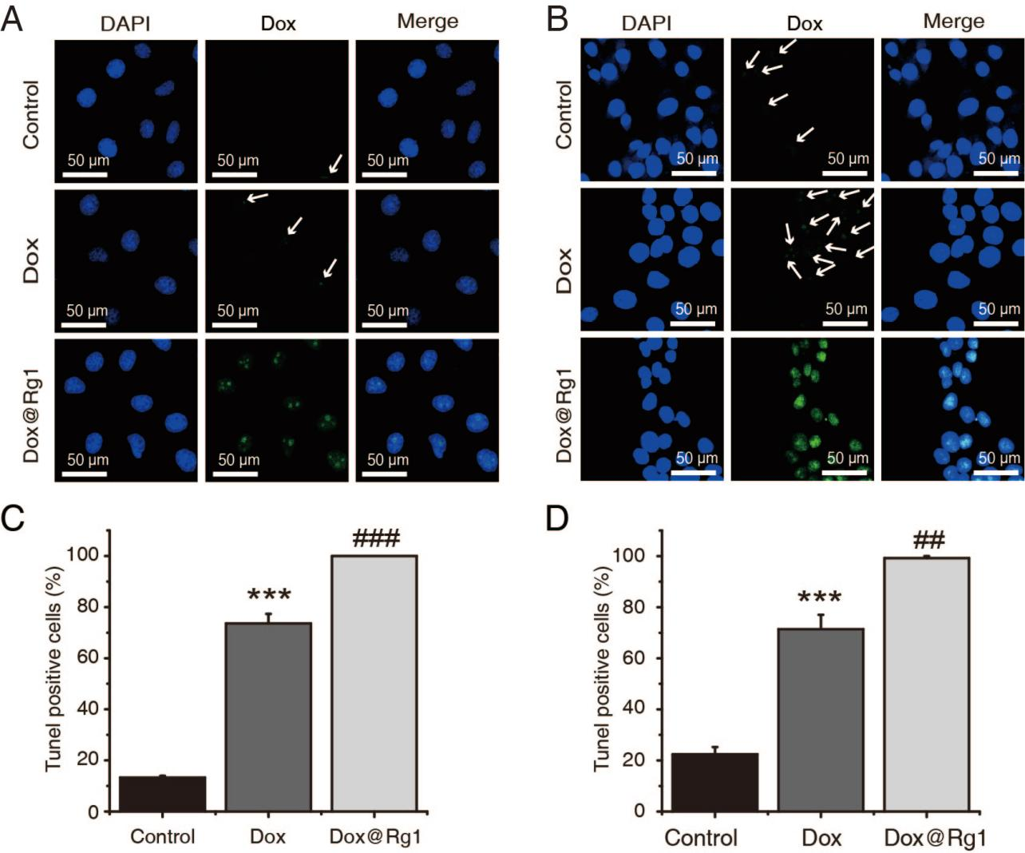

Figure S5 (A) Representative images of TUNEL staining on MCF-7 tumor cells, the apoptotic cells were visualized by green fluorescence and the nuclei were identified as blue with DAPI. (B) Representative images of TUNEL staining on 4T1 tumor cells, the apoptotic cells were visualized by green fluorescence and the nuclei were identified as blue with DAPI. (C) The quantitative analysis of apoptotic cells by TUNEL staining. (D) The quantitative analysis of apoptotic cells by TUNEL staining. ***p<0.001, compared with the control group; ###p<0.001 or ##p<0.01, compared with Dox-treated group.

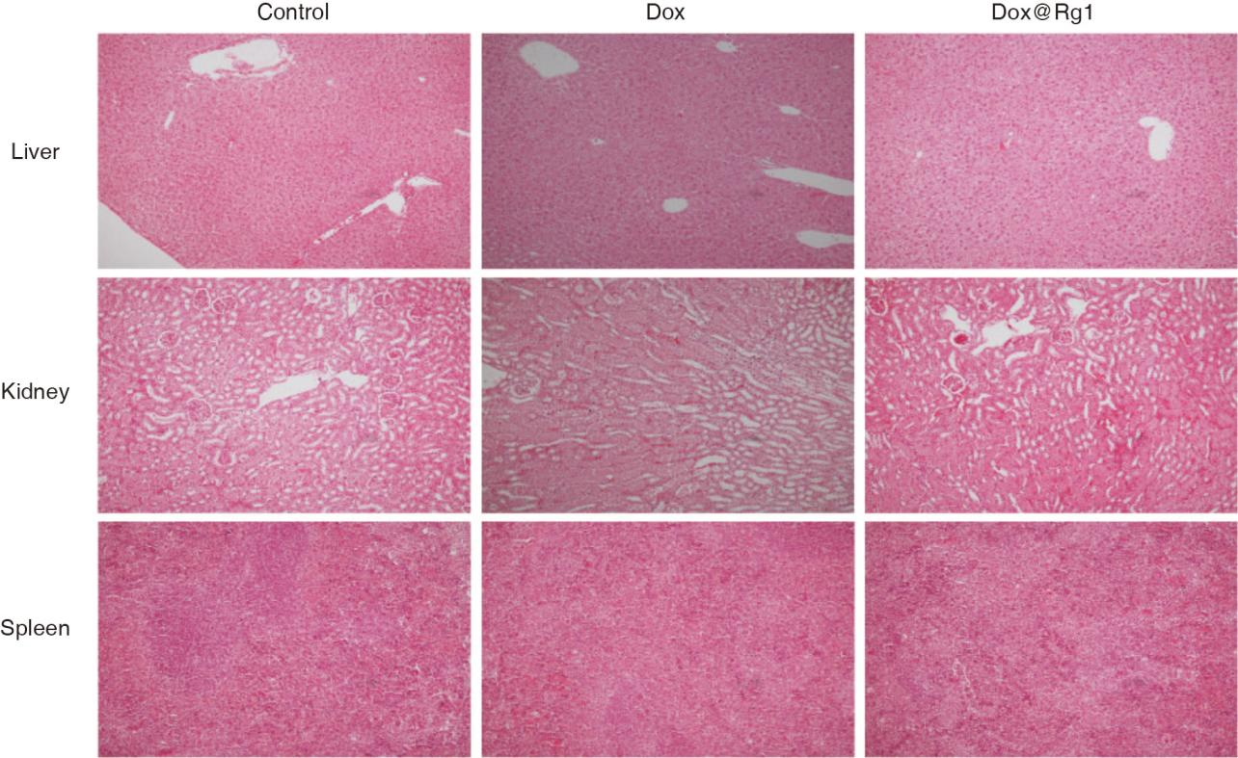
Figure S6 Representative images of HE staining of liver, kidney and spleen of mice in different group (×100).

