**Table 1 Supplementary Material.** Study with mono-immunotherapy in first line in NSCLC: CheckMate 026 and Keynote 024

|  |  |  |  |
| --- | --- | --- | --- |
|  | | **CheckMate 026**[1] | **Keynote 024**[2] |
| Phase | | III | III |
| Time to enrolment | | March 2014 – April 2015 | Sept 2014 – Oct 2015 |
| Patients | Number | 530 | 305 |
| Characteristics | Stage IV or recurrent NSCLC, SQ or nSQ; no sensitizing EGFR mut or ALK trasl, | Stage IV NSCLC, SQ or nSQ, no sensitizing EGFR mut or ALK trasl, PD-L1 ≥50% |
| Median age (range) | 63 (32-89) (11% ≥ 75 yr) | 64,5 (33-90) |
| M/F (%) | 68/32 | 59,7/40,3 |
| BMI | NA | NA |
| EGFR / ALK (%) | 0 | 0 |
| Intervention | | **Nivolumab** 3 mg/kg q2w | **Pembrolizumab** 200 mg q3w iv for 35 cycles |
| Comparison | | Investigator’s choice of platinum doublet chemotherapy q3w for 4 to 6 cycles | Investigator’s choice between one of:  - CBDCA + pemetrexed  - CDDP + pemetrexed  - CBDCA + gemcitabine  - CDDP + gemcitabine  - CBDCA + paclitaxel  for 4 to 6 cycles |
| Outcome | OS | mOS: 14,4 (11,7-17,4) vs 13,2 (10,7-17,1), HR 1,02 (0,80-1,30) | mOS NR in either group; HR 0,60 (0,41-0,89), p = 0,005 |
| PFS | Primary end-point  mPFS: 4,2 (95% CI 3,0-5,6) vs 5,9 (5,4-6,9) mo; HR 1,15 (0,91-1,45), p =0,25 | Primary end point  10,3 (6,7-NR) vs 6,0 (4,2-6,2); HR 0,50 (0,37-0,68), p <0,001 |
| RR | Among pts with PD-L1 ≥5%: 26% vs 33% | 44,8% (36,8-53,0) vs 27,8 (20,8 – 35,7) |
| Tox | Any grade: 71% vs 92%  G3-4: 18% vs 51% | Any grade: 73,4% vs 90,0%  G3-5: 26,6% vs 53,3% |
| Tox IT:  Fatigue  Diarrhea  Decrease appetite  Nausea  Rash  Vomiting  Constipation  Anemia  Asthenia  Hypothyroidism  Hyperthyroidism  Pneumonitis  Colitis  Myositis  Hypophysitis  Nephritis  Pancreatitis | any - G3-4 (%)  21 - 1  14 - 1  12 - <1  12 - <1  10 - 1  15 - 1  3 - 0  3 - <1  3 – 0  NA  NA  NA  NA  NA  NA  NA  NA | any - G3-5 (%)  10,4 – 1,3  14,1 – 3,9  9,1 – 0  9,7 – 0  3,9 – 3,9 (severe skin react)  2,6 – 0,6  3,9 – 0  5,2 – 1,9  NA  9,1 – 0  7,8 – 0  5,8 – 2,6  1,9 – 1,3  1,9 – 0  0,6 – 0,6  0,6 – 0,6  0,6 – 0,6 |

Abbreviations: Squamous cell carcinoma (SQ), non squamous cell carcinoma (nSQ), male (M), female (F), body mass index (BMI), carboplatin (CBDCA), cisplatin (CDDP), not reached (NR), overall survival (OS), progression free survival (PFS), hazard-ratio (HR), response rate (RR), toxicities (tox), immunotherapy (IT), not available (NA), grade (G).

**Table 2 Supplementary Material.** Variation of blood exams and CT scan values from baseline to first re-staging°

|  |  |  |  |
| --- | --- | --- | --- |
|  | Total variation rate | Median of variation rate* | Median of variation rate/time |
| **Blood exams** (44 available) | | | |
| WBC | ↑ | 1,3 % | 1,1% |
| RDW | ↑ | 2,8 % | 1,4% |
| Albumin | = | 0 | 1% |
| **CT scan values** (34available) | | | |
| SMI | ↓ | -3,1 % | -1,3% |
| MA | ↓ | -2,0 % | -0,8% |
| SFI | ↓ | -6,7 % | -2,5% |
| VFI | = | +0,3 % | -0,1% |
| VSR | ↑ | +5,5 % | +2,0% |

°First re-staging: CT scan of first revaluation (obtained a median of 2,5 months after starting treatment, 95% CI 2-3 months, standard deviation 0,99); blood exams in the same period of the first CT scans or earlier if patient did not undergo any imaging revaluation

* variation rate = (value at time of first revaluation – value at baseline) x 100 / value at baseline

↑ increase; ↓ decrease; = stable

**Table 3 Supplementary Material**. Correlation between different characteristics of patients

|  |  |  |  |  |  |  |  |  |  |  |  |  |  |  |  |  |  |  |  |  |
| --- | --- | --- | --- | --- | --- | --- | --- | --- | --- | --- | --- | --- | --- | --- | --- | --- | --- | --- | --- | --- |
|  |  | Age | BMI | PNI | GNRI | albumin | CAR | SII | ALI | mALI | NLR | PLR | WBC | CRP | Psaos area | SMI | Total MA | IMAC psoas | SFI | VFI |
| BMI | P value  R Sp. | 0,8458  0,0302 |  |  |  |  |  |  |  |  |  |  |  |  |  |  |  |  |  |  |
| PNI | P value  R Sp. | 0,0663  -0,329 | 0,6548  0,0822 |  |  |  |  |  |  |  |  |  |  |  |  |  |  |  |  |  |
| GNRI | P value  R Sp. | 0,0236  -0,182 | <0,0001  0,577 | <0,0001  0,805 |  |  |  |  |  |  |  |  |  |  |  |  |  |  |  |  |
| Albumin | P value  R Sp. | 0,1563  -0,217 | 0,8756  0,0243 | <0,0001  0,936 | <0,0001  0,774 |  |  |  |  |  |  |  |  |  |  |  |  |  |  |  |
| CAR | P value  R Sp. | 0,2605  -0,190 | 0,5946  -0,0904 | <0,0001  -0,695 | 0,0004  -0,549 | <0,0001  -0,620 |  |  |  |  |  |  |  |  |  |  |  |  |  |  |
| SII | P value  R Sp. | 0,1696  -0,249 | 0,4095  -0,151 | 0,0066  -0,470 | 0,0043  -0,491 | 0,0031  -0,507 | 0,0015  0,571 |  |  |  |  |  |  |  |  |  |  |  |  |  |
| ALI | P value  R Sp. | 0,8681  0,0306 | 0,0518  0,347 | <0,0001  0,722 | <0,0001  0,773 | <0,0001  0,728 | 0,0002  -0,646 | <0,0001  -0,855 |  |  |  |  |  |  |  |  |  |  |  |  |
| mALI | P value  R Sp. | 0,8182  -0,0455 | 0,0817  0,335 | <0,0001  0,696 | <0,0001  0,739 | <0,0001  0,699 | 0,0014  -0,604 | <0,0001  -0,867 | <0,0001  0,966 |  |  |  |  |  |  |  |  |  |  |  |
| NLR | P value  R Sp. | 0,4926  -0,126 | 0,3601  -0,167 | 0,0025  -0,516 | 0,0051  -0,483 | 0,0032  -0,505 | 0,0102  0,478 | <0,0001  0,914 | <0,0001  -0,894 | <0,0001  -0,932 |  |  |  |  |  |  |  |  |  |  |
| PLR | P value  R Sp. | 0,7739  -0,0529 | 0,3538  -0,169 | 0,0210  -0,406 | 0,0343  -0,375 | 0,0856  -0,309 | 0,0194  0,439 | <0,0001  0,817 | 0,0001  -0,624 | 0,0004  -0,621 | <0,0001  0,675 |  |  |  |  |  |  |  |  |  |
| WBC | P value  R Sp. | 0,0002  -0,531 | 0,9670  -0,0064 | 0,2825  -0,196 | 0,1428  -0,225 | 0,0236  -0,341 | 0,0104  0,416 | <0,0001  0,691 | 0,0007  -0,568 | 0,0019  -0,562 | 0,0001  0,642 | 0,1863  0,240 |  |  |  |  |  |  |  |  |
| CRP | P value  R Sp. | 0,1530  -0,240 | 0,5956  -0,0902 | 0,0005  -0,612 | 0,0021  -0,490 | 0,0008  -0,530 | <0,0001  0,990 | 0,0030  0,541 | 0,0008  -0,597 | 0,0071  -0,524 | 0,0205  0,435 | 0,0268  0,418 | 0,0145  0,399 |  |  |  |  |  |  |  |
| Psoas area | P value  R Sp. | 0,8053  0,0402 | 0,3172  0,162 | 0,2412  0,225 | 0,0335  0,337 | 0,0826  0,278 | 0,2439  -0,209 | 0,1172  -0,297 | 0,1163  0,298 | 0,0219  0,431 | 0,1468  -0,276 | 0,1159  -0,298 | 0,7619  -0,0494 | 0,4060  -0,150 |  |  |  |  |  |  |
| SMI | P value  R Sp. | 0,5707  -0,0924 | 0,0055  0,431 | 0,2467  0,222 | 0,0089  0,408 | 0,4588  0,121 | 0,7902  0,0481 | 0,4260  -0,154 | 0,2169  0,236 | 0,0465  0,379 | 0,2429  -0,224 | 0,2769  -0,209 | 0,8128  0,0387 | 0,6490  0,0823 | 0,0002  0,548 |  |  |  |  |  |
| Total MA | P value  R Sp. | 0,0201  -0,366 | 0,1596  -0,227 | 0,0483  0,370 | 0,2994  0,168 | 0,0104  0,401 | 0,9602  0,00903 | 0,7051  -0,0734 | 0,2915  0,203 | 0,0824  0,334 | 0,2608  -0,216 | 0,6741  -0,0815 | 0,4889  0,113 | 0,6606  0,0794 | 0,0175  0,374 | 0,0420  0,323 |  |  |  |  |
| IMAC psoas | P value  R Sp. | 0,2650  0,181 | 0,0870  0,274 | 0,5066  -0,128 | 0,8829  0,0240 | 0,1431  -0,236 | 0,5781  -0,100 | 0,2828  -0,206 | 0,6711  0,0823 | 0,9768  0,00575 | 0,9671  -0,00801 | 0,2038  -0,243 | 0,5049  -0,109 | 0,4751  -0,129 | 0,3725  -0,145 | 0,2586  -0,183 | <0,0001  -0,727 |  |  |  |
| SFI | P value  R Sp. | 0,464  0,119 | <0,0001  0,738 | 0,5396  0,119 | 0,0025  0,466 | 0,8737  0,0259 | 0,1385  -0,263 | 0,1202  -0,295 | 0,0522  0,364 | 0,1181  0,302 | 0,2228  -0,234 | 0,1365  -0,283 | 0,5769  -0,0909 | 0,1366  -0,265 | 0,6036  0,0846 | 0,1551  0,229 | 0,0018  -0,479 | 0,0070  0,420 |  |  |
| VFI | P value  R Sp. | 0,1635  0,225 | <0,0001  0,638 | 0,9111  -0,0217 | 0,0368  0,331 | 0,5674  -0,0932 | 0,1255  -0,272 | 0,0168  -0,440 | 0,0179  0,436 | 0,0380  0,394 | 0,0388  -0,386 | 0,0145  -0,449 | 0,2600  -0,182 | 0,1128  -0,281 | 0,5726  0,0919 | 0,2512  0,186 | 0,0135  -0,388 | 0,0009  0,506 | <0,0001  0,689 |  |
| VSR | P value  R Sp. | 0,2094  0,203 | 0,2599  0,182 | 0,9858  -0,00345 | 0,6820  0,0668 | 0,6615  -0,0714 | 0,4029  -0,151 | 0,0211  -0,426 | 0,0371  0,389 | 0,0706  0,347 | 0,0187  -0,434 | 0,0342  -0,394 | 0,2284  -0,195 | 0,4435  -0,138 | 0,3629  0,148 | 0,7803  0,0455 | 0,4940  -0,111 | 0,0567  0,304 | 0,4539  0,122 | <0,0001  0,746 |

**Table 4 Supplementary Material**. Overall Survival Univariate analysis with baseline WBC, albumin, CRP and NLR considered as continuous variable and Multivariate analysis with WBC, albumin, SMI and VSR as continuous variables

|  |  |  |  |  |
| --- | --- | --- | --- | --- |
| 1. **Univariate analysis** | | | | |
|  |  | HR | 95% CI | p |
| **WBC** | Like continuous variable: from low to high | 2,73 | 1,27-5,86 | 0,010 |
| **Albumin** | Like continuous variable: from low to high | 0,55 | 0,29-1,06 | 0,073 |
| **CRP** | Like continuous variable: from low to high | 1,01 | 0,95-1,07 | 0,848 |
| **NLR** | Like continuous variable: from low to high | 1,81 | 0,76-4,32 | 0,179 |

|  |  |  |  |
| --- | --- | --- | --- |
| **B. Multivariate analysis** | | | |
|  | HR | 95% CI | p |
| **ECOG** | 1,21 | 0,70-2,10 | 0,497 |
| **WBC** | 5,20 | 1,89-14,31 | 0,001 |
| **Albumin** | 0,81 | 0,35-1,90 | 0,635 |
| **BMI** | 0,35 | 0,11-1,14 | 0,082 |
| **SMI** | 0,99 | 0,97-1,02 | 0,569 |
| **VSR** | 1,91 | 0,96-3,78 | 0,064 |



p = 0,09



p = 0,06

**Figure 1 Supplementary Material.** Kaplan-Meier Overall Survival curves according to SFI and CRP variation

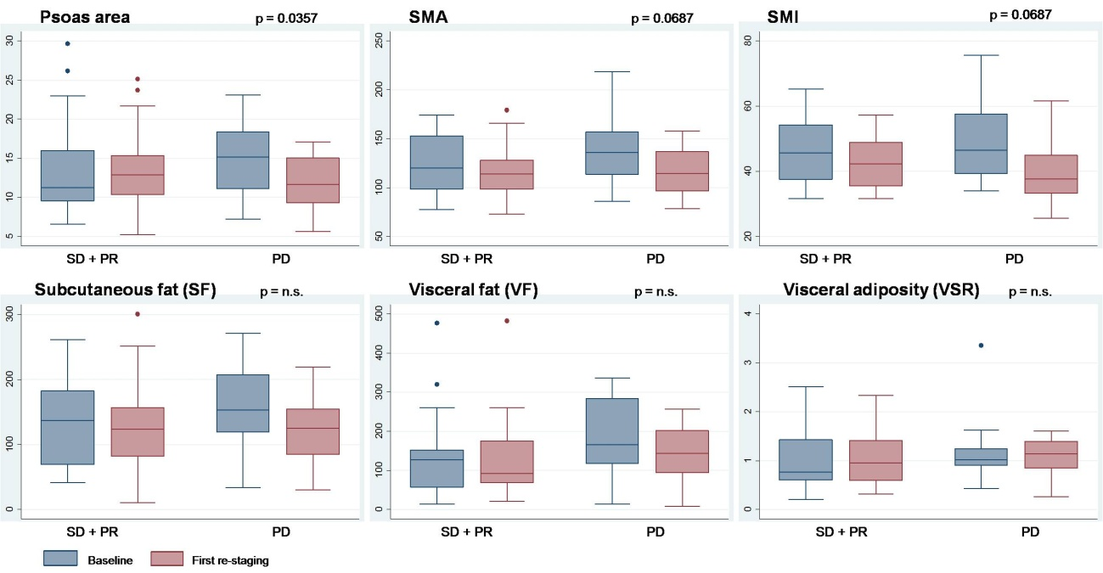

**Figure 2 Supplementary Material.** Selected CT scan parameters (3 for muscle mass and 3 for adipose tissue) in relation with response, comparing values at baseline and first re-staging

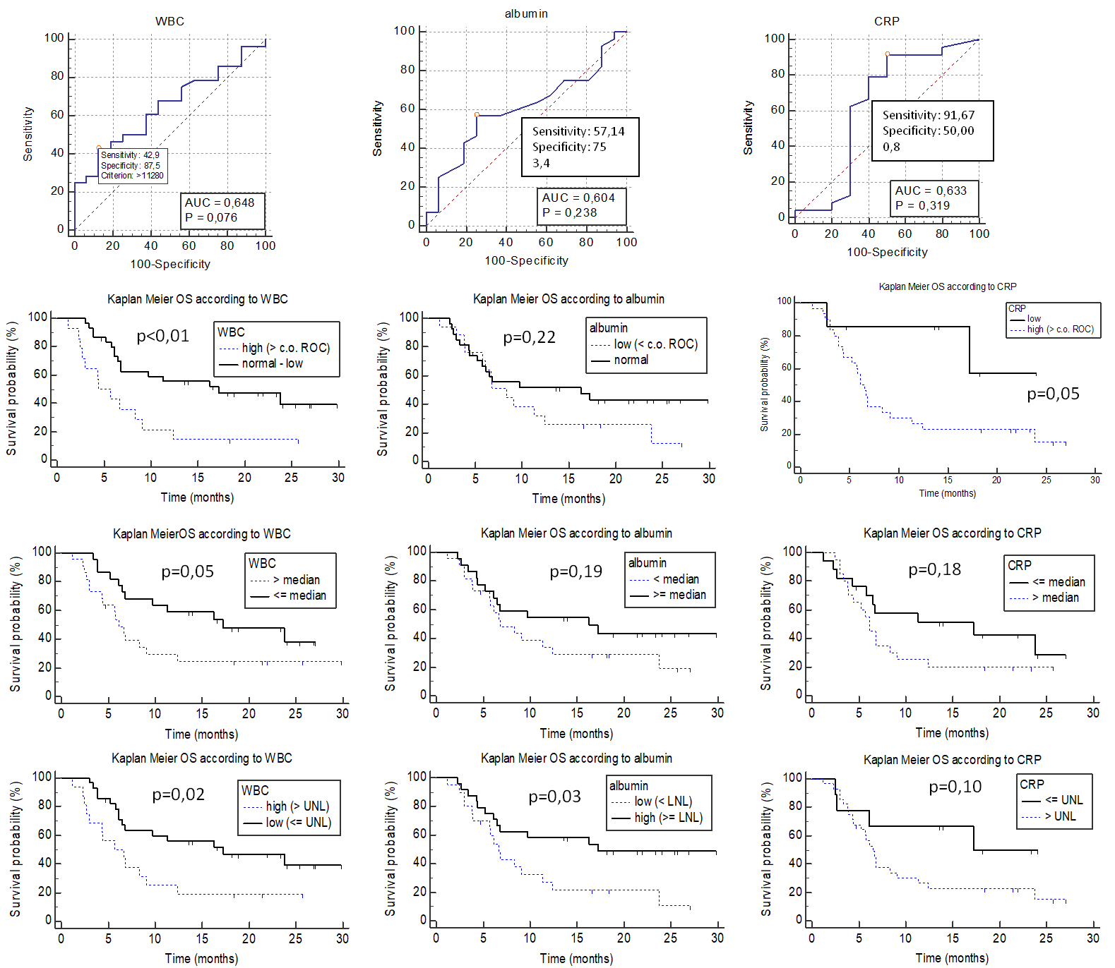

A1

B1

C1

A2

B2

C2

A3

B3

C3

A4

B4

C4

**Figure 3 Supplementary Material:** ROC curves and Kaplan Meier (KM) Overall Survival curves according to selected parameters. A: white blood cell (WBC), B: albumin, C: C-reactive protein (CRP). 1: ROC curves; 2: KM curves divided with cut-offs derived from ROC curves, 3: KM curves divided with median, 4: KM curves divided with selected cut-offs (upper normal limit (UNL) or low normal limit (LNL).

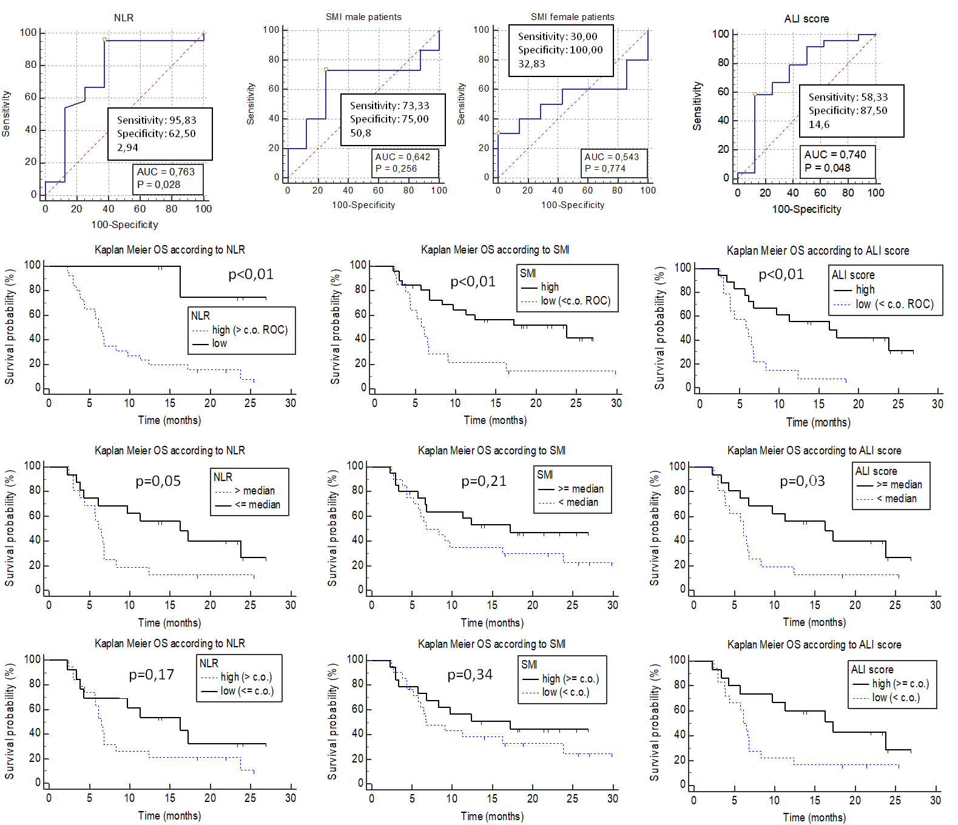

D1

E1

F1

D2

E2

F2

D3

E3

F3

D4

E4

F4

**Figure 4 Supplementary Material:** ROC curves and Kaplan Meier (KM) Overall Survival curves according to selected parameters. D: Neutrophil-to-lymphocyte ratio (NLR), E: Skeletal Muscle Index (SMI), F: Advance lung cancer inflammation index (ALI score). 1: ROC curves; 2: KM curves divided with cut-offs derived from ROC curves, 3: KM curves divided with median, 4: KM curves divided with selected cut-offs derived from literature (c.o.).

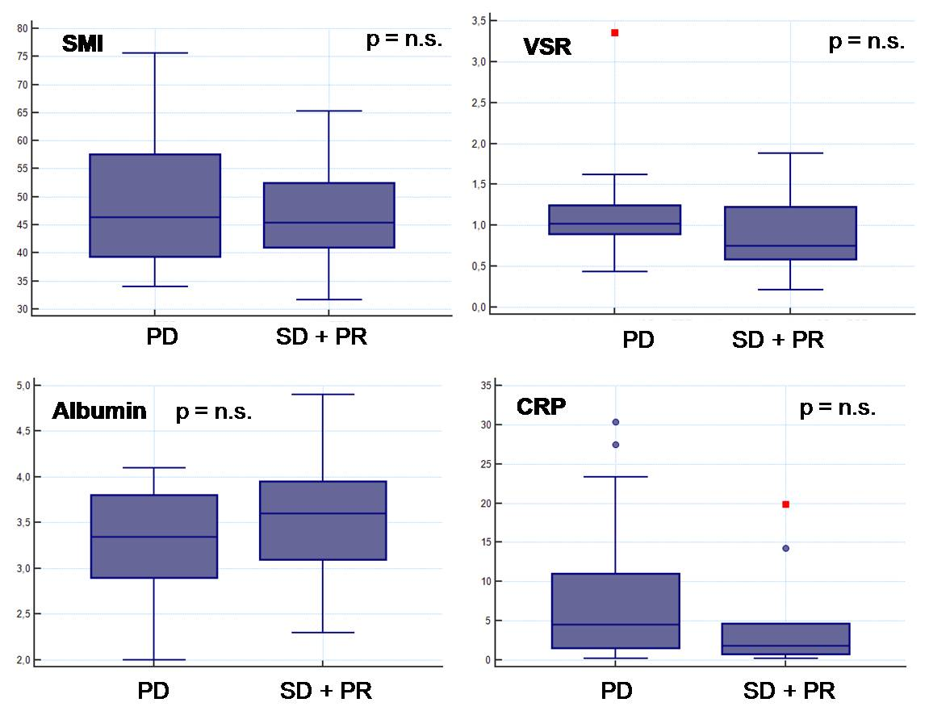

**Figure 5 Supplementary Material.** SMI, VSR, albumin and CRP at baseline in relation with response in our patients.

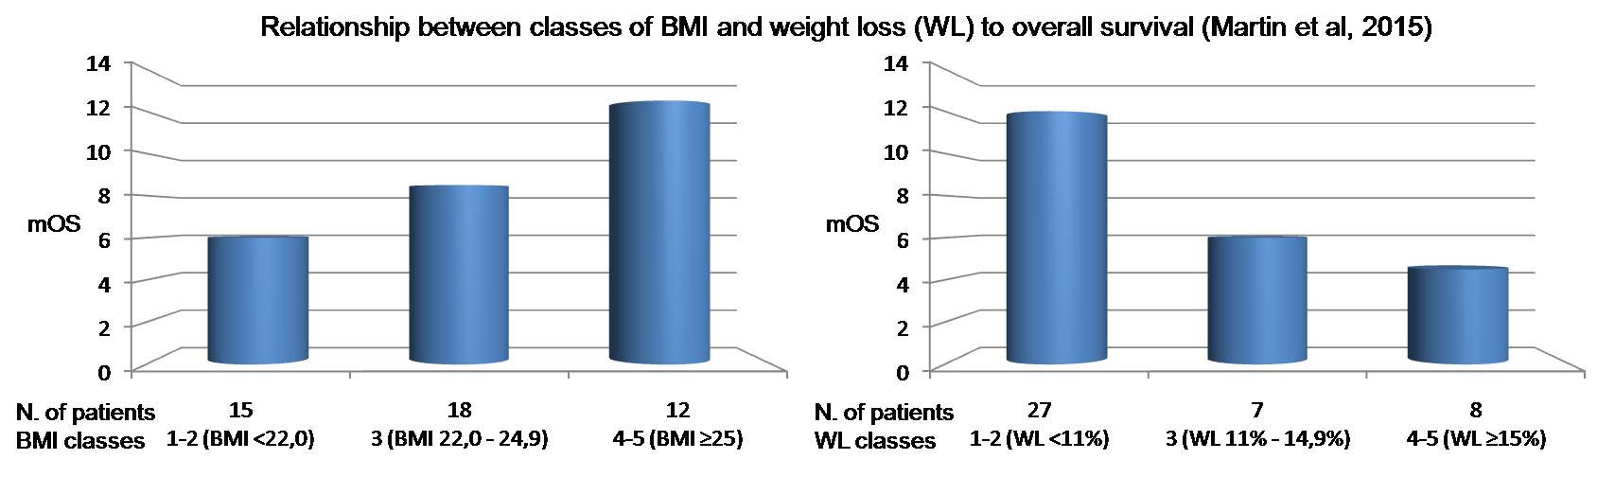

**Figure 6 Supplementary Material.** Relationship between classes of BMI and weight loss and mOS in our patients