Supplemental Materials
Supplemental Figure 1. Kaplan–Meier curves of time to first SSE after the start of second-line therapy. (A) Radium-223 cohort. (B) Alternative NHT cohort.
CI, Confidence interval; NE, Not estimable; NHT, Novel hormonal therapy; SSE, Symptomatic skeletal event.
A
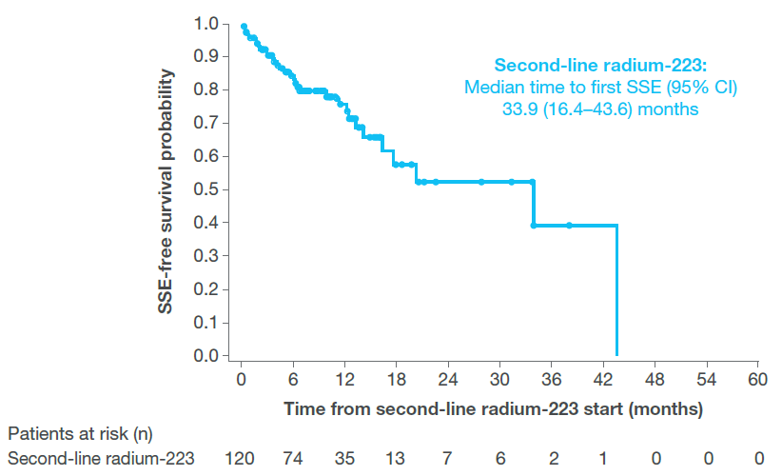
B
