Supporting Information (SI)

Enhanced therapeutic efficacy of a novel self-micellizing nanoformulation loading fisetin on acetaminophen-induced liver injury

Running title: Fisetin formulation with glycyrrhizin as nanocarrier for liver injury

Hui Yang^{1,2}, Qilong Cao³, Zhixin Yuan³, Xianggen Wu^{1*}, Mengshuang Li^{1,2*}
1 College of Chemical Engineering, Qingdao University of Science and Technology, Qingdao, China;
2 Qingdao Women and Children’s Hospital, Qingdao 266034, China;
3 Qingdao Haier Biotech Co. Ltd, Qingdao, China.

*Correspondence:
Xianggen Wu, Department of Pharmacy, College of Chemical Engineering, Qingdao University of Science and Technology, Qingdao 266042, China. E-mail: wuxianggen@126.com; Phone/Fax: 0086-532-84023003
Mengshuang Li, Qingdao Women and Children’s Hospital, Qingdao, China. E-mail: 15563938493@163.com

SI Results and figures

Figure S1 Schematic illustration of the survival rate of mice in 72-h experimental period after expose of acetaminophen; n = 12. DG: dipotassium glycyrrhizinate; FIT: fisetin; DG-FIT: FIT-loaded self-micellizing nanosystem with DG as nanocarriers; i.p.: intraperitoneal.

Figure S2 Characterization of DG-FIT micelle changing profiles. (A) encapsulation efficiencies, (B) micelle size, (C) polydispersity index (PDI), and (D) zeta potential were tested as functions of different weight ratios of DG to FIT. DG: dipotassium glycyrrhizinate; FIT: fisetin; DG-FIT: FIT-loaded self-micellizing nanosystem with DG as nanocarriers.

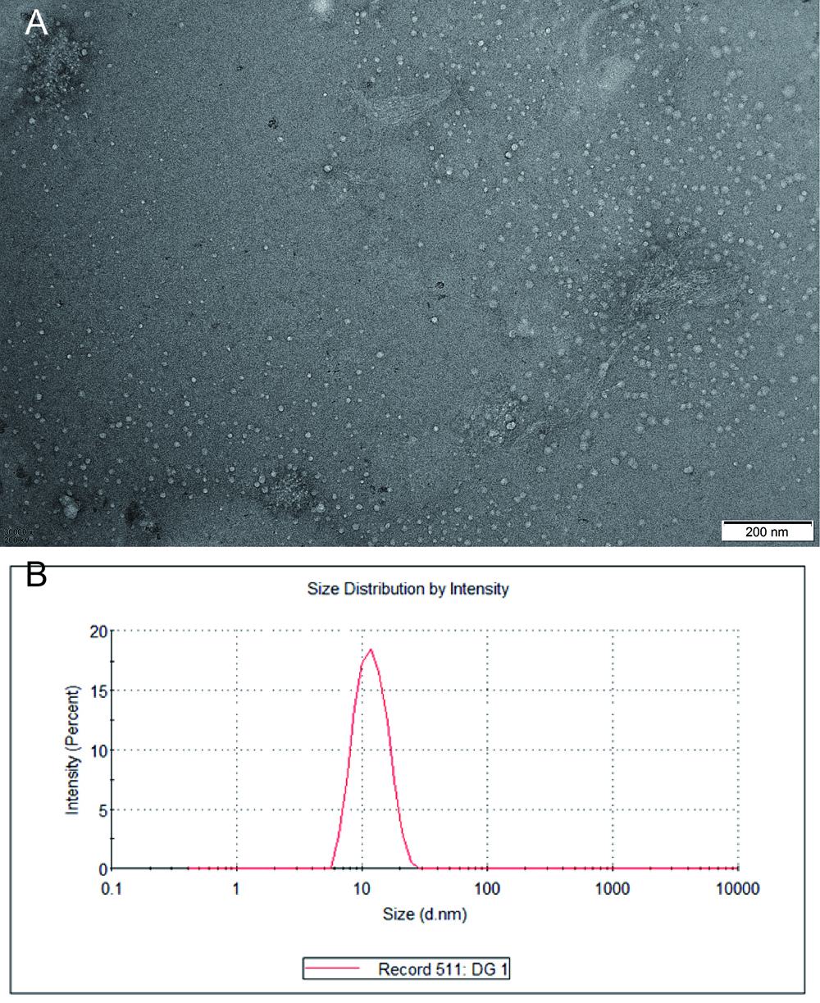
Figure S3 TEM observation (×30 k magnification, bar = 200 nm) and size distribution of blank dipotassium glycyrrhizinate (DG) micelles (15 mg/ml in water). The average size of the blank DG micelles with dynamic light scattering determination was 13.23 ± 2.49 nm.

Figure S4 DG-FIT storage stability. (A) FIT remaining in DG-FIT; (B) Micelle size; (C) polydispersity index (PDI). DG-FIT stored at 4 °C and 25 °C with protection from light. At one interval, the DG-FIT was dissolved in water and its encapsulation efficiency was determined by HPLC. FIT remaining in DG-FIT (%) was expressed as the actual level of the encapsulation efficiency to each interval normalized to its actual encapsulation efficiency at day 0. (n=3). DG: dipotassium glycyrrhizinate; FIT: fisetin; DG-FIT: FIT-loaded self-micellizing nanosystem with DG as nanocarriers; PDI: polydispersity index.

Figure S5 Characterizations of in vitro release and PAMPA assays. (A) In vitro release profiles of FIT from DG-FIT with using dialysis method; (B) In vitro PAMPA assay was determined by transwell method. DG: dipotassium glycyrrhizinate; FIT: fisetin; DG-FIT: FIT-loaded self-micellizing nanosystem with DG as nanocarriers; PAMPA: parallel artificial membrane permeability.

Figure S6 Measured antioxidant characterizations. Measured FRAP values of the free FIT and DG-FIT with different incubation times as functions of concentration (A) and (B) different concentrations as functions of time. DG: dipotassium glycyrrhizinate; FIT: fisetin; DG-FIT: FIT-loaded self-micellizing nanosystem with DG as nanocarriers.

Figure S7 Hemolysis results for tested solutions. Hemolysis ratio. No hemolysis was obviously observed to these tested concentrations, as the %hemolysis <5%, these samples have good hemobiocompatibility n=3. DG: dipotassium glycyrrhizinate; FIT: fisetin; DG-FIT: FIT-loaded self-micellizing nanosystem with DG as nanocarriers.

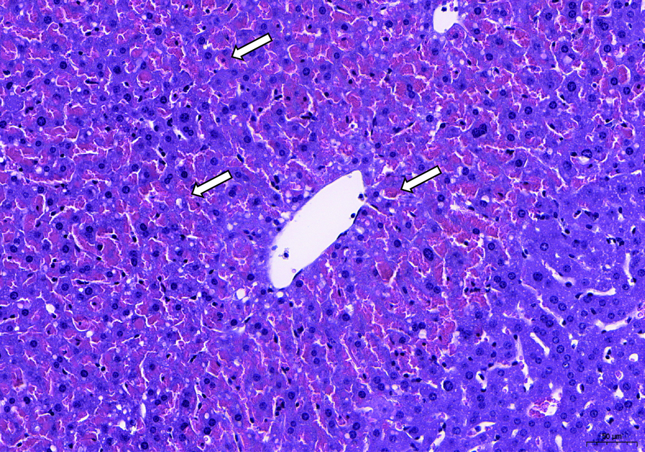
Figure S8 Typical hematoxylin&eosin stained mouse liver of PBS treated acetaminophen-induced liver injury model. Arrows showed the hemorrhagic spots. Bar=50 μm
Figure S9 Treatment efficacy evaluation with tested indexes. Mean ± SEM, n = 4. (A) Body weight of mouse before (day 0) and after (day 7) the experiment; (B) Liver weights of the different tested groups; (C) Spleen weights of the different tested groups; and (D) Spleen/body weight ratios of the different tested groups. *P < 0.05 vs. the healthy control group; #P < 0.05 vs. the acetaminophen control group; &P < 0.05 vs. the NAC group; $P < 0.05 vs. the DG group; @P < 0.05 vs. the FIT group; %P < 0.05 vs. the DG&FIT group; ^P < 0.05 vs. the DG-FIT 5 mg/kg group; ⁺P < 0.05 vs. the DG-FIT 25 mg/kg group. DG: dipotassium glycyrrhizinate; FIT: fisetin; DG-FIT: FIT-loaded self-micellizing nanosystem with DG as nanocarriers; NAC: N-acetylcysteine.

Figure S10 Histological scores (A) and Tunel stained area (%) (B). n=3. DG: dipotassium glycyrrhizinate; FIT: fisetin; DG-FIT: FIT-loaded self-micellizing nanosystem with DG as nanocarriers; NAC: N-acetylcysteine.

Figure S11 Thermal analysis for dipotassium glycyrrhizinate (DG), Fisetin (FIT), a physical mixture of DG and FIT (DG&FIT), and FIT-loaded self-micellizing nanosystem with DG as nanocarriers (DG-FIT) powder were performed with a TG-DSC STA 449 F3 Jupiter® differential scanning calorimeter (NETZSCH Group, Selb, Germany).
For DSC measurements, aluminum pans were filled with samples weighing 5–10 mg, and the samples were heated from 25 to 400 °C at a rate of 10 °C/min in a nitrogen atmosphere (flow rate 100 ml/min).The DSC curves obtained were shown in Figure S11. The endothermic peak of FIT begins at 105 °C, which is caused by the evaporation of water. The thermal spectrum of FIT showed a sharp heat absorption peak at 329 °C, which could be ascribed to the melting point of crystalline FIT. For the physical mixture of DG and FIT, a small thermal event at 321 °C was displayed. When the DG and FIT were formulated into DG-FIT, the peaks corresponding to the FIT melting point disappeared, indicating that FIT was dispersed within the solid dispersion in a non-crystalline state.
Figure S12 XRD analysis for dipotassium glycyrrhizinate (DG), Fisetin (FIT), a physical mixture of DG and FIT (DG&FIT), and FIT-loaded self-micellizing nanosystem with DG as nanocarriers (DG-FIT) powder were performed with a x-ray diffractometer (D/max-2400; Rigaku, Tokyo, Japan).
XRD patterns for FIT, DG, the DG&FIT physical mixture, and the DG-FIT were shown in Figure S12. The powder X-ray diffraction pattern of FIT revealed several high intensity peaks at different diffraction angles (2θ) of 7.92, 12.44, 15.5, 17.44, 24.08, 25.72, and 28.26, suggesting that FIT existed in a crystalline nature; however, the diffraction patterns of DG corresponded to the amorphous state. The patterns for the physical mixture of DG and FIT (DG&FIT) showed some typical bands of FIT, such as 12.46°, 15.5°, 17.4° and 28.28°. In the DG-FIT, the diffraction pattern was similar to that of the amorphous structure of DG, and as the spectra did not reveal any characteristic peaks, indicating the amorphous state of FIT in DG-FIT.
Figure S13 Fourier Transform InfraRed spectroscopy (FTIR) for dipotassium glycyrrhizinate (DG), Fisetin (FIT), a physical mixture of DG and FIT (DG&FIT), and FIT-loaded self-micellizing nanosystem with DG as nanocarriers (DG-FIT) powder were performed with a Nicolet iS10 IR-spectrophotometer (ThermoFisher, Madison, WI, USA).
FT-IR spectroscopy was used to investigate possible chemical reactions or H-bonding formation in binary systems of FIT with DG. In addition, the FT-IR spectra of FIT, DG, the DG&FIT physical mixture, and the DG-FIT are shown in Figure S13. Absorption bands at 3519, 1607, and 1280 cm⁻¹ could be ascribed to O-H stretching, C=C stretching, and C-O-H bending vibrations, respectively, indicating the characteristic functional groups of FIT. The spectrum for DG was observed at 3417.84 cm⁻¹ for −O-H vibrations of Alcohols and/or Phenols . The −C=C vibrations are visible at 1614.89 cm⁻¹ and 1456.22 cm⁻¹, and the −C-H fragment is visible at 1450−1280 cm⁻¹. In the DG-FIT and DG&FIT, the infrared absorption spectra mainly showed the characteristic peak in the same region of DG, which may revealed that there are no new chemicals were produced during the preparation of micelles, and the presence of excessive DG masked the characteristic absorption peak of FIT.
Figure S14 UV-vis spectra for dipotassium glycyrrhizinate (DG), Fisetin (FIT), a physical mixture of DG and FIT (DG&FIT), and FIT-loaded self-micellizing nanosystem with DG as nanocarriers (DG-FIT) powder were performed with a Molecular Devices SpectraMax i3 (Tacan Austria GmbH, Grodig, Austria)
The UV-Vis spectra of FIT, DG, the DG&FIT physical mixture, and the DG-FIT were shown in Figure S14. FIT has a typical structure of benzopyranone, and the maximum UV absorption peak was at 366nm.The UV-Vis spectra of DG-FIT also exhibited the adsorption peaks of DG and FIT but with a slightly shift, indicating there were interactions between the two agents.

