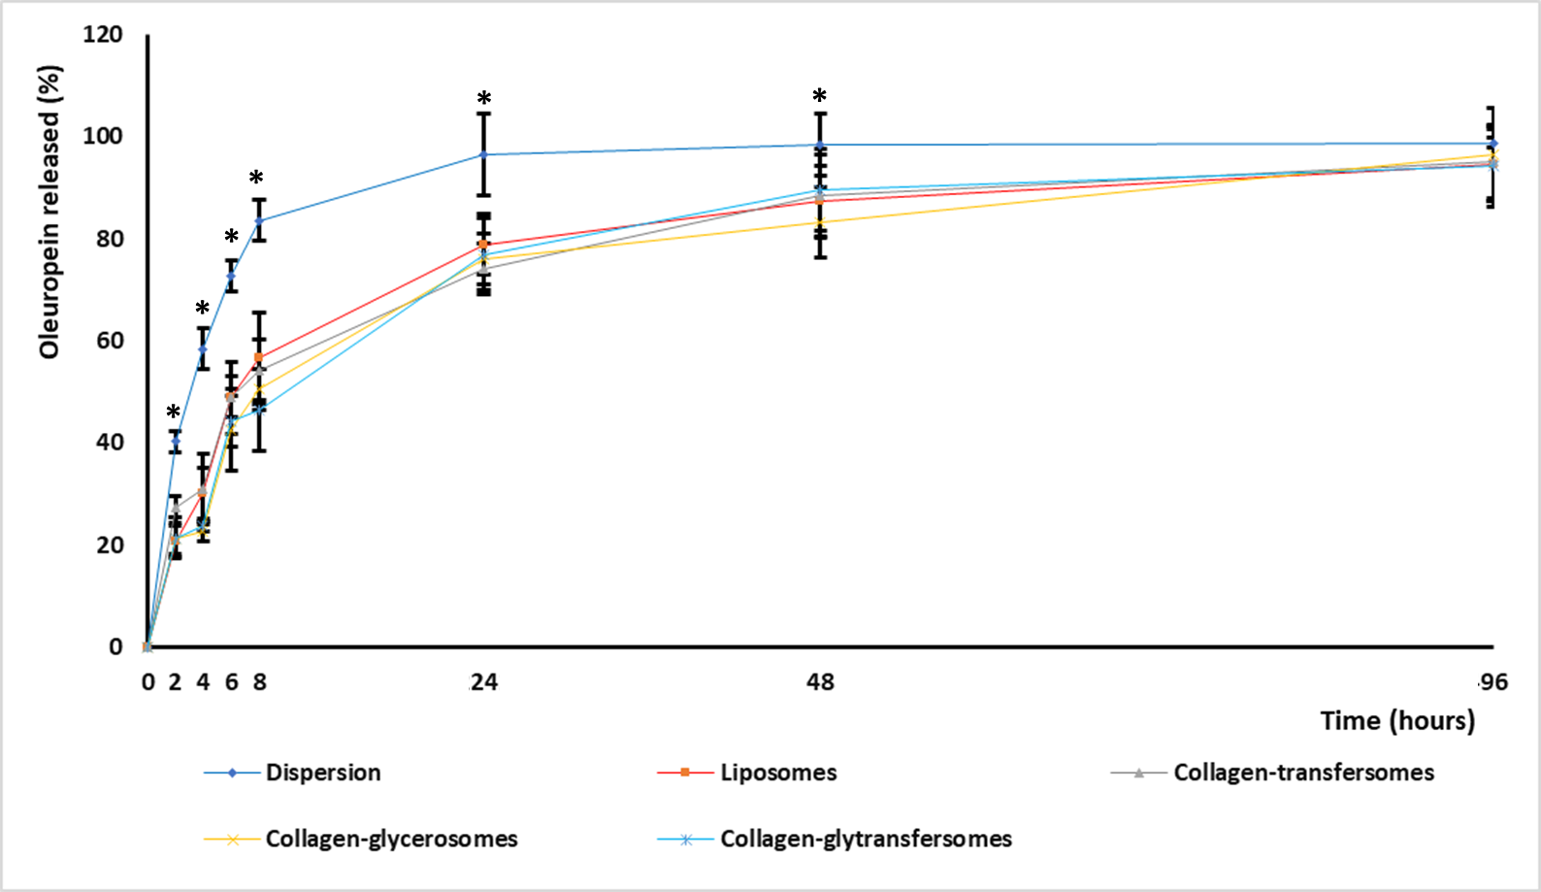
Figure S1. Percentage of oleuropein released from the dispersion or vesicles during 96 hours. The mean values ± standard deviations (error bars) are reported (n=3). Symbol * indicates values statistically different from the other values at the same time.

