SUPPLEMENTARY DATA

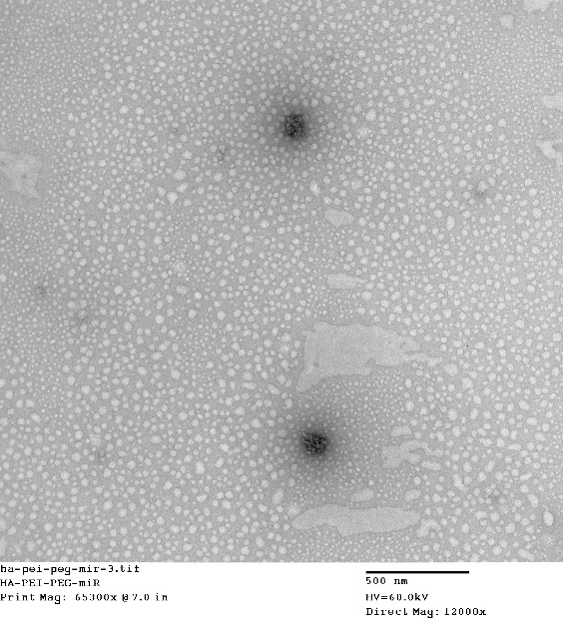
Supplementary Figure 1: The HA-PEI/PEG miR particles made at 54:1 ratio in deionized water were visualized by transmission electron microscopy. Scale bar indicates 500 nm.

