Supplementary data

Stimuli-responsive graphene oxide and methotrexate loaded magnetic nanoparticles for breast cancer targeted therapy
Mitra Dolatkhah ^{1,2,3}, Nastaran Hashemzadeh ^{1,2,3}, Jaleh Barar ^{1,2}, Khosro Adibkia ^{1,2}, Ayuob Aghanejad¹, Mohammad Barzegar-Jalali ², Hossein Omidian⁴, Yadollah Omidi^{4*}
¹ Research Center for Pharmaceutical Nanotechnology, Biomedicine Institute, Tabriz University of Medical Sciences, Tabriz, Iran
² Department of Pharmaceutics, Faculty of Pharmacy, Tabriz University of Medical Sciences, Tabriz, Iran

³ Student Research Committee, Faculty of Pharmacy, Tabriz University of Medical Sciences, Tabriz, Iran

⁴ Department of Pharmaceutical Sciences, College of Pharmacy, Nova Southeastern University, Fort Lauderdale, Florida 33328, USA

Short title: GO-SPION-MTX for breast cancer targeting

* Corresponding author: Y. Omidi, College of Pharmacy, Nova Southeastern University, Fort Lauderdale, Florida 33328, USA. Email: yomidi@nova.edu

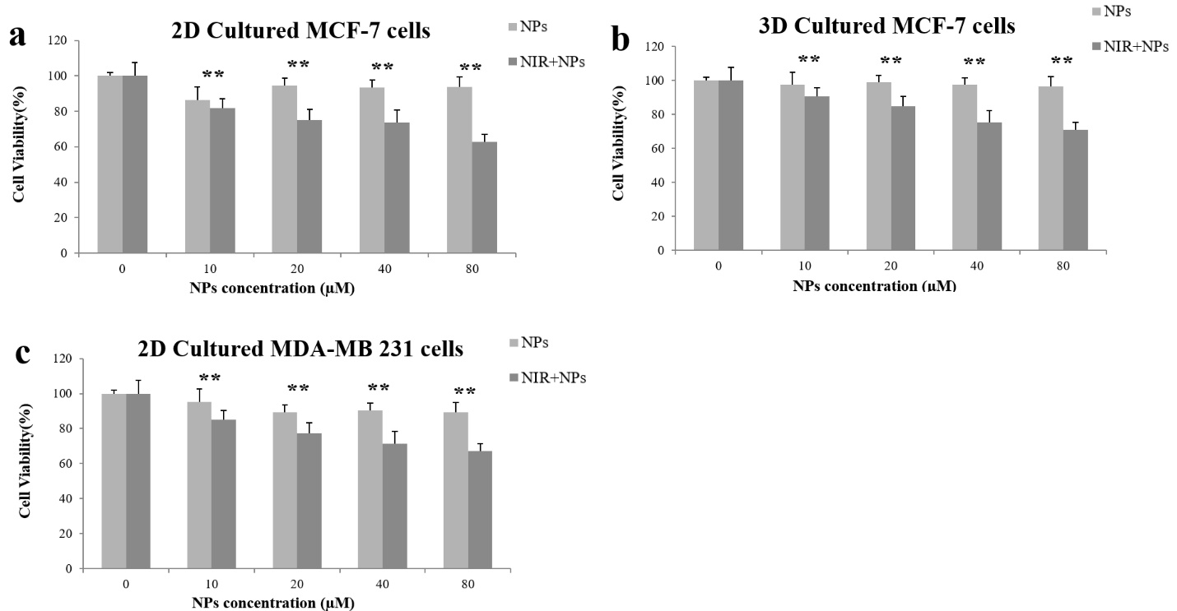

Fig. S1. The cell viability assay of (a) the 2D and (b) 3D cultured MCF-7 cells, and (c) the 2D cultured MDA-MB 231 cells. Cells were exposed to the different concentrations (10,20,40 and 80 μg/mL) of NPs for 24 h with and without NIR laser [810 nm, 16 J/(s/m2)] in the 2D and 3D cultured MCF-7 cells, and the 2D cultured MDA-MB231 cells. Data present means ± SD of three separate experiments. (**p < 0.05). NIR: Near-infrared laser irradiation, NPs: Nanoparticles.

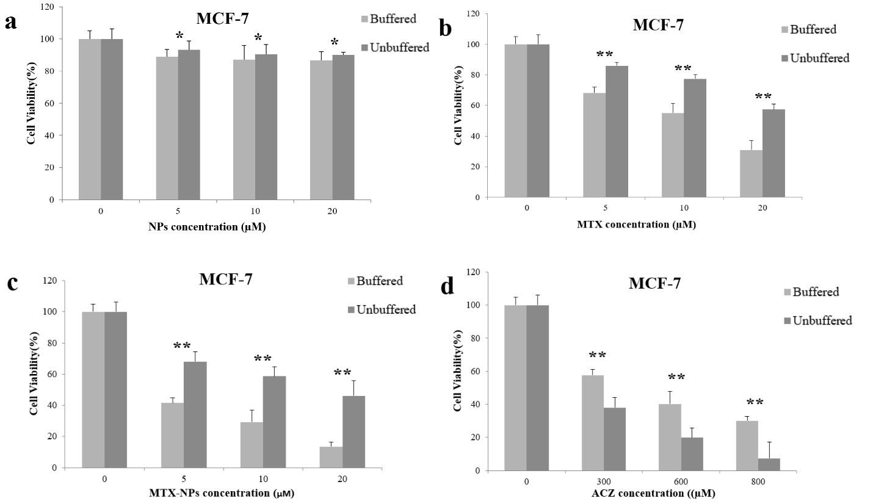

Fig. S2. Cytotoxic effects of (a) NPs, (b) MTX, (c) MTX-NPs, (d) ACZ as single treatments in breast cancer cell lines in vitro, in both buffered and unbuffered growth media to consider the acidic TME role in cancer therapy. MCF-7 cells were incubated for 4 h in the buffered or unbuffered media, and after 4 h of incubation different doses of the treatments (NPs, MTX, MTX-NPs, and ACZ) were added. Cytotoxic effect was evaluated after 48 h. The data present means ± SD of three separate experiments. (**p < 0.05). MTX: Methotrexate, NPs: Nanoparticles, ACZ: Acetazolamide.

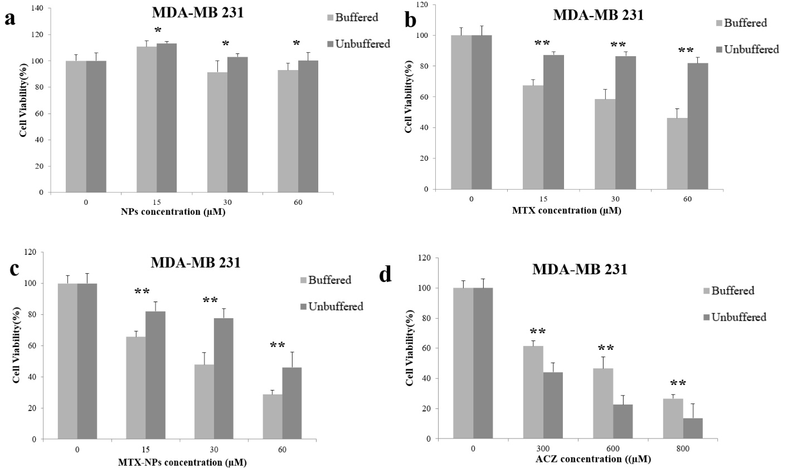
Fig. S3. Cytotoxic effects of (a) NPs, (b) MTX, (c) MTX-NPs, (d) ACZ as single treatments in breast cancer cell lines in vitro, in both buffered and unbuffered growth media to consider the acidic TME role in cancer therapy. MDA-MB231 cells were incubated for 4 h in the buffered or unbuffered media, and after 4 h of incubation different doses of the treatments (NPs, MTX, MTX-NPs, and ACZ) were added. Cytotoxic effect was evaluated after 48 h. The data present means ± SD of three separate experiments. (**p < 0.05). MTX: Methotrexate, NPs: Nanoparticles, ACZ: Acetazolamide.

