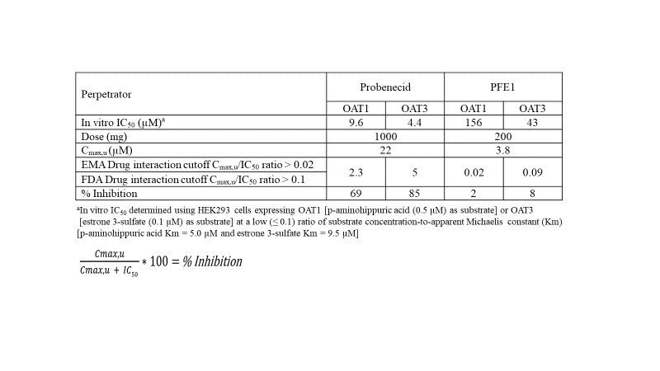

**Supplemental Table 1**. In Vitro DDI potential for OAT1/3 inhibition for Probenecid and Pfizer NCE1.



**Supplemental Table 2**. Standard curve results from three accuracy and precision batches.



**Supplemental Table 3**. Accuracy and precision batch results.



**Supplemental Table 4**. Parallelism results.



**Supplemental Table 5**. Room-temperature and freeze/thaw stability results.