Supplementary Figure. Best Karnofsky Performance Scale Among ICU survivors¹
a. KPS² Before ICU³ Admission vs. Best KPS after ICU Admission Among Survivors
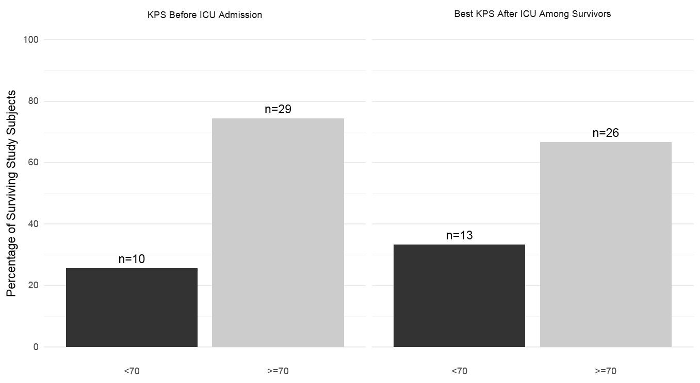
b.
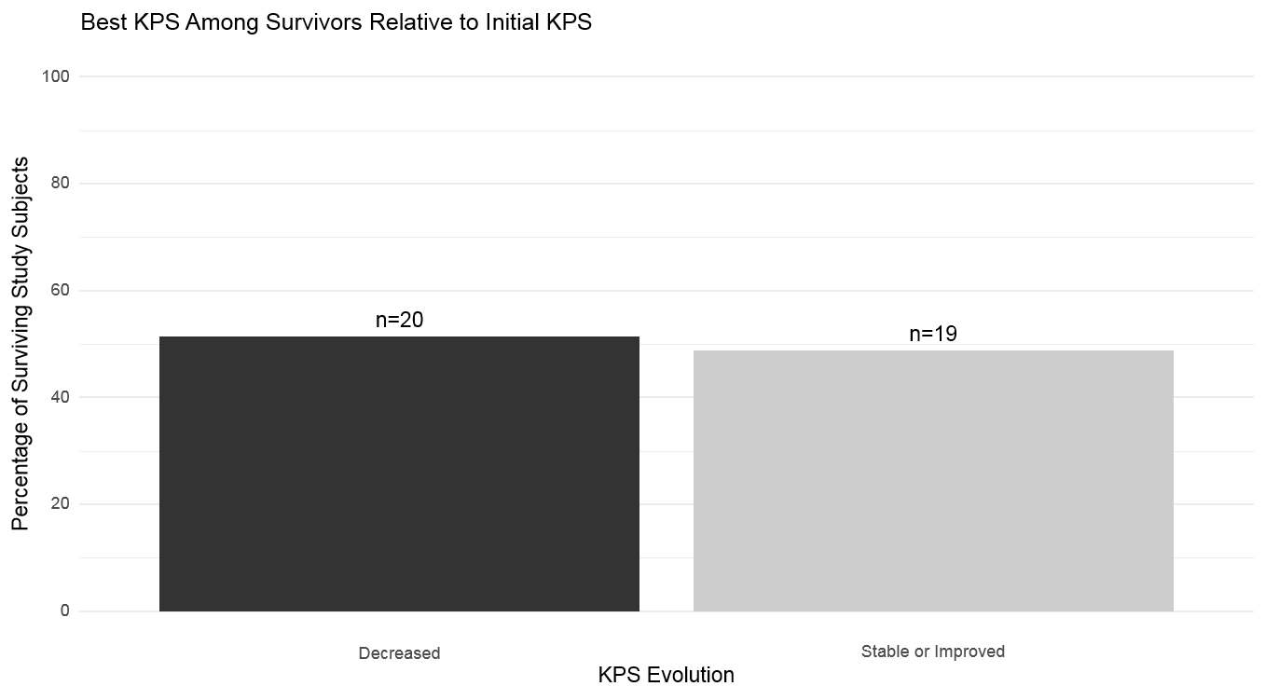
¹within 6-month post-discharge period, ²KPS karnofsky performance scale, ³ICU intensive care unit

