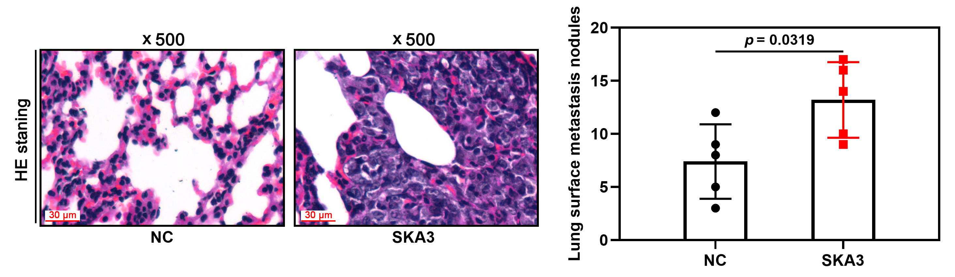
Supplementary Figure 1. The lung metastasis model of A549 cells was used to detect the effects of overexpression of SKA3 on lung metastasis of NSCLC cells.

