Supplementary information for:

Transition metal-catalysed synthesis of new 3-substituted coumarin derivatives as antibacterial and cytostatic agents

Contents:
Table S1. | S2–S3
¹H NMR spectra of selected compounds | S4−S14

Table S1. Activity of coumarin derivatives (1−5, 10, 11, 16, 17, 21−23, 25, 26, 28, 29−38) against Gram-positive (Staphylococcus aureus, MRSA (methicillin-resistant Staphylococcus aureus), Enterococcus faecalis and VRE (vancomycin-resistant) Enterococcus faecium) and Gram-negative bacteria (Escherichia coli, Klebsiella pneumoniae, Pseudomonas aeruginosa, Acinetobacter baumannii, Escherichia coli ESBL (extended-spectrum β -lactamases), Klebsiella pneumoniae ESBL and Acinetobacter baumanii.
Compd. | MIC (µg/mL)ª
 | Gram-positive bacteria |  |  |  |  |  | Gram-negative bacteria
 | S.  aureus^{b} |  | MRSA^{c} | E.  faecalis^{d} | MRSA^{e} | E.  faecium VRE^{f} | E.  coli^{g} | K.  pneumonia^{h} | P.  aeruginosa^{i} | A.  baumannii^{j} | E.  coli ESBL^{k} | K.  pneumoniae ESBL^{l} | A.  baumanii^{m} | cLogP^{n}
1 | >128 |  | >128 | >128 | >128 | 128 | >128 | >128 | >128 | >128 | >128 | >128 | >128 | 1.46
2 | >128 |  | >128 | >128 | >128 | >128 | >128 | >128 | >128 | >128 | >128 | >128 | >128 | 5.03
3 | >128 |  | >128 | >128 | >128 | >128 | >128 | >128 | >128 | >128 | >128 | >128 | >128 | 5.57
4 | >128 |  | >128 | >128 | >128 | >128 | >128 | >128 | >128 | >128 | >128 | >128 | >128 | 6.10
5 | >128 |  | >128 | >128 | >128 | >128 | >128 | >128 | >128 | >128 | >128 | >128 | >128 | 6.80
10 | 16 |  | 16 | 32 | 16 | 32 | >128 | >128 | >128 | >128 | >128 | >128 | >128 | 3.92
11 | >128 |  | >128 | >128 | >128 | >128 | >128 | >128 | >128 | >128 | >128 | >128 | >128 | 3.27
16 | >128 |  | 128 | >128 | 128 | >128 | >128 | >128 | >128 | >128 | >128 | >128 | >128 | 3.13
17 | >128 |  | >128 | >128 | >128 | >128 | >128 | >128 | >128 | >128 | >128 | >128 | >128 | 3.65
21 | >128 |  | >128 | >128 | >128 | >128 | >128 | >128 | >128 | >128 | >128 | >128 | >128 | 0.23
22 | >128 |  | 128 | >128 | 128 | >128 | >128 | >128 | >128 | >128 | >128 | >128 | >128 | 0.61
23 | >128 |  | >128 | >128 | >128 | >128 | >128 | >128 | >128 | >128 | >128 | >128 | >128 | 0.54
25 | >128 |  | >128 | >128 | >128 | >128 | >128 | >128 | >128 | >128 | >128 | >128 | >128 | 3.37
26 | >128 |  | >128 | >128 | >128 | >128 | >128 | >128 | >128 | >128 | >128 | >128 | >128 | 3.87
28 | >128 |  | >128 | >128 | >128 | >128 | >128 | >128 | >128 | >128 | >128 | >128 | >128 | 3.30
29 | >128 |  | >128 | >128 | >128 | >128 | >128 | >128 | >128 | >128 | >128 | >128 | >128 | 2.74
30 | >128 |  | >128 | >128 | >128 | >128 | >128 | >128 | >128 | >128 | >128 | >128 | >128 | 3.30
31 | >128 |  | 128 | >128 | 128 | 128 | >128 | >128 | >128 | >128 | >128 | >128 | >128 | 2.73
32 | >128 |  | >128 | >128 | >128 | >128 | >128 | >128 | >128 | >128 | >128 | >128 | >128 | 3.51
33 | >128 |  | >128 | >128 | >128 | >128 | >128 | >128 | >128 | >128 | >128 | >128 | >128 | 5.14
34 | >128 |  | >128 | >128 | >128 | >128 | >128 | >128 | >128 | >128 | >128 | >128 | >128 | 3.66
35 | >128 |  | >128 | >128 | >128 | >128 | >128 | >128 | >128 | >128 | >128 | >128 | >128 | 3.49
36 | >128 |  | >128 | >128 | >128 | >128 | >128 | >128 | >128 | >128 | >128 | >128 | >128 | 2.09
37 | >128 |  | >128 | >128 | >128 | >128 | >128 | >128 | >128 | >128 | >128 | >128 | >128 | 4.23
38 | >128 |  | >128 | >128 | >128 | >128 | >128 | >128 | >128 | >128 | >128 | >128 | >128 | 3.01
Ampicillin |  | 1 | 4 | 2 |  | 1
Gentamicin |  | 0.125 | 0.25 | 8 |  | 0.25
Amikacin |  |  |  |  |  |  |  |  | 2
Ceftazidime |  |  |  |  |  |  | 0.5 |  | 4 |  | 8 | >128
Ciprofloxacine |  | 0.25 |  | 0.5 |  | >128 | 0.004 | 0.06 | 0.5 |  | >128 | 1 | 0.06
ª MIC (minimum inhibitory concentration); ^{b} Staphylococcus aureus ATCC 25923; ^{c} MRSA (methicillin-resistant Staphylococcus aureus) 11710; ^{d} Enterococcus faecalis ATCC; ^{e} MRSA 13276; ^{f} VRE (vancomycin-resistant) Enterococcus faecium MKB 3019; ^{g} Escherichia coli ATCC 25922; ^{h} Klebsiella pneumoniae ATCC 700603; ^{i} Pseudomonas aeruginosa ATCC 27853; ^{j} Acinetobacter. baumannii ATCC 19606; ^{k} ESBL (extended-spectrum β -lactamases (resistant to most β-lactam antibiotics)) Escherichia coli 26001; ^{l} ESBL Klebsiella pneumoniae 9350; ^{m} Acinetobacter baumanii 9768; ^{n} clogP (calculated logP values) were obtained by using ChemDraw Professional 15.

¹H NMR spectrum of compound 16
¹H NMR spectrum of compound 17

¹H NMR spectrum of compound 18

¹H NMR spectrum of compound 19

¹H NMR spectrum of compound 19

¹H NMR spectrum of compound 21

¹H NMR spectrum of compound 22

¹H NMR spectrum of compound 23

¹H NMR spectrum of compound 24

¹H NMR spectrum of compound 25

¹H NMR spectrum of compound 26

¹H NMR spectrum of compound 27

¹H NMR spectrum of compound 28

¹H NMR spectrum of compound 29

¹H NMR spectrum of compound 30
¹H NMR spectrum of compound 31

¹H NMR spectrum of compound 32

¹H NMR spectrum of compound 33

¹H NMR spectrum of compound 35

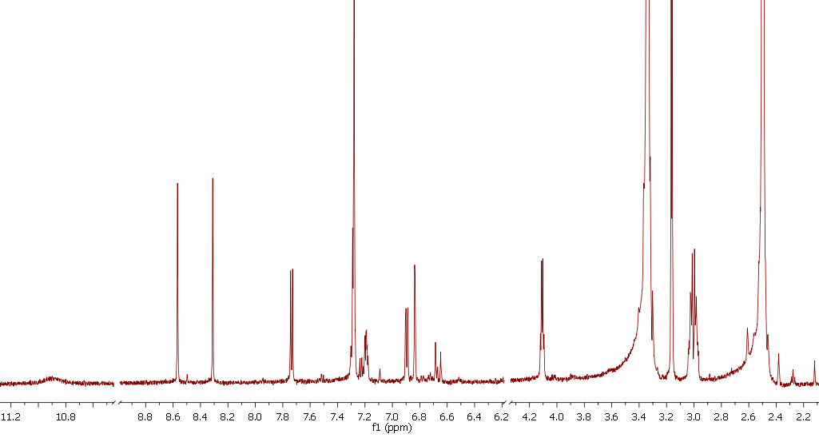

¹H NMR spectrum of compound 37
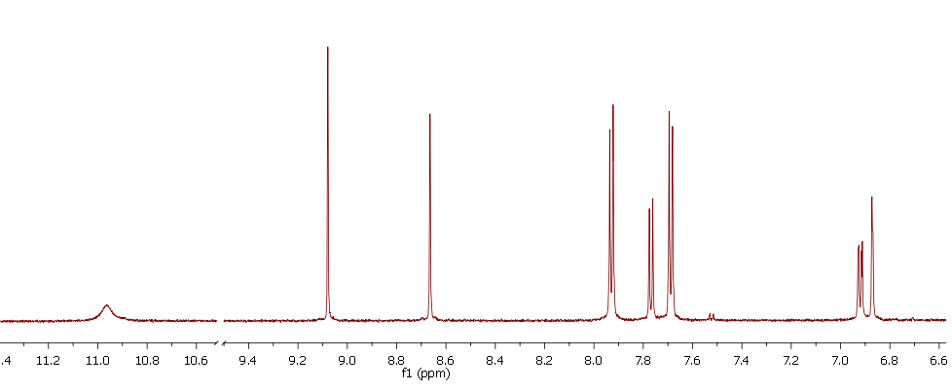

¹H NMR spectrum of compound 38

