Supplementary Information

Supplementary Figure 1. Schematic of light-controlled liposome–membrane fusion process. UCNPs: Upconversion nanoparticles; DOX: Doxorubicin. Reproduced with permission from [1], licensed with CC BY 3.0.

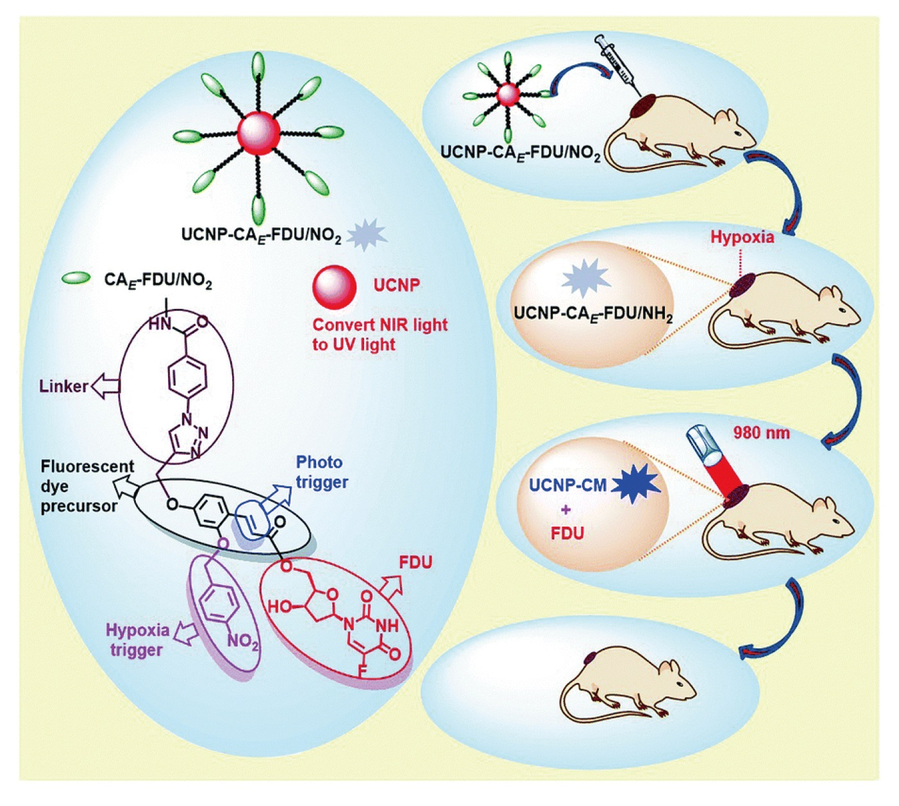

Supplementary Figure 2. Schematic illustration of the UCNP-CA_{E}-FDU/NO₂-based theranostic nanoplatform under the hypoxia state. UCNPs: Upconversion nanoparticles; NIR: Near infrared; UV: Ultraviolet; CA_{E}: (E)-o-hydroxycinnamic acid; FDU: Floxuridine; CM: 7-propargyloxycoumarin. Reproduced with permission from [2], © 2018 Royal Society of Chemistry.

Supplementary Figure 3. Schematic demonstration of NO-modulated and overloaded Ca²⁺-triggered tumor cell killing effect. UC: Upconversion; ZIF: Zeolitic framework; BER: Berbamine; NO: Nitric oxide; RyR: Ryanodine receptors. Reproduced with permission from [3], © 2021 Wiley-VCH GmbH.

Supplementary Figure 4. Illustration of the design for separating the imaging and PDT. UCL: Upconversion light; PDT: Photodynamic therapy; RB-HA: rose bengal hexanoic acid; BHQ: Black hole quencher. Reproduced with permission from [4], © 2019 Elsevier Ltd.

Supplementary Figure 5. Illustration of the pH dependent FRET process. Reproduced with permission from [5], © 2020 Elsevier B.V.

Supplementary Figure 6. Schematic illustration of the glycans detection on the cancer cell membrane. UCNP: Upconversion nanoparticle. Reproduced with permission from [6], licensed with CC BY-NC 3.0.

Supplementary Figure 7. Schematic overview of tumor immunotherapy activated by dual-mode ROS. AUNPs: AIEgen-coupled upconversion nanoparticles; NIR: Near infrared; PDT: Photodynamic therapy; ICD: Immunogenic cell death; TAA: Tumor-associated antigen; DLN: Draining lymph node; I.T.: Intratumoral injection. Reproduced with permission from [7], licensed with CC BY-NC 4.0.

Supplementary Figure 8. Schematic illustration of NIR-controlled dePEGylation for improving the tumor penetration. UCNPs: Upconversion nanoparticles; NIR: Near infrared; UV: Ultraviolet; PEG: Polyethyleneglycol; DOX: doxorubicin; PAE: poly(β-aminoester)s. Reproduced with permission from [8], © 2019 American Chemical Society.

Supplementary Table 1. A summary of UCNP-based nanoplatforms for light-controlled drug release.
Nanoplatform | UCNP | Photoresponsive moieties | Drug | Ref.
UCNP–ONB–FU | NaYF₄:Yb,Tm@NaYF₄ | o-nitrobenzyl | 5-FU | [9]
DOX-UCNP@PNB-b-POEG | NaYF₄:Yb,Tm@NaYF₄ | o-nitrobenzyl | DOX | [10]
DOX-UCNP@mPEG-PEI-(NBS,OA) | NaYF₄:Yb,Er | o-nitrobenzyl | DOX | [11]
UCNP@Azo-Lipo/DOX | NaGdF₄:Yb,Tm@NaGdF₄ | azobenzene | DOX | [12]
DOX-UCNPs@PAzo/MAA | NaYF₄:Yb,Tm@NaYF₄ | azobenzene | DOX | [13]
DOX-UCNPs@PMA | NaYF₄:Yb,Tm@NaLuF₄ | azobenzene | DOX | [14]
DOX-UCNP@mSiO₂-Azo | NaYF₄:Yb,Tm@NaYF₄ | azobenzene | DOX | [15]
DOX-UCNP@mSiO₂-DNQ-CD | NaYF₄:Yb,Tm@NaYF₄ | DNQ | DOX | [16]
UCNP@mSiO₂(DOX)-S-BP@β-CD | NaYF₄:Yb,Tm@NaYF₄ | thioether | DOX | [17]
DOX-UCNP-TiO₂@mSiO₂-Ru2-Au | NaYF₄:Yb,Tm,Er,Fe@NaYbF₄:Tm | Ru2 | DOX | [18]
UCNP@mSiO₂/HA-DOX@CNBA | NaYF₄:Yb,Tm@NaYF₄ | CNBA | DOX | [19]
UCNPs@SiO₂@mSiO₂-SP/Curcumin | NaYF₄:Yb,Tm | spiropyran | Curcumin | [20]
UCNP: Upconversion nanoparticle; ONB: o-nitrobenzyl; 5-FU: 5-fluorouracil; DOX: Doxorubicin; PNB: Poly(4,5-dimethoxy-2-nitrobenzyl methacrylate); POEG: Poly(methoxy polyethylene glycol monomethacrylate); mPEG-PEI: mPEGylated polyethyleneimine; NBS: o-nitrobenzyl succinate; OA: Oleic acid; Azo: Azobenzene; PMAA: Poly(methacrylic acid); mSiO₂: mesoporous silica; DNQ: 2-diazo-1,2-naphthoquinones; CD: Cyclodextrin; -S-BP: Thioether linkers; HA: Hypocrellin A; CNBA: 4-(2-carboxy-ethylsulfanylmethyl)-3-nitro-benzoic acid linker; SP: Spiropyran.

Reference
1. Huang F, Duan R, Zhou Z, Vazquez-Gonzalez M, Xia F, Willner I. Near-infrared light-activated membrane fusion for cancer cell therapeutic applications. Chem. Sci. 11(21), 5592-5600 (2020).
2. Li H, Lei W, Wu J et al. An upconverting nanotheranostic agent activated by hypoxia combined with NIR irradiation for selective hypoxia imaging and tumour therapy. J. Mater. Chem. B 6(18), 2747-2757 (2018).
3. Chu X, Jiang X, Liu Y et al. Nitric oxide modulating calcium store for Ca2+-initiated cancer therapy. Adv. Funct. Mater. 31(13), 2008507 (2021).
4. Feng Y, Chen H, Wu Y et al. Optical imaging and pH-awakening therapy of deep tissue cancer based on specific upconversion nanophotosensitizers. Biomaterials 230, 119637 (2020).
5. Ghosh S, Chang YF, Yang DM, Chattopadhyay S. Upconversion nanoparticle-mOrange protein FRET nanoprobes for self-ratiometric/ratiometric determination of intracellular pH, and single cell pH imaging. Biosens. Bioelectron. 155, 112115 (2020).
6. Zhang R, Zheng J, Zhang T. In vivo selective imaging of metabolic glycosylation with a tetrazine-modified upconversion nanoprobe. RSC Adv. 10(27), 15990-15996 (2020).
7. Mao D, Hu F, Yi Z, Kenry K, Liu B. AIEgen-coupled upconversion nanoparticles eradicate solid tumors through dual-mode ROS activation. Sci. Adv. 6(26), eabb2712 (2020).
8. Zhou M, Huang H, Wang D et al. Light-triggered PEGylation/dePEGylation of the nanocarriers for enhanced tumor penetration. Nano Lett. 19(6), 3671-3675 (2019).
9. Fedoryshin L, Tavares A, Petryayeva E, Doughan S, Krull U. Near-infrared-triggered anticancer drug release from upconverting nanoparticles. ACS Appl. Mater. Interfaces 6(16), 13600-13606 (2014).
10. Xiang J, Tong X, Shi F, Yan Q, Yu B, Zhao Y. Near-infrared light-triggered drug release from UV-responsive diblock copolymer-coated upconversion nanoparticles with high monodispersity. J. Mater. Chem. B 6(21), 3531-3540 (2018).
11. Zhang J, Tang X, Huang C, Liu Z, Ye Y. Oleic acid copolymer as a novel upconversion nanomaterial to make doxorubicin-loaded nanomicelles with dual responsiveness to pH and NIR. Pharmaceutics 12(7), 680 (2020).
12. Yao C, Wang P, Li X et al. Near-infrared-triggered azobenzene-liposome/upconversion nanoparticle hybrid vesicles for remotely controlled drug delivery to overcome cancer multidrug resistance. Adv. Mater. 28(42), 9341-9348 (2016).
13. Wang X, Liu X, Wang L et al. Synthesis of yolk–shell polymeric nanocapsules encapsulated with monodispersed upconversion nanoparticle for dual-responsive controlled drug release. Macromolecules 51(24), 10074-10082 (2018).
14. Ma K, Wei X, Liu J et al. Near-infrared-light-responsive nanocomposites of cell membrane mimetic copolymers and upconverting nanoparticles for on-demand drug release. ACS Appl. Nano. Mater. 3(8), 8294-8303 (2020).
15. Liu J, Bu W, Pan L, Shi J. NIR-triggered anticancer drug delivery by upconverting nanoparticles with integrated azobenzene-modified mesoporous silica. Angew. Chem. Int. Ed. Engl. 52(16), 4375-4379 (2013).
16. Han R, Shi J, Liu Z, Hou Y-F, Wang Y. Novel NIR light-triggered hydrophobic-to-hydrophilic switch nanovalve for on-demand cancer therapy. ACS Biomater. Sci. Eng. 4(10), 3478-3486 (2018).
17. Shi J, Zhao Z, Liu Z, Wu R, Wang Y. Ultralow-intensity NIR light triggered on-demand drug release by employing highly emissive UCNP and photocleavable linker with low bond dissociation energy. Int. J. Nanomedicine 14, 4017-4028 (2019).
18. Kumar B, Murali A, Mattan I, Giri S. Near-infrared-triggered photodynamic, photothermal, and on demand chemotherapy by multifunctional upconversion nanocomposite. J. Phys. Chem. B 123(17), 3738-3755 (2019).
19. Zhang T, Lin H, Cui L et al. NIR-sensitive UCNP@mSiO2 nanovehicles for on-demand drug release and photodynamic therapy. RSC Adv. 6, 26479-26489 (2016).
20. Liu C, Zhang Y, Liu M et al. A NIR-controlled cage mimicking system for hydrophobic drug mediated cancer therapy. Biomaterials 139 151-162 (2017).

