Supplementary Figures

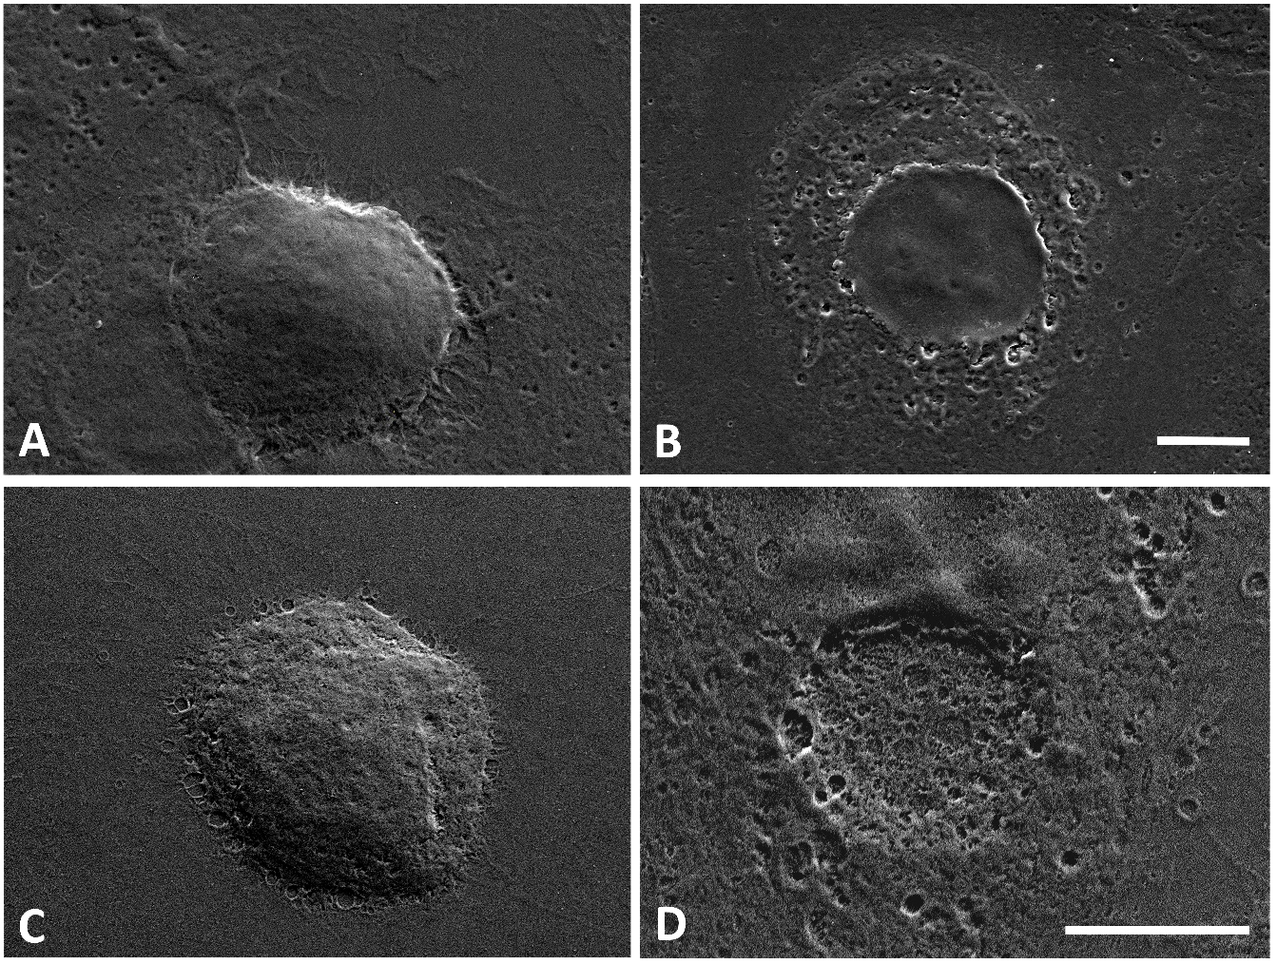

**Supplementary Figure 1: Representative SEM images ovarian cancer cell bioimprints showing the high level of resolution and replication with very robust integrity:** SKOV-3 Positive bioimprinted polystyrene (A), SKOV-3 Negative bioimprinted polystyrene (B), OVCAR-8 Positive bioimprinted polystyrene (C), OVCAR-8 Negative bioimprinted polystyrene (D). Scale bar 10 µm.

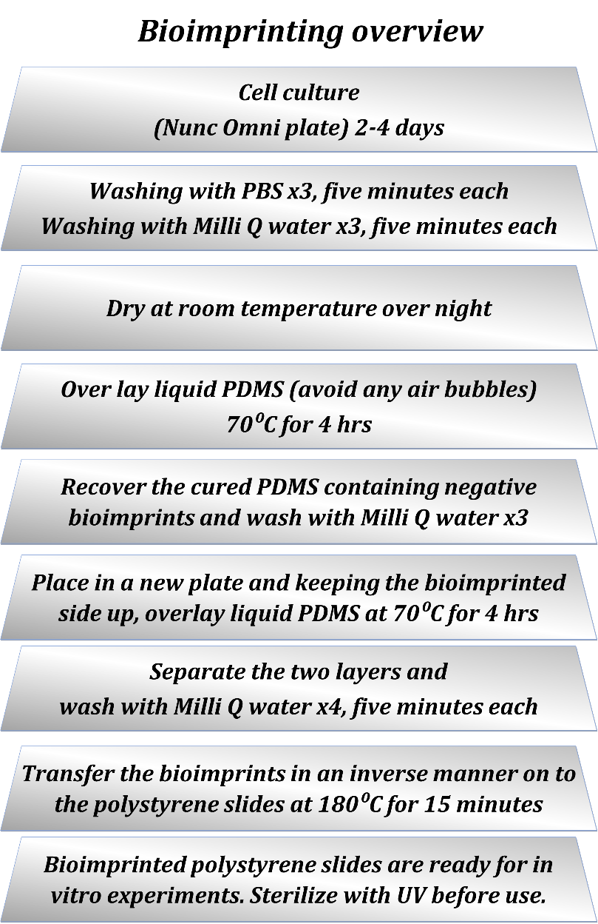

**Supplementary Figure 2: Cartoon illustration of bioimprinting**: A brief overview of bioimprinting process showing key steps of the technique.