Supplementary Materials

Supplementary Figure 1. UMAP plots coloured by disease for leave-one-out dataset. Data was pre-processed and batch corrected with the indicated dataset removed. Clustering was then performed using the resultant consensus exmiRNA common to all datasets included. UMAP plots were then regenerated (n_neighbours = 30, n_epochs = 2500) and showed similar clustering as the full super-series, suggesting that no one dataset significantly skewed UMAP results.

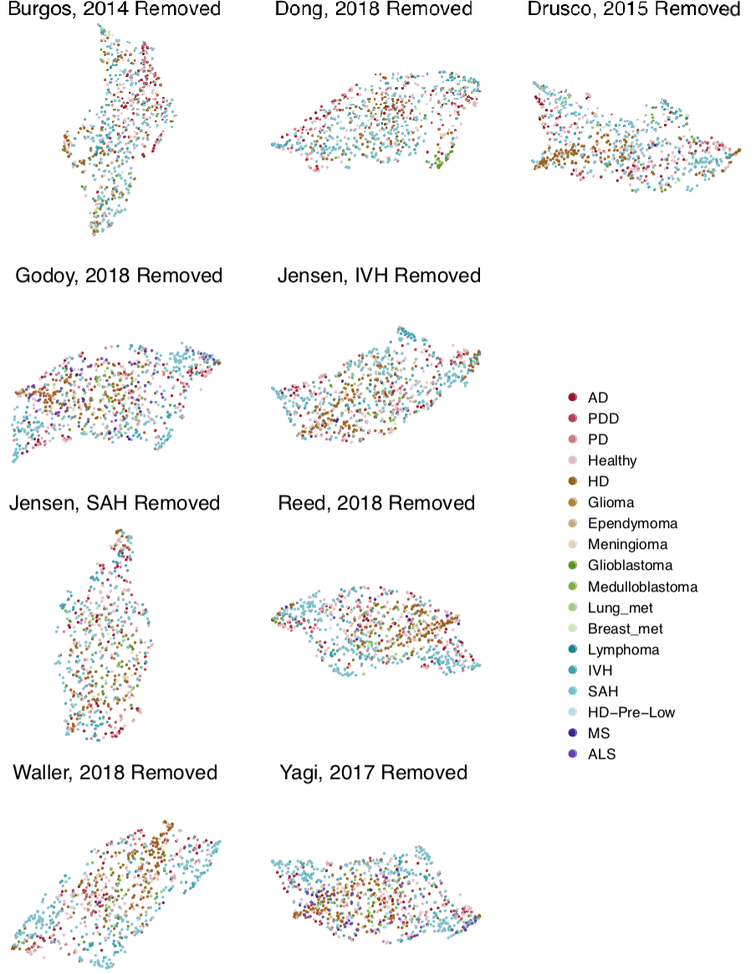

Supplementary Figure 2. UMAP plots coloured by disease category for leave-one-out datasets. As in Supplementary Figure 1, data were pre-processed and batch-corrected with the indicated dataset removed. As in the full super-series, exmiRNA were again restricted to those common between all datasets included, and clustering with UMAP was performed in two dimensions (n_neighbours = 30, n_epochs = 2500), and points coloured by disease category. Again, similar clustering as in the full super-series is observed, suggesting that there is no strong driving influence by any one dataset in the UMAP analysis.

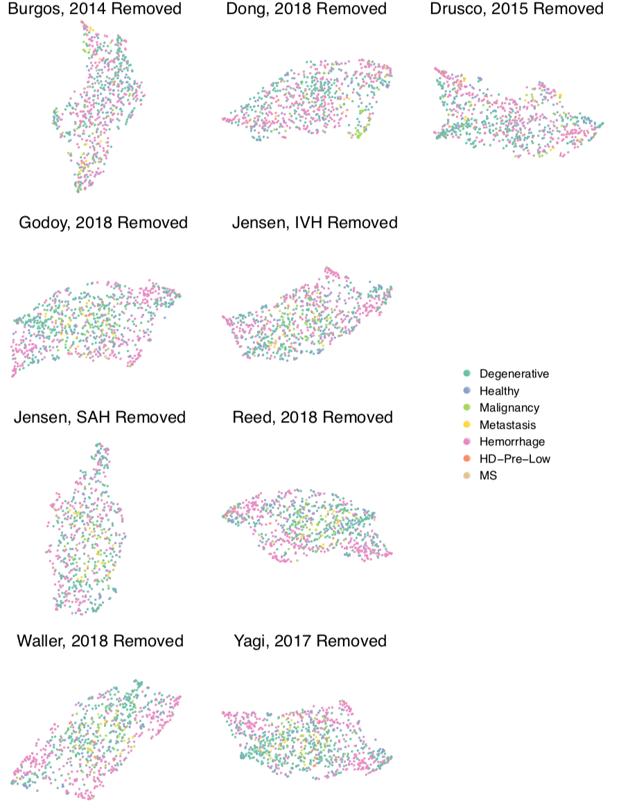

Supplementary Figure 3. Expression of key exmiRNA differentiating disease states from healthy CSF samples. (a) hsa-miR-767-5p is statistically significantly detected at a higher level in CSF of patients with Alzheimer’s disease (AD) as compared to healthy patients. (b) hsa-miR-142-5p is detected at a lower level in CSF of patients with amyotrophic lateral sclerosis (ALS) compared to healthy controls. (c) hsa-miR-361-3p is detected at a lower level in the CSF of patients with Huntington’s disease compared to healthy controls. (d) hsa-miR-885-5p is detected at higher levels of patients with low clinical probability of Huntington’s disease (HD-Pre-Low), as defined by the PREDICT-HD study, as compared to healthy control populations. (e, f) When comparing patients with degenerative conditions more generally to healthy controls, hsa-miR-142-5p and hsa-miR-361-3p show statistically significant decrease in expression.
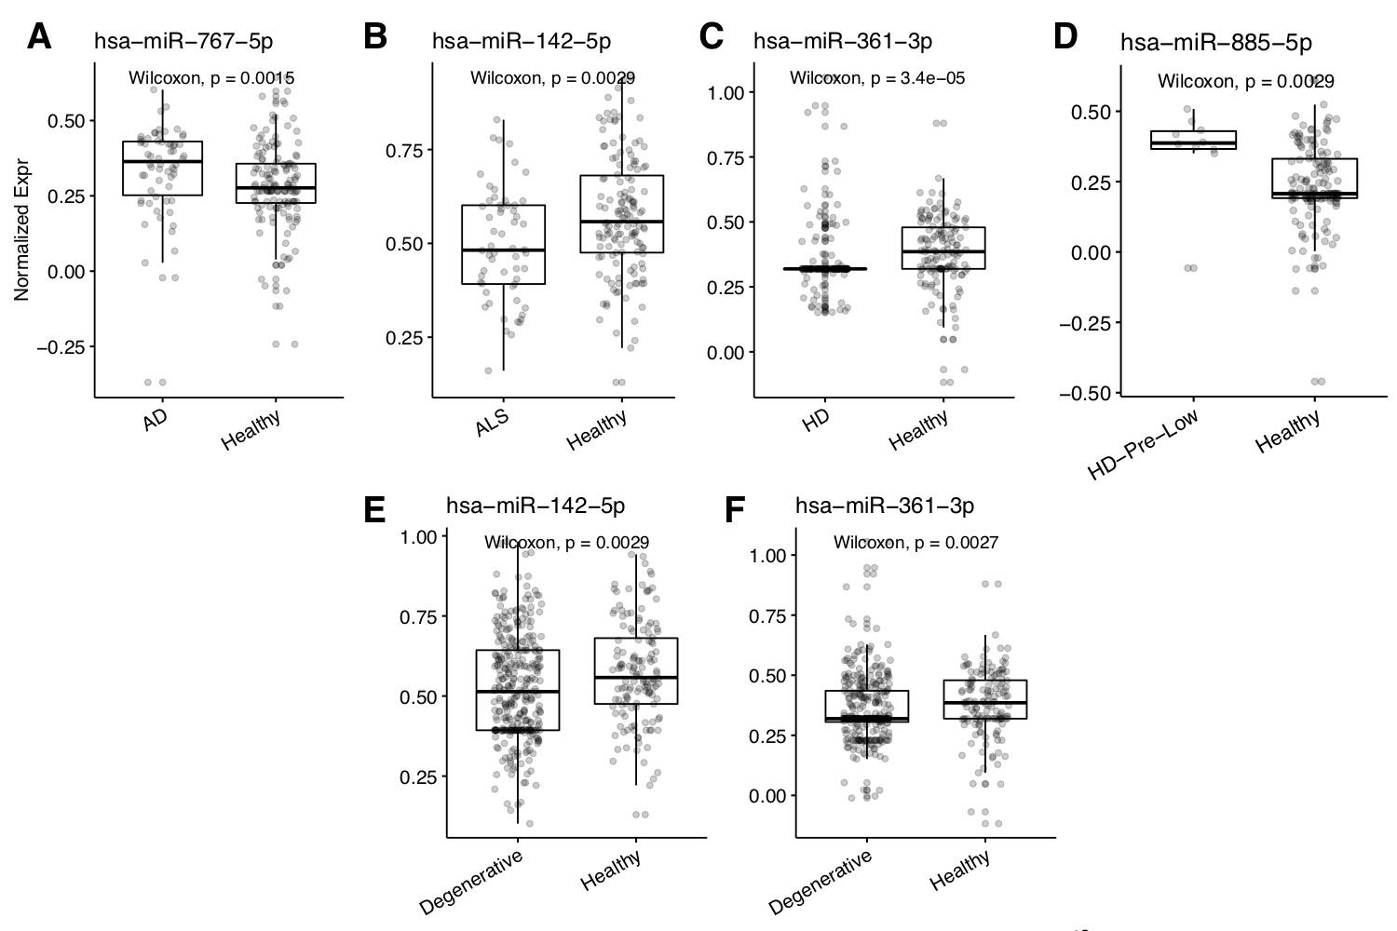

Supplementary Figure 4. UMAP plot for patients with selected degenerative conditions. UMAP (Universal Manifold Approximation) plots computed for consensus miRNA profiles among patients with Alzheimer’s disease (AD), Parkinson disease (PD), and Parkinson disease dementia (PDD). UMAP settings with n_epochs = 10000 and n_neighbors = 5.
