Supplementary material
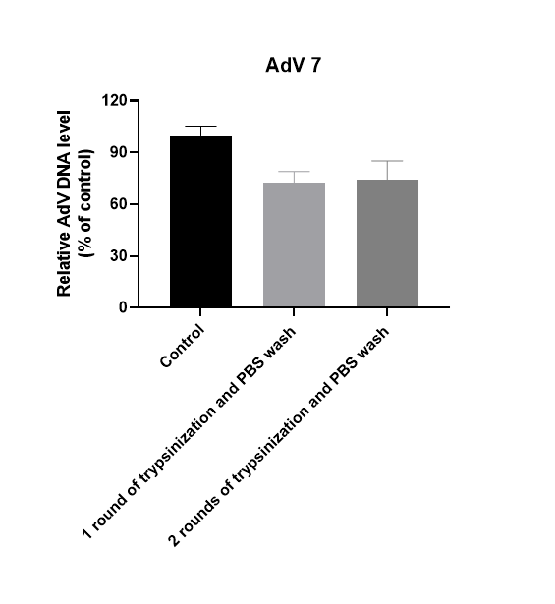
Figure S1. Removal of uninternalized virus from cell surface by trypsinization. Cells were first treated with 0.25% trypsin-EDTA for 5 min at 37 °C, and then washed 2 twice with PBS. Following washes, cells were pelleted and AdV DNA was quantified by qPCR.

