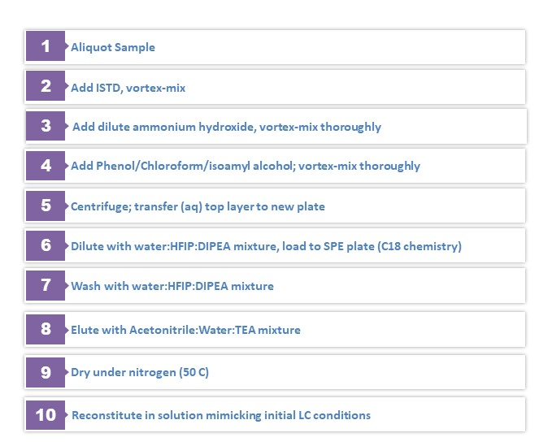
Supplemental Figure 1. Extraction Details

Supplemental Table 1: 2% hemolyzed plasma test results at LQC (0.60 ng/mL) and HQC (80 ng/mL) levels. For both LQC and HQC levels, 6 replicates were extracted/analyzed.
 | LQC level (0.60 ng/mL) |  | HQC level (80 ng/mL)
Replicate 1 | 0.546 |  | 80.5
Replicate 2 | 0.561 |  | 79.2
Replicate 3 | 0.554 |  | 78.6
Replicate 4 | 0.560 |  | 80.8
Replicate 5 | 0.527 |  | 80.6
Replicate 6 | 0.553 |  | 81.6
Average | 0.550 |  | 80.2
%CV | 2.29 |  | 1.38
Accuracy (%) | 91.69 |  | 100.27

Supplemental Table 2: Hyperlipidemic plasma test results at LQC (0.60 ng/mL) and HQC (80 ng/mL) levels. For both LQC and HQC levels, 6 replicates were extracted/analyzed.
 | LQC level (0.60 ng/mL) |  | HQC level (80 ng/mL)
Replicate 1 | 0.603 |  | 85.8
Replicate 2 | 0.592 |  | 88.8
Replicate 3 | 0.632 |  | 89.4
Replicate 4 | 0.603 |  | 87.0
Replicate 5 | 0.563 |  | 85.1
Replicate 6 | 0.558 |  | 86.7
Average | 0.592 |  | 87.1
%CV | 4.68 |  | 1.92
Accuracy (%) | 98.64 |  | 108.92

Supplemental Table 3; Recovery for analyte and ISTD at LQC, MQC, and HQC levels.
 | Analyte peak area | ISTD peak area
LQC (n=6) | 6,462 | 134,163
LQC post-spiked (n=3) | 10,494 | 238,554
Recovery | 61.6 | 56.2
MQC (n=6) | 459,578 | 120,661
MQC post-spiked (n=3) | 843,507 | 231,508
Recovery | 54.5 | 52.1
HQC (n=6) | 711,367 | 117,734
HQC post-spiked (n=3) | 1,253,762 | 219,767
Recovery | 56.7 | 53.6

Supplemental Table 4; matrix factor for both analyte and internal standard
 | Analyte |  |  | ISTD
 | Area Counts | Matrix Factor |  | Area Counts | Matrix Factor
LQC Matrix Lot 1 (n=1) | 10,498 | 0.951 |  | 240,899 | 0.992
LQC Matrix Lot 2 (n=1) | 10,797 | 0.978 |  | 239,820 | 0.987
LQC Matrix Lot 3 (n=1) | 10,988 | 0.995 |  | 239,607 | 0.986
LQC Matrix Lot 4 (n=1) | 9,679 | 0.877 |  | 237,997 | 0.980
LQC Matrix Lot 5 (n=1) | 10,602 | 0.960 |  | 241,656 | 0.995
LQC Matrix Lot 6 (n=1) | 11,234 | 1.017 |  | 240,934 | 0.992
LQC post spiked (no matrix; n=3) | 11,042 |  |  | 242,961
HQC Matrix Lot 1 (n=1) | 1,307,749 | 0.978 |  | 223,333 | 0.992
HQC Matrix Lot 2 (n=1) | 1,305,557 | 0.977 |  | 224,093 | 0.995
HQC Matrix Lot 3 (n=1) | 1,363,833 | 1.020 |  | 232,722 | 1.034
HQC Matrix Lot 4 (n=1) | 1,148,902 | 0.859 |  | 229,829 | 1.021
HQC Matrix Lot 5 (n=1) | 1,297,819 | 0.971 |  | 224,194 | 0.996
HQC Matrix Lot 6 (n=1) | 1,339,689 | 1.002 |  | 221,232 | 0.983
HQC post spiked (no matrix; n=3) | 1,336,927 |  |  | 225,140

