Supplementary Figure 1. PRISMA flowchart of literature review and identification of studies for inclusion in the NMA.

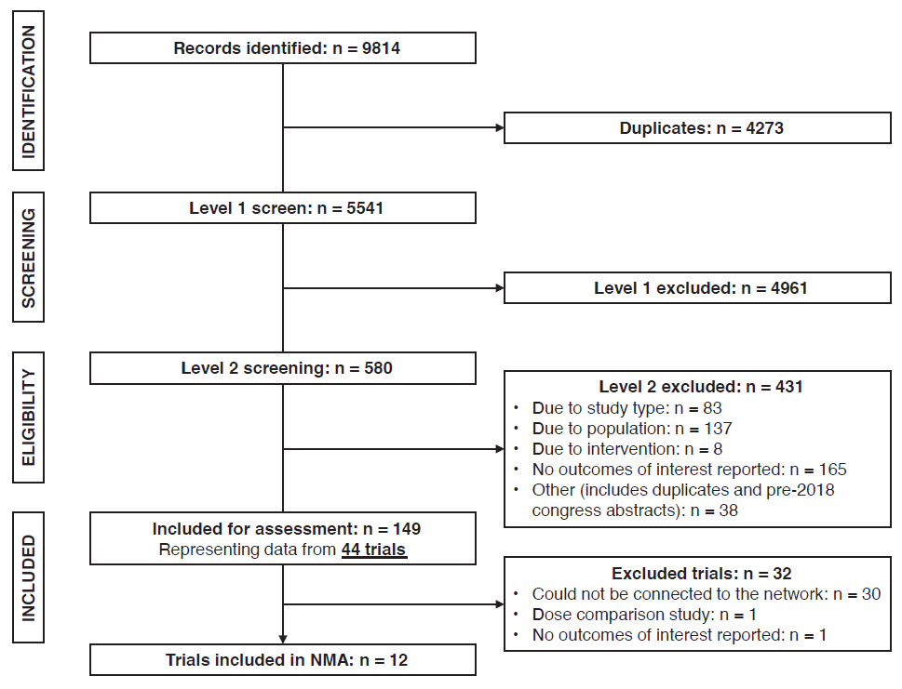NMA, network meta-analysis.

Supplementary Figure 2. Bayesian FE fractional polynomial estimates for (A) PFS by study arm; (B) PFS by treatment; (C) OS by study arm; (D) OS by treatment.
A | 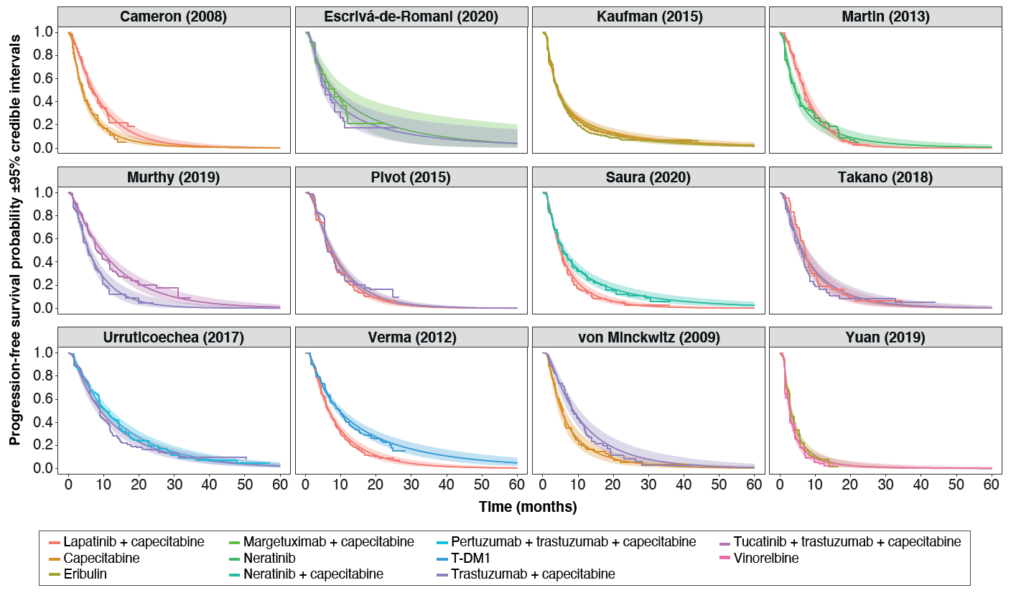
B | 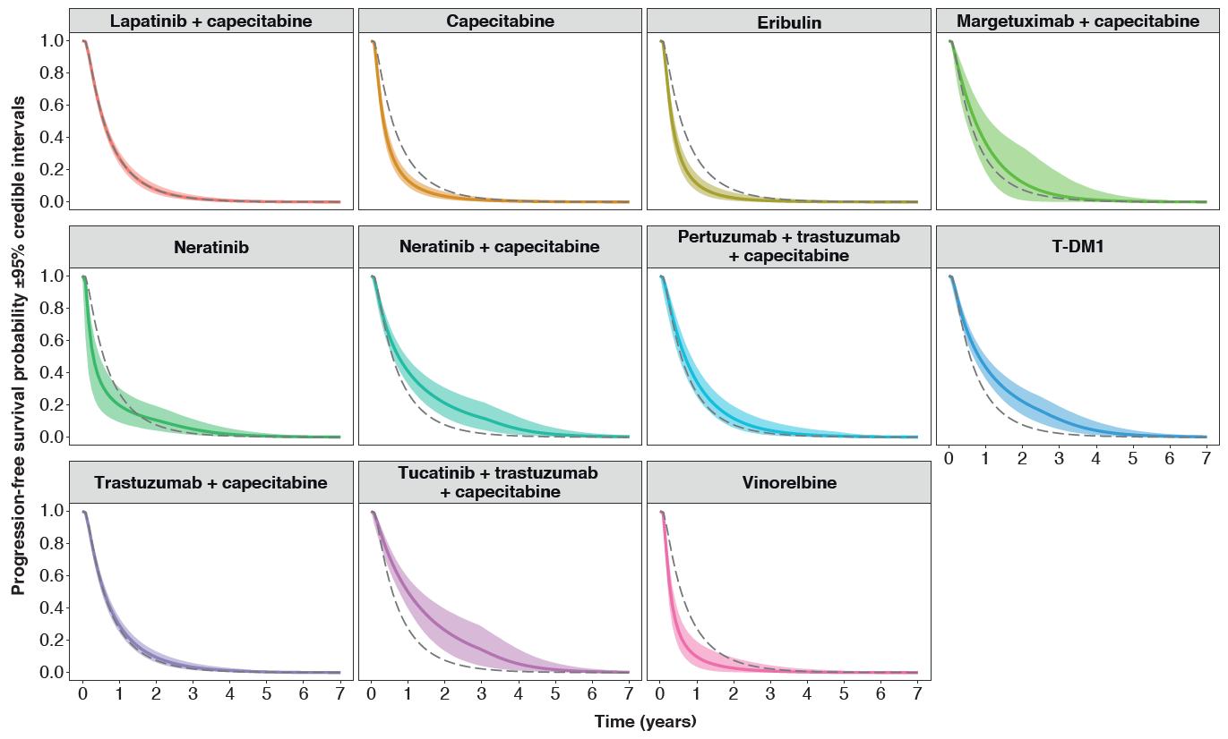
C | 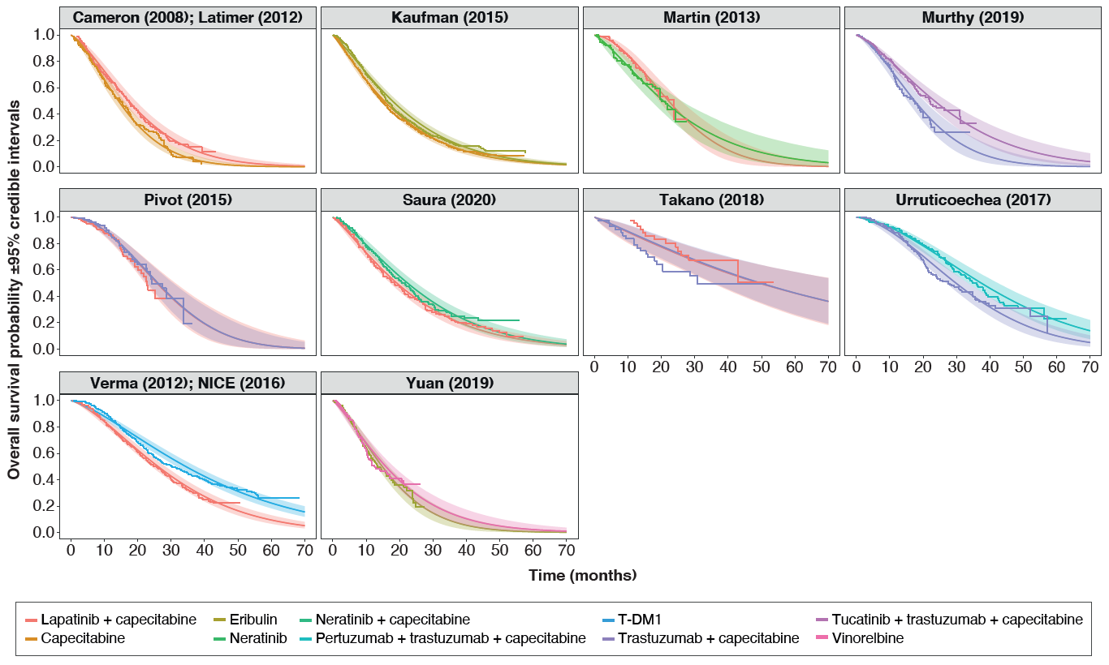
D | 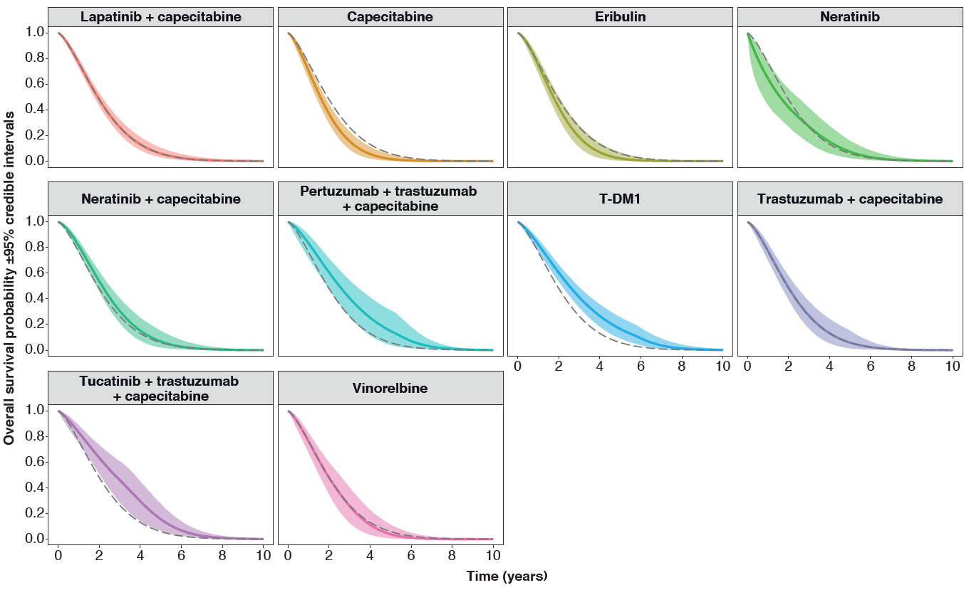
FE, fixed effects; OS, overall survival; PFS, progression-free survival; T-DM1, trastuzumab emtansine. Dotted line indicates reference treatment (lapatinib plus capecitabine)

Supplementary Figure 3. Analyses of heterogeneity and inconsistency between included trials reporting PFS data. (A) Node-splitting analysis (inconsistency) of direct and indirect evidence [34,57]. (B) Duplicate comparisons (heterogeneity).
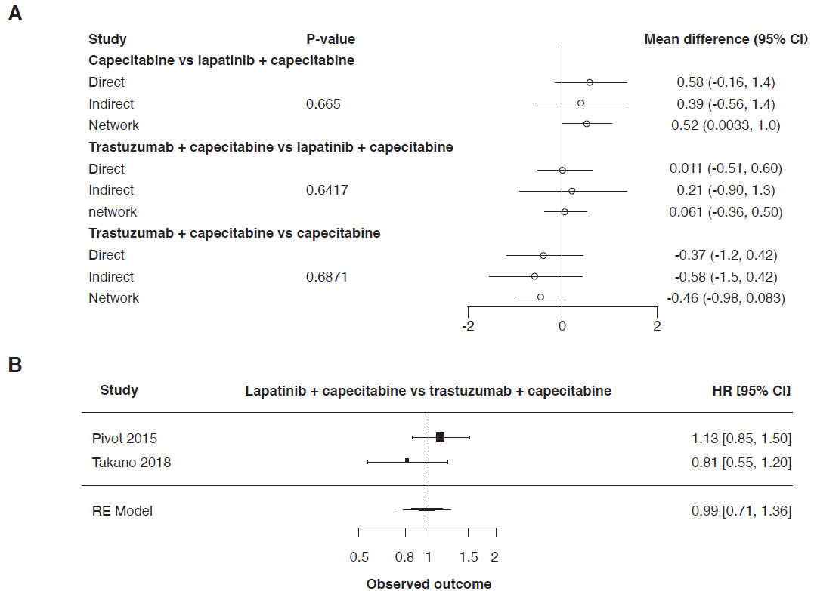Higgins I² = 44.563%; Cochran’s Q = 1.804 (P = 0.179).
CI, credible interval; HR, hazard ratio; PFS, progression-free survival; RE, random effects; T-DM1, trastuzumab emtansine.

Supplementary Figure 4. SUCRA scores for Bayesian fixed-effects analysis of (A) PFS hazard ratios and (B) differences in mean PFS based on fractional polynomial NMA (with anchoring). 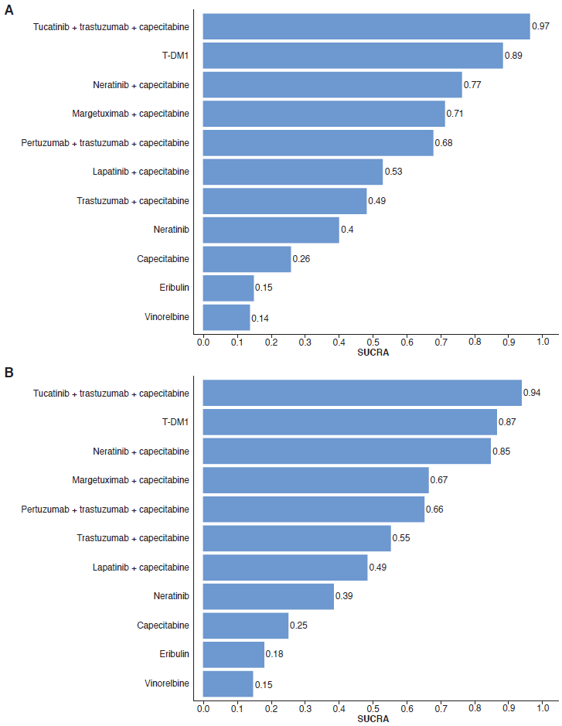
NMA, network meta-analysis; PFS, progression-free survival; SUCRA, surface under the cumulative rankogram; T-DM1, trastuzumab emtansine.

Supplementary Figure 5. Bayesian random-effects pairwise comparisons. (A) PFS hazard ratios. (B) Differences in mean PFS based on fractional polynomial NMA (with anchoring).
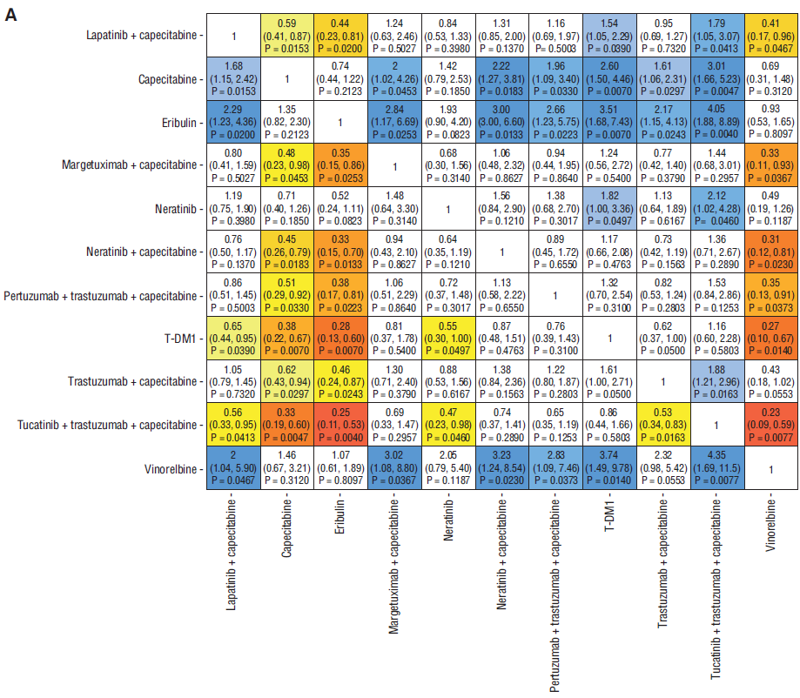
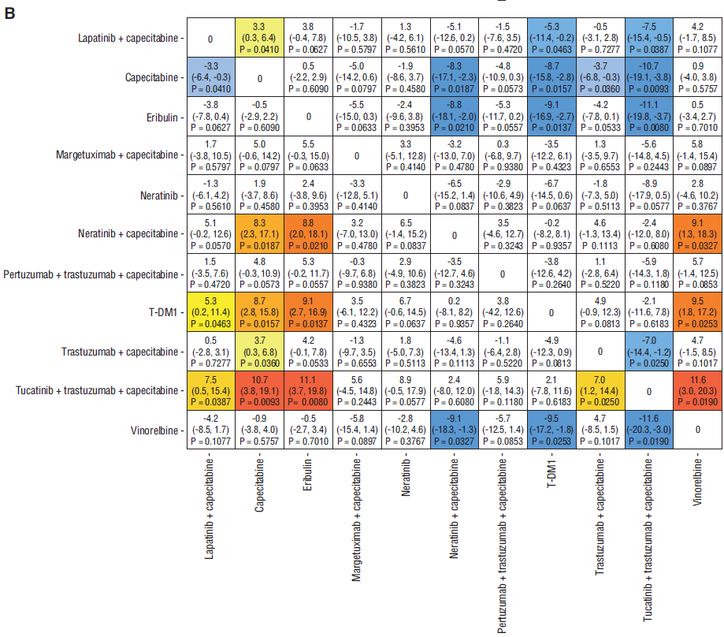
NMA, network meta-analysis; PFS, progression-free survival; T-DM1, trastuzumab emtansine.

Supplementary Figure 6. Log(-log(survival)) plots and tests of non-proportionality for trials included in the fractional polynomial NMAs for (A) PFS and (B) OS.
A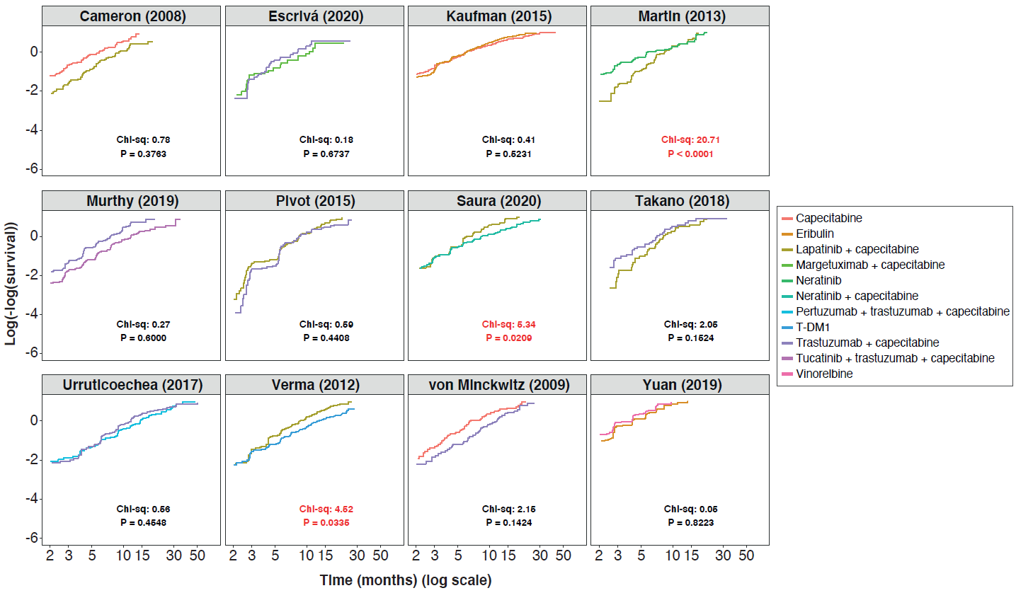B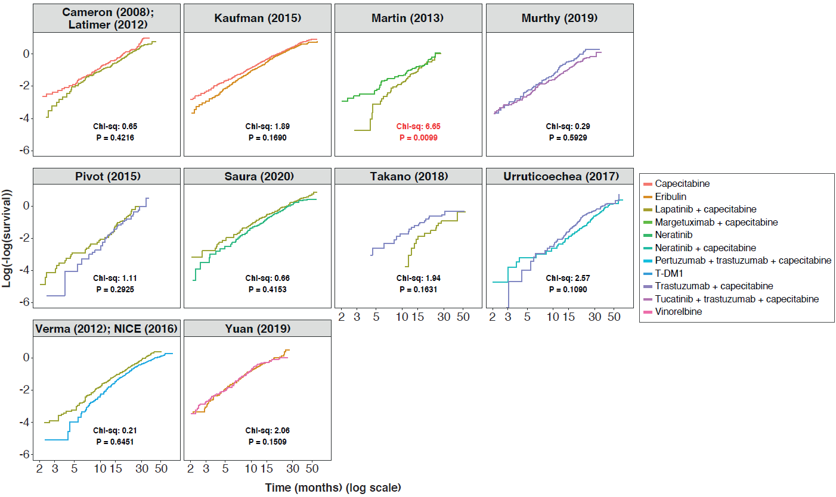
Data that meet the proportional hazards assumption will produce approximately parallel survival curves. Additionally, chi-squared tests of proportional hazards assumption are shown on each plot; comparisons that violated this assumption are indicated in red. OS, overall survival; PFS, progression-free survival; T-DM1, trastuzumab emtansine.

Supplementary Figure 7. Mean survival estimates based on fractional polynomial analysis. (A) fixed-effects estimates for PFS; (B) random-effects estimates for PFS; (C) fixed-effects estimates for OS; (D) random-effects estimates for OS.
A
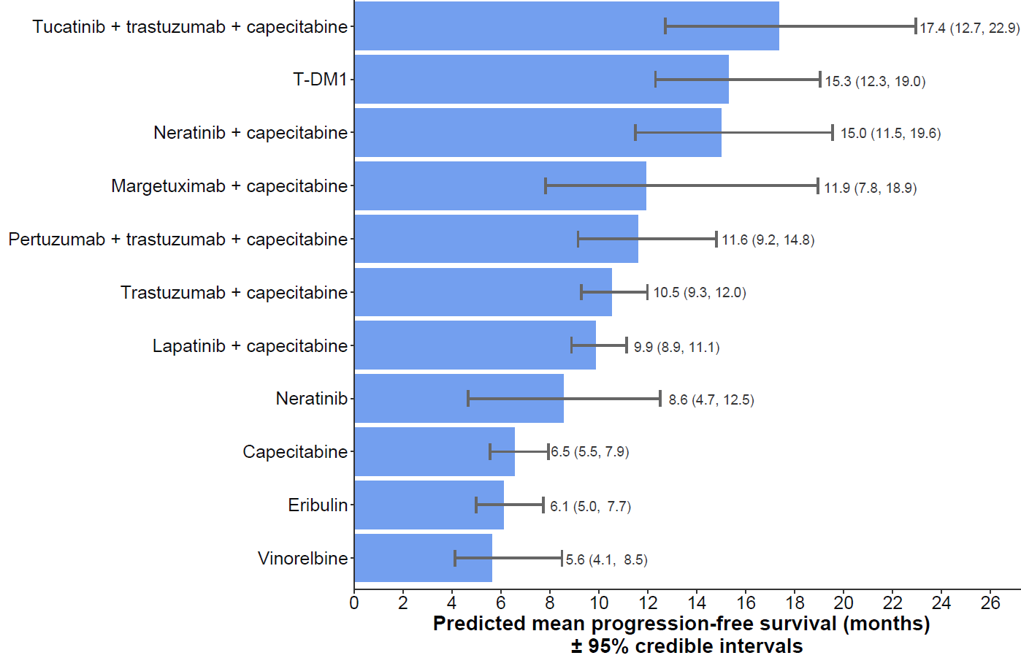
B
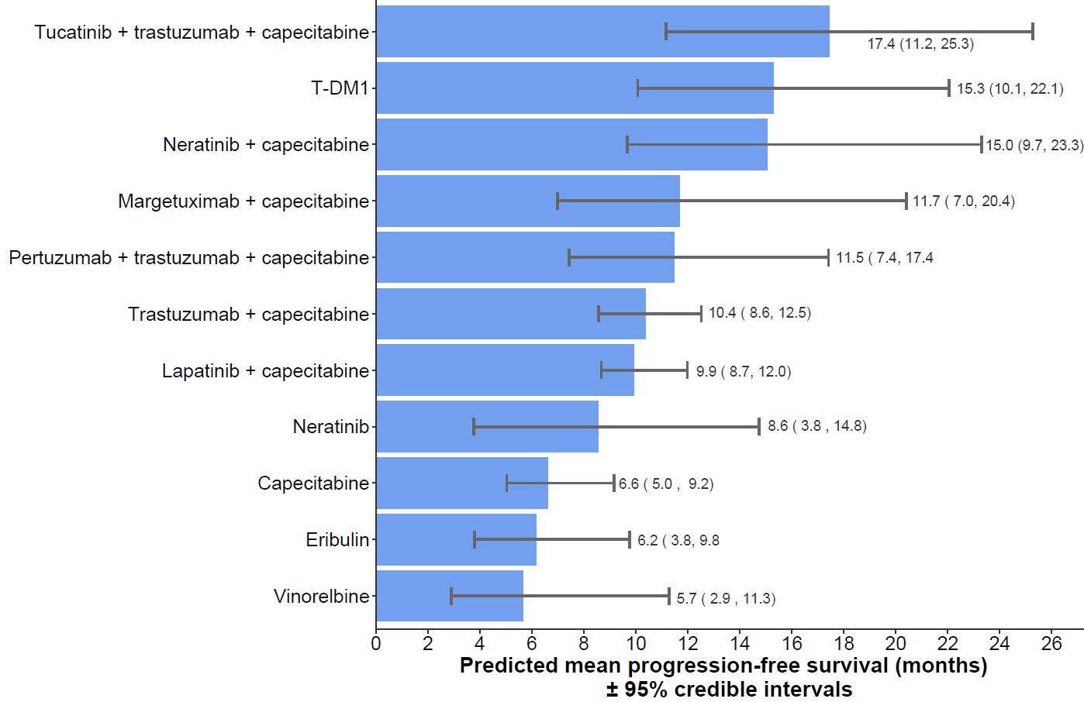
C
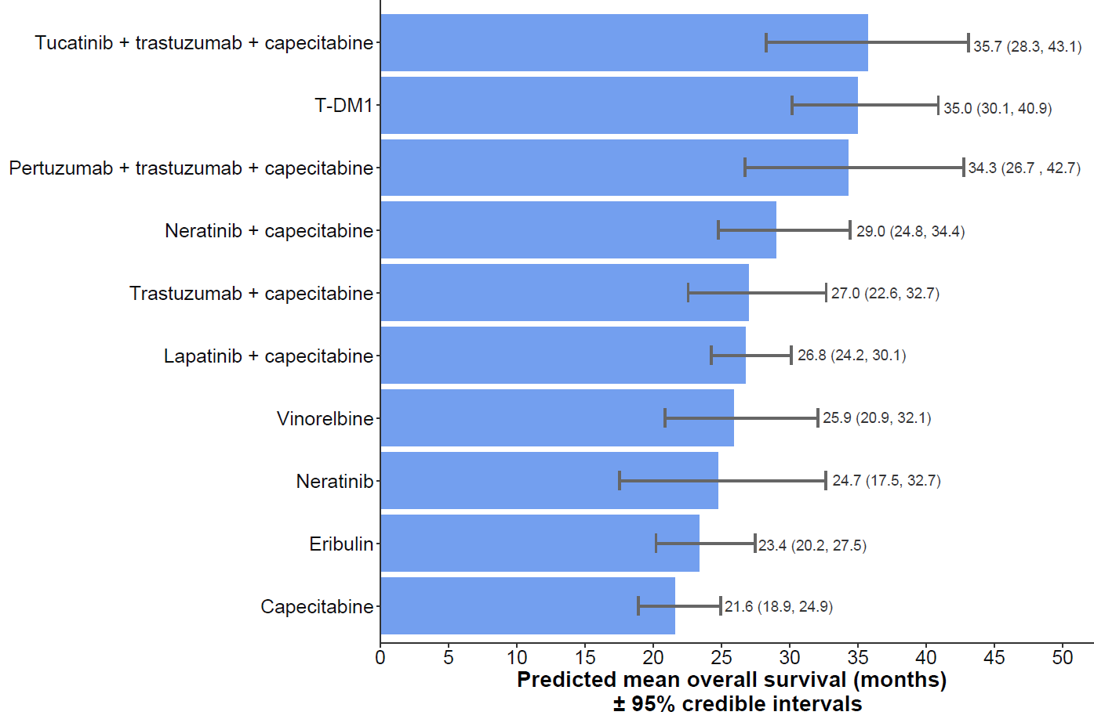
D
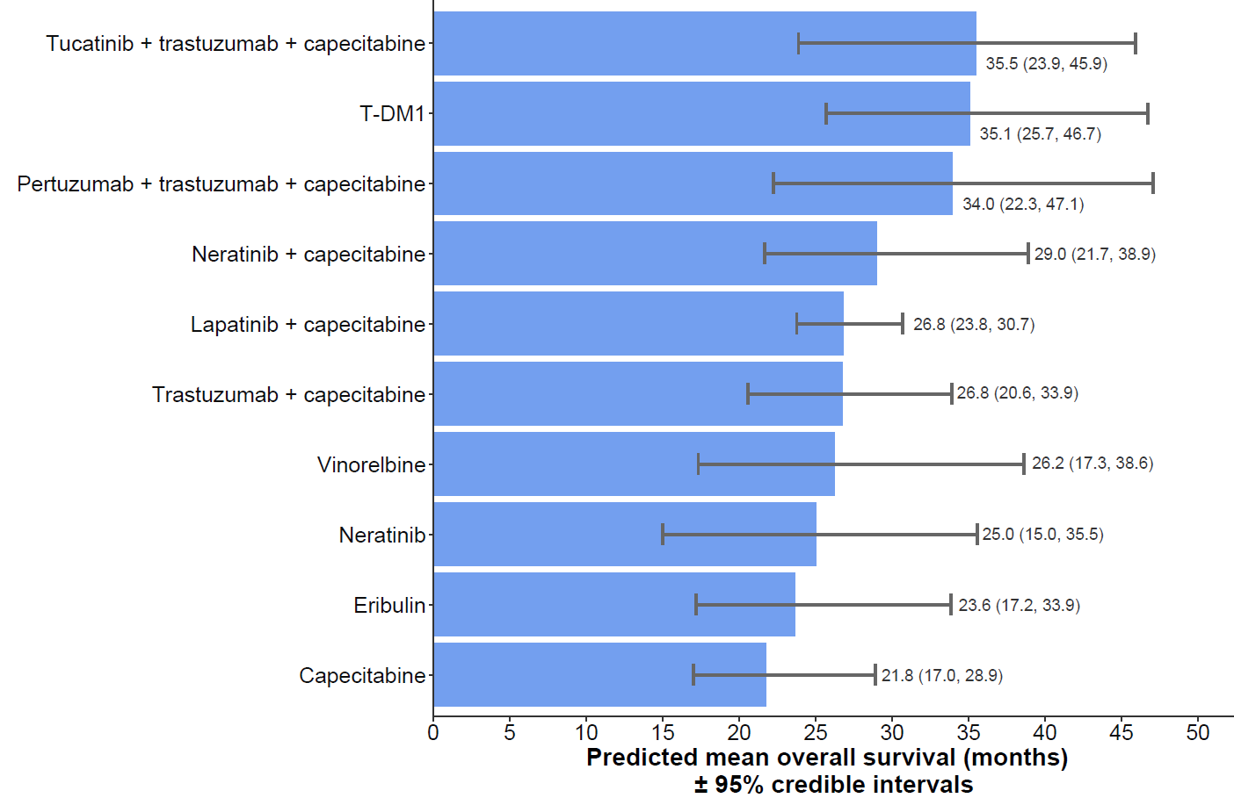

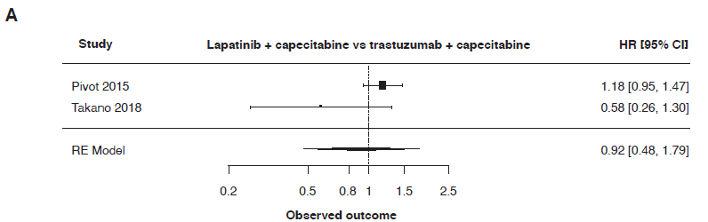
Supplementary Figure 8. Analysis of heterogeneity between duplicate comparisons of OS.
Higgins I2 = 63.738%; Cochran’s Q = 2.758 (P = 0.097). OS, overall survival; T-DM1, trastuzumab emtansine.

Supplementary Figure 9. SUCRA scores for Bayesian fixed-effects analysis of (A) OS hazard ratios and (B) differences in mean OS based on fractional polynomial NMA (with anchoring). 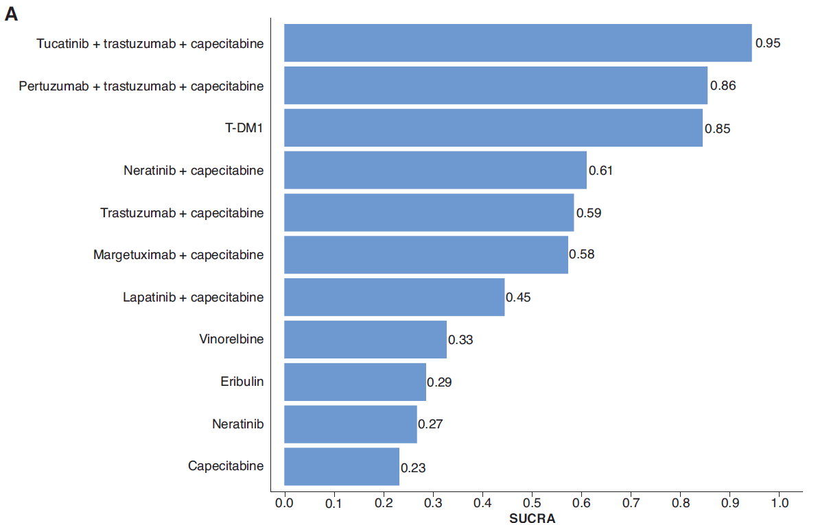
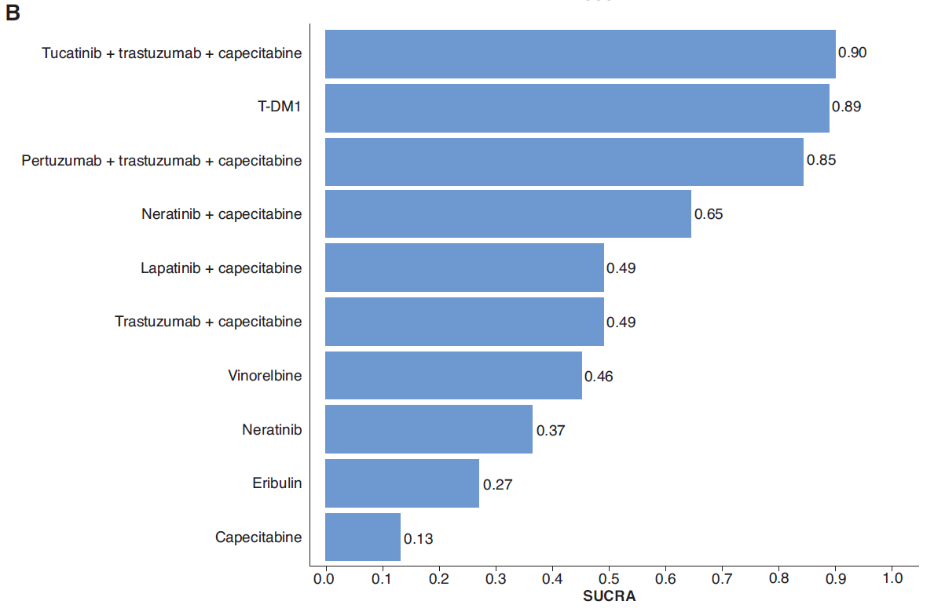
NMA, network meta-analysis; OS, overall survival; PFS, progression-free survival; SUCRA, surface under the cumulative rankogram; T-DM1, trastuzumab emtansine.

Supplementary Figure 10. Bayesian random-effects pairwise comparisons. (A) OS hazard ratios. (B) Differences in mean OS based on fractional polynomial NMA (with anchoring).
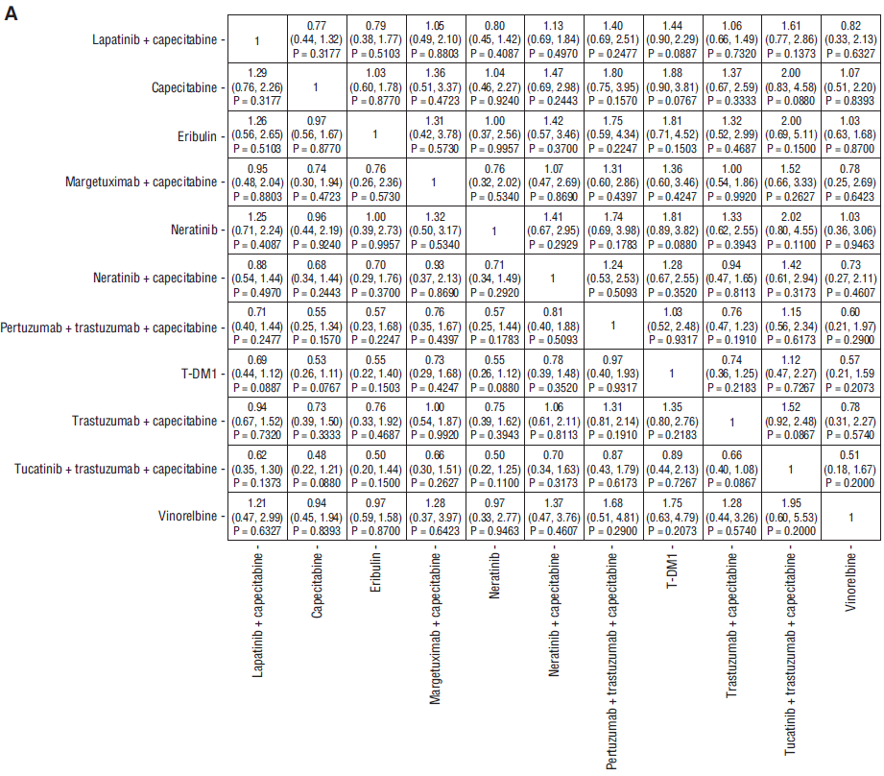
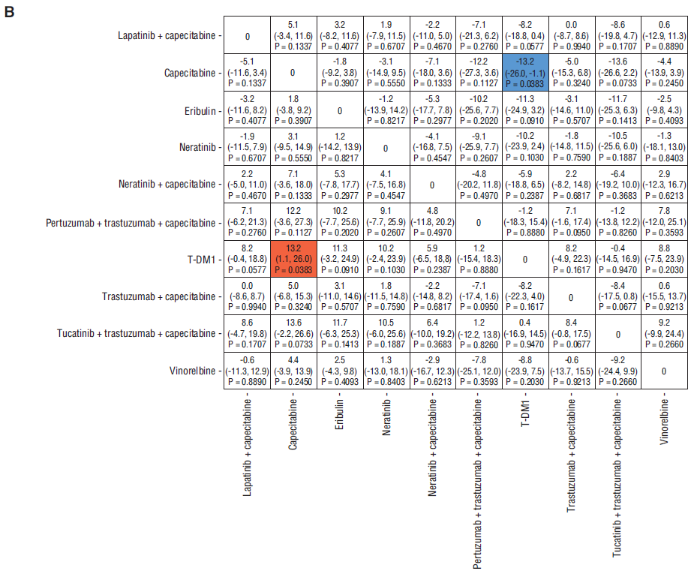
NMA, network meta-analysis; OS, overall survival.

