Supplemental Figures

Supplemental figure 1: Cohort attrition
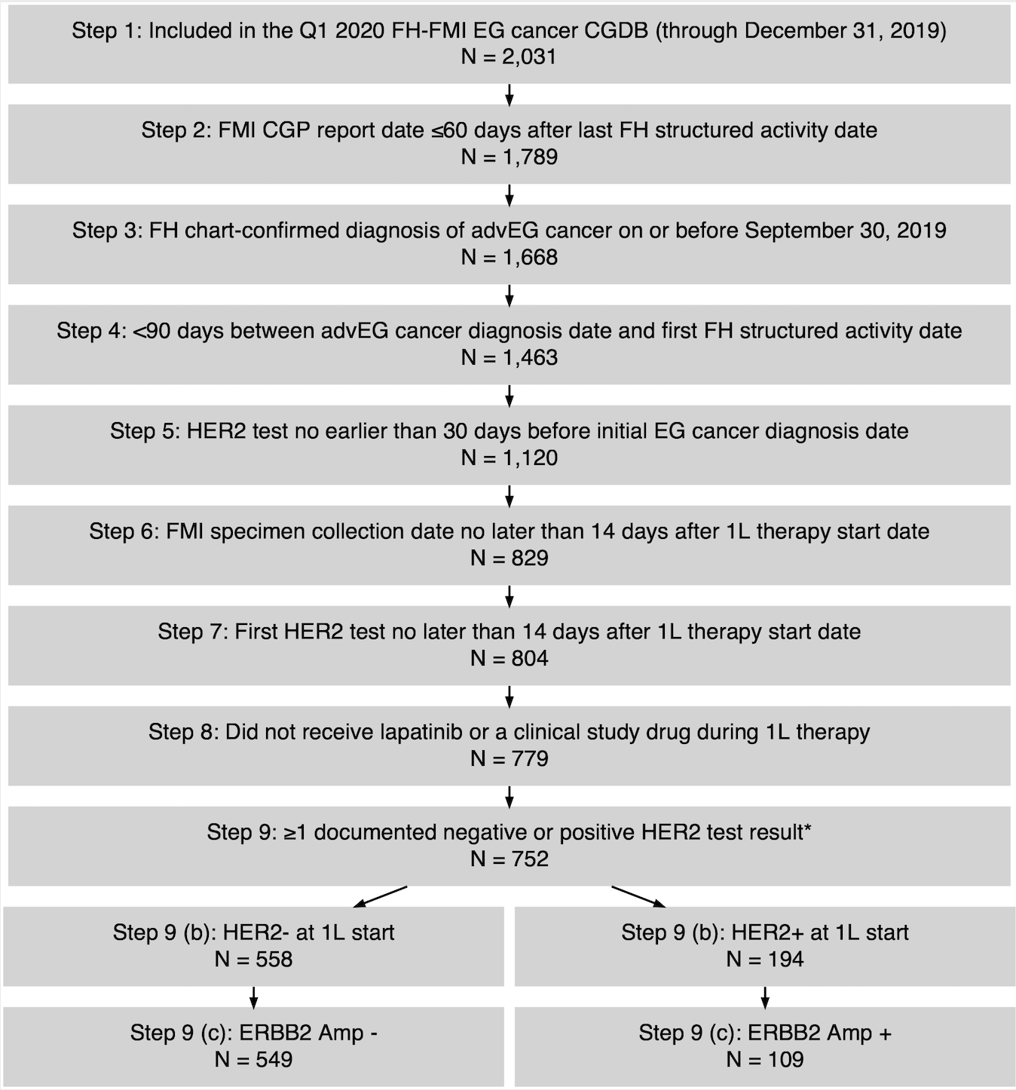
*Abstracted HER2 test result for IHC, ISH, or method NOS.
Abbreviations: 1L, first-line; adv, advanced; CGDB, clinico-genomic database; CGP, comprehensive genomic profiling; FH, Flatiron Health; FMI, Foundation Medicine Inc; EG, esophagogastric; HER2, human epidermal growth factor receptor-2; IHC, immunohistochemistry; ISH, in situ hybridization; NOS, not otherwise specified; Q1, first quarter.

Supplemental Figure 2: TTD and OS by IHC status for HER2 ISH+ patients with IHC results (n = 38)

TTD
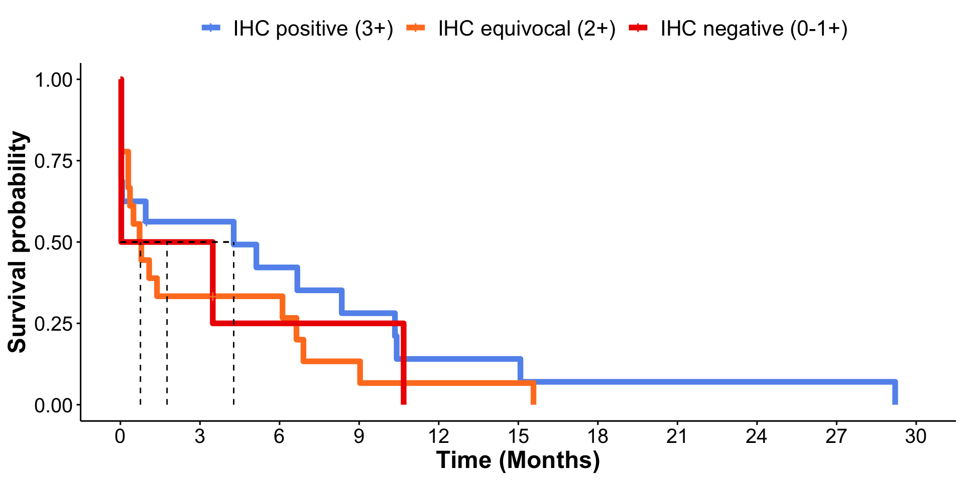

Survival Table
Group | Patients | Number of patients | Median TTD | 95% CI (lower) | 95% CI (upper)
IHC positive (3+) | 16 | 15 | 4.27 | 0.03 | 15.08
IHC equivocal (2+) | 18 | 17 | 0.76 | 0.30 | 6.90
IHC negative (0-1+) | 4 | 4 | 1.76 | 0.03 | NA
Abbreviations: CI, confidence interval; IHC, immunohistochemistry; NA, not applicable; OS, overall survival; TTD, time-to-treatment discontinuation.

OS
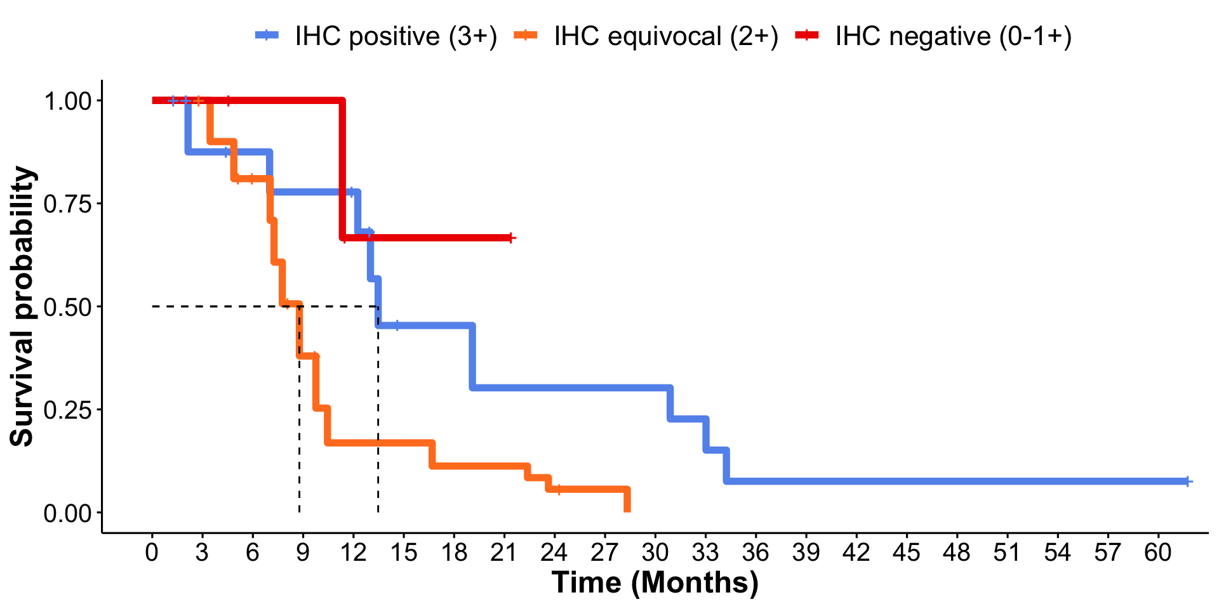
Survival Table
Group | Patients | Number of patients | Median OS | 95% CI (lower) | 95% CI (upper)
IHC positive (3+) | 16 | 9 | 13.47 | 12.25 | NA
IHC equivocal (2+) | 18 | 12 | 8.77 | 7.03 | 22.37
IHC negative (0-1+) | 4 | 1 | NA | 11.33 | NA
Abbreviations: CI, confidence interval; IHC, immunohistochemistry; NA, not applicable; OS, overall survival; TTD, time-to-treatment discontinuation.

Supplemental figure 3: TTD and OS by KRAS status
TTD
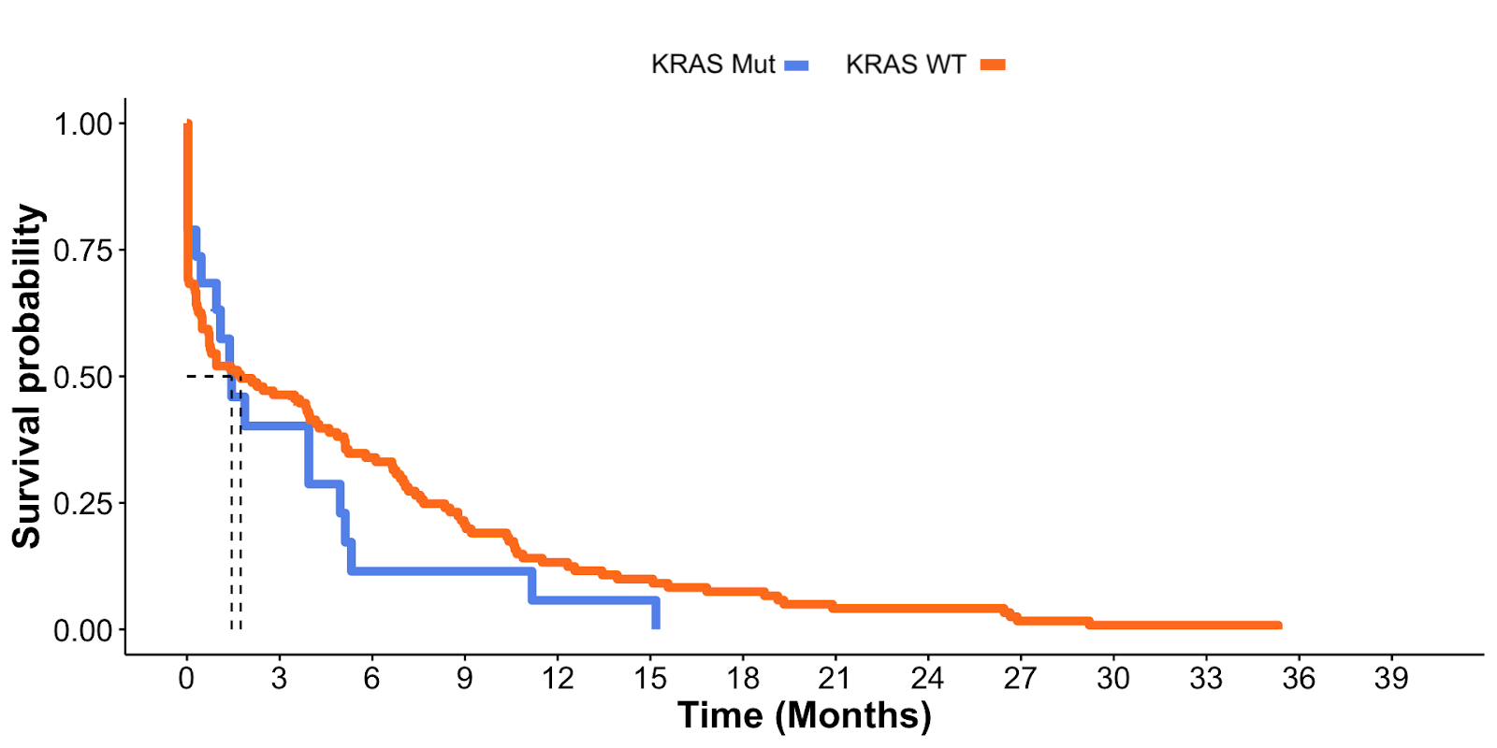
Survival Table
Group | Patients | Number of patients | Median TTD | 95% CI (lower) | 95% CI (upper)
KRAS mut | 19 | 18 | 1.45 | 0.95 | 5.13
KRAS WT | 123 | 122 | 1.74 | 0.72 | 4.27
Abbreviations: CI, confidence interval; mut, mutated; WT, wild type.

OS
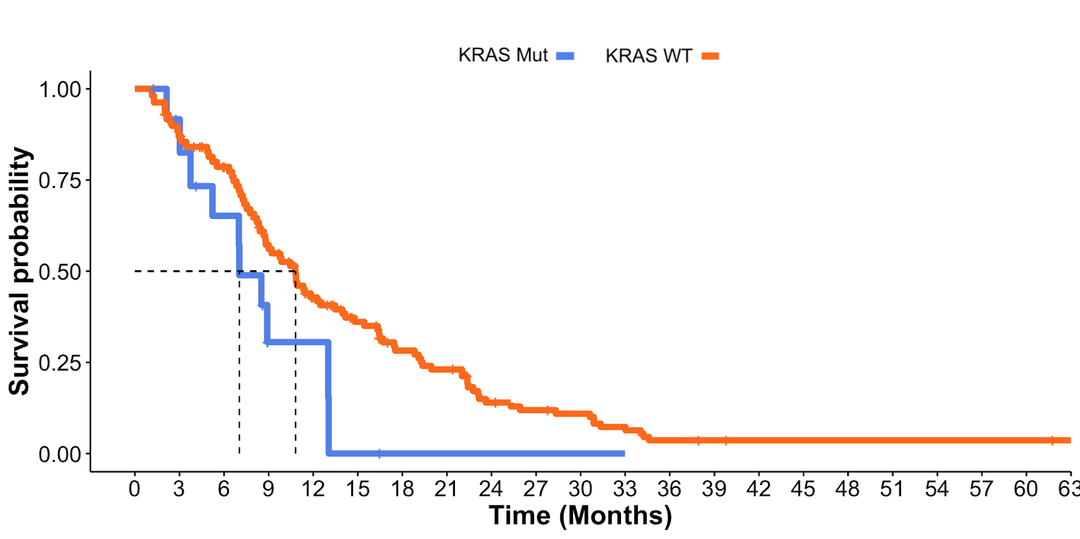
Survival Table
Group | Patients | Number of patients | Median OS | 95% CI (lower) | 95% CI (upper)
KRAS mut | 19 | 13 | 7.03 | 5.22 | NA
KRAS WT | 123 | 83 | 10.81 | 8.67 | 14.16
Abbreviations: CI, confidence interval; mut, mutated; WT, wild type.

