Supplemental Figures

Supplemental Figure 1. PRISMA Diagram
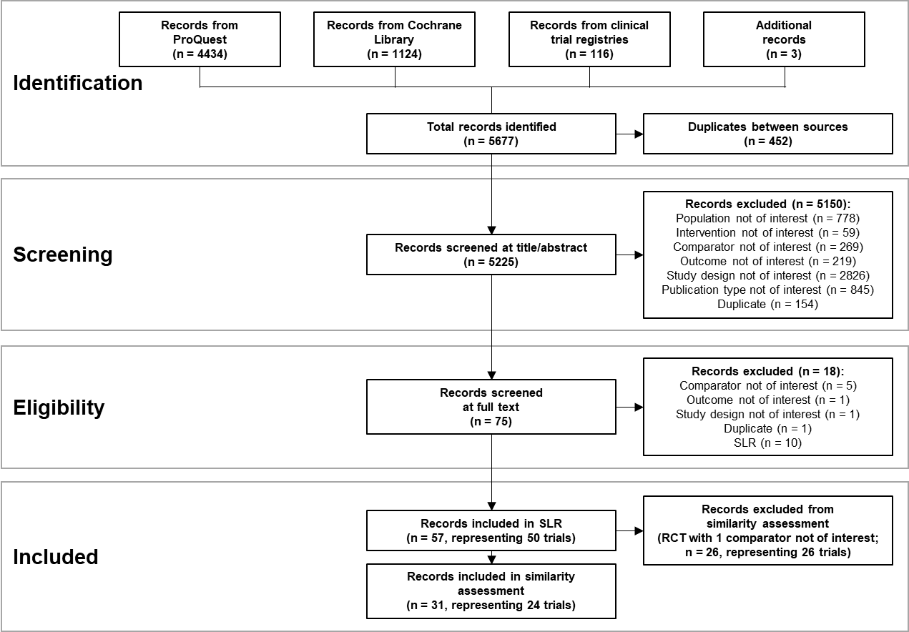
Abbreviations: PRISMA, Preferred Reporting Items for Systematic Reviews and Meta-Analyses; RCT, randomized controlled trial; SLR, systematic literature review.

Supplemental Figure 2. Hepatitis B and Hepatitis C Prevalence Based on Asia-Pacific Enrollment
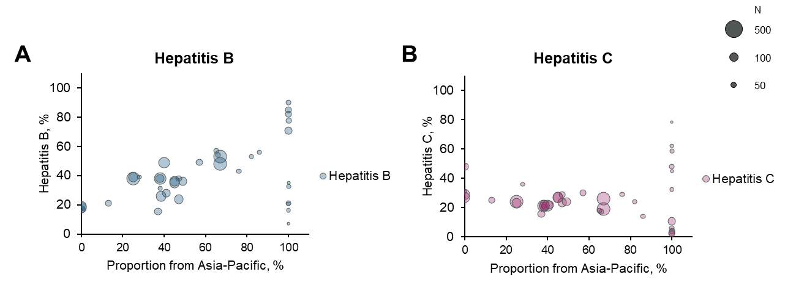
Abbreviations: ITT, intent to treat.
Markers indicate proportion of patients in each arm from Asia-Pacific versus hepatitis B prevalence(A) or hepatitis C prevalence (B) from each trial arm. The bubble size indicates the size of the ITT population.

Supplemental Figure 3. ECOG Performance Status in 2L Trials
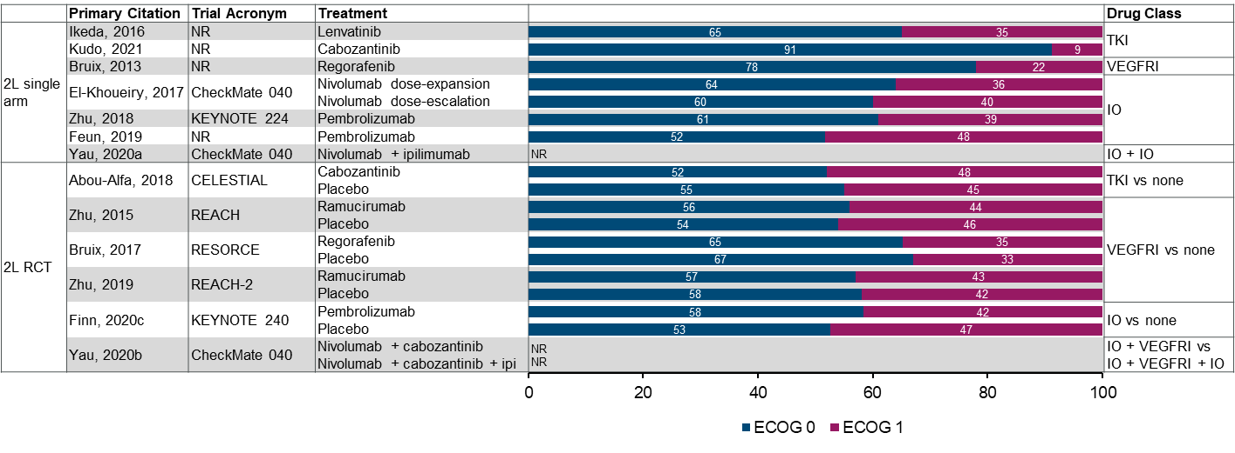
Abbreviations: 1L, first-line; BSC, best supportive care; ECOG; Eastern Cooperative Oncology Group; IO, immuno-oncology agent; NR, not reported; RCT, randomized controlled trial; TKI, tyrosine kinase inhibitor; VEGFRI, vascular endothelial growth factor receptor inhibitor.

Supplemental Figure 4. BCLC Stage in 1L and 2L Trials
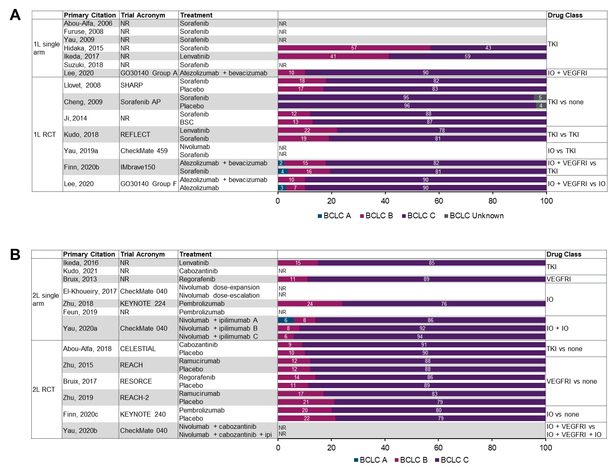
Abbreviations: 1L, first-line; 2L, second-line; BCLC, Barcelona Clinic Liver Cancer; BSC, best supportive care; IO, immuno-oncology agent; ipi, ipilimumab; NR, not reported; RCT, randomized controlled trial; TKI, tyrosine kinase inhibitor; VEGFRI, vascular endothelial growth factor receptor inhibitor.
A, 1L setting; B, 2L setting.

Supplemental Figure 5. Child-Pugh Class in 1L and 2L Trials
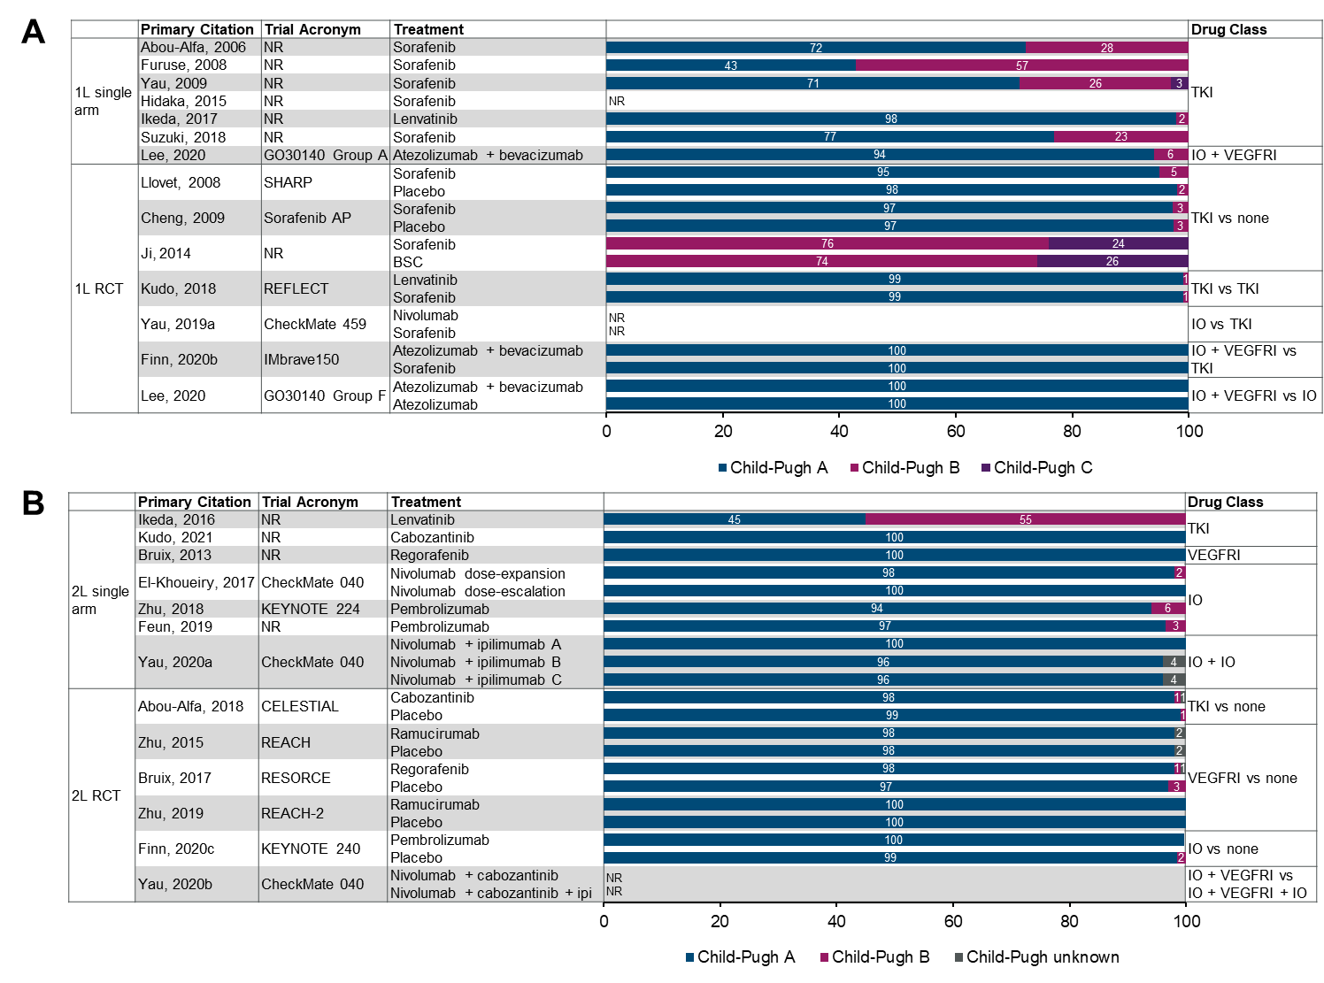
Abbreviations: 1L, first-line; 2L, second-line; BSC, best supportive care; IO, immuno-oncology agent; ipi, ipilimumab; NR, not reported; RCT, randomized controlled trial; TKI, tyrosine kinase inhibitor; VEGFRI, vascular endothelial growth factor receptor inhibitor.
A, 1L setting; B, 2L setting.

Supplemental Figure 6. Median Survival in 2L Trials

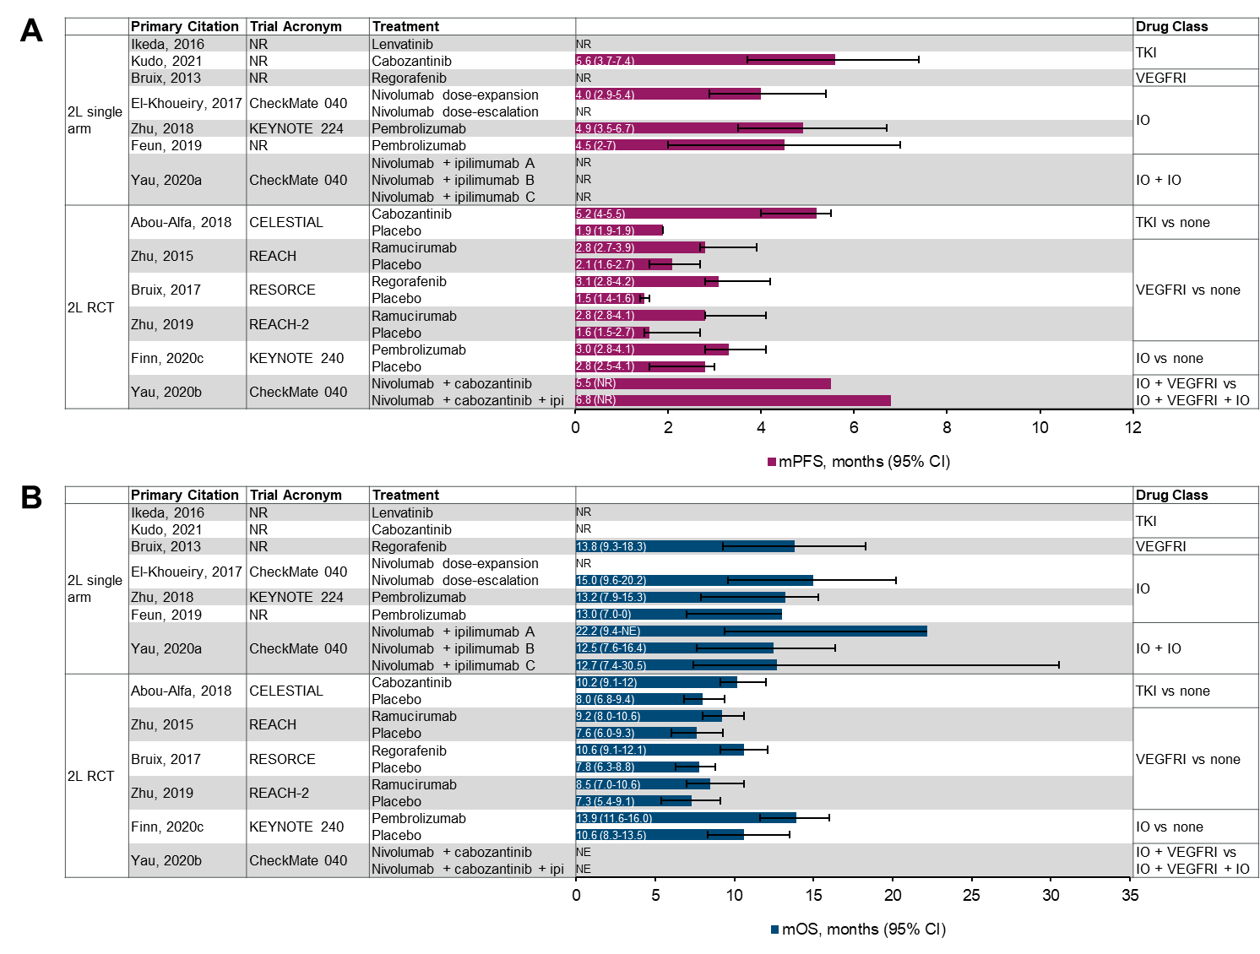
Abbreviations: 2L, second-line; BSC, best supportive care; IO, immuno-oncology agent; NE, not evaluable; NR, not reported; mOS, median overall survival; mPFS, median progression-free survival; RCT, randomized controlled trial; TKI, tyrosine kinase inhibitor; VEGFRI, vascular endothelial growth factor receptor inhibitor.
A, mPFS; B, OS.

Supplemental Figure 7. Within-Trial Survival Comparisons in 2L Trials
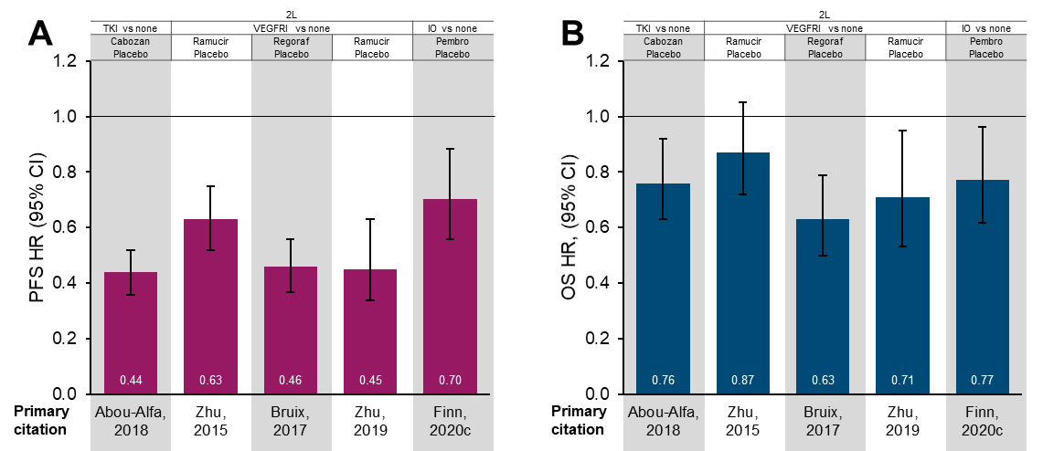
Abbreviations: 2L, second-line; BSC, best supportive care; cabozan; cabozantinib; CI, confidence interval; HR, hazard ratio; IO, immuno-oncology agent; NS, not significant; OS, overall survival; pembro, pembrolizumab; PFS, progression-free survival; ramucir, ramucirumab; regoraf, regorafenib; TKI, tyrosine kinase inhibitor; VEGFRI, vascular endothelial growth factor receptor inhibitor.
A, PFS; B, OS.

Supplemental Figure 8. Performance Status and Disease Stage Versus mOS in 1L Trials
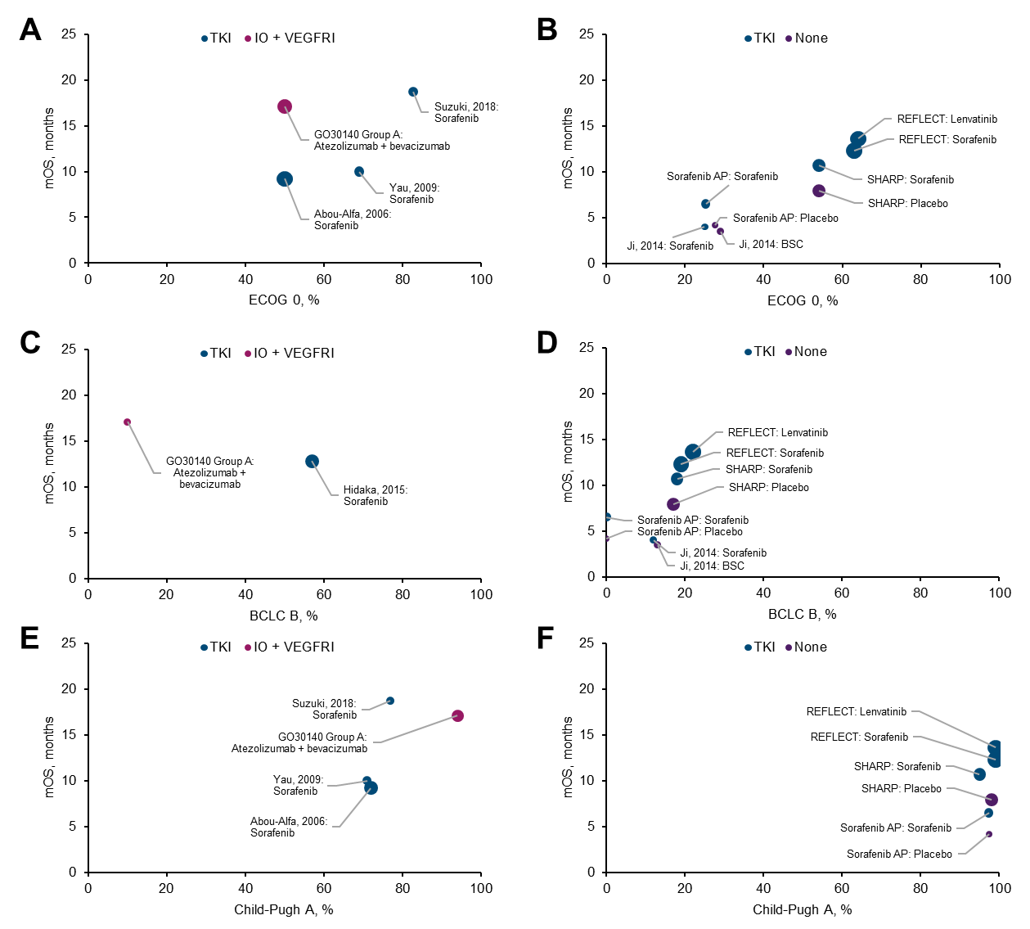
Abbreviations: 1L, first-line; BCLC, Barcelona Clinic Liver Cancer; ECOG; Eastern Cooperative Oncology Group; IO, immuno-oncology agent; mOS, median overall survival; RCT, randomized controlled trial; TKI, tyrosine kinase inhibitor; VEGFRI, vascular endothelial growth factor receptor inhibitor.
A-B, ECOG 0 vs mOS; C-D, BCLC B vs mOS; E-F, Child-Pugh A vs mOS. A, C, and E, single arm trials; B, D, and F, RCTs. Bubble size indicates the relative sample size of the trial arm.

Supplemental Figure 9. Tumor Response in 1L Trials
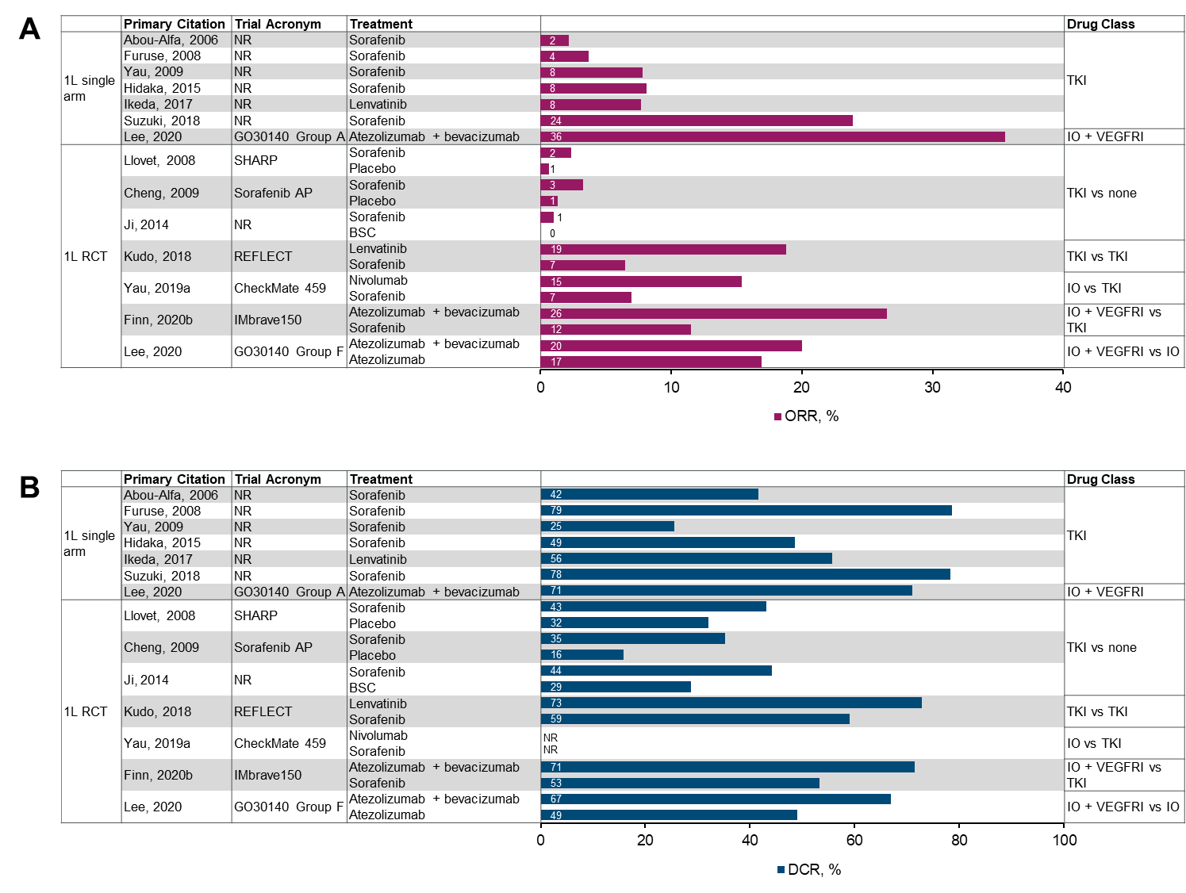
Abbreviations: 1L, first-line; BSC, best supportive care; DCR, disease control rate; IO, immuno-oncology agent; ITT, intent to treat; NE, not evaluable; NR, not reported; ORR, objective response rate; RCT, randomized controlled trial; RECIST, Response Evaluation Criteria in Solid Tumors TKI, tyrosine kinase inhibitor; VEGFRI, vascular endothelial growth factor receptor inhibitor.
Note: Percentages based on ITT population and using RECIST or RECIST 1.1 criteria, except for the studies published by Abou-Alfa, 2006 (modified World Health Organization criteria) and Hidaka, 2015 (modified RECIST).
A, ORR, %; B, DCR, %.

Supplemental Figure 10. Tumor Response in 2L Trials
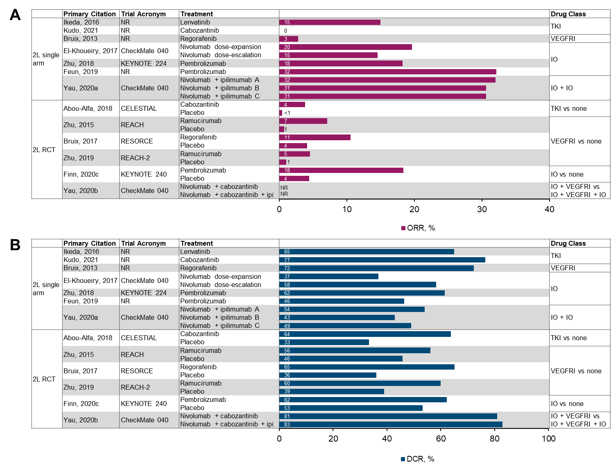
Abbreviations: 2L, second-line; BSC, best supportive care; DCR, disease control rate; IO, immuno-oncology agent; ITT, intent to treat; NR, not reported; ORR, objective response rate; RCT, randomized controlled trial; RECIST, Response Evaluation Criteria in Solid Tumors TKI, tyrosine kinase inhibitor; VEGFRI, vascular endothelial growth factor receptor inhibitor.
Note: Percentages based on ITT population and using RECIST or RECIST 1.1 criteria, except for the studies published by Bruix, 2013 and Bruix, 2017 (modified RECIST).
A, ORR, %; B, DCR, %.

Supplemental Figure 11. Grade ≥3, Serious, and Discontinuation-Related Treatment-Emergent Adverse Events in 2L Trials
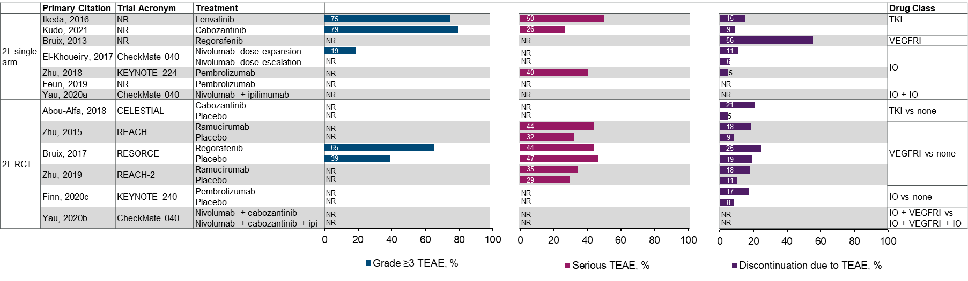
Abbreviations: 2L, second-line; BSC, best supportive care; IO, immuno-oncology agent; ipi, ipilimumab; NR, not reported; RCT, randomized controlled trial; TEAE, treatment-emergent adverse events; TKI, tyrosine kinase inhibitor; VEGFRI, vascular endothelial growth factor.

Supplemental Figure 12. Treatment Networks Created by RCTs
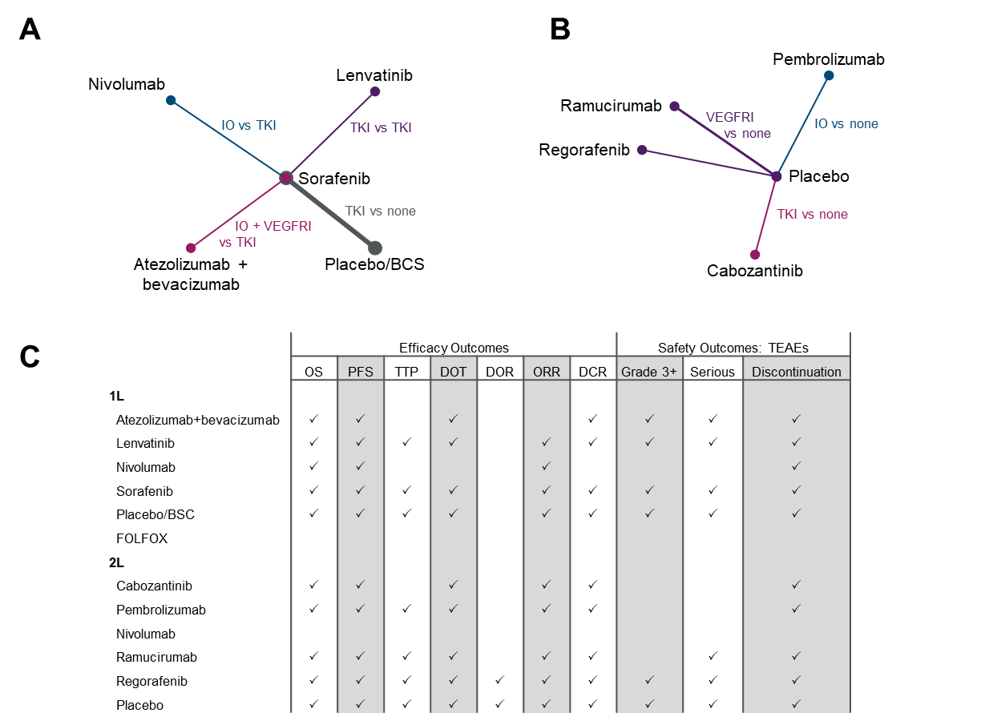
Abbreviations: 1L, first-line; 2L, second-line; BSC, best supportive care; DOR, duration of response; DOT, duration of treatment; IO, immuno-oncology agent; NMA, network meta-analysis; OS, overall survival; PFS, progression-free survival; RCT, randomized controlled trial; TEAE, treatment-emergent adverse events; TKI, tyrosine kinase inhibitor; TTP, time to progression; VEGFRI, vascular endothelial growth factor receptor inhibitor.
Diagrams indicate recommended treatments used in 1L RCTs (A) and 2L RCTs (B). Lines indicate direct comparisons; line thickness indicates the relative number of trials making a direct comparison. Networks represent maximum possible comparisons and do not account for outcomes not reported. C, Summary of outcomes possible to analyze via NMA for NCCN Guidelines-recommended treatments in 1L and 2L settings.

