Supplementary Figure 1. Adjusted treatment outcomes including (A) OS, (B) PFS, (C) TTD, and (D) DOR* in the overall population (≥1% PD-L1 expression; N=484). Each model controlled for the following patient characteristics: age, sex, insurance type, histology, ECOG performance status, weighted comorbidity index, bone metastasis, liver metastasis, brain metastasis, and PD-L1 expression group. 1L, first line; CR, complete response; ICI, immune checkpoint inhibitor; DOR, duration of response; ECOG, Eastern Cooperative Oncology Group; NA, not applicable; OS, overall survival; PFS, progression-free survival; PR, partial response; TTD, time to discontinuation. *Analysis only includes patients who achieved CR or PR by the end of 1L.

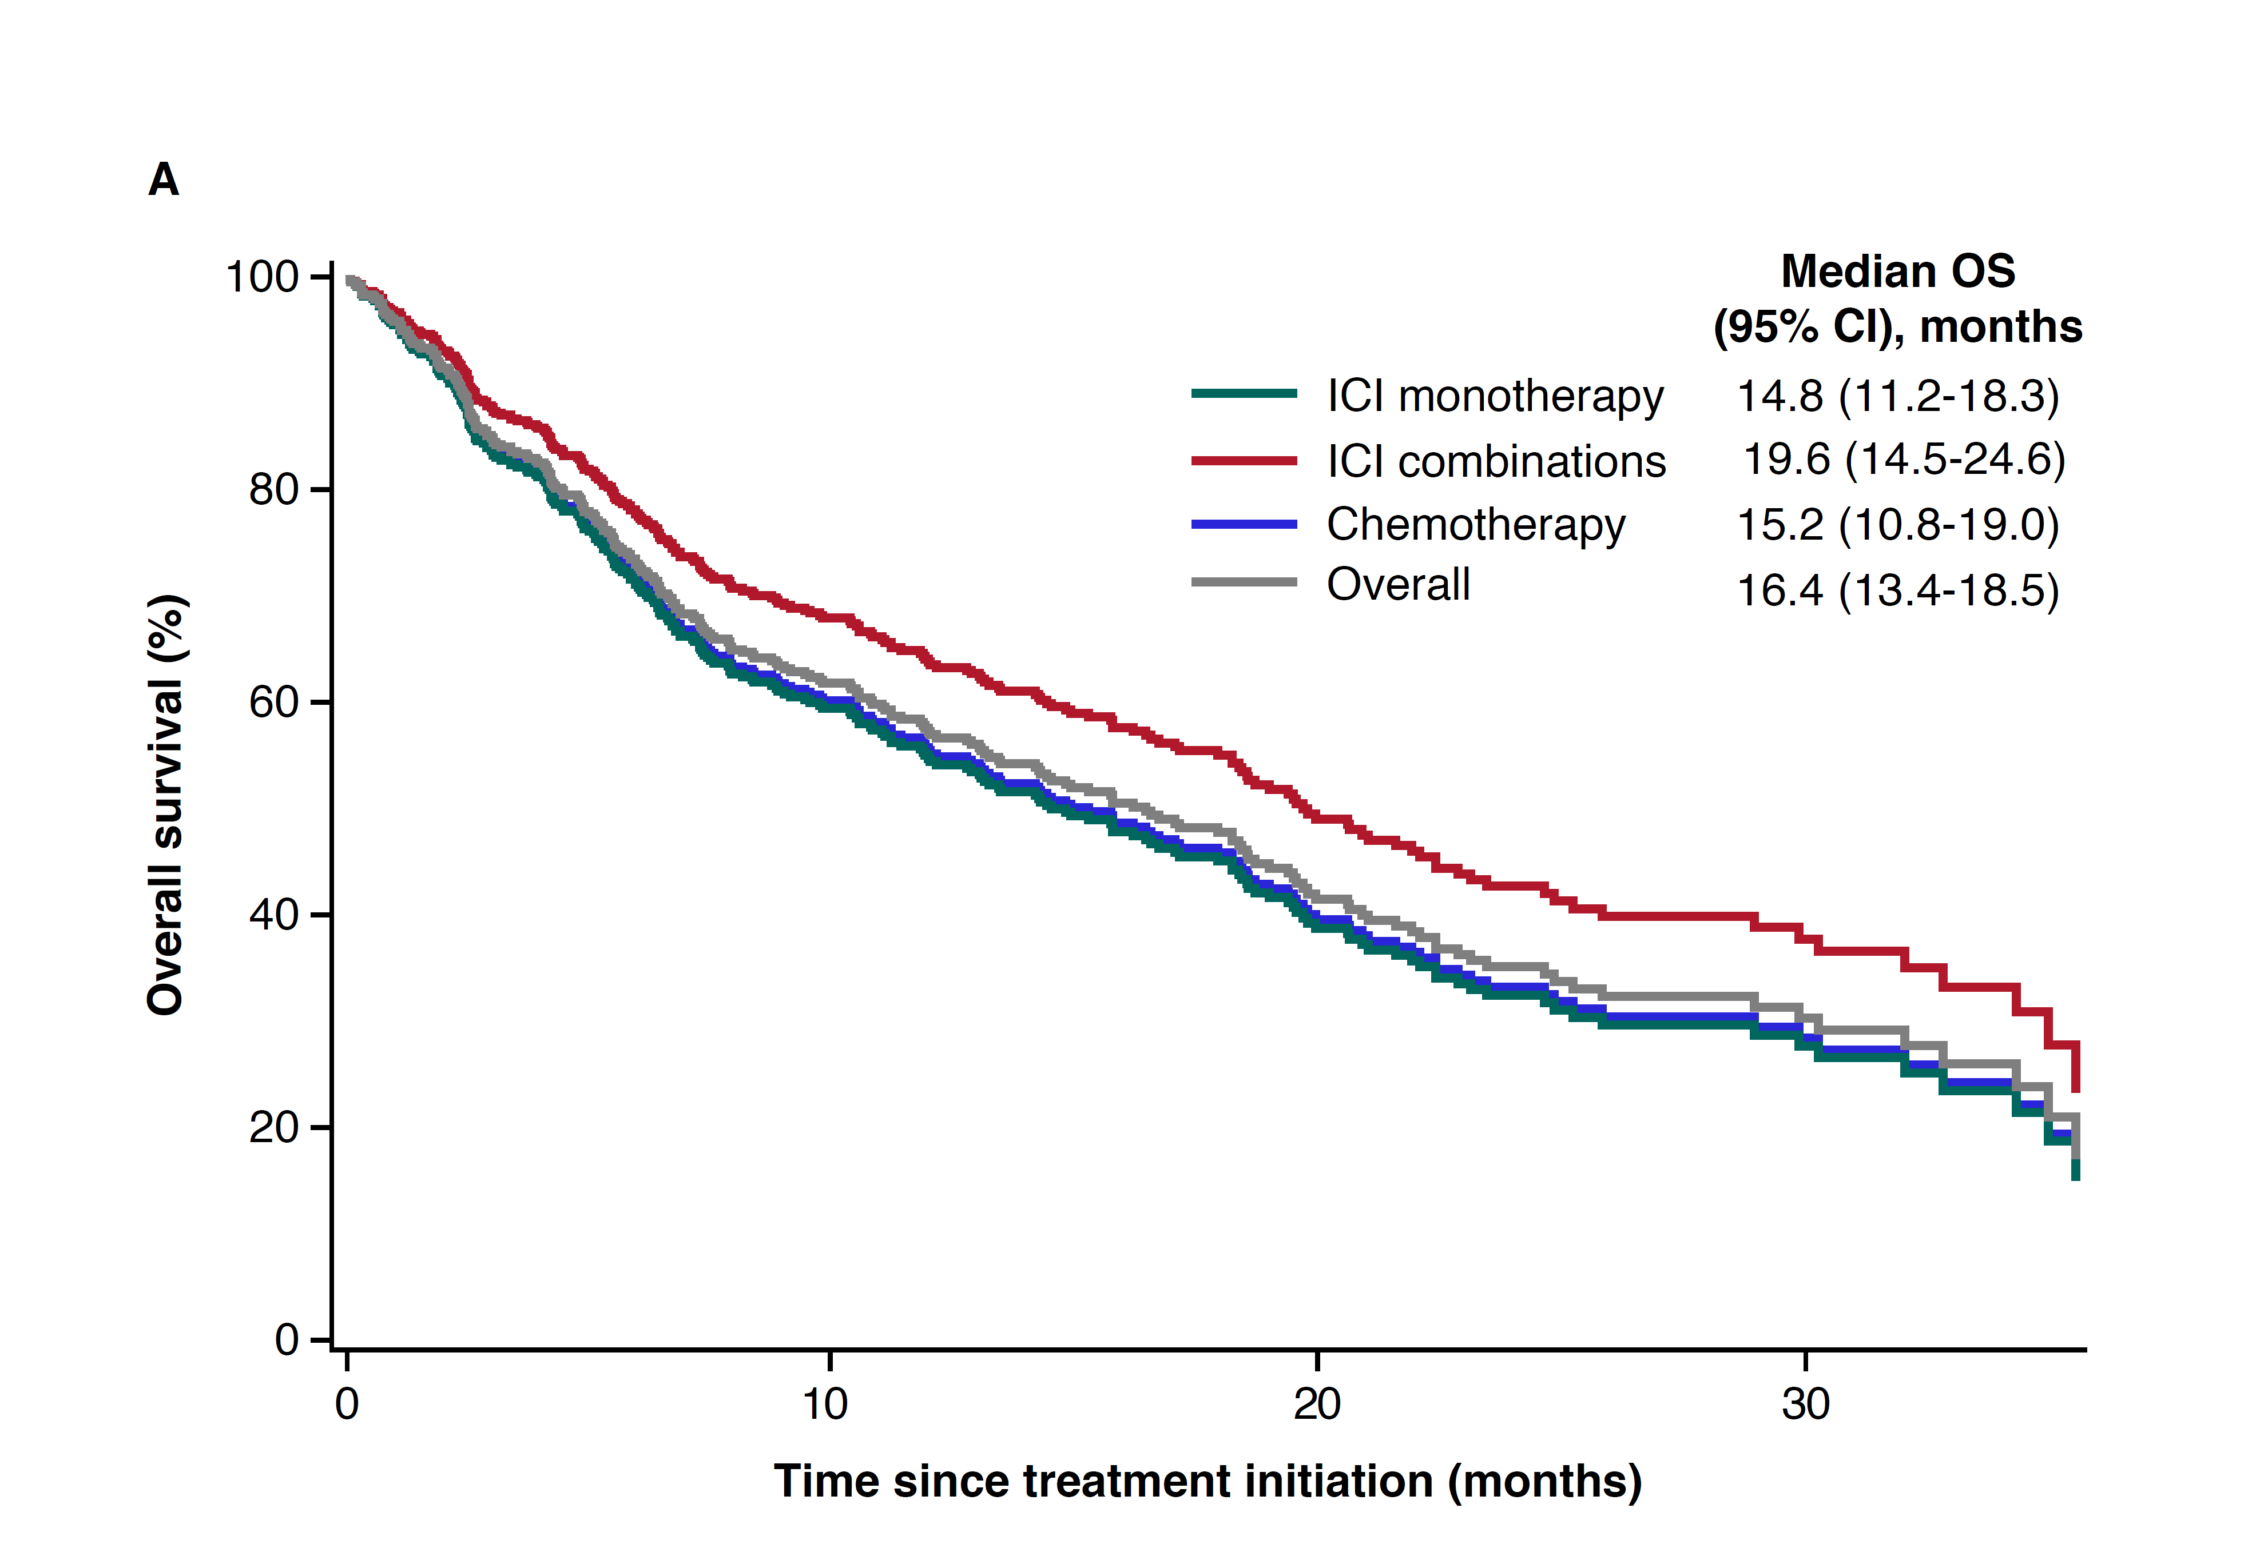
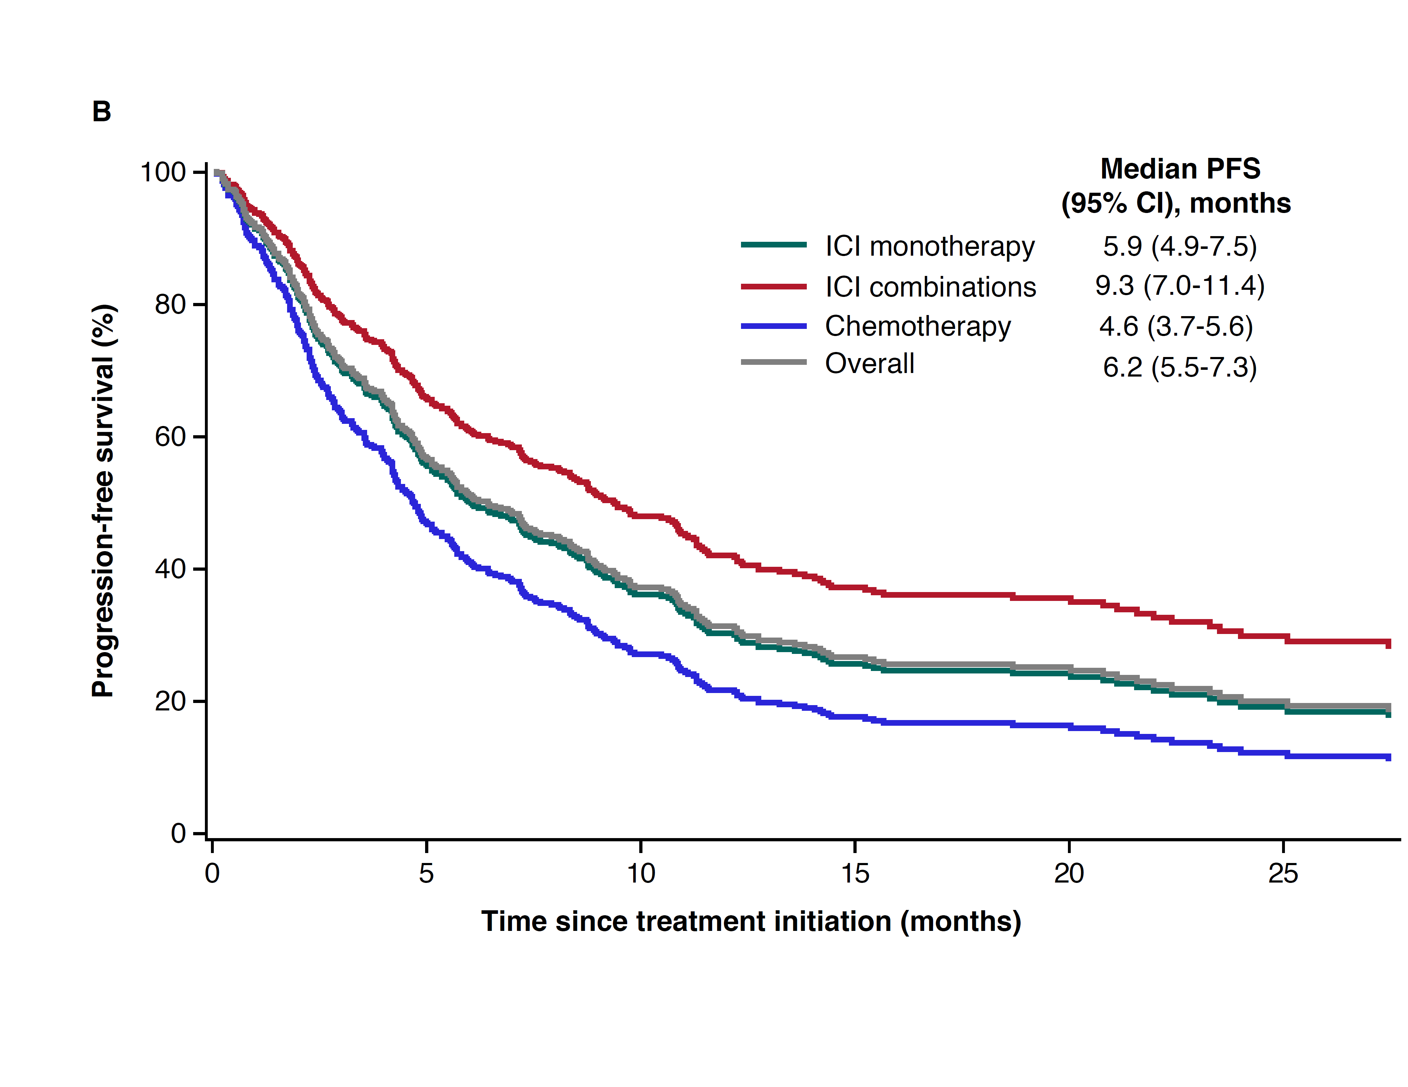

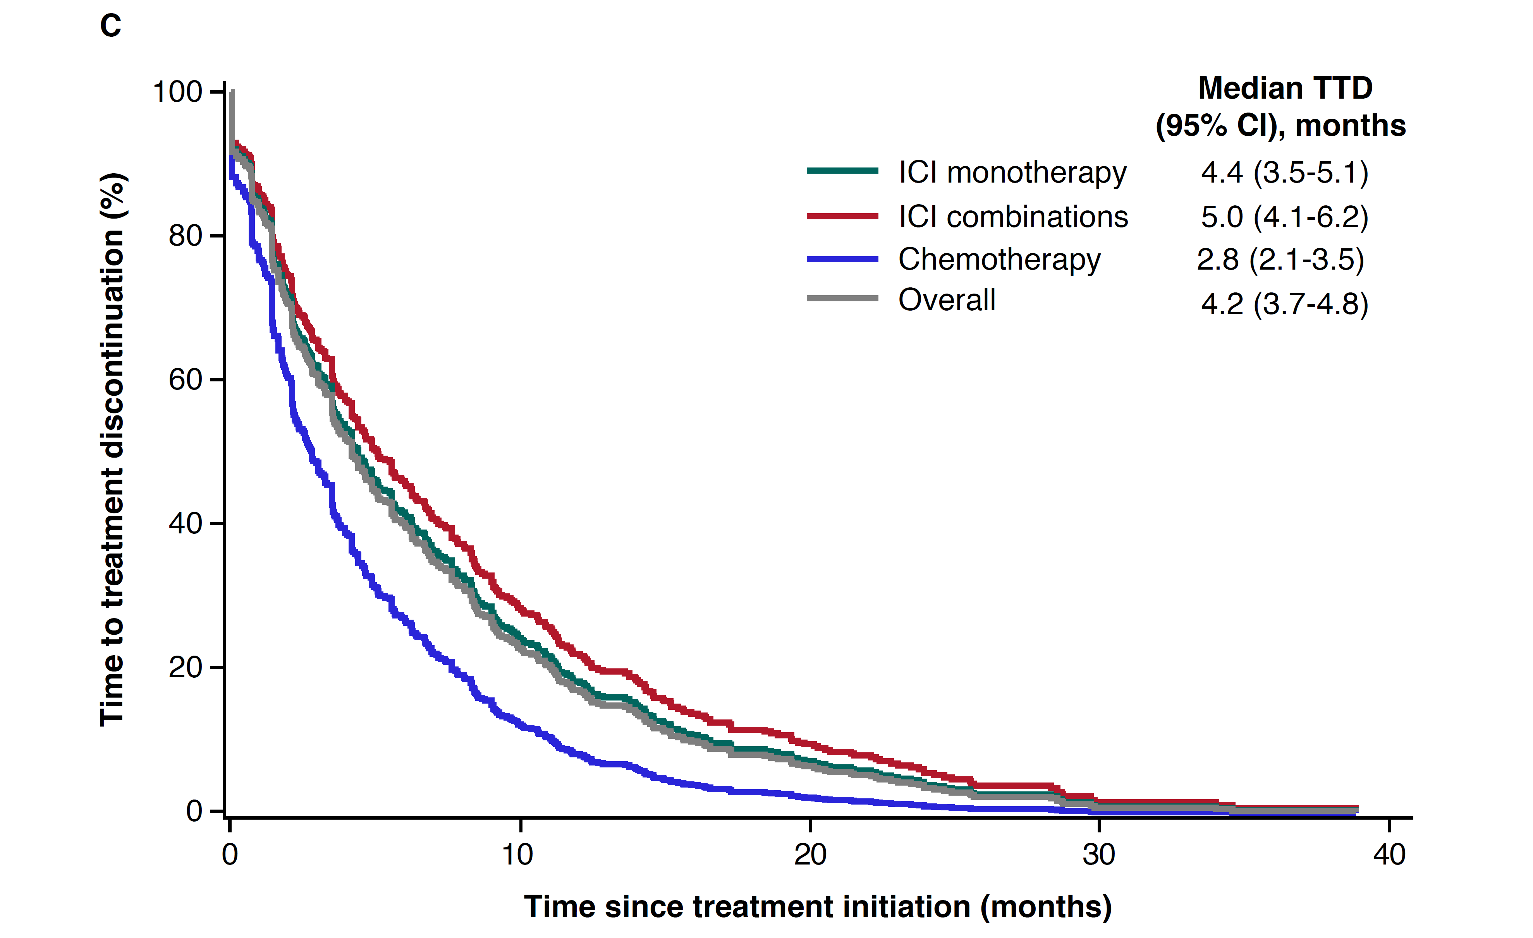
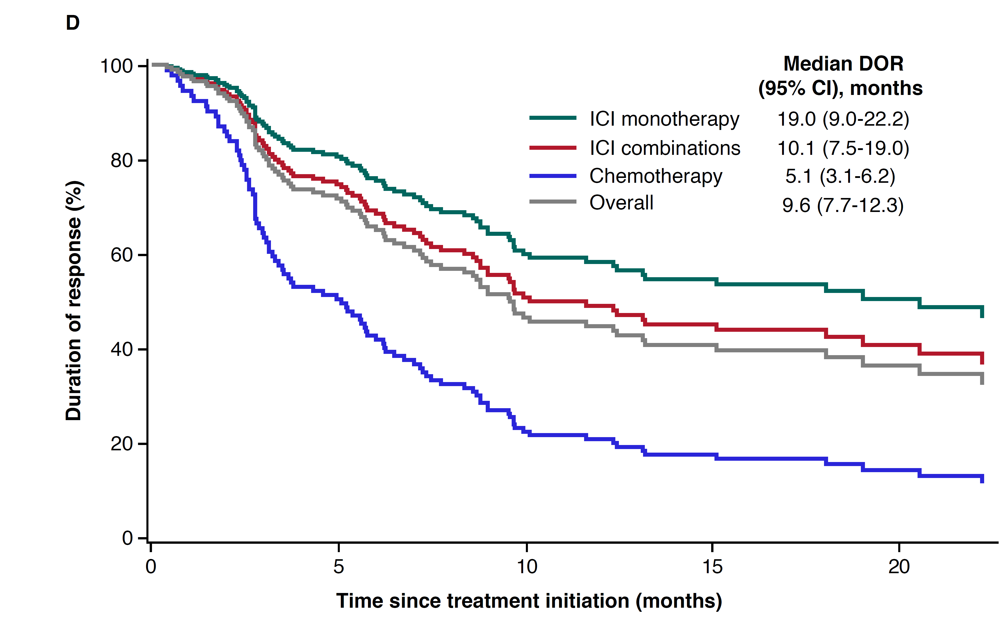

Supplementary Figure 2. Adjusted treatment outcomes, including (A) OS, (B) PFS, (C) TTD, and (D) DOR* in the low-to-moderate PD-L1 subgroup (1%-49% PD-L1 expression; N=183). Each model controlled for age, sex, insurance type, histology, ECOG performance status, weighted comorbidity index, bone metastasis, liver metastasis, and brain metastasis. 1L, first line; CR, complete response; ICI, immune checkpoint inhibitor; DOR, duration of response; ECOG, Eastern Cooperative Oncology Group; OS, overall survival; PFS, progression-free survival; PR, partial response; TTD, time to discontinuation. *Analysis only includes patients who achieved CR or PR by the end of 1L.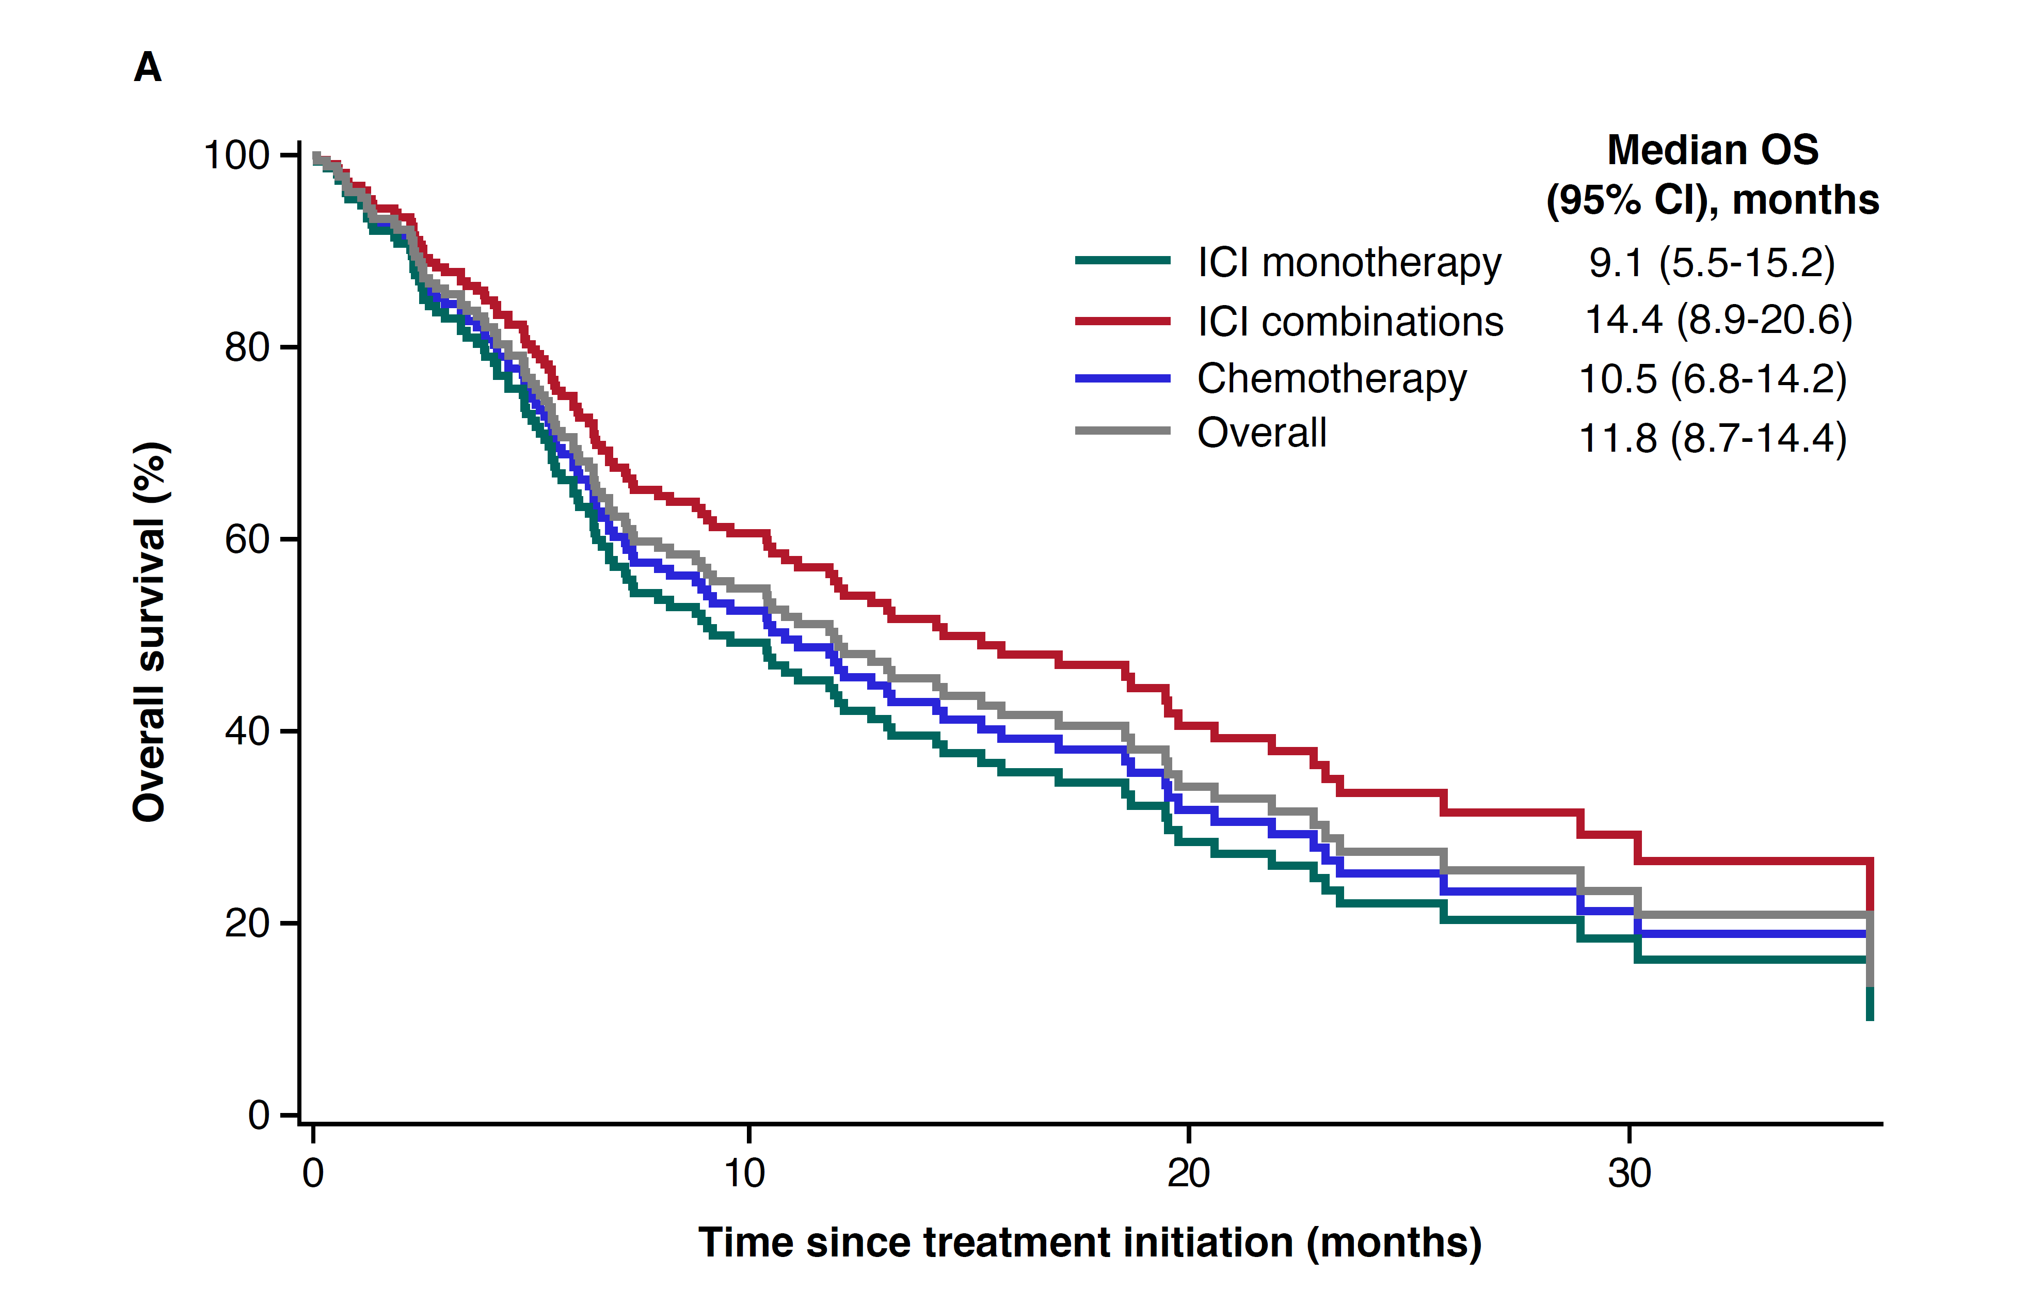

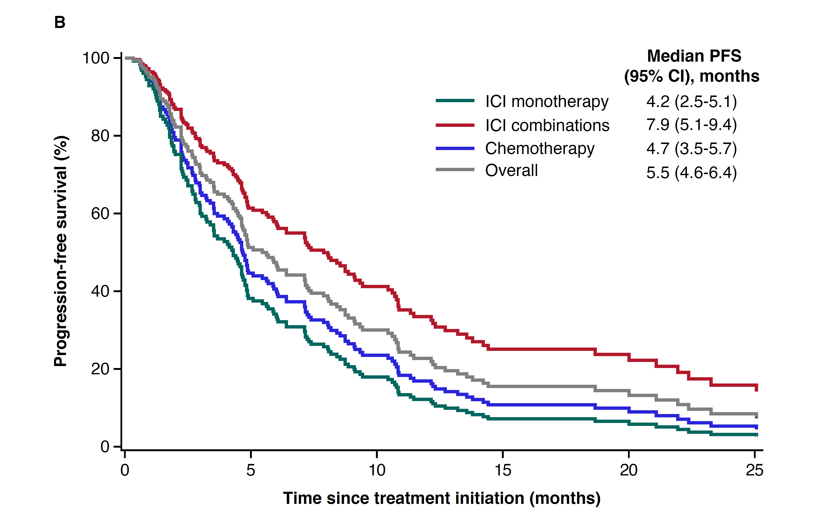
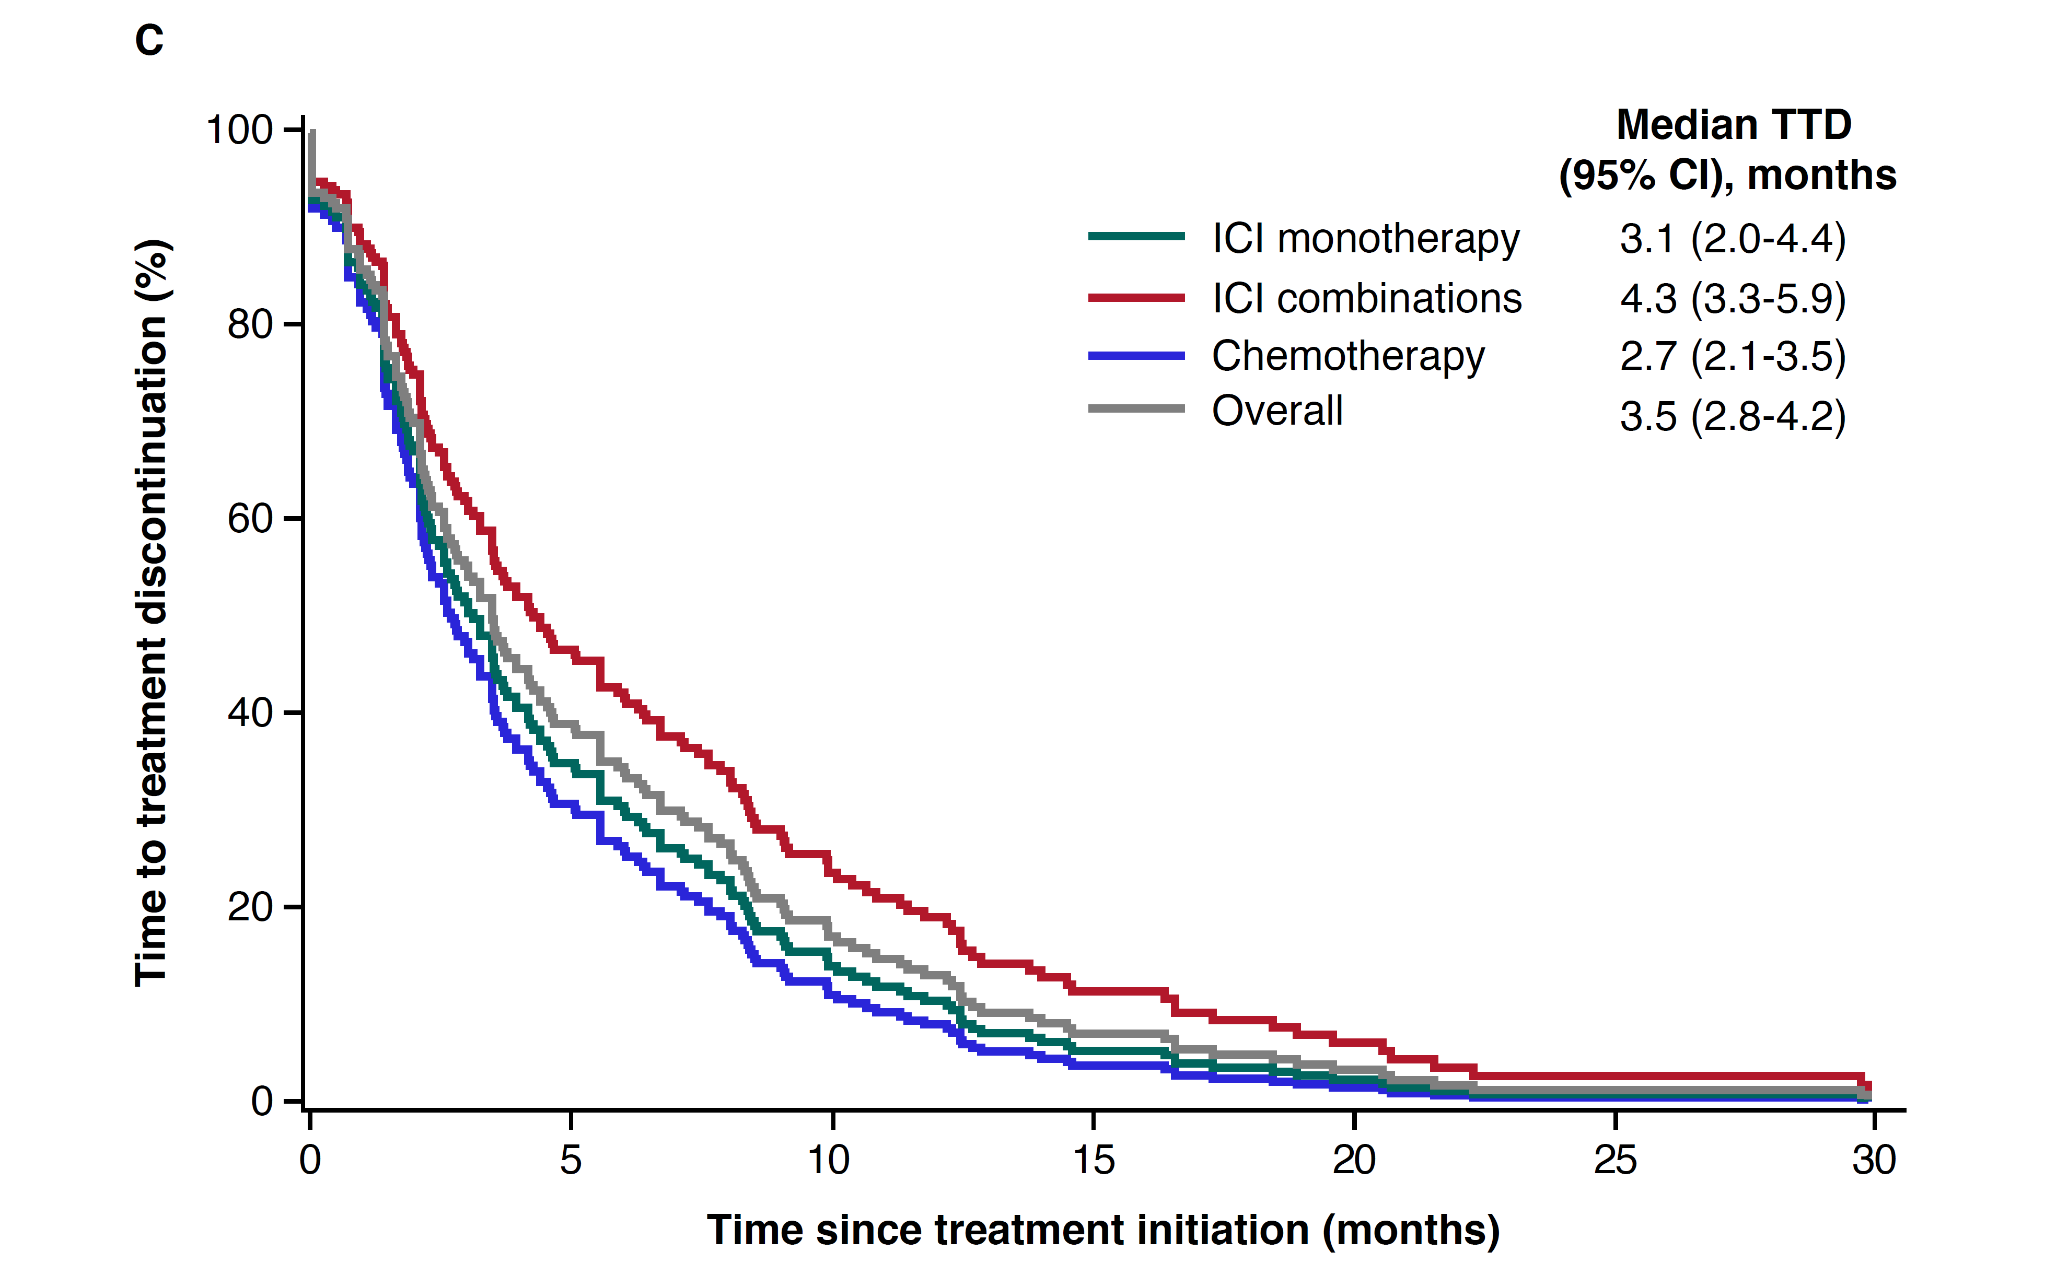
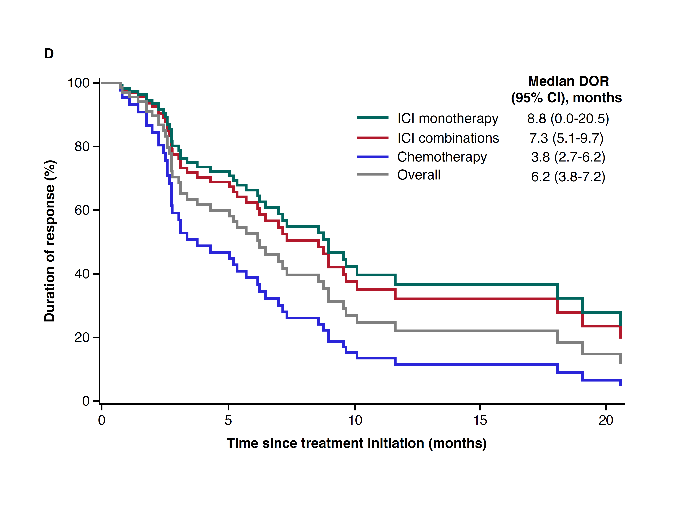

Supplemental Figure 3. Adjusted treatment outcomes, including (A) OS, (B) PFS, (C) TTD, and (D) DOR* in the high PD-L1 subgroup (≥50% PD-L1 expression; N=301).
Each model controlled for age, sex, insurance type, histology, ECOG performance status, weighted comorbidity index, bone metastasis, liver metastasis, and brain metastasis. 1L, first line; CR, complete response; ICI, immune checkpoint inhibitor; DOR, duration of response; ECOG, Eastern Cooperative Oncology Group; OS, overall survival; PFS, progression-free survival; PR, partial response; TTD, time to discontinuation. *Analysis only includes patients who achieved CR or PR by the end of 1L. *Analysis only includes patients who achieved complete response (CR) or partial response (PR) by the end of 1L.

