Supplementary figures
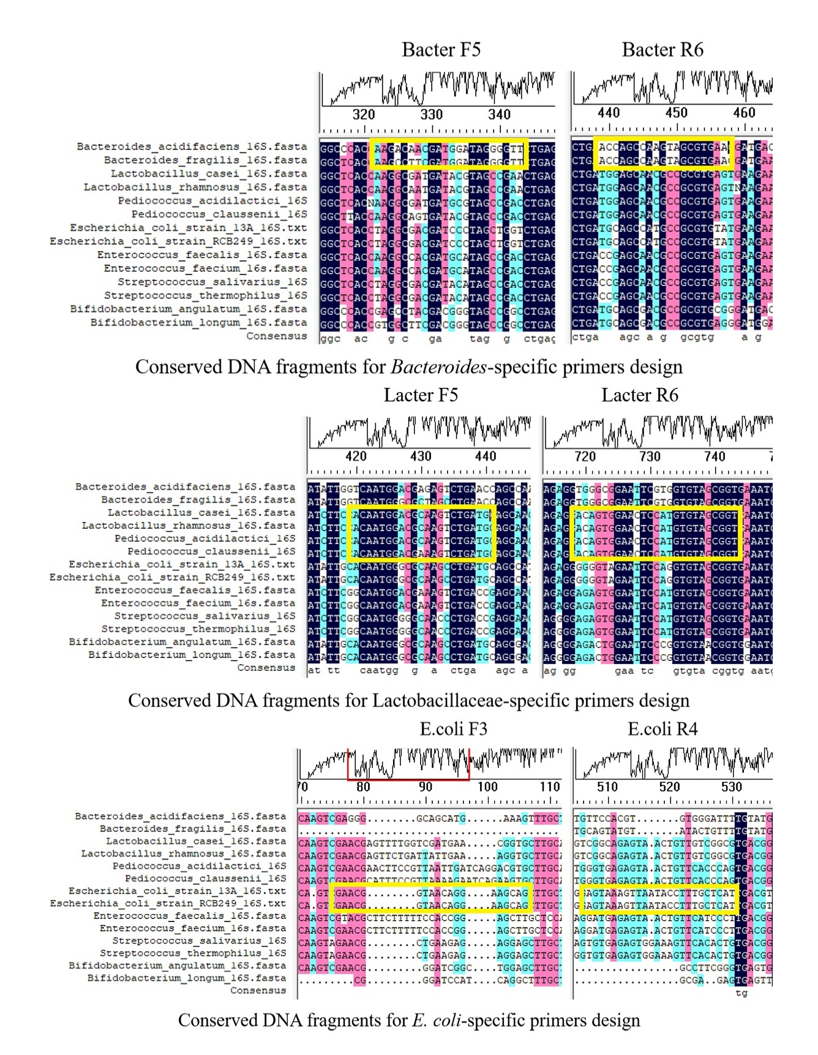
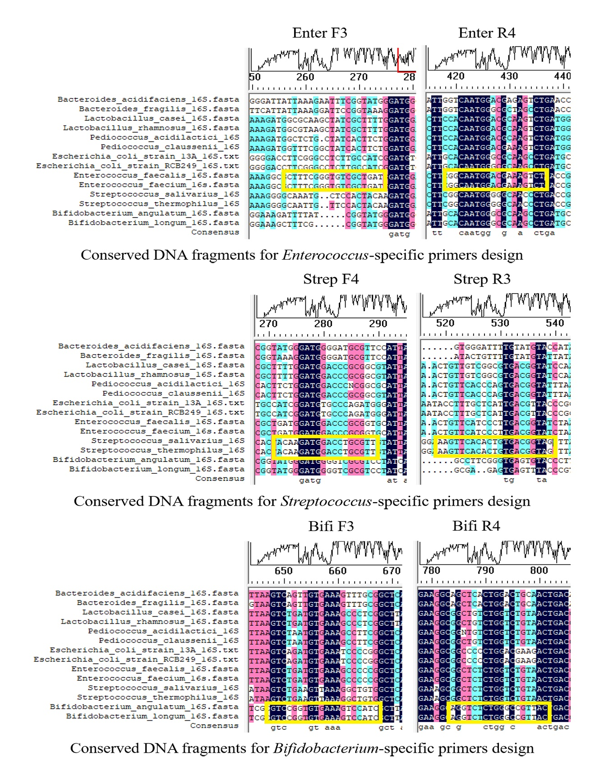
Figure S1 Alignment of nucleotide sequences of 16S rRNA genes of six bacterial genera for specific primer pairs design. 16S rRNA gene sequences of Bacteroides (Bacteroides acidfaciens and Bacteroides fragilis), Lactobacillaceae (Lactobacillus casei, Lactobacillus rhamnosus, Pediococcus acidilactici and Pediococcus claussenii), E. coli (E. coli strain 13A and E. coli strain RCB249), Enterococcus (Enterococcus faecalis and Enterococcus faecium), Streptococcus (Streptococcus salivarius and Streptococcus thermophilus) and Bifidobacterium (Bifidobacterium angulatum and Bifidobacterium longum) were aligned with DNAMAN8.0. The yellow frames show the regions selected for primer design.
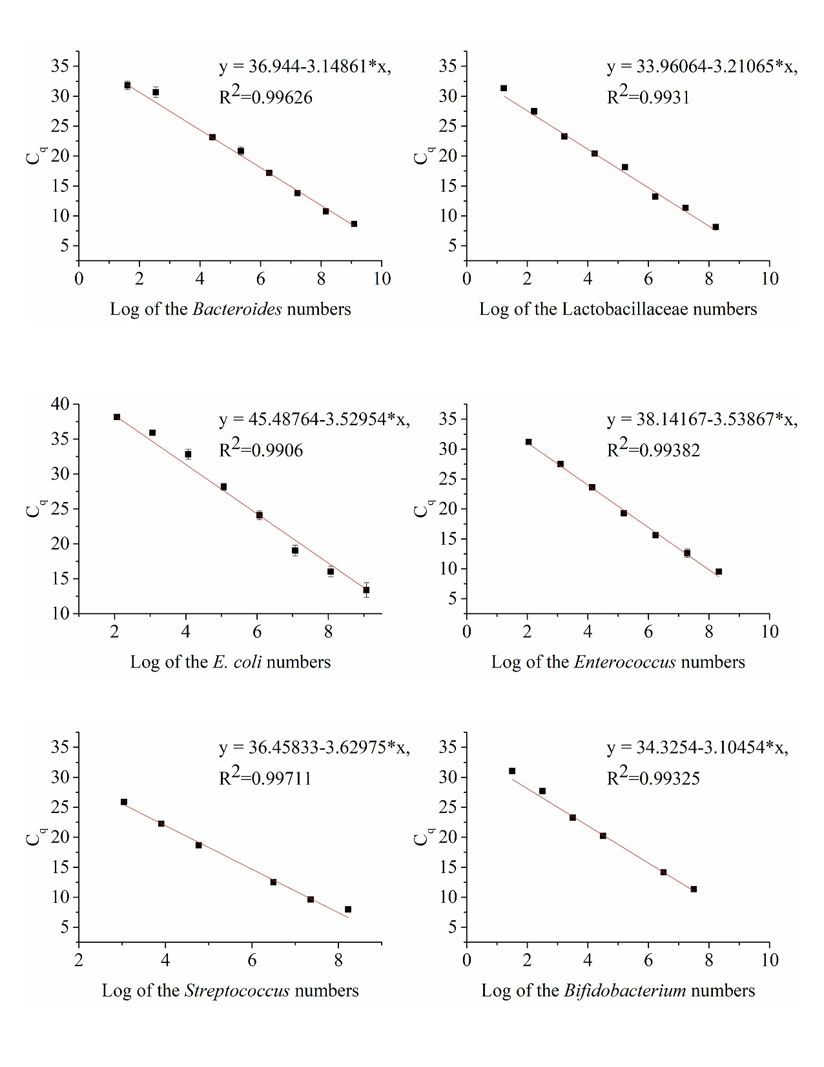
Figure S2 The standard curves for six target bacteria genera. The number of target copies on a log-scaled X-axis were plotted against the Ct values on the Y-axis. Linear regression equations of the standard curves were shown in figures. Vertical bars represent the standard deviation of three technical replicates.

