Supplemental material

Table S1. Evolution of the wild-colony morphotype of SA ATCC and SAI during 120 h of growth in TSA.
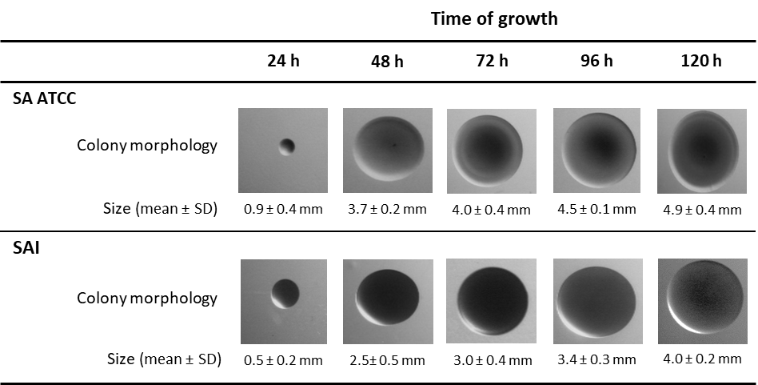
SD - standard deviation
Table S2. Detailed morphological description of the colonies produced by S. aureus strains after 48 h of growth on TSA.

 | Form | Margin | Sheath | Type of Surface | Texture | Consistency | Elevation | Opacity | Size | Diameter (mm) | Colour
SA ATCC
WMT | circular | Entire | absent | homogeneous | smooth | moist | flat | opaque | large | 3.7±0.2 | beige
SAI
WMT | circular | Entire | absent | homogeneous | smooth | moist | flat | opaque | large | 2.5±0.5 | beige
SCV | circular | Entire | absent | homogeneous | smooth | moist | flat | opaque | small | 0.7±0.2 | beige
PAO1
WMT | circular | Undulate | present | homogeneous | rough | dry | flat | opaque | large | 14±0,5 | yellow
PAI
WMT | circular | entire | absent | homogeneous | rough | dry | flat | iridescent | large | 5.24±0.3 | blue-green
SCV | circular | undulate | absent | heterogeneous | smooth/rough | dry | flat | iridescent | small | 2.4±0.2 | blue-green

WMT – wild-colony morphotype; SCV – small colony variants

Table S3. Oligonucleotide sequences of the primers used for gene expression quantification by qPCR and target gene function.
Primer | Forward | Reverse | Melting Temperature (ºC) | Amplicon size (bp) | Priming efficiency (%) | Gene Function
16S | GGAGAAAGTGGGGGATCTTC | CCGGTGCTTATTCTGTTGGT | 59.87 | 316 | 90. 6 | Housekeeping
lasR | AAGGACAGCCAGGACTACGA | GTAGATGGACGGTTCCCAGA | 59.87 | 156 | 94.5 | QS
pqsE | ATGATGACCTGTGCCTGTTG | GTCGTAGTGCTTGTGGGTGA | 59.75 | 188 | 97.9 | QS
rhlR | TGGATGTTCTTGTGGTGGAA | GTTGCATGATCGAGTTGCTG | 60.42 | 193 | 92.7 | QS

