Supplemental material

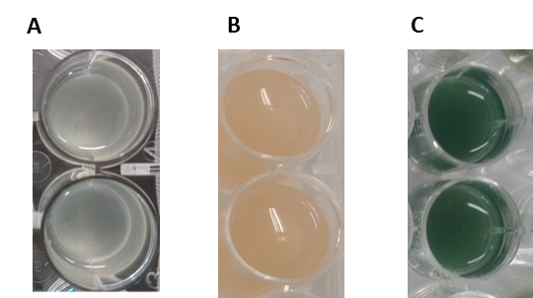

Figure S1. The ASM characteristics (volume and colour) (A) at the inoculation time (0 h), (B) after 15 days of PAO1 growth and (C) 20 days of PAI growth. The losses by evaporation are residual during the 20-day experiments.

Figure S2. Growth kinetic profile of PAO1 in the presence of (A) SA ATCC and (B) SAI, and the growth kinetic profile of PAI in the presence of (C) SA ATCC and (D) SAI, when co-inoculated in ASM. Error bars indicate standard deviations from five biological replicates performed in triplicate. The statistical significancy of the differences in log₁₀ CFU/ml of P. aeruginosa and S. aureus in coculture were determined using one-way ANOVA followed by Tukey’s multiple comparison post-hoc test. All data points were statistically significant. CFU, colony forming units.

Figure S3. The amount of pyocyanin produced by P. aeruginosa PAO1 in the presence of (A) SA ATCC and (B) SAI, and the amount of pyocyanin produced by P. aeruginosa PAI in the presence of (C) SA ATCC and (D) SAI in ASM. Error bars indicate standard deviations from five biological replicates performed in triplicate. Statistical significance was determined by performing a two-way analysis of variance (ANOVA) with Bonferroni's multiple comparisons post test. ****, p<0,0001

Figure S4. The amount of pyocyanin produced by P. aeruginosa PAO1 in the presence of (A) SA ATCC and (B) SAI, exposed to 4 mg/L of ciprofloxacin in ASM, and the amount of pyocyanin produced by P. aeruginosa PAI in the presence of (C) SA ATCC and (D) SAI, exposed to 4 mg/L of ciprofloxacin in ASM. Error bars indicate standard deviations from five biological replicates performed in triplicate. Statistical significance was determined by performing a two-way analysis of variance (ANOVA) with Bonferroni's multiple comparisons post test. **, p < 0,01; ****, p < 0,0001.

