Supplementary Materials

Supplementary Figure S1: Overall Patient Population – AUC 60-day
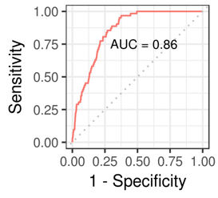

Supplementary Figure S2: Overall Patient Population – AUC 90-day
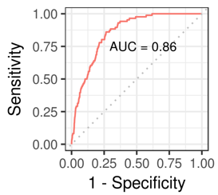

Supplementary Figure S3: Overall Patient Population – AUC 180-day
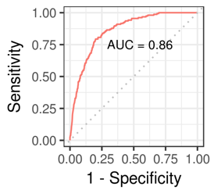

Supplementary Figure S4: Subpopulation A – AUC 60-day
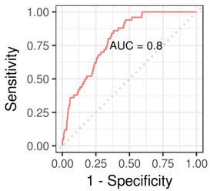

Supplementary Figure S5: Subpopulation A – AUC 90-day
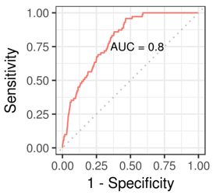

Supplementary Figure S6: Subpopulation A – AUC 180-day
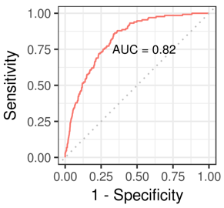

Supplementary Figure S7: Subpopulation B – AUC 60-day
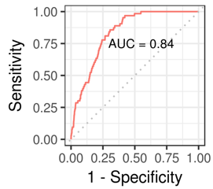

Supplementary Figure S8: Subpopulation B – AUC 90-day
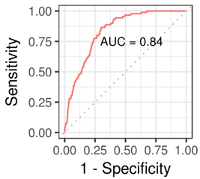

Supplementary Figure S9: Subpopulation B – AUC 180-day
