# PROTOCOL FOR:

**The influence of sample quantity and lysis parameters on the success of ancient DNA extraction from skeletal remains**

Alina Euskirchen, Larissa Hartmann, Janine Mazanec, Patrick Wittmeier and Susanne Hummel: Johann-Friedrich-Blumenbach Institut für Zoologie und Anthropologie, Abteilung Historische Anthropologie und Humanökologie, Bürgerstr. 50, 37073 Göttingen, +49 551 39-29728, shummel1@gwdg.de

## LEGEND

***ATTENTION***

* ***HINT***

***REST***

# REAGENTS AND MATERIALS

**Chemicals:**

Agarose Roti (Roth)

Ambion nuclease-free water (Invitrogen)

BigDye Terminator v1.1 5X Sequencing Buffer (Applied Biosystems)  
BigDye Terminator v1.1 Ready Reaction Mix (Applied Biosystems)

Buffer PB Binding Buffer (Qiagen)  
Buffer PE Wash Buffer (Qiagen)

Distilled water

Dye Set D (Applied Biosystems)

EDTA UltraPure 0.5 M, pH 8 (Invitrogen by Life Technologies)

Ethidium bromide (Serva) ***ATTENTION*** carcinogen, wear appropriate protective clothing!

GeneScan 500 ROX (Applied Biosystems)

Hi-Di Formamid (Applied Biosystems)

LMW DNA-ladder (New England Biolabs)

Multiplex PCR Master Mix plus (Qiagen)

NaClO solution, 12.5 % (Laboratorium Dr. Seeger GmbH)

POP7 3500 Series (Applied Biosystems)

Proteinase K, 0.01 M, pH 7.5 (Merck)

RNase-free water (Qiagen)

Sodium acetate buffer, pH 5.2 (SIGMA Life Science)

Sodium dodecyl sulfate (SDS), 10 mg/ml (SIGMA Life Science)

**Consumables:**

Eppendorf reaction tubes safe-lock, 0.5 ml (Eppendorf)

Eppendorf reaction tubes safe-lock, 2.0 ml (Eppendorf)  
ExoSAP-IT Express PCR Product Cleanup Kit (Affymetrix USB)

Falcon Tubes (Sarstedt)  
MinElute Purification Kit (Qiagen)

nucleoSEQ columns (Macherey-Nagel GmbH & Co. KG)

Pipette tips (Sarstedt)  
Pipette tips epT.I.P.S. (Eppendorf)  
Reaction Plate Micro Amp® Optical 96-Well (Applied Biosystems)

**Materials:**

The experiments were carried out on one femur from the skeletal series Goslar (GS97, 250 BP) and one from the burial site Lichtenstein cave (DO902.01, 3000 BP).

**Supplementary Figure 1:** **Representative bones used in the present studies.** The extended sampling sites are due to previous studies. The upper image shows the left femur (GS97) of an individual from the skeletal series of Goslar from the Early Modern Age (250 BP). The image below shows the left femur (DO902.01) of an individual from the burial site Lichtenstein cave from the Bronze Age (3000 BP). Both individuals were male, which means that both X and an Y chromosomal signals are expected to be present in the nuclear DNA.

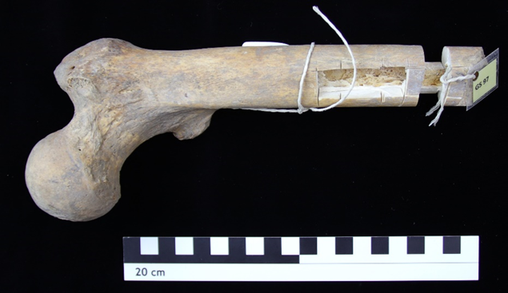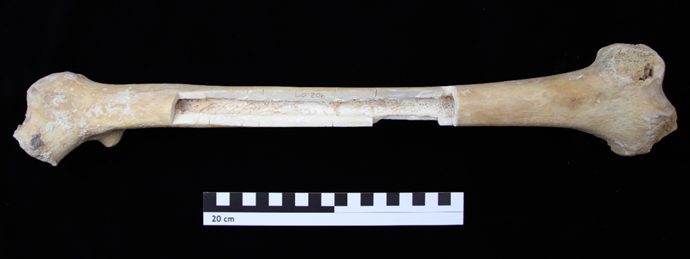

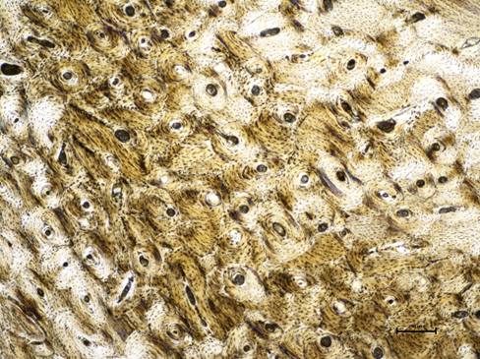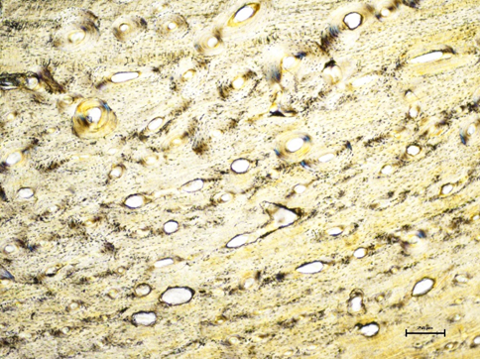**Supplementary Figure 2: Histological thin sections of the samples**. The image on the left shows the microstructure of the compact bone of GS97; the microstructure of DO902.01 is presented on the right. Both microstructures appear to be perfectly intact and do not reveal evidence of extended microbial colonization. Also, there are no indications of extensive chemical decomposition. Therefore, a high quality of DNA can be expected.

|  |  |  |  |  |  |  |  |  |  |  |  |
| --- | --- | --- | --- | --- | --- | --- | --- | --- | --- | --- | --- |
|  | Amelogenin | D3 S1358 | D8 S1179 | D5 S818 | vWA | D21S11 | D13 S317 | FGA | D18S51 | D7 S820 | TH01 |
| GS97* | X/Y | 15/17 | 10/13 | 12/12 | 18/19 | 30.2/ 32.2 | 12/- | 18/20 | 14/16 | 10/12 | n.a. |
| DO902.01 ** | X/Y | n.a. | n.a. | 12/- | n.a. | 31.2/ 32.2 | 9/13 | 22/24 | n.a. | 6/9.3 | n.a. |

**Supplementary Table 1: Genetic fingerprints of GS97 and DO902.01.**

*results adopted from Bramanti (internal report 1999, unpublished)

**results adopted from Seidenberg (2016)

n.a. = not analysed

# PROCEDURE

**Sample preparation:**

Approximately 3 x 2 cm pieces were cut out from both femora on the anterior-proximal side. To remove traces of contamination, the samples were rinsed with bleach (NaCIO solution, 12.5%, Laboratorium Dr. Seeger GmbH) for ten minutes and then incubated in distilled water. The pieces were then dried overnight at 30°C.



When dried, the samples were pulverized in a ball triturator (Retsch MM) at 24 Hz. Aliquots of 250 mg, 150 mg, 50 mg, and 10 mg of the bone powder were prepared and 3900 μl EDTA (UltraPure, 0.5 M, pH 8, invitrogen by Life Technologies) and 100 μl Proteinase K (0,01 M, pH 7.5, Merck) were added. The samples were then lysed for different amounts of time (Supplementary MaterialsTable 2) under constant rotation at a temperature of 56°C. Subsequently, 50 μl sodium dodecyl sulfate (SDS; 10 mg/ml, SIGMA Life Science) was added to each of the samples and incubated for another five minutes at 65°C for further protein denaturation. Finally, the lysates were centrifuged at 3300 rpm for 3 minutes (Eppendorf type 5430) to be ready for DNA extraction.

As an initial experiment (pre-test), we made a comparison between the DNA extraction protocol that includes an 18-hour lysis at 37°C and a subsequent 2-hour lysis at 56°C, and an 18-hour lysis at a constant temperature of 56°C. The parameters used in the pre-test are also shown in the experimental design matrix below (Supplementary Materials Table 2).

**Supplementary Materials Table 2:** Experimental design (4x5) for sample amount and lysis duration. The green colour shows the parameters used in the pre-test.

|  |  |  |  |  |  |  |  |
| --- | --- | --- | --- | --- | --- | --- | --- |
|  | 2 h | 4 h | 10 h | 18 h | 48 h | 18 h | 18+2 h |
| 250 mg |  |  |  | All performed with a lysis temperature of 56°C. |  |  | 18 h at 37°C,  2 h at 56 °C |
| 150 mg |  |  |  |  |  | 56°C |
| 50 mg |  |  |  |  |  |  |
| 10 mg |  |  |  |  |  |  |

**Ancient DNA extraction:**

The aDNA extraction was performed with the QiaVac system (Qiagen) and the MinElute Purification Kit (Qiagen). The lysis temperature of the extraction protocol used at the Department of Historical Anthropology and Human Ecology, University Göttingen (Germany), where lysis is mainly performed at 37°C (Schmidt *et al.* 2020), was changed to 56°C and the further addition of proteinase K was omitted.

First, 16 ml of PB-Buffer (Qiagen) was added into Falcon Tubes (Sarsted), as well as 100 µl of sodium acetate buffer (pH 5.2, SIGMA Life Science). The lysate was then transferred to the mixture in the Falcon Tubes; they were mixed manually and centrifuged at 3300 rpm for three minutes. Afterwards, the lysate-buffer mixture was distributed to MinElute columns (large volume funnels) and a vacuum was generated. Then, a washing process was carried out with two subsequent repetitions. Thereafter, 700 µl PE-Buffer (Qiagen) was added to the MinElute columns and drained off after a five-minute reaction time. After the three washing steps, the columns were transferred from the QiaVac rack to Collection Tubes and were centrifuged at 13000 rpm (Eppendorf type 5415R) for one minute. Then, the columns were placed on 2.0 ml cups (Eppendorf) with open lids for the evaporation of remaining buffer for at least 15 min. For the elution, which was repeated three times in total, 20 µl H2O (56°C) was added onto each of the membranes in the MinElute columns. After a 5 minutes incubation, the samples were centrifuged for one minute at 13000 rpm.



Step by step instruction:

* 16 ml PB-Buffer in large Falcon Tubes
* Add 100 µl sodium acetate buffer (pH 5.2)
* Transfer of lysate into the prepared Falcon Tubes
* Manually blend PB-Buffer and lysate
* Centrifuge for 3 minutes at 3300 rpm
* Transfer buffer-lysate mixture to MinElute columns (large volume funnels), apply vacuum
* Washing (three repetitions):
  + Add 700 µl PE-Buffer to MinElute columns (5 minutes incubation)
  + Transfer of MinElute columns from QiaVac rack to Collection Tubes
  + Centrifuge for 1 minute at 13000 rpm
* Transfer of MinElute columns on 2 mL cups (evaporation of remaining buffer with open lid, at least 15 min)
* Elution (three repetitions):
  + Add 20 µl H2O (56°C) to membrane in MinElute columns and incubate for 5 minutes
  + Centrifuge for 1 minute at 13000 rpm

**Amplification of chromosomal aDNA:**

For chromosomal aDNA amplification, we used a heptaplex kit (Supplementary MaterialsFigure 5), specially developed for aDNA analysis. The kit contains one primer pair for Amelogenin and six primer pairs for amplification of the autosomal STRs D5S818, D13S317, D18S51, D21S11, TH01, and FGA (Supplementary MaterialsTable 3). One primer of each primer pair is labelled with a fluorescent dye (Seidenberg *et al.* 2012 and Seidenberg 2016).

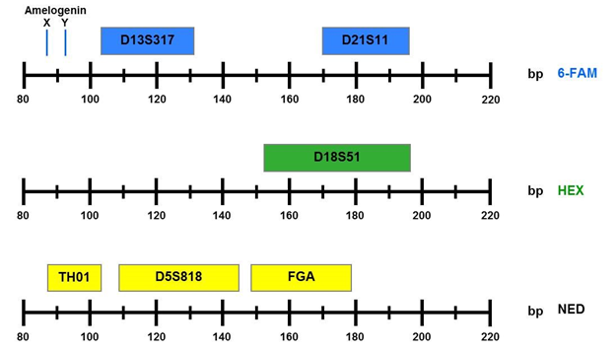**Supplementary Figure 3: Allelic range of the sequences amplified by the heptaplex-kit**. The autosomal STR systems are presented with their respective fragment length and their arrangement in different colour panels**.**

**Supplementary Table 3: Primer pairs of Heptaplex PCR for Amelogenin and the autosomal STRs.**

|  |  |  |  |  |  |  |
| --- | --- | --- | --- | --- | --- | --- |
| Marker | Primer | Fluorescence labelling | Primer sequence  (5´→ 3´) | Alleles | Fragment length ranges | [µM] |
| Amelogenin | up  low | 6FAM | CCTGGGCTCTGTAAAGAATAGTG  AGCTGATGGTAGGAACTGTAAAAT | X  Y | 86  92 | 0.2  0.2 |
| D13S317 | up  low | 6FAM | CTAACGCCTATCTATCTGTATTTACAAATA  AGCCCAAAAAGACAGACAGA | 8-15 | 103-131 | 0.16  0.16 |
| D21S11 | up  low | 6FAM | CAATTCCCCAAGTGAATTGC  GGAGGTAGATAGACTGGATAGATAGAC | 27-33.2 | 170-196 | 0.24  0.24 |
| D18S51 | up  low | HEX | CACTGCACTTCACTCTGAGTGAC  GTGTGTGGAGATGTCTTACAATAACA | 10-21 | 152-196 | 0.28  0.28 |
| TH01 | up  low | NED | GCCTGTTCCTCCCTTATTTC  ATTCCGAGTGCAGGTCACAG | 6-10 | 87-103 | 0.24  0.24 |
| D5S818 | up  low | NED | GGTATCCTTATGTAATATTTTGAAGAT  ATCATAGCCACAGTTTACAACATT | 7-16 | 109-145 | 0.15  0.15 |
| FGA | up  low | NED | AATAAAATTAGGCATATTTACAAGCTAG  ATTGCTGAGTGATTTGTCTGTAATTG | 18-26 | 149-179 | 0.32  0.32 |

Target sequences were amplified using PCR. The PCR parameters were based on prior experiments. These parameters, as well as all other parameters, were kept constant to ensure sample comparability. 5 µl of ancient DNA extract was used for each reaction and 35 cycles were applied. All components for the heptaplex PCR are presented in Supplementary Materials Table 4.

**Supplementary Table 4: Reagents used for heptaplex PCR.**

|  |  |
| --- | --- |
| Mastermix | μl |
| Multiplex PCR Master Mix plus (Qiagen) | 12.5 |
| Primer Set | 2.85 |
| H2O | 4.65 |
| DNA | 5.0 |
| Vol. | 25.0 |

The PCR was performed in a thermal cycler (DNA Mastercycler, Eppendorf). After denaturation, a combined step for annealing and elongation (Two-Step PCR) follows. The parameters for the PCR are presented in Supplementary MaterialsTable 5.

**Supplementary Table 5: PCR Cycling Parameters.**

|  |  |
| --- | --- |
| Initial | 95°C for 5 minutes |
| Cycling | 94°C for 1 minute | 59°C for 2.5 minutes |
| Number of cycles | 35 |
| Endadenylation | 60°C for 45 minutes |
| Soak | 10°C for 10 minutes |

**Amplification of mitochondrial aDNA:**

For the mitochondrial aDNA amplification, we used the primers mt_H_034 (upper primer) and mt_L_262 (lower primer), each with a concentration of 0.2 µM. The primers were designed by Seidenberg (2016) to amplify parts of the hypervariable region II (HVR II) of the mitochondrial genome. The sequences of the primers are listed in Supplementary MaterialsTable 6.

**Supplementary Table 6: Primer sequences for the amplification of HVR II.**

|  |  |  |  |
| --- | --- | --- | --- |
| Primer | Primer sequence (5´→3´) | Fragment length | [µM] |
| mt_H_034 | GGGAGCTCTCCATGCATTG | 262 bp | 0.2 |
| mt_L_262 | GGCTGTGCAGACATTCAATTGT | 0.2 |

Target sequences were amplified using PCR. The PCR parameters were based on prior experiments. These parameters, as well as all other parameters, were kept constant to ensure sample comparability. 5 µl of ancient DNA extract was used for each reaction and 30 cycles were applied.

The PCR was performed in a thermal cycler (DNA Mastercycler, Eppendorf). The parameters for the PCR are presented in Supplementary Materials Table 7.

**Supplementary Table 7: PCR Cycling Parameters.**

|  |  |
| --- | --- |
| Initial | 95°C for 5 minutes |
| Cycling | 94°C for 1 minute | 57°C for 1 minute | 72°C for 1.5 minutes |
| Number of cycles | 30 |
| Soak | 10°C for 10 minutes |



**Agarose gel electrophoresis:**

The PCR products were labelled with bromophenol blue (loading dye) and loaded into lanes of a prepared 2.5 % agarose gel. Ethidium bromide (Serva) and TBE-Buffer were used. For the electrophoresis, we used a low molecular weight DNA ladder (New England Biolabs). The running time was about 30 minutes at a voltage of 110 V. For evaluation, the gel was examined under UV light (Gel Jet Imager & Analyzer with the software Intas Gel Capture, Intas).



**Taq-Cycle-Sequencing:**

Before the PCR product can be sequenced, it must be purified. Therefore, we used the ExoSAP-IT Express PCR Product Cleanup Kit (Affymetrix USB). The purification was carried out according to the manufacturer's instructions.



Step by step instruction:

* Blend of 5 µl PCR product with 2 µl ExoSAP-IT Express reagent
* Short centrifugation
* Incubate of the samples in a thermal cycler for 4 minutes at 37°C
* Deactivate the ExoSAP-IT Express reagent by increasing the temperature in the cycler to 80°C for 1 minute
* Cooling time for another 4 minutes
* Purification is completed and the PCR products are ready for further use

The maximum use of the respective PCR product was determined based on band intensity of the corresponding agarose gel. A reaction mix for forward sequencing was prepared according to the manufacturer's instructions:

* 4 µl BigDye Terminator v1.1 5X Sequencing Buffer (Applied Biosystems)
* 2 µl BigDye Terminator v1.1 Ready Reaction Mix (BDT) (Applied Biosystems)
* 0.3 µl forward/upper Primer
* 0.5-13.7 µl DNA-extract (depending on the intensity of the bands on the agarose gel)
* 0-13.2 µl nuclease-free H2O (Ambion)

The Taq-Cycle-Sequencing was carried out with the parameters shown in Supplementary Materials Table 8.

**Supplementary Table 8: Parameters for the Taq-Cycle-Sequencing.**

|  |  |
| --- | --- |
| Initial | 96°C for 10 minutes |
| Cycling | 96°C for 10 seconds | 50°C for 5 seconds | 60°C for 4 minutes |
| Number of Cycles | 25 |
| Hold | 10°C |

Subsequent purification of the sequencing products was performed using nucleoSEQ columns (Macherey-Nagel) according to the manufacturer's instructions.



Step by step instruction:

* Centrifuge the centrifugation-columns for 30 seconds at 2700 rpm
* Add 600 µl HPLC water and vortex
* Remove air bubbles by tapping
* Let the gel matrix sit inside the columns for approximately 2 hours at room temperature
* Remove the closing plugs
* Centrifuge for 2 minutes at 2700 rpm
* Discard the collection tubes
* Place the columns on new 2.0 ml Eppendorf tubes
* Apply the sequencing product dropwise to the centre of the gel matrix without touching the borders of the columns
* Centrifuge for 6 minutes at 2700 rpm

The sequencing products are analysed by capillary electrophoresis with the 3500 Genetic Analyzer (Applied Biosystem).



**Capillary electrophoresis**:

Preparation for capillary electrophoresis followed the manufacturer’s instructions.



Step by step instruction:

* Prepare a 96-well plate with 12 μl HiDi-Formamide
* Add 0.25 μl of GeneScan 500 ROX length standard
* Add 1-2 μl PCR product
* Add 0.5 μl of an allelic ladder
* Short centrifugation of the samples
* Denature for 5 minutes at 95°C
* Cool down to 4°C

For capillary electrophoresis, we used the 3500 Genetic Analyzer (Applied Biosystems). The length of the capillaries was 36 cm in both fragment length analyses. Data was collected with the 3500 Data Collection Software v2.0 (Applied Biosystems) and the GeneMapper software 5 (Applied Biosystems) was used for evaluation.

# RECIPES

**TBE buffer**:

10,903 g TRIS

0,931 g EDTA

5,565 g H3BO3

Fill up to 1 l with distilled water

**Loading dye:**

0,025 g bromophenol blue sodium salt

4 g sucrose  
Fill up to 10 ml with distilled water

# EQUIPMENT

Ball triturator (Retsch MM)

Centrifuge (Eppendorf type 5430; Eppendorf)

Centrifuge (Eppendorf type 5415R; Eppendorf)

Centrifuge (miniSpin; Eppendorf)

Drill (K-POWERgrip 4941) with diamond saw blade (KaVo)

Electronic shaker (Lab dancer; Ikamag, IKA-Werke GmbH & CO. KG)

Electronic shaker (Vibrofix VF1; Ikamag, IKA-Werke GmbH & CO. KG)

Electrophoresis chamber (Midi Large horizontal 15 × 17 cm; G & P Kunststofftechnik)  
Electrophoresis chamber (Horizon 11-14; Gibco BRL Life Technologies)

Gel Jet Imager & Analyzer (Intas) with Intas Gel Capture software (Intas)

GeneMapper software 5 (Applied Biosystems)  
Incubator (Typ B 5028; Heraeus)  
MegAlign software (DNASTAR)

Microscope (Nikon Eclipse Ci; Nikon) with Digital Sight System (Typ DS-U3; Nikon)  
Pipettes (Eppendorf Reference 0,1-0,25 μl, 0,5-10 μl, 2-20 μl, 5-10 μl, 2-20 μl, 50- 200 μl, 100-1000 μl; Eppendorf)  
Power supply (Typ ST606 Electrophoresis Power Supply; Gibco BRL Life Technologies)

Precision scale (PFB 200-3A; Kern&Sohn GmbH)

QiaVac system (Qiagen)

Rotator (LC-1; Steward)

SeqA software (Applied Biosystems)

SeqMan software (DNASTAR)

Thermal cycler (DNA Mastercycler; Eppendorf)  
Thermal mixer (Thermomixer comfort; Eppendorf)

3500 Genetic Analyzer with 36 cm capillary array (Applied Biosystems) with 3500 Data Collection Software v2.0 (Applied Biosystems)