**Supplementary Materials 3: Electropherograms of STR typing (Genetic Fingerprints)**

The influence of sample quantity and lysis parameters on the success of ancient DNA extraction from skeletal remains

The allele determination was carried out with the GeneMapper software 5 (Applied Biosystems) (cf. Supplementary Material 1). The electropherograms, which can be seen in the following, show that allele determination was successful even in cases which showed very weak signals in the agarose gel electrophoreses (Figure 1).

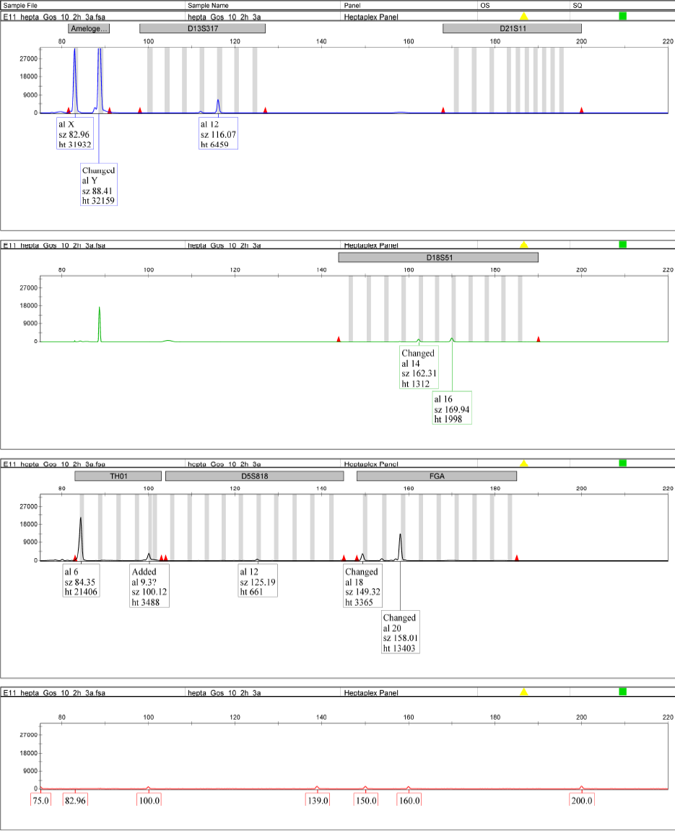

**Supplementary figure 4: Genetic fingerprint for GS97 (10 mg, 2 hours).**

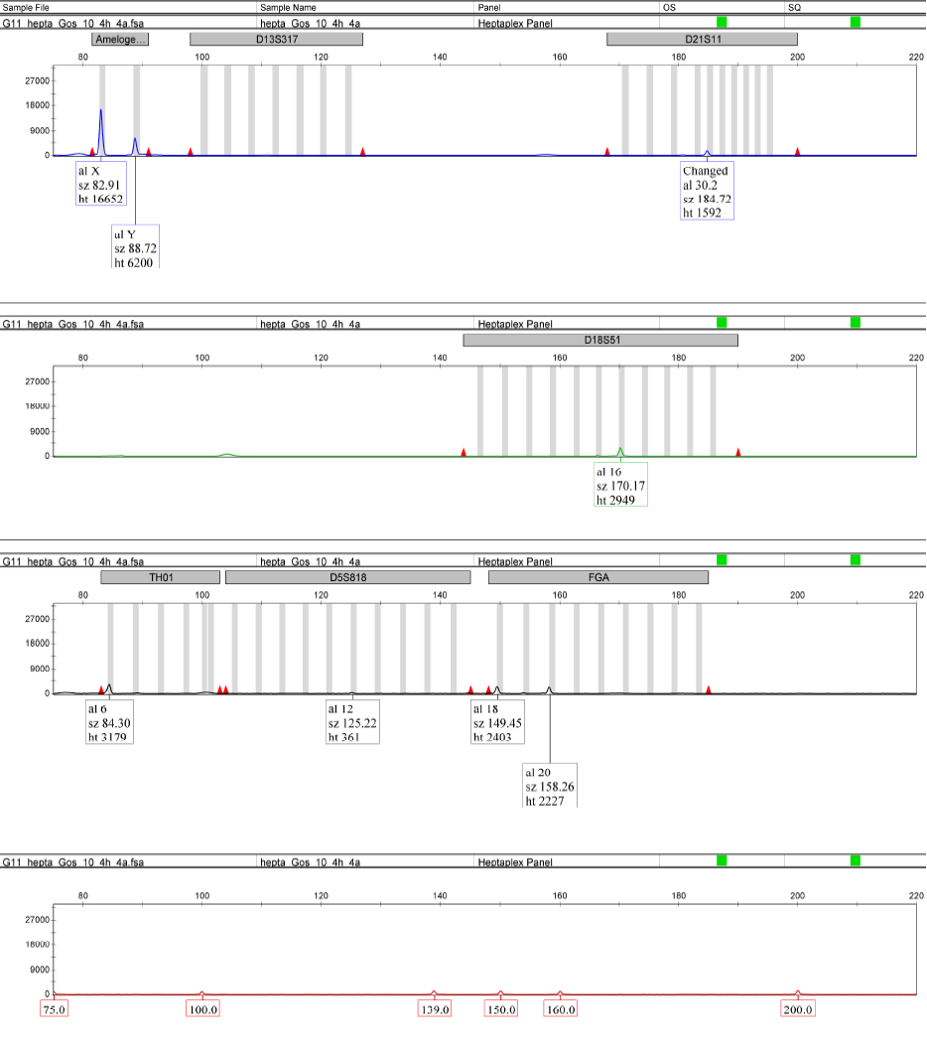

**Supplementary figure 5: Genetic fingerprint for GS97 (10 mg, 4 hours).**

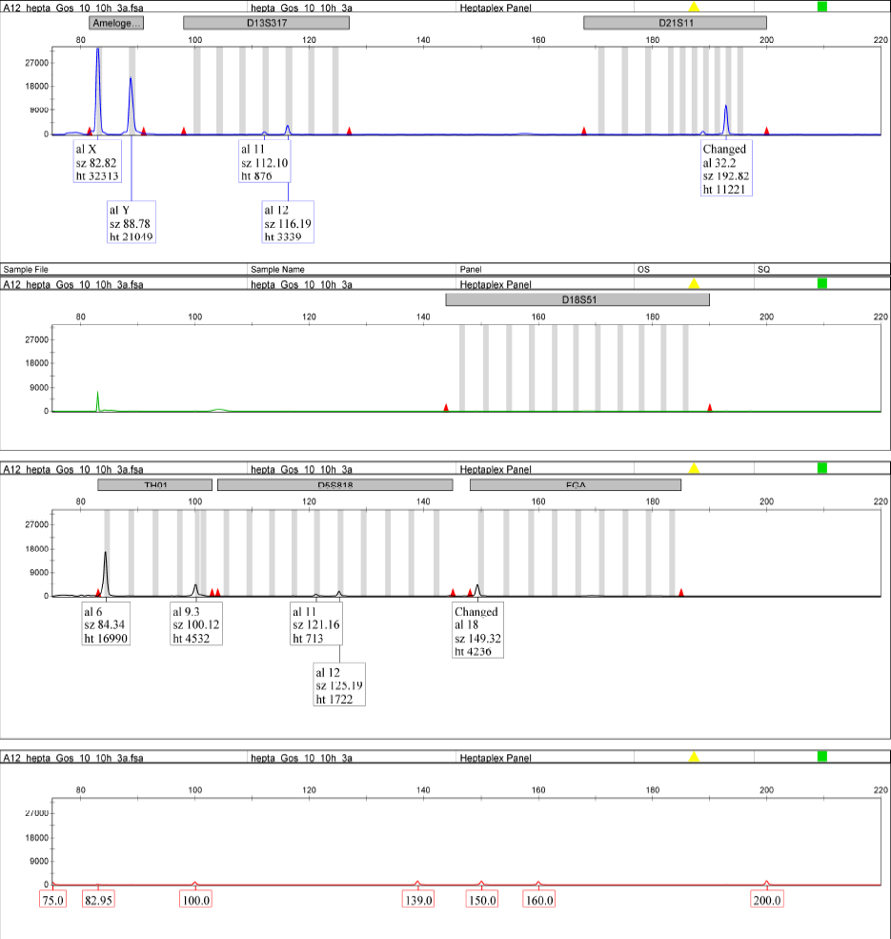

**Supplementary figure 6: Genetic fingerprint for GS97 (10 mg, 10 hours).**

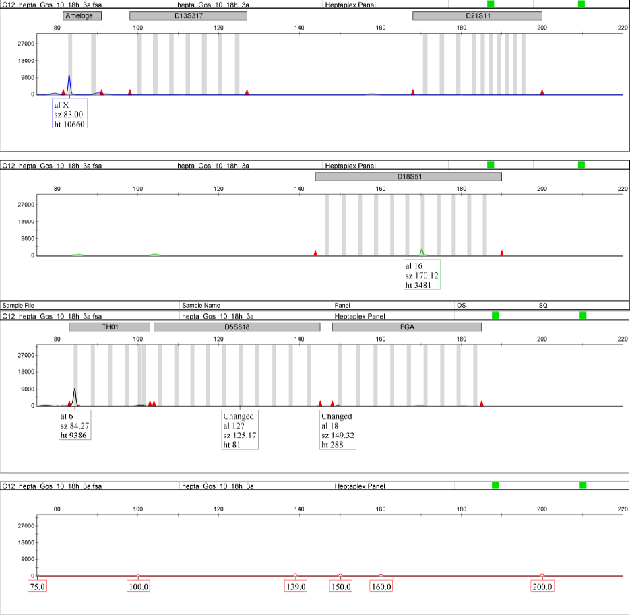

**Supplementary figure 7: Genetic fingerprint for GS97 (10 mg, 18 hours).**

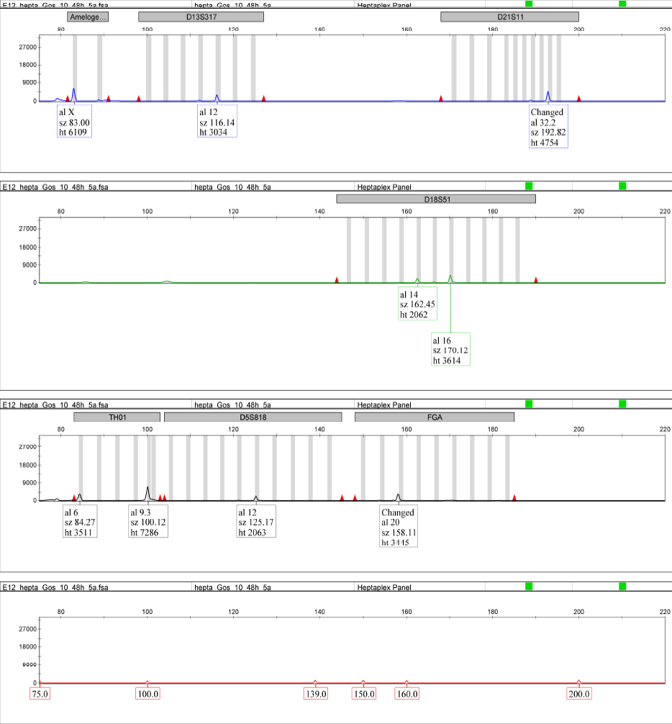

**Supplementary figure 8: Genetic fingerprint for GS97 (10 mg, 48 hours).**

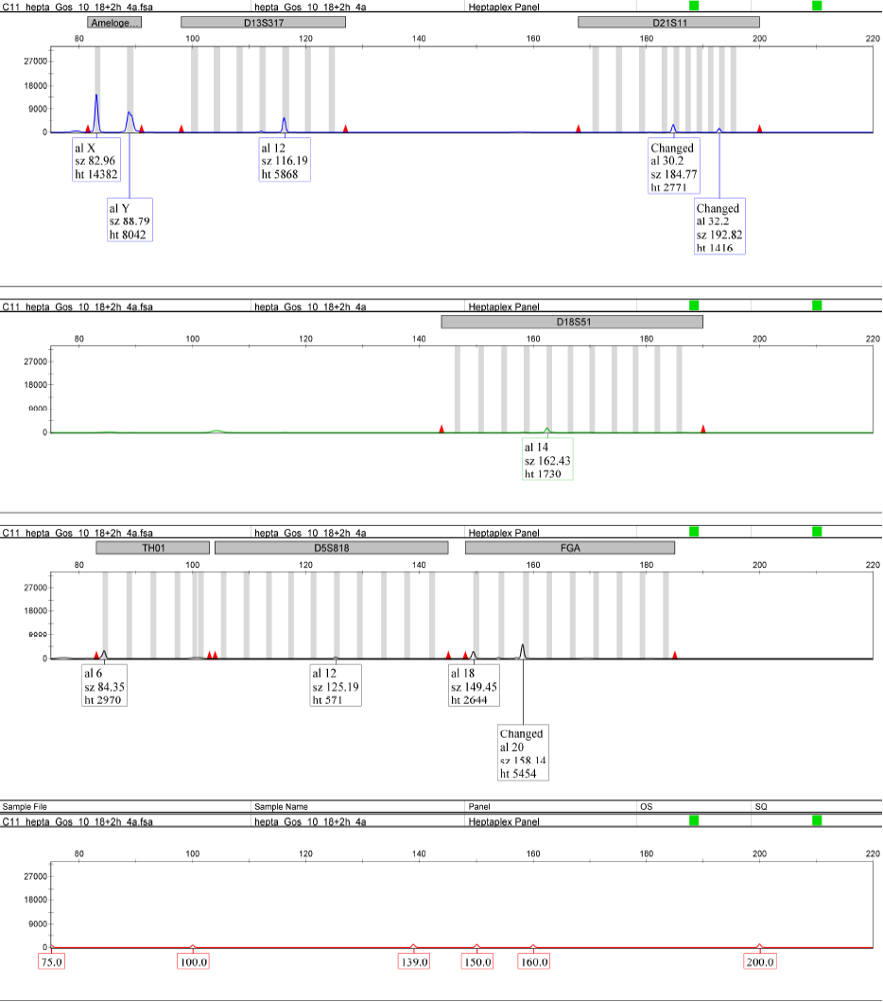

**Supplementary figure 9: Genetic fingerprint for GS97 (10 mg, 18 + 2 hours).**

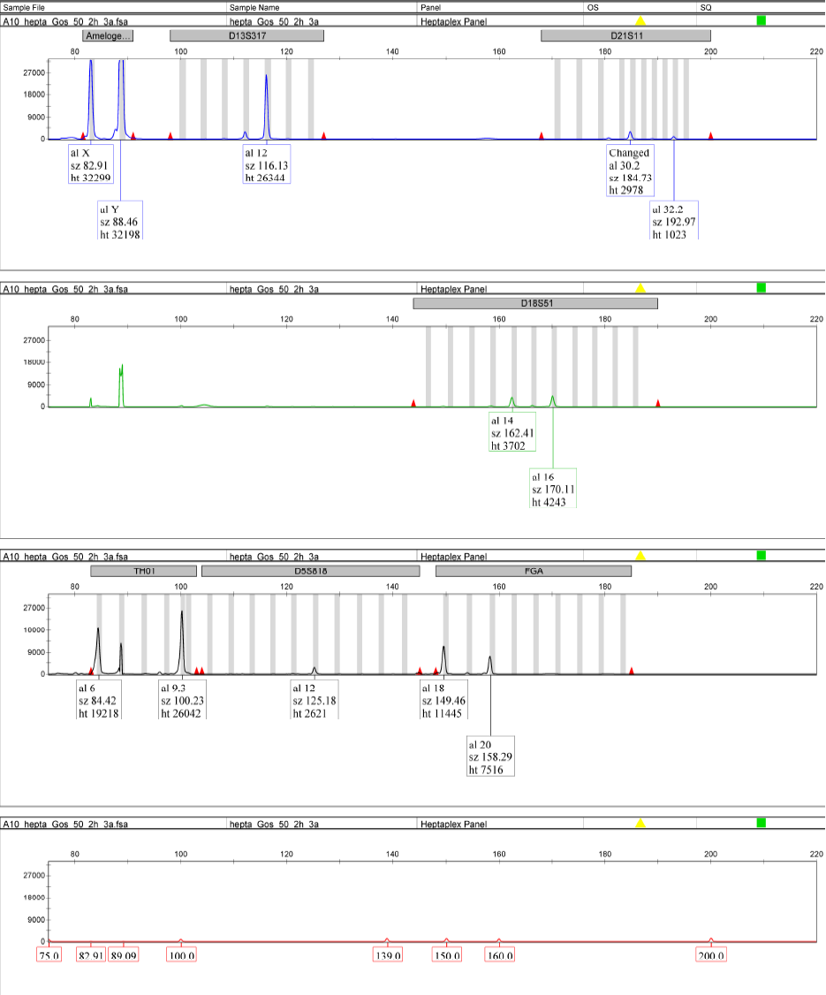

**Supplementary figure 10: Genetic fingerprint for GS97 (50 mg, 2 hours).**

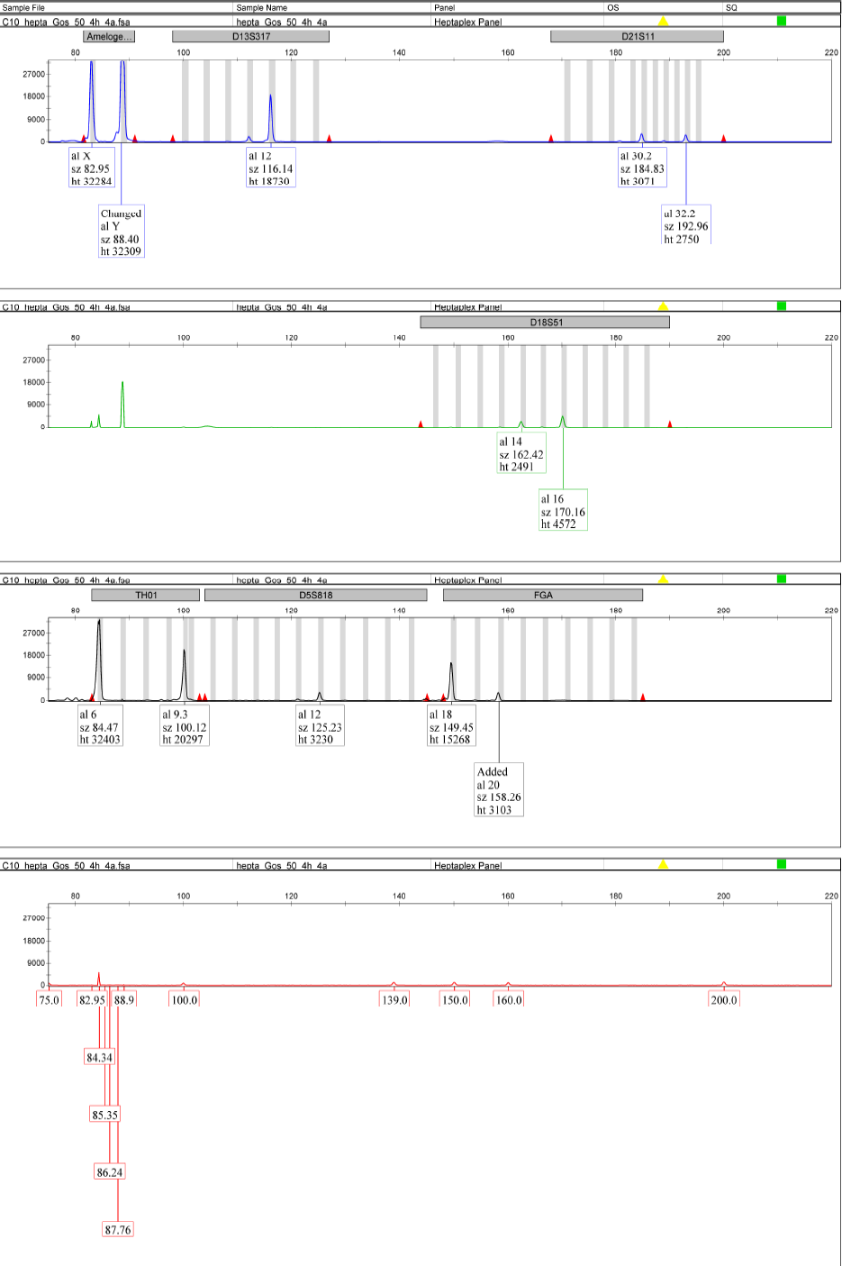**Supplementary figure 11: Genetic fingerprint for GS97 (50 mg, 4 hours).**

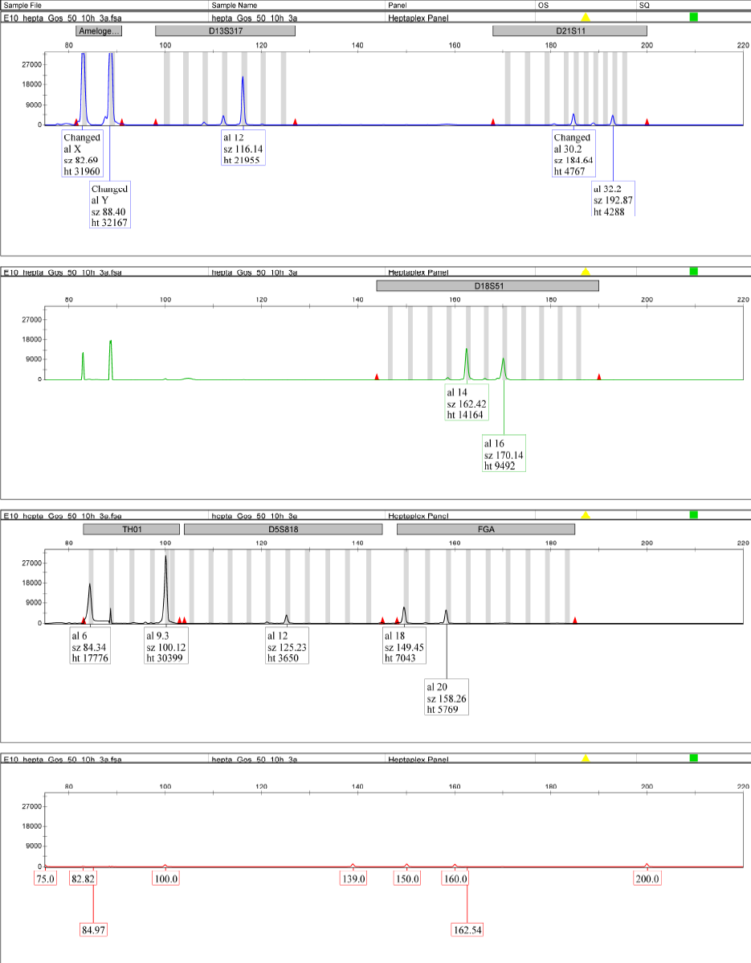

**Supplementary figure 12: Genetic fingerprint for GS97 (50 mg, 10 hours).**

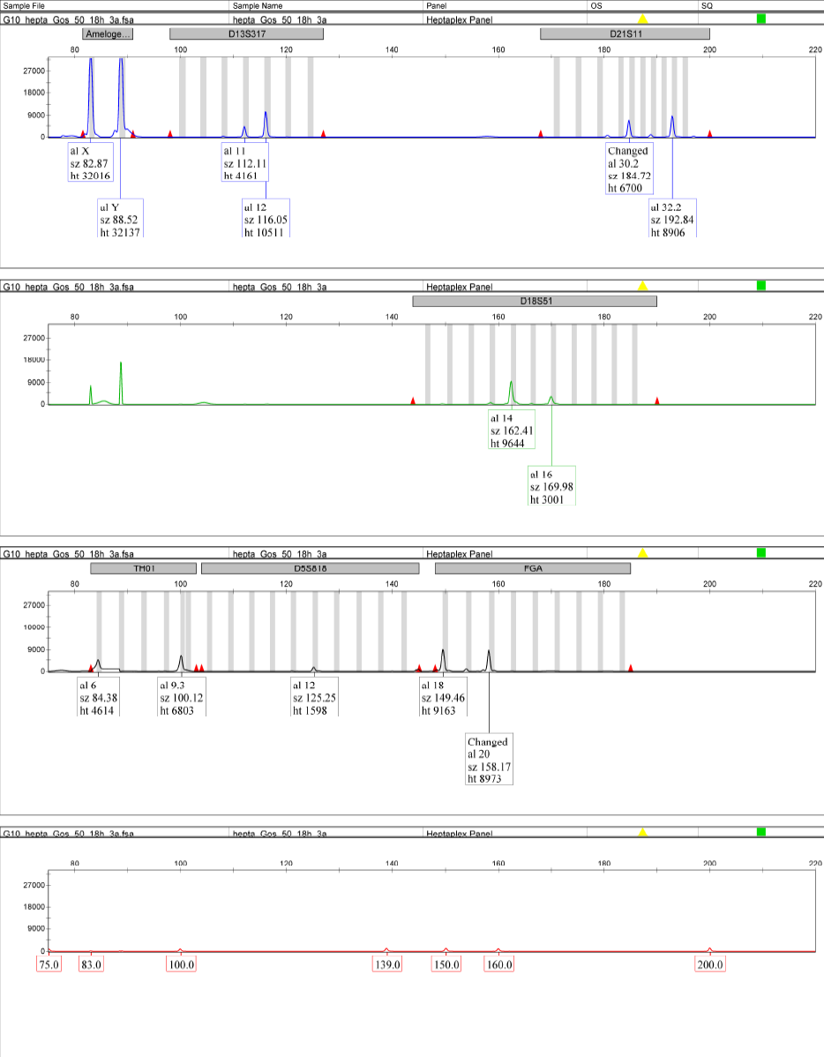**Supplementary figure 13: Genetic fingerprint for GS97 (50 mg, 18 hours).**

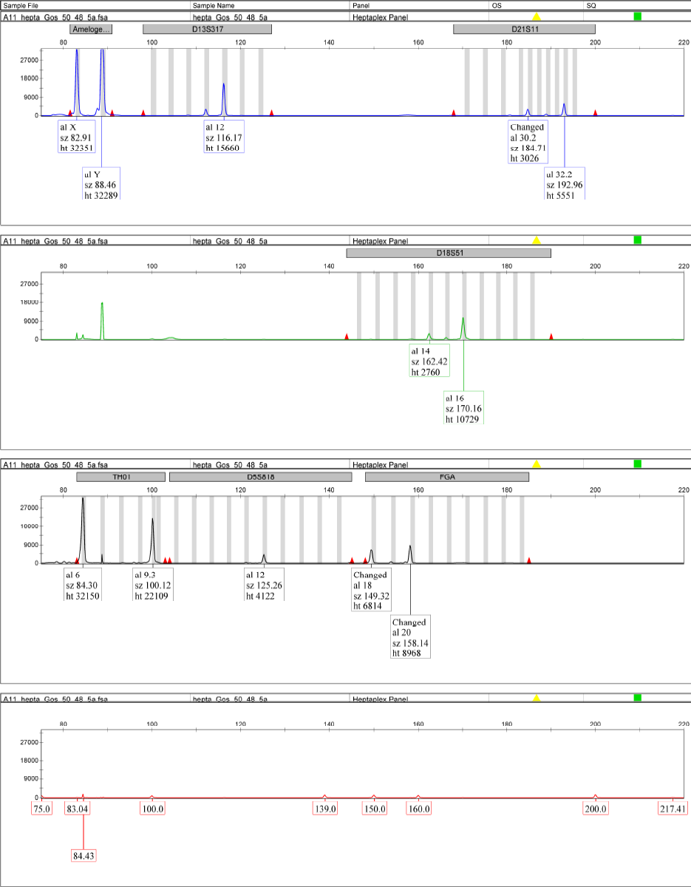

**Supplementary figure 14: Genetic fingerprint for GS97 (50 mg, 48 hours).**

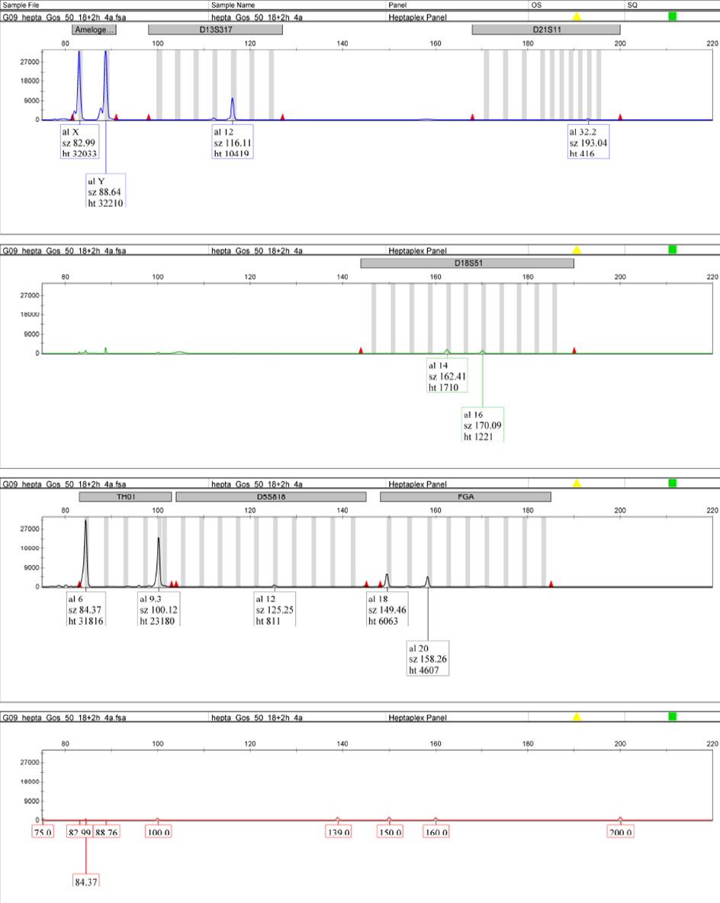

**Supplementary figure 15: Genetic fingerprint for GS97 (50 mg, 18 + 2 hours).**

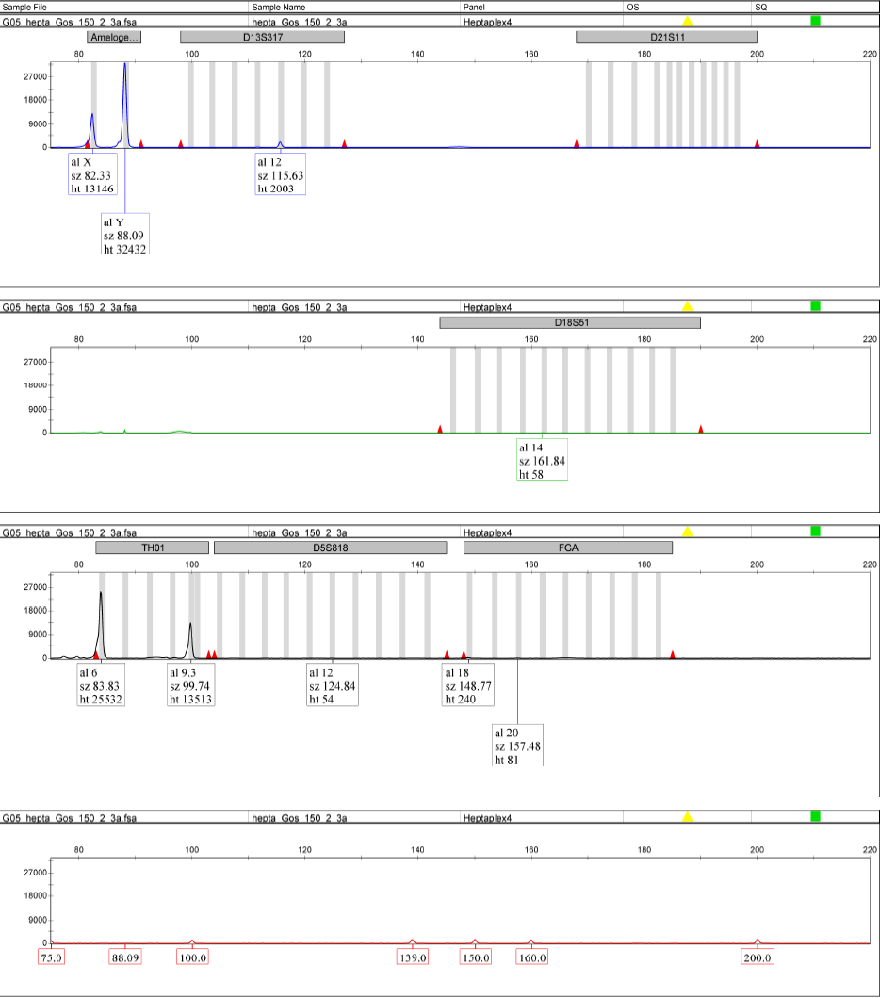

**Supplementary figure 16: Genetic fingerprint for GS97 (150 mg, 2 hours).**

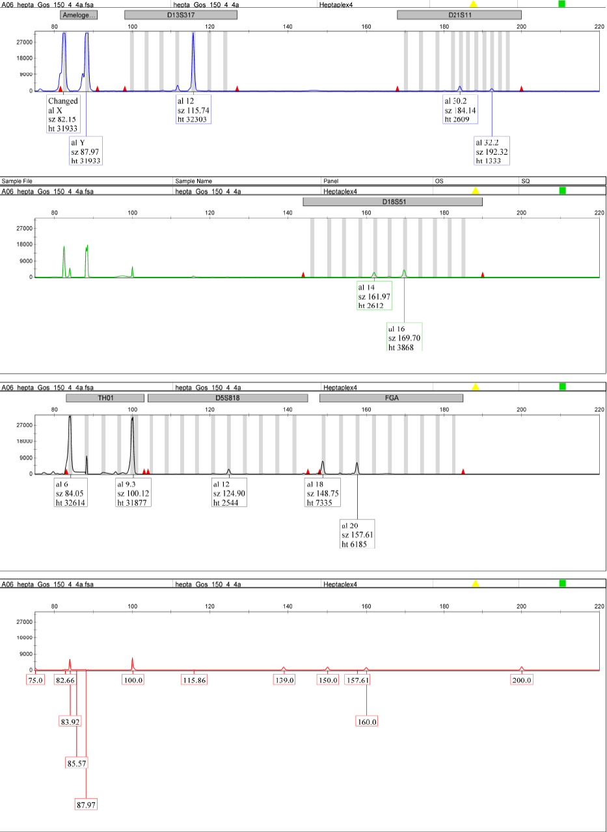

**Supplementary figure 17: Genetic fingerprint for GS97 (150 mg, 4 hours).**

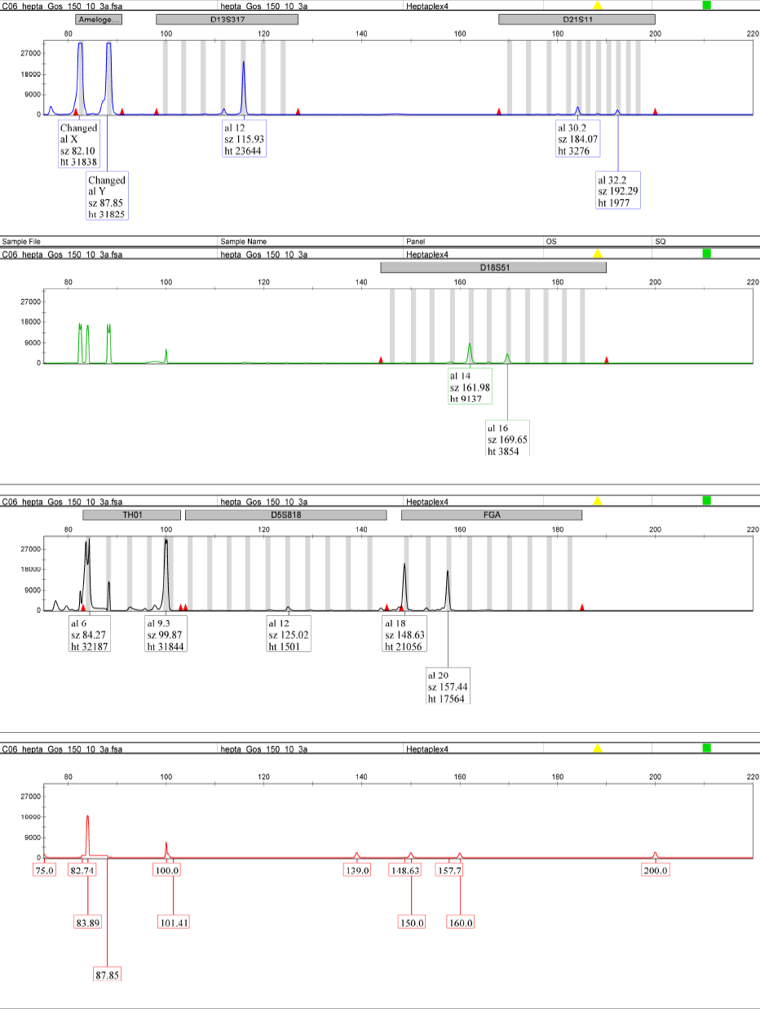**Supplementary figure 18: Genetic fingerprint for GS97 (150 mg, 10 hours).**

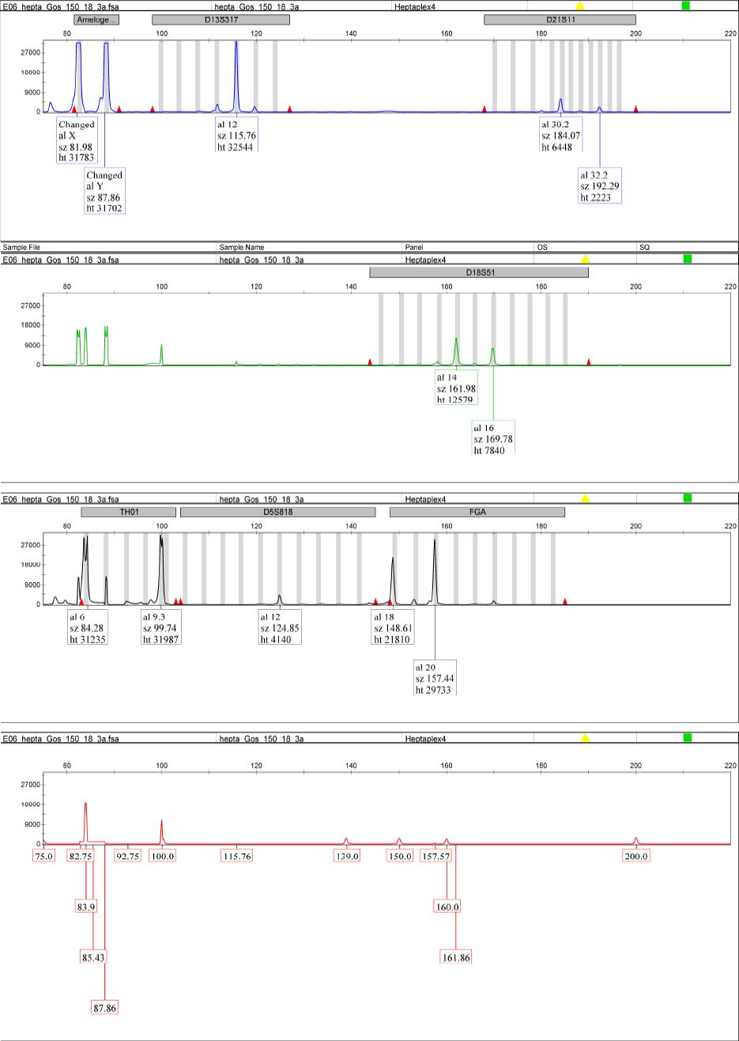**Supplementary figure 19: Genetic fingerprint for GS97 (150 mg, 18 hours).**

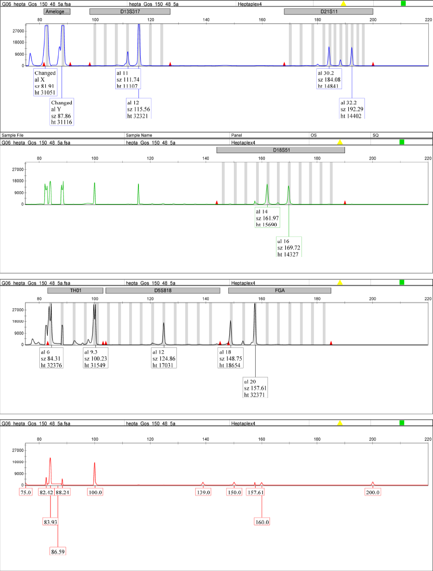

**Supplementary figure 20: Genetic fingerprint for GS97 (150 mg, 48 hours).**

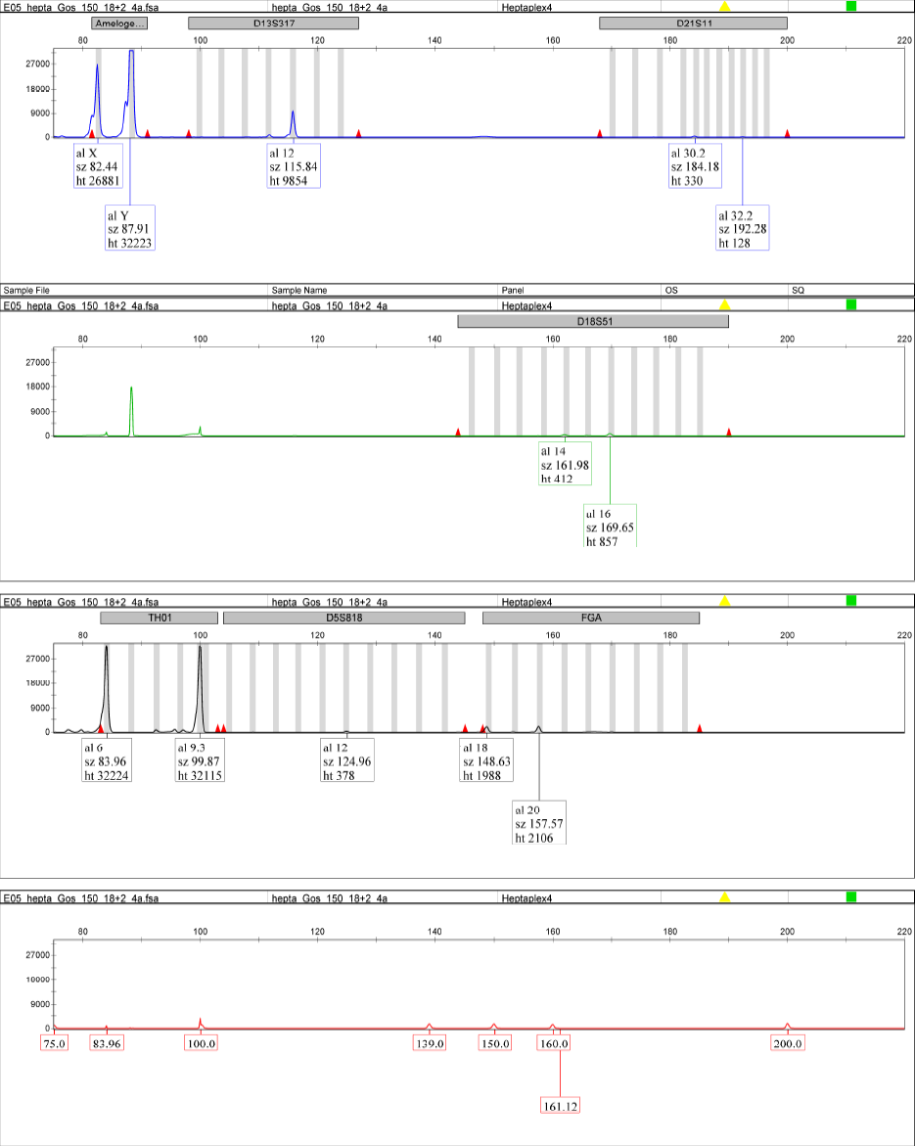

**Supplementary figure 21: Genetic fingerprint for GS97 (150 mg, 18 + 2 hours).**

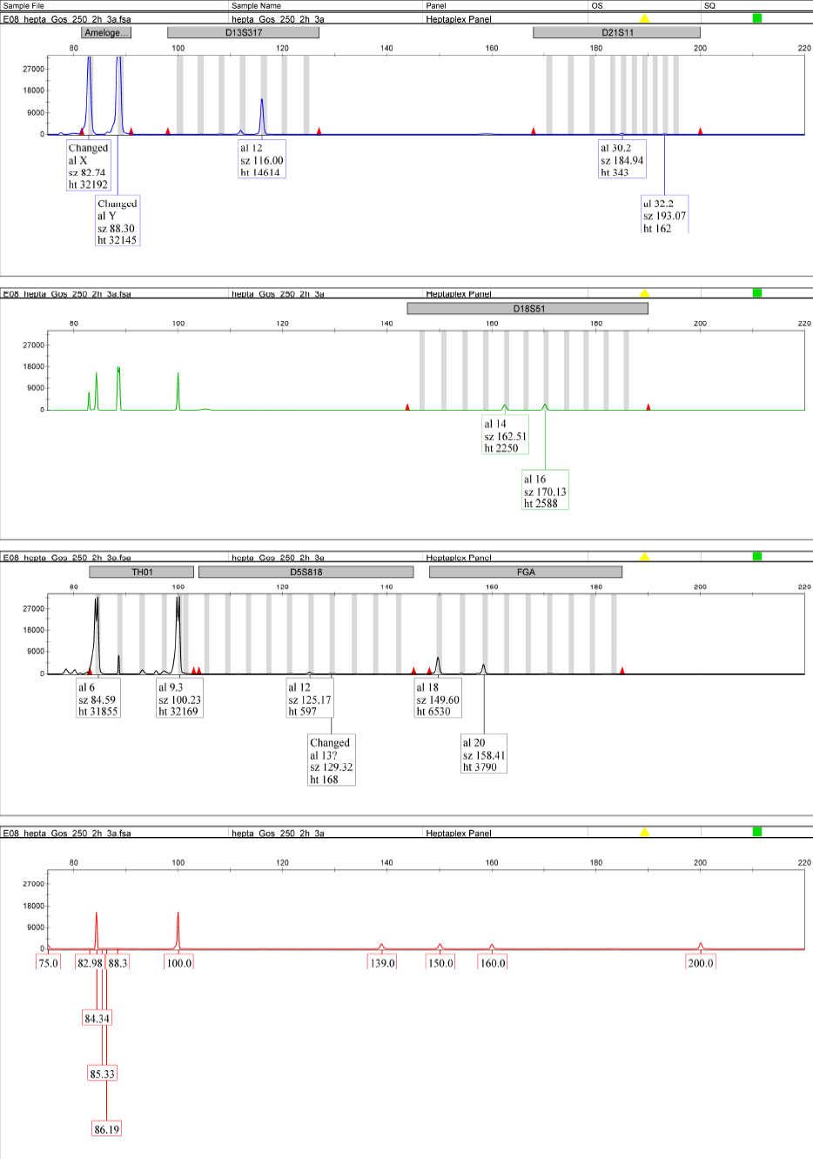

**Supplementary figure 22: Genetic fingerprint for GS97 (250 mg, 2 hours).**

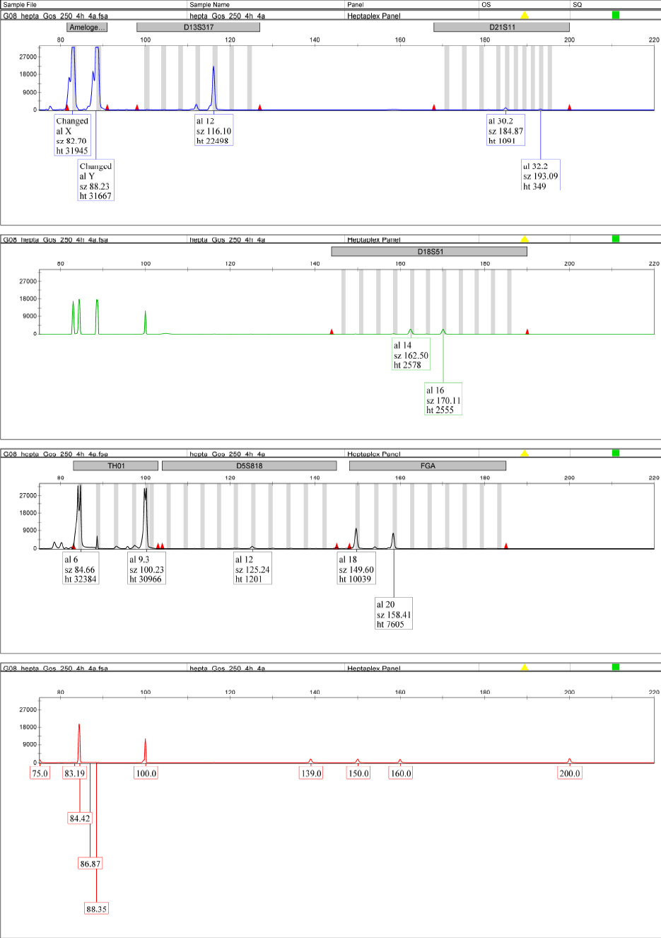

**Supplementary figure 23: Genetic fingerprint for GS97 (250 mg, 4 hours).**

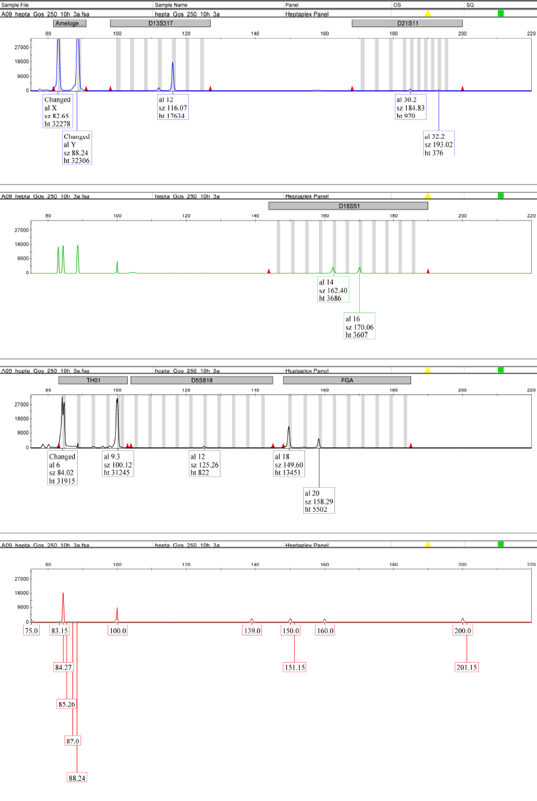

**Supplementary figure 24: Genetic fingerprint for GS97 (250 mg, 10 hours).**

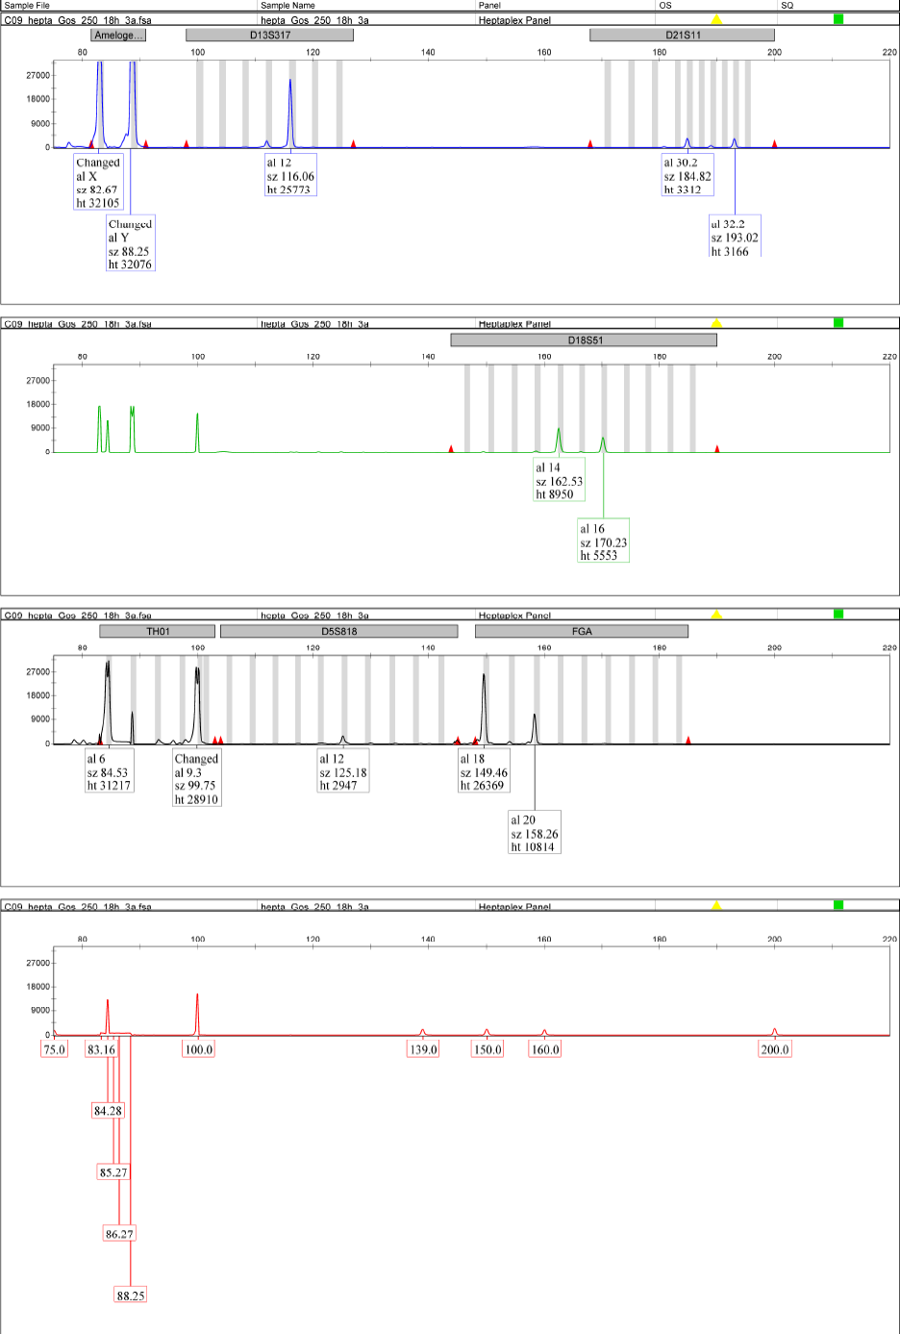

**Supplementary figure 25: Genetic fingerprint for GS97 (250 mg, 18 hours).**

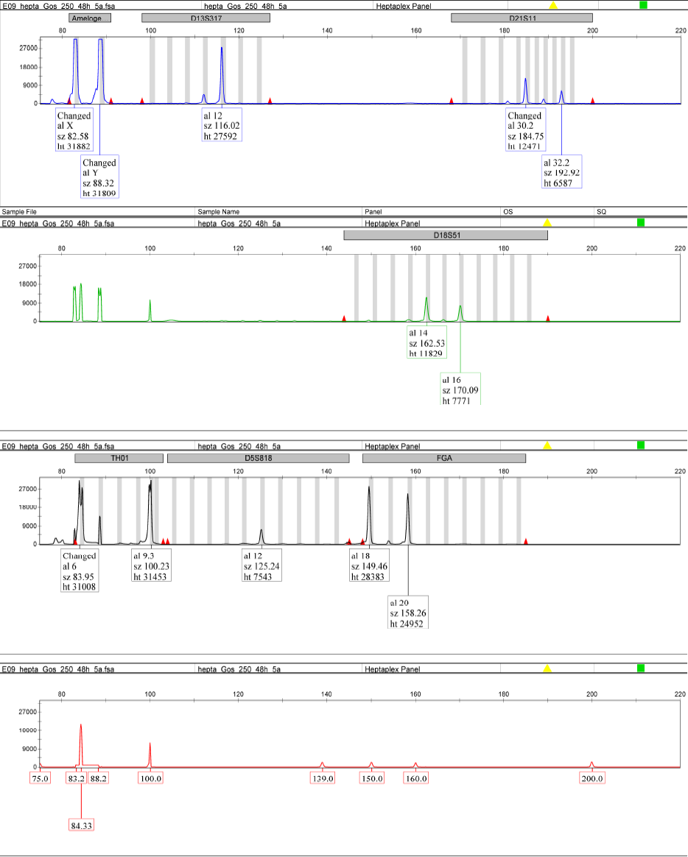

**Supplementary figure 26: Genetic fingerprint for GS97 (250 mg, 48 hours).**

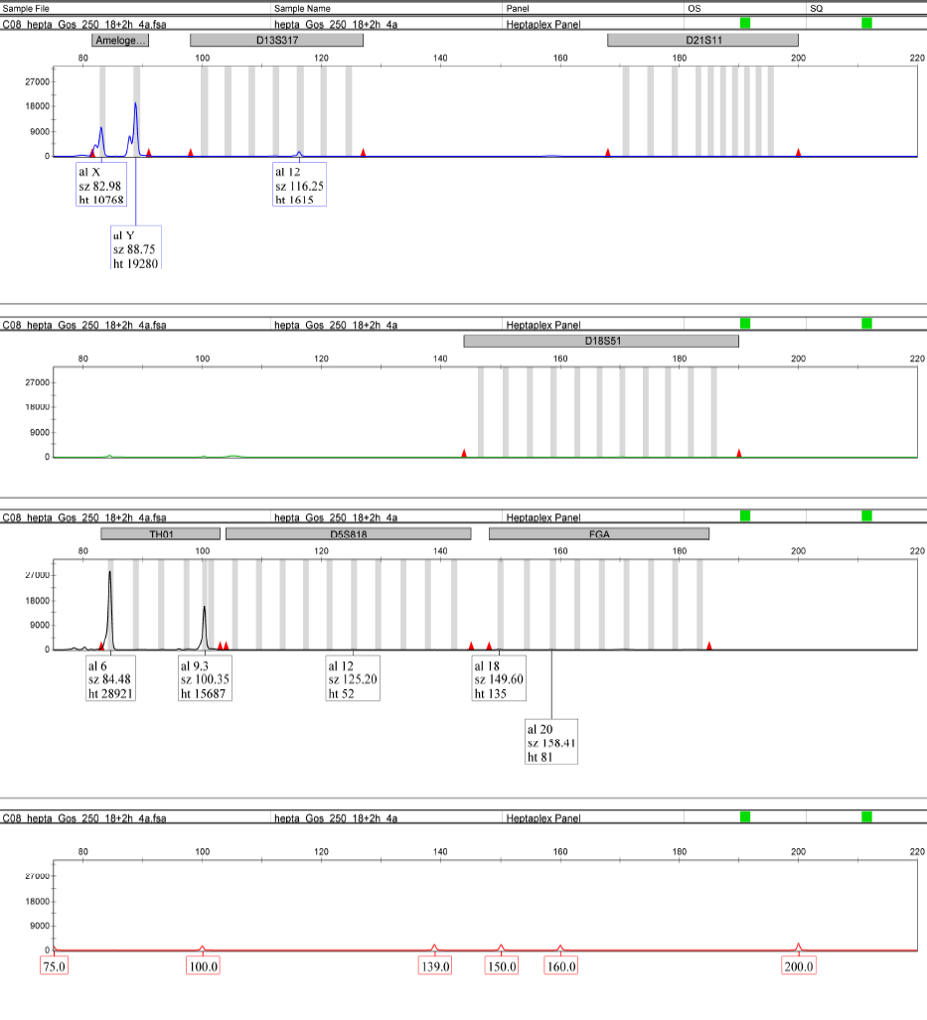

**Supplementary figure 27: Genetic fingerprint for GS97 (250 mg, 18 + 2 hours).**

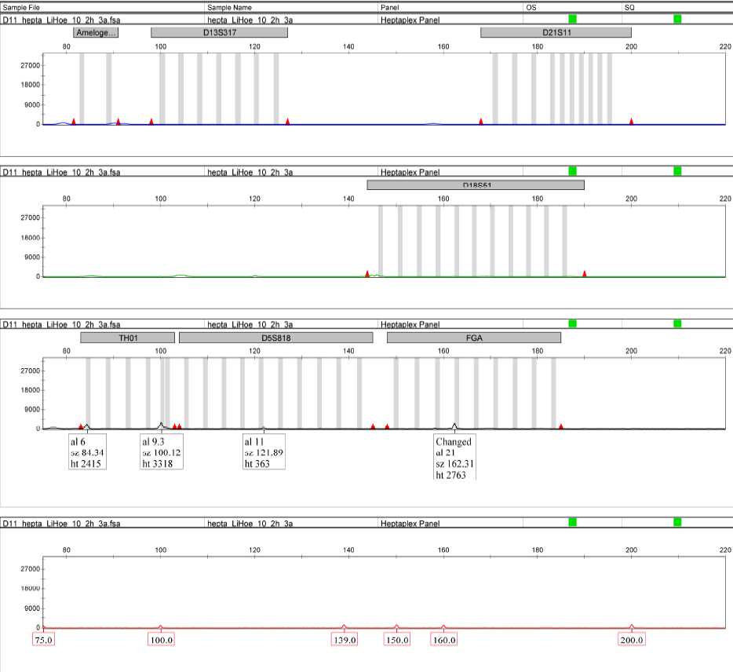

**Supplementary figure 28: Genetic fingerprint for DO902.01 (10 mg, 2 hours).**

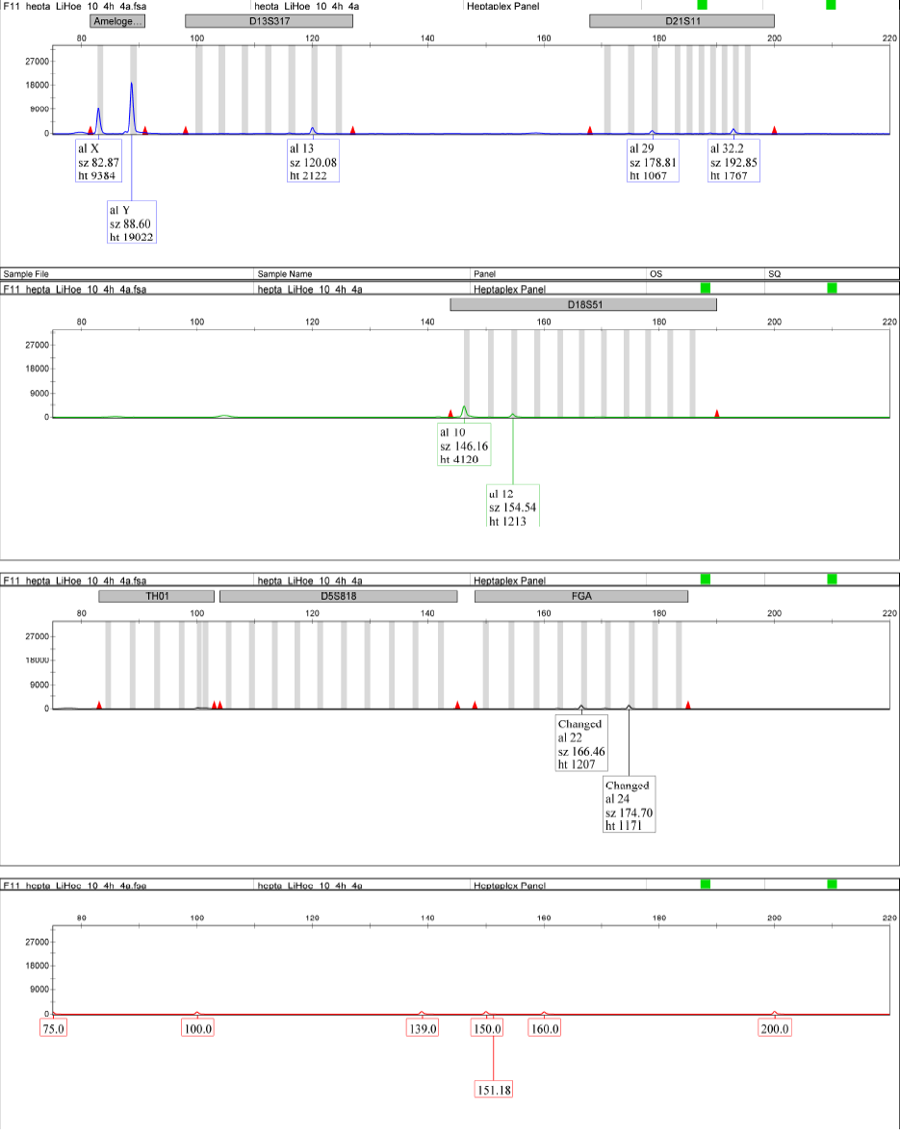

**Supplementary figure 29: Genetic fingerprint for DO902.01 (10 mg, 4 hours).**

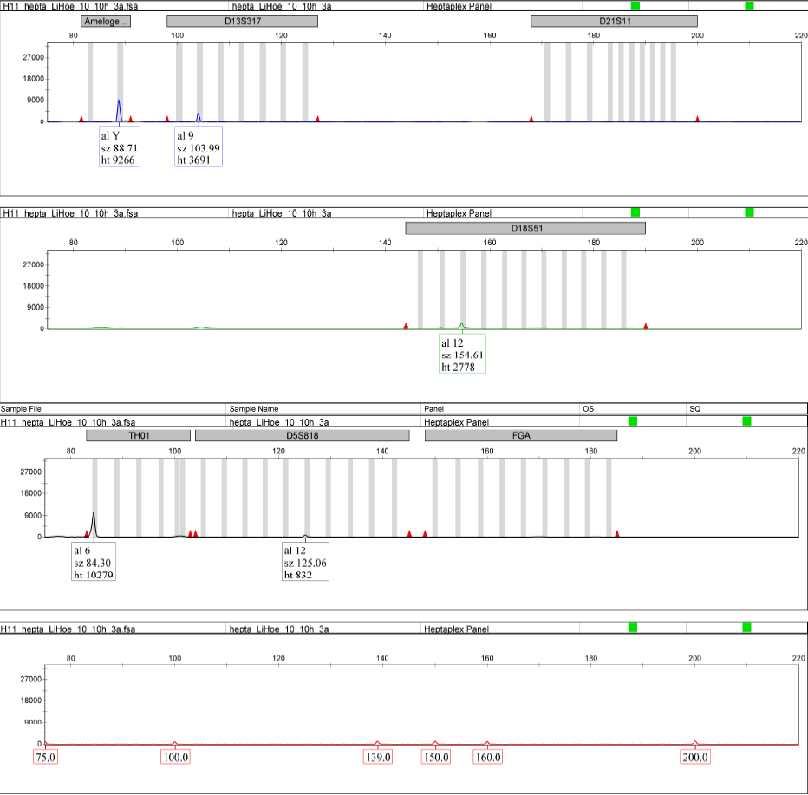

**Supplementary figure 30: Genetic fingerprint for DO902.01 (10 mg, 10 hours).**

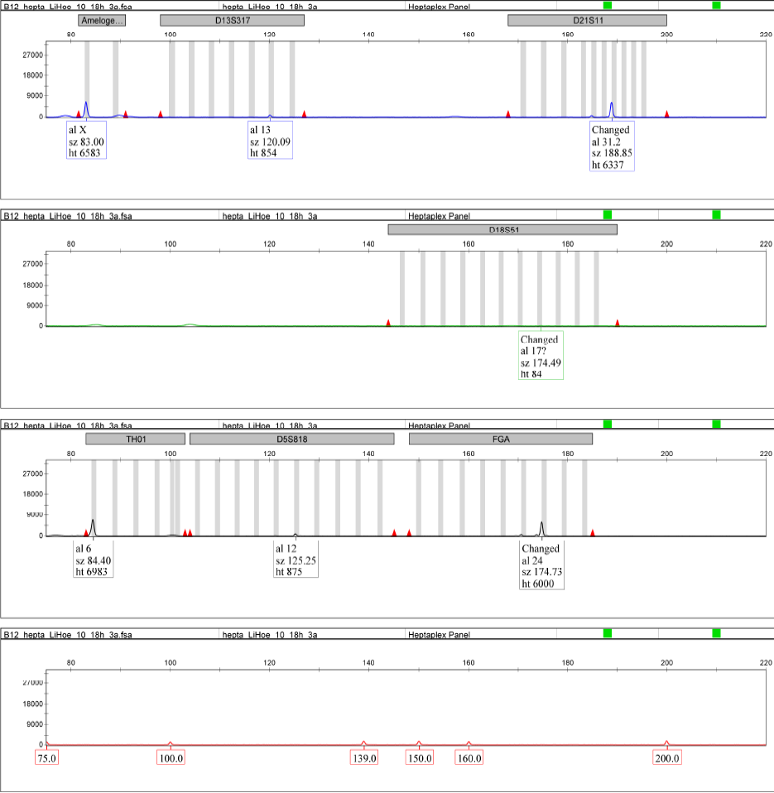

**Supplementary figure 31: Genetic fingerprint for DO902.01 (10 mg, 18 hours).**

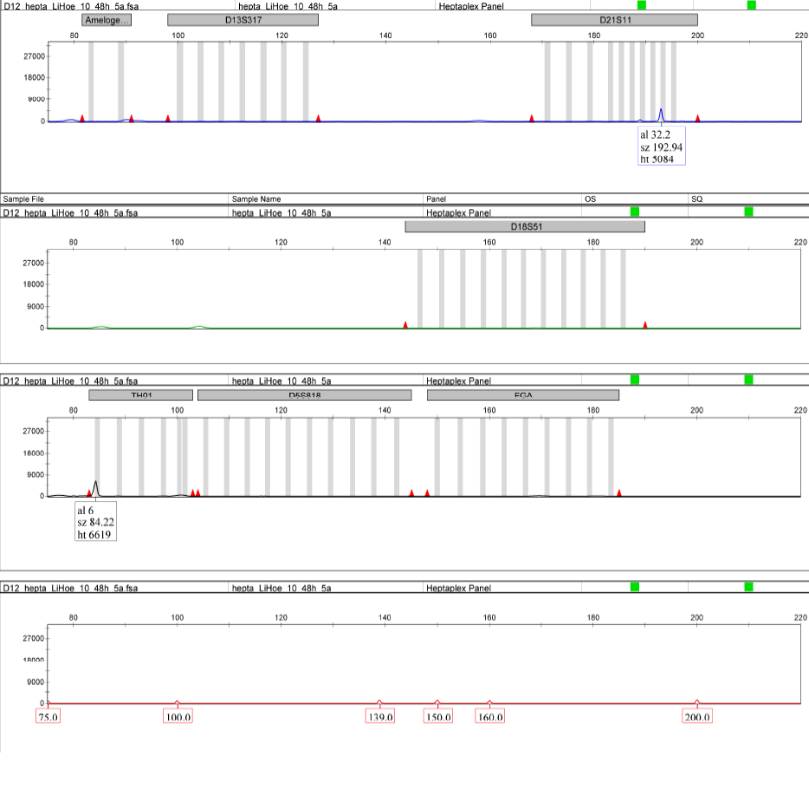

**Supplementary figure 32: Genetic fingerprint for DO902.01 (10 mg, 48 hours).**

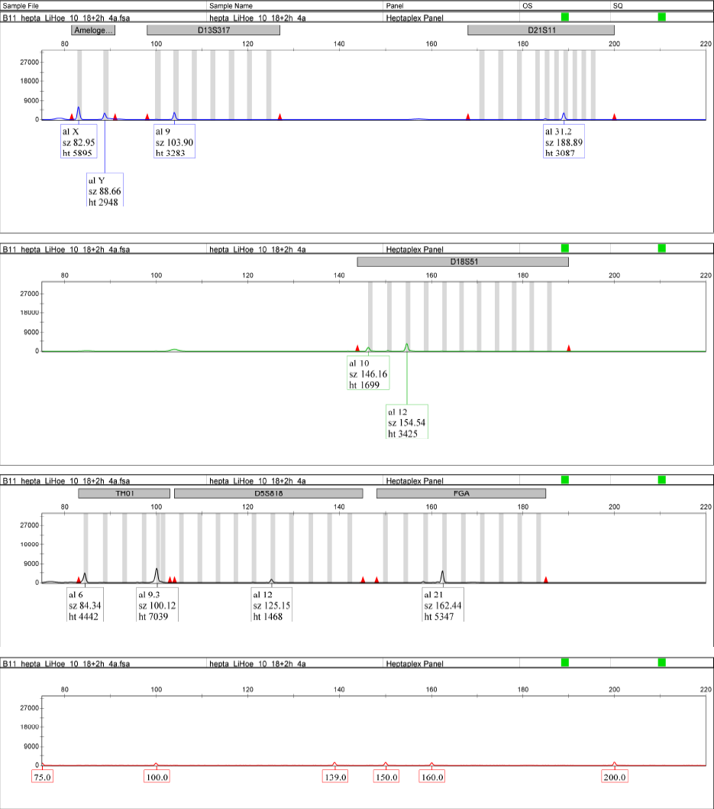

**Supplementary figure 33: Genetic fingerprint for DO902.01 (10 mg, 18 + 2 hours).**

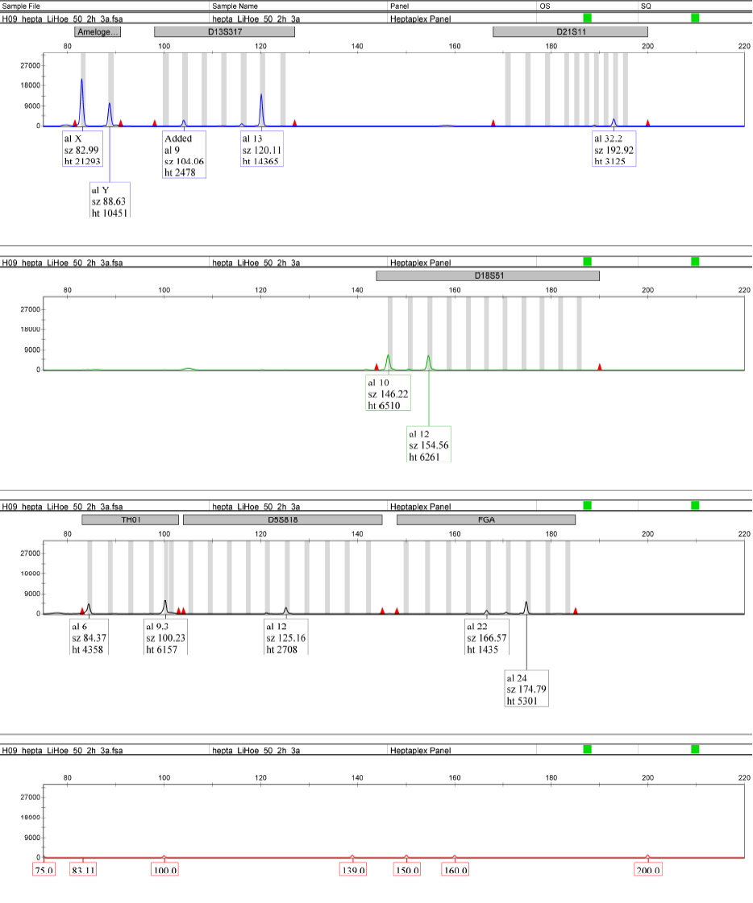**Supplementary figure 34: Genetic fingerprint for DO902.01 (50 mg, 2 hours).**

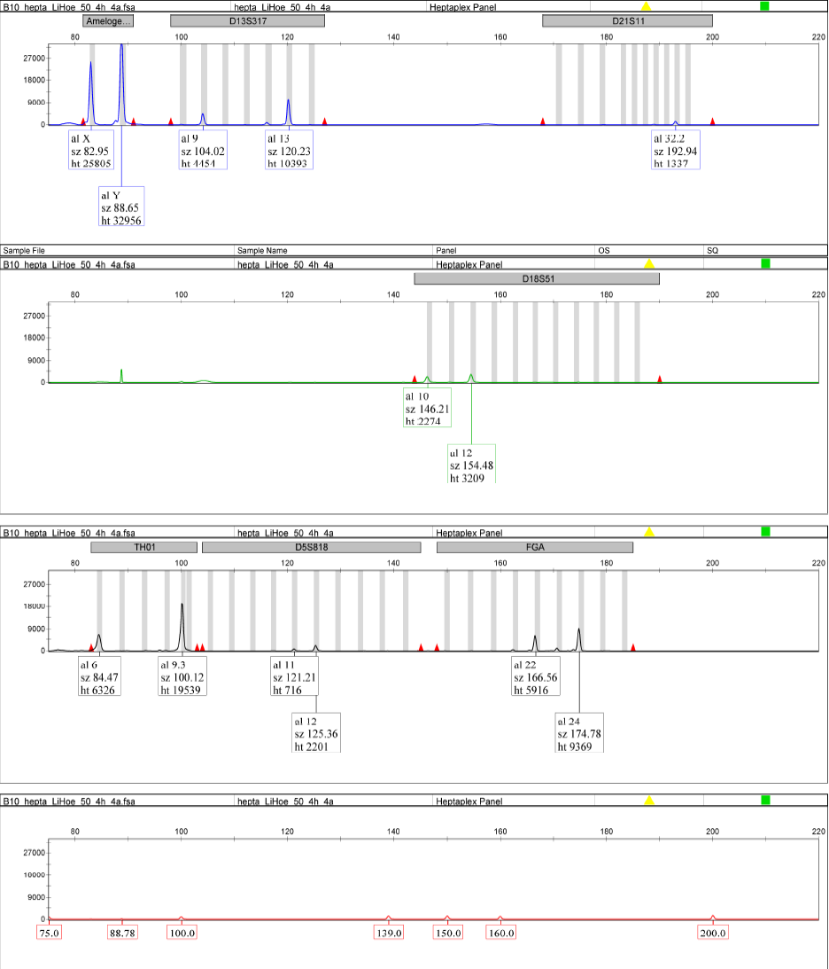

**Supplementary figure 35: Genetic fingerprint for DO902.01 (50 mg, 4 hours).**

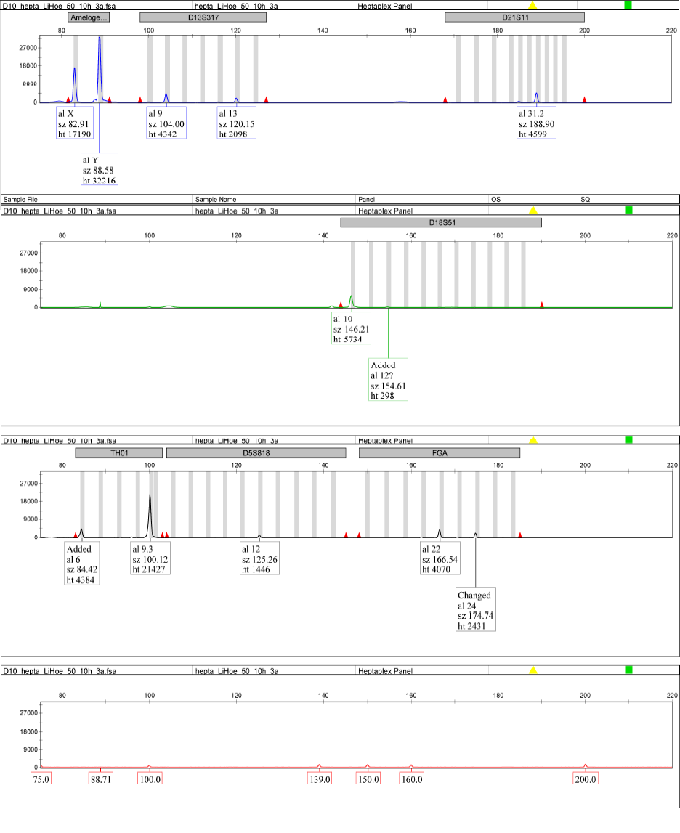

**Supplementary figure 36: Genetic fingerprint for DO902.01 (50 mg, 10 hours).**

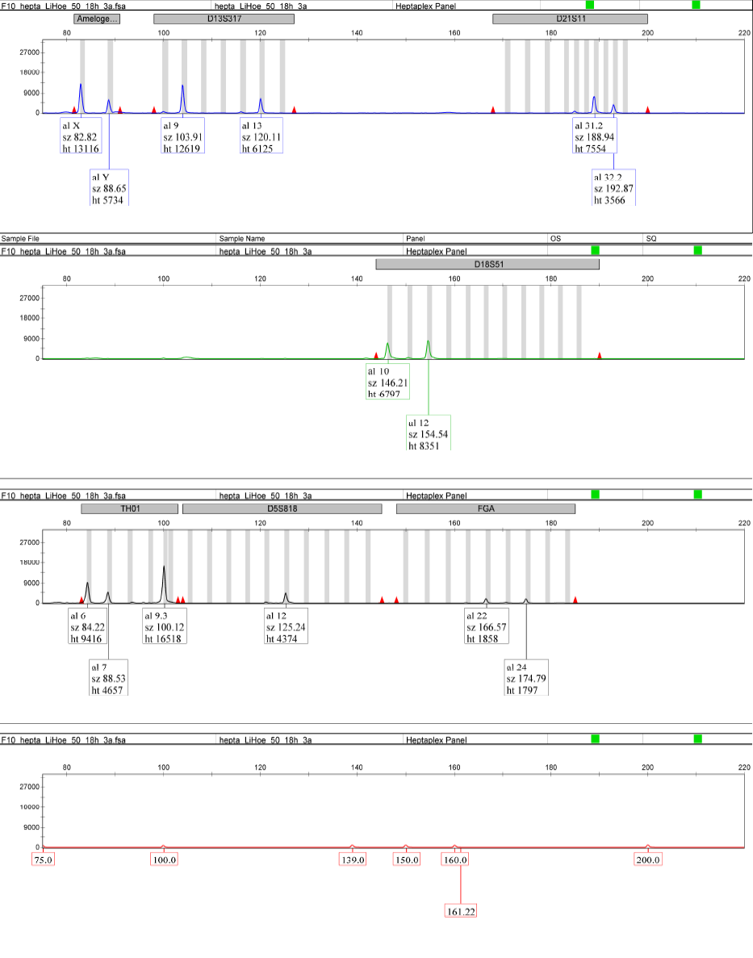

**Supplementary figure 37: Genetic fingerprint for DO902.01 (50 mg, 18 hours).**

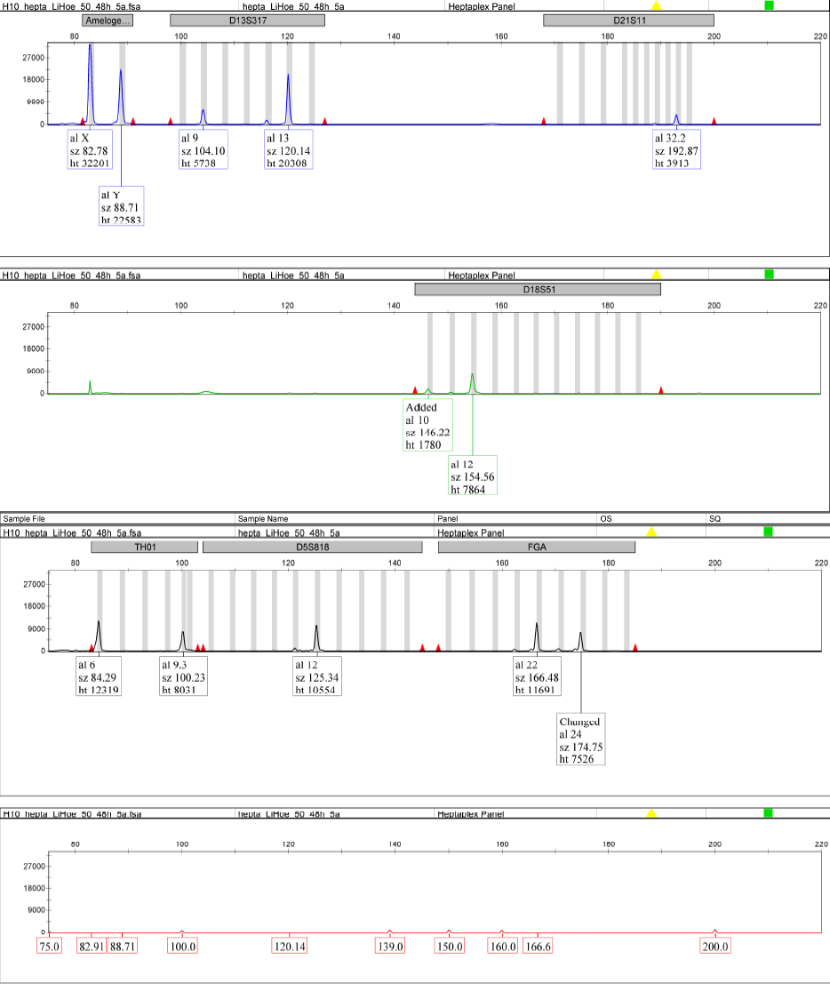

**Supplementary figure 38: Genetic fingerprint for DO902.01 (50 mg, 48 hours).**

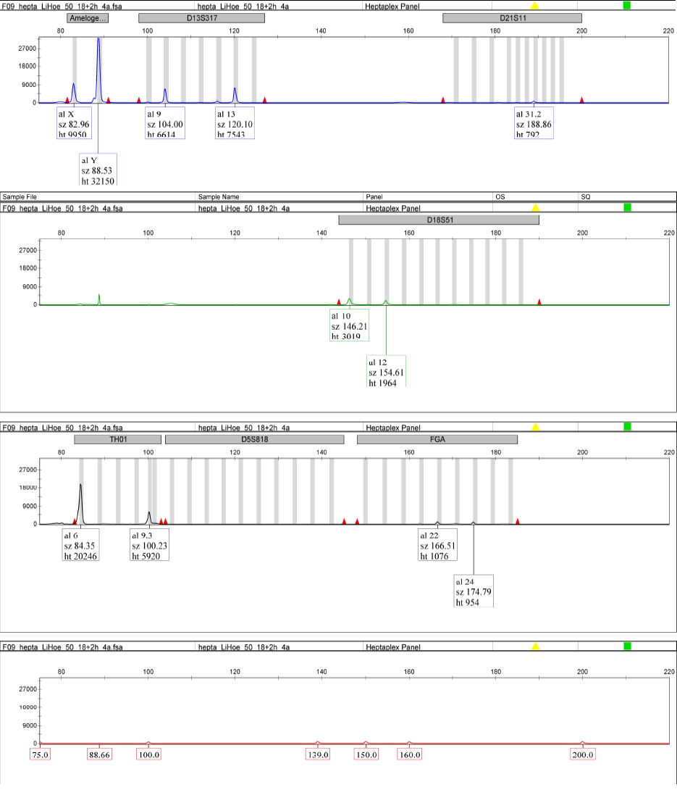

**Supplementary figure 39: Genetic fingerprint for DO902.01 (50 mg, 18 + 2 hours).**

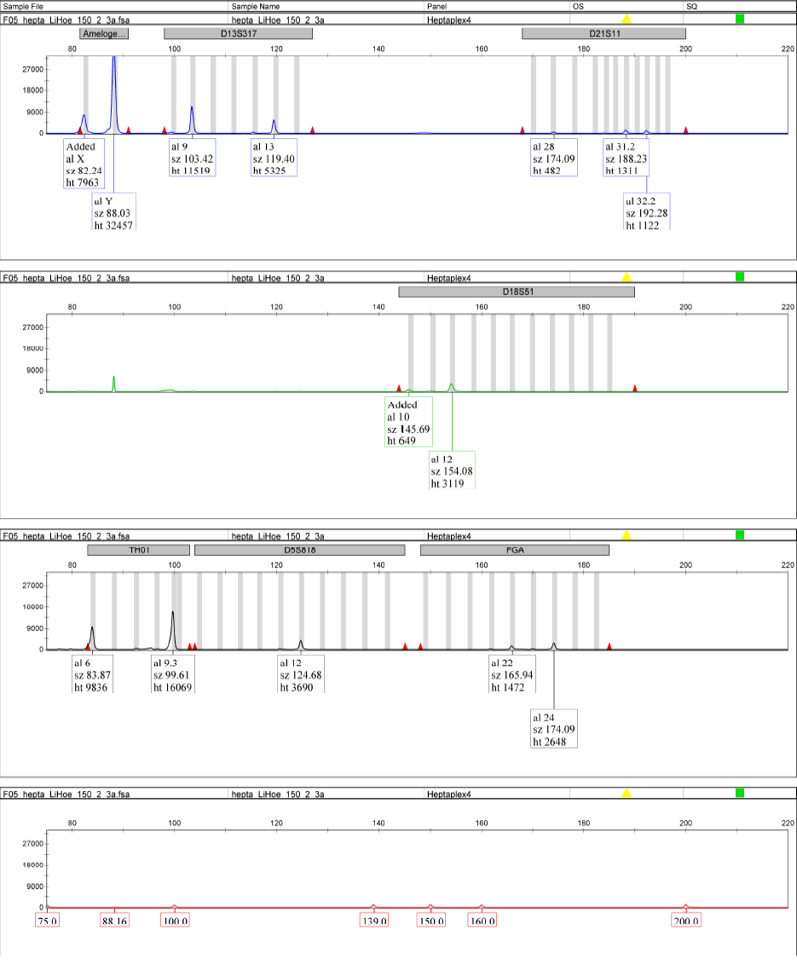

**Supplementary figure 40: Genetic fingerprint for DO902.01 (150 mg, 2 hours).**

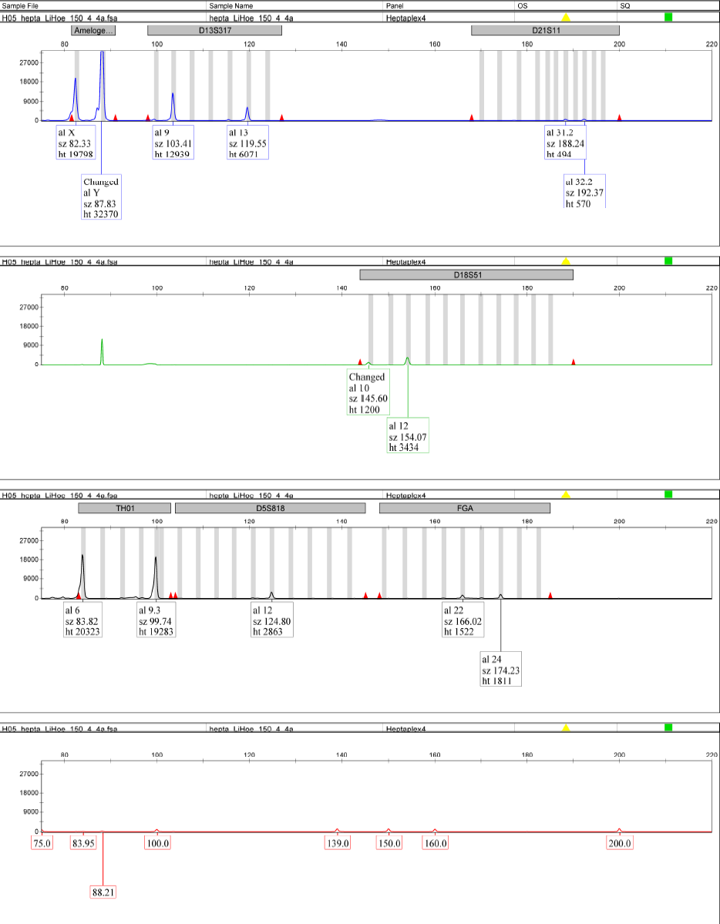

**Supplementary figure 41: Genetic fingerprint for DO902.01 (150 mg, 4 hours).**

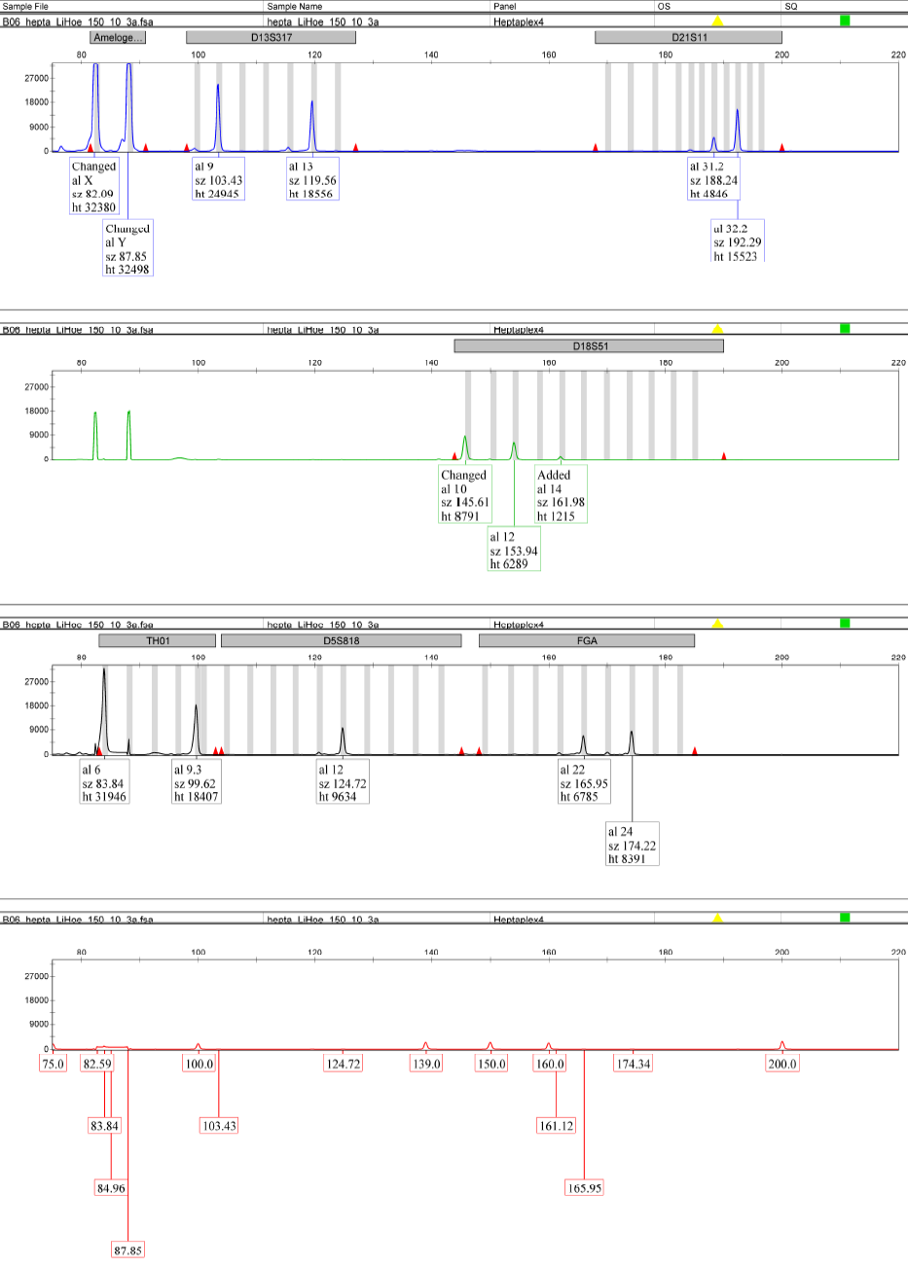

**Supplementary figure 42: Genetic fingerprint for DO902.01 (150 mg, 10 hours).**

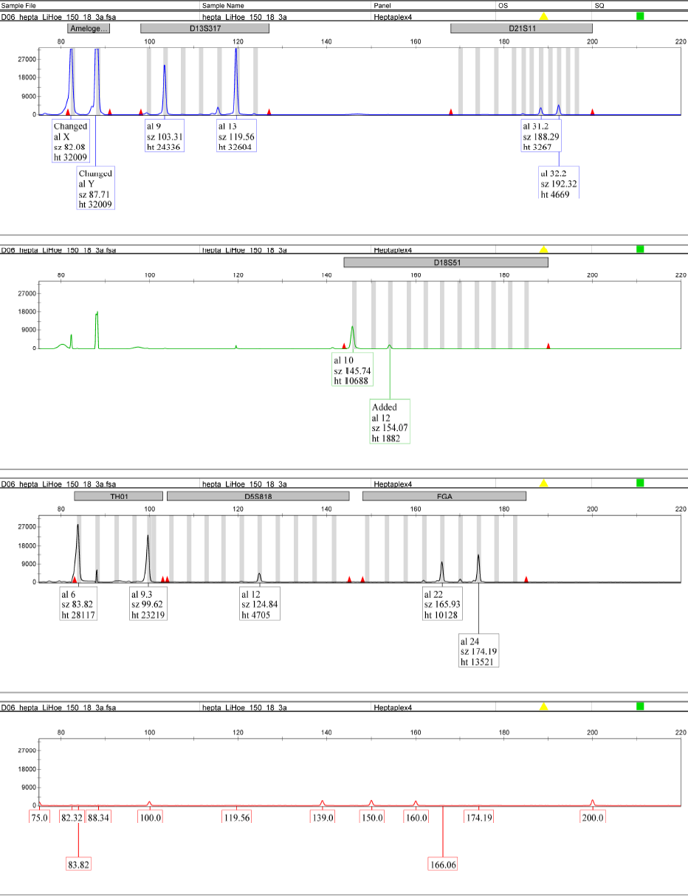

**Supplementary figure 43: Genetic fingerprint for DO902.01 (150 mg, 18 hours).**

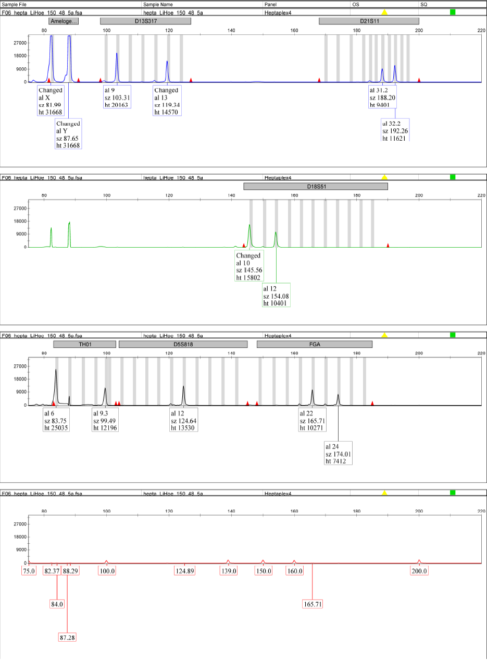

**Supplementary figure 44: Genetic fingerprint for DO902.01 (150 mg, 48 hours).**

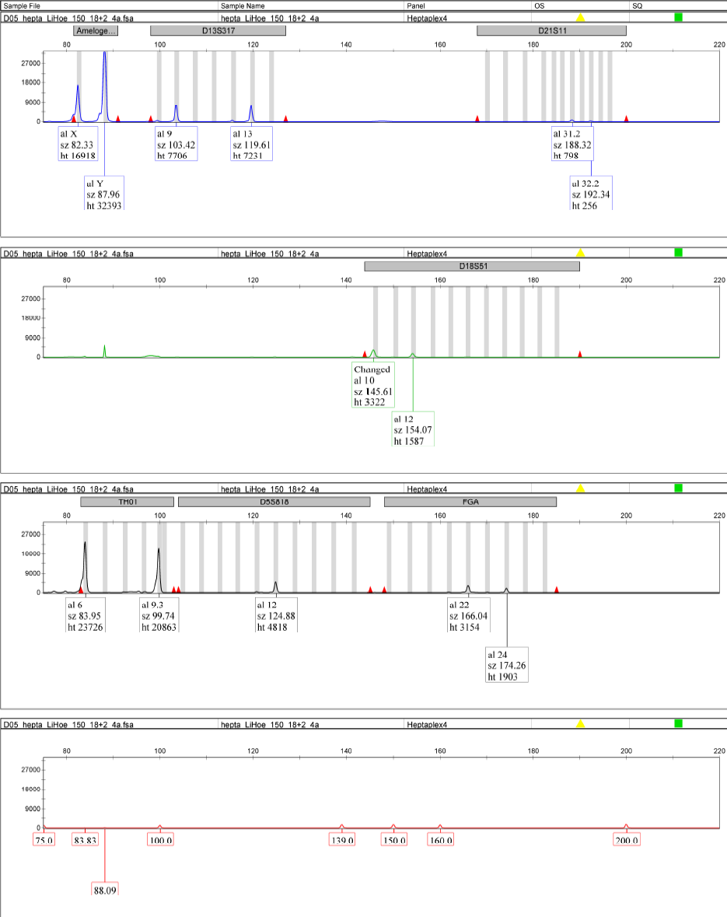

**Supplementary figure 45: Genetic fingerprint for DO902.01 (150 mg, 18 + 2 hours).**

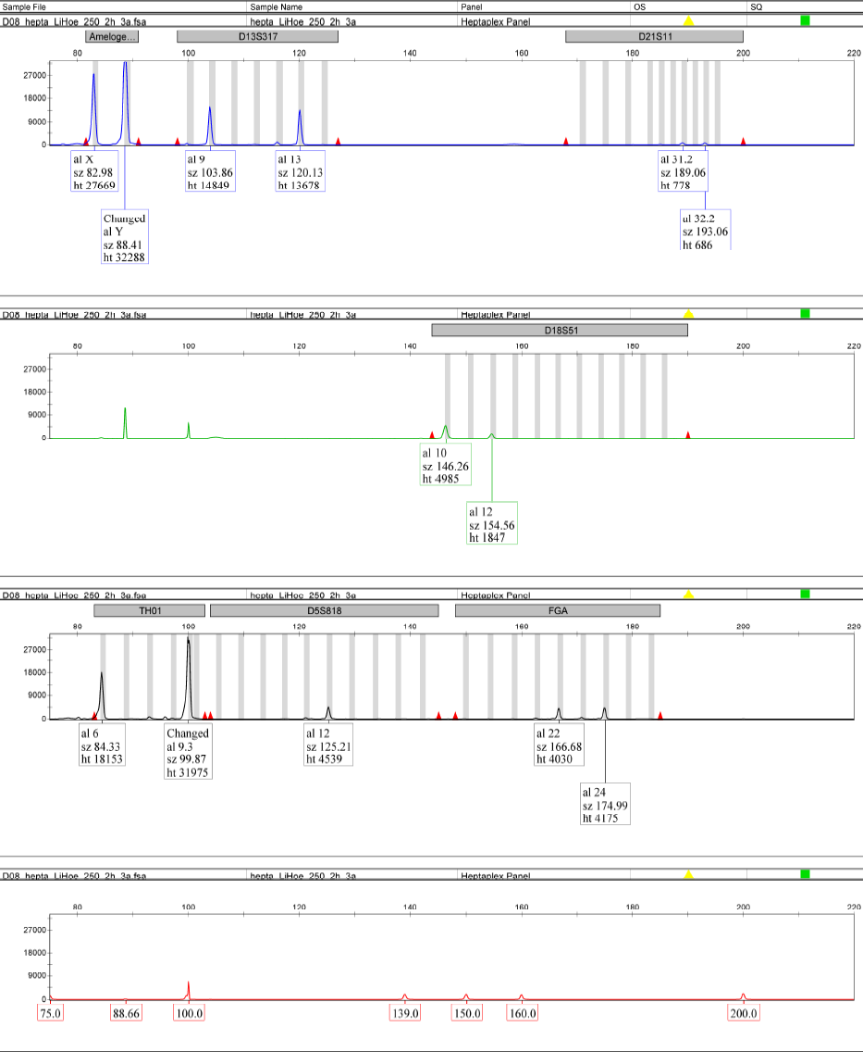

**Supplementary figure 46: Genetic fingerprint for DO902.01 (250 mg, 2 hours).**

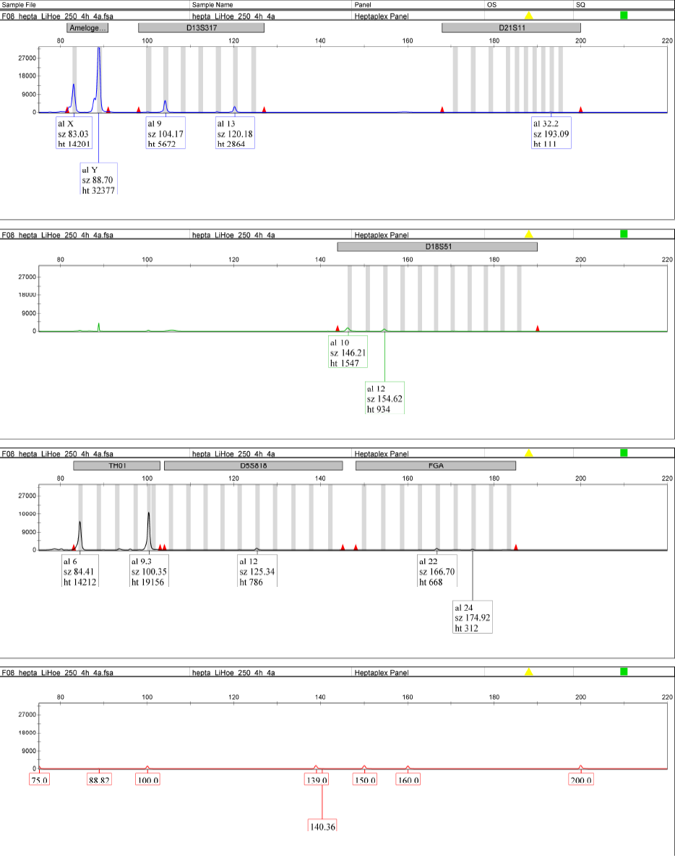

**Supplementary figure 47: Genetic fingerprint for DO902.01 (250 mg, 4 hours).**

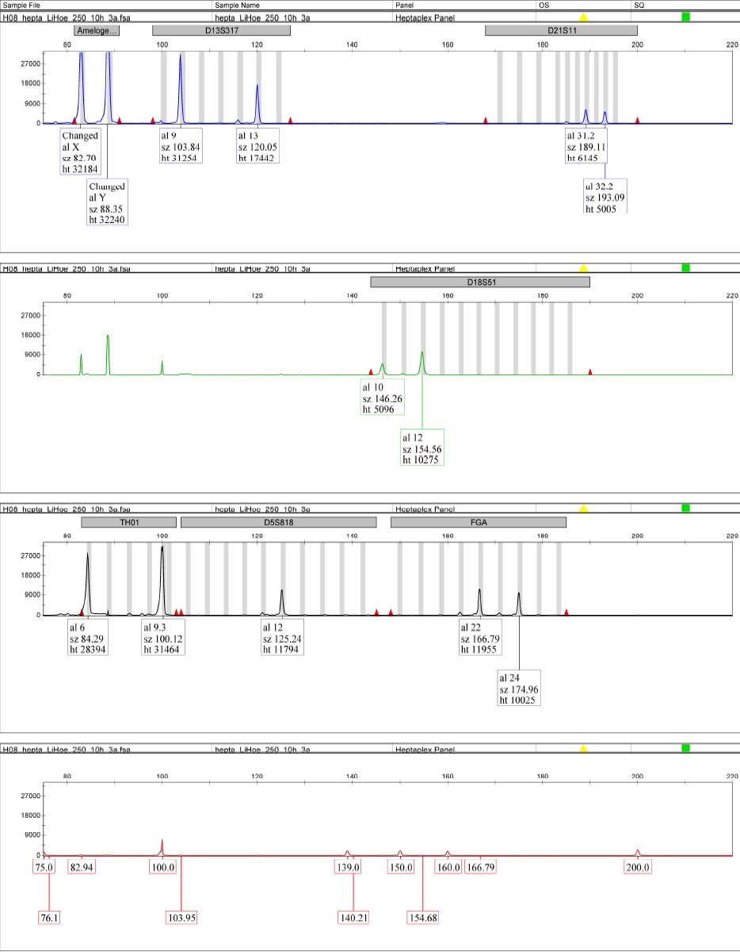

**Supplementary figure 48: Genetic fingerprint for DO902.01 (250 mg, 10 hours).**

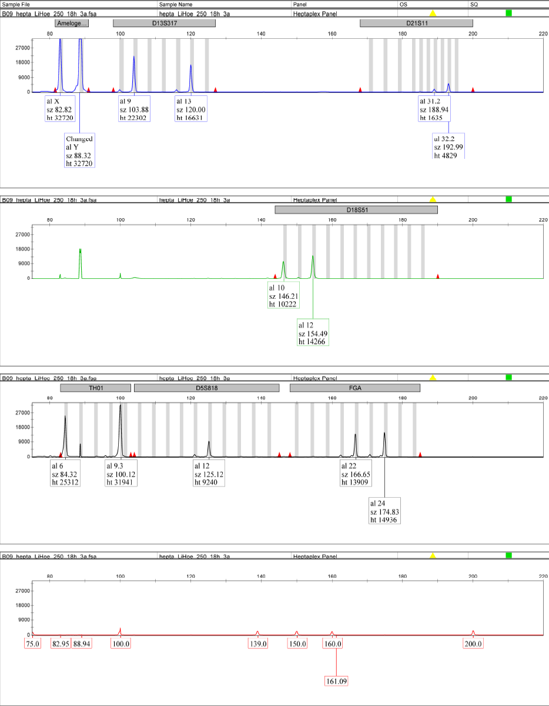

**Supplementary figure 49: Genetic fingerprint for DO902.01 (250 mg, 18 hours).**

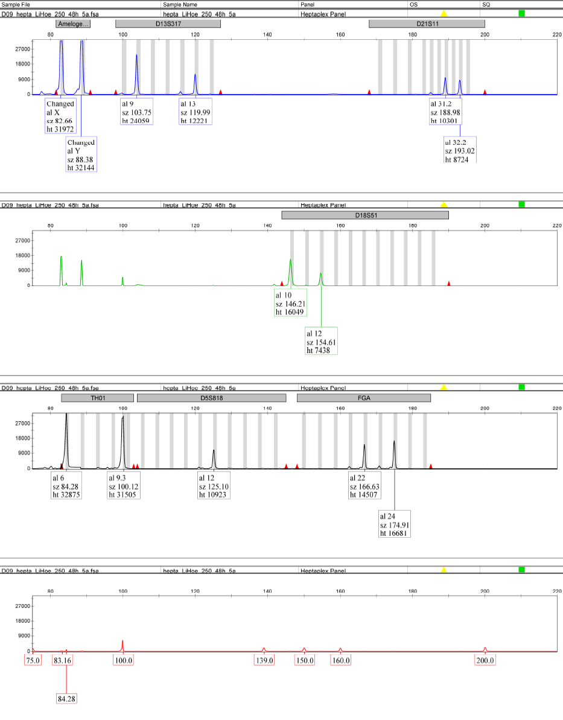

**Supplementary figure 50: Genetic fingerprint for DO902.01 (250 mg, 48 hours).**

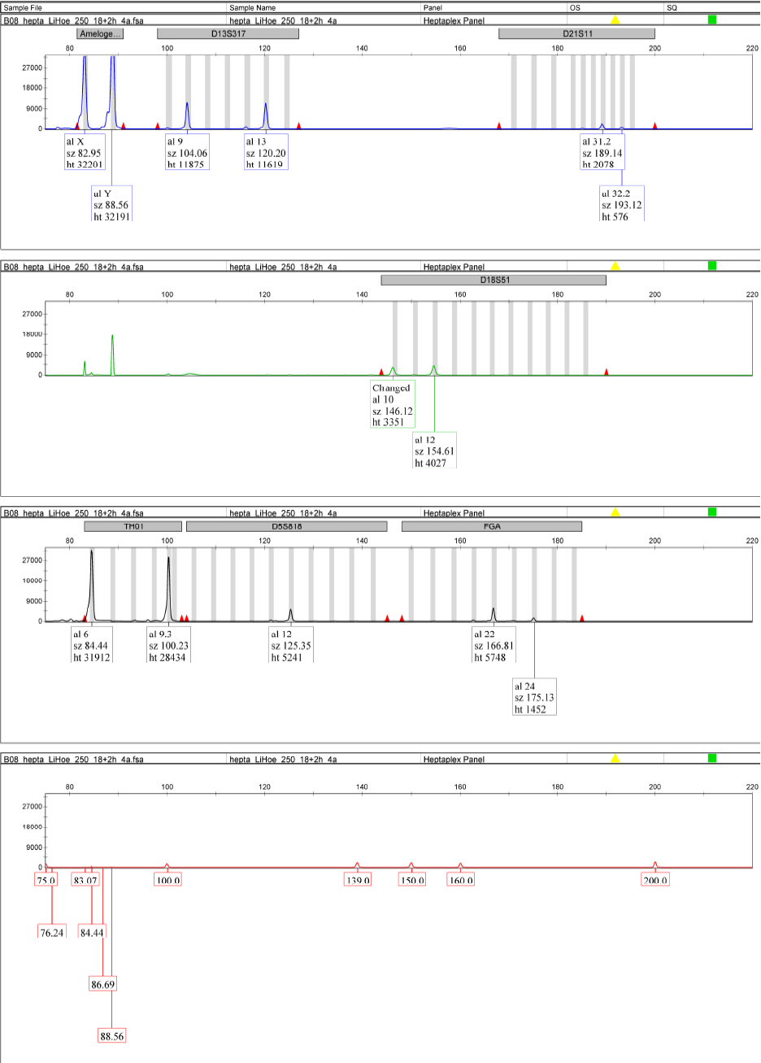

**Supplementary figure 51: Genetic fingerprint for DO902.01 (250 mg, 18 + 2 hours).**