Supplementary Materials 4: Alignments of mitochondrial DNA
The influence of sample quantity and lysis parameters on the success of ancient DNA extraction from skeletal remains

The software MegAlign (DNASTAR) and SeqMan (DNASTAR) were used to evaluate the electropherogram base sequences. The alignments are listed below.

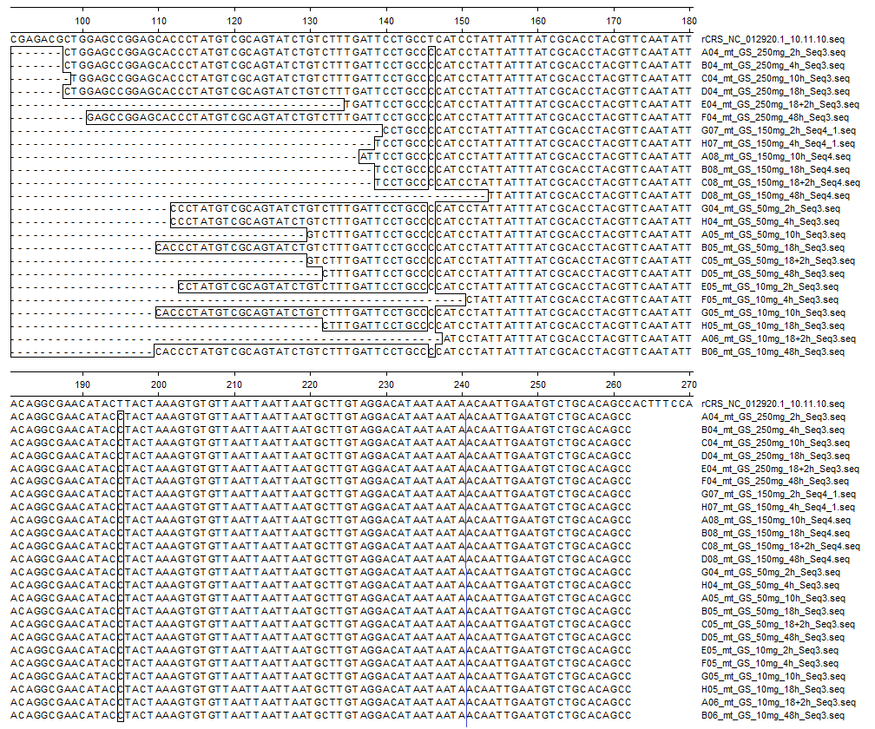
Supplementary figure 60: Alignments of GS97. Here, the individual was named GS. The first sequence above is a reference sequence (rCRS) to which the base sequences were compared. Polymorphisms can be seen in the three boxes. The sequence of the reverse primer is located starting at the blue marker (241-262).

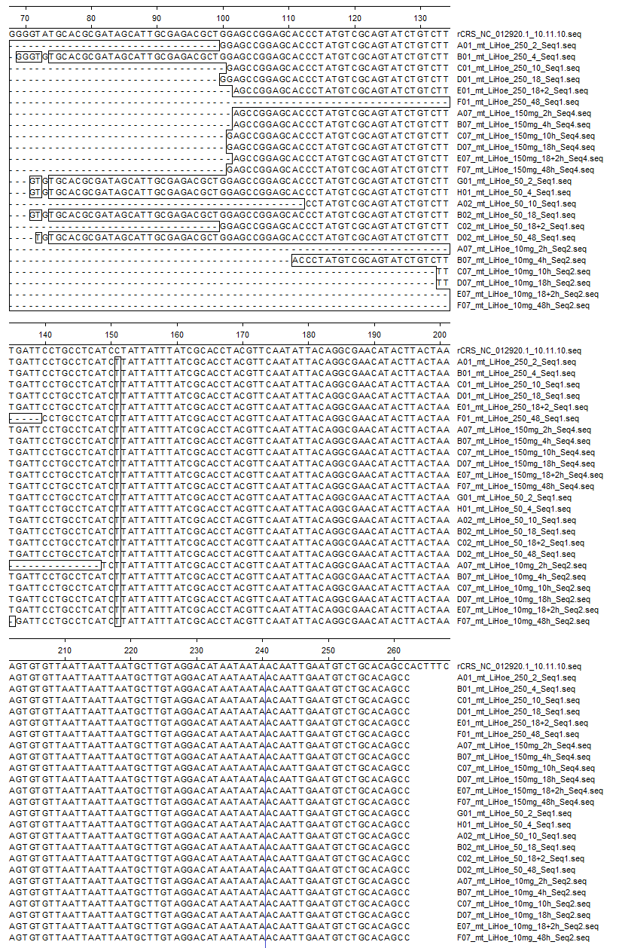

Supplementary figure 61: Alignments of DO902.01. Here, the individual was named LiHoe. The first sequence above is a reference sequence (rCRS) to which the base sequences were compared. Polymorphisms can be seen in the two boxes. The sequence of the reverse primer is located starting at the blue marker (241-262).

