Supplementary Figure 1
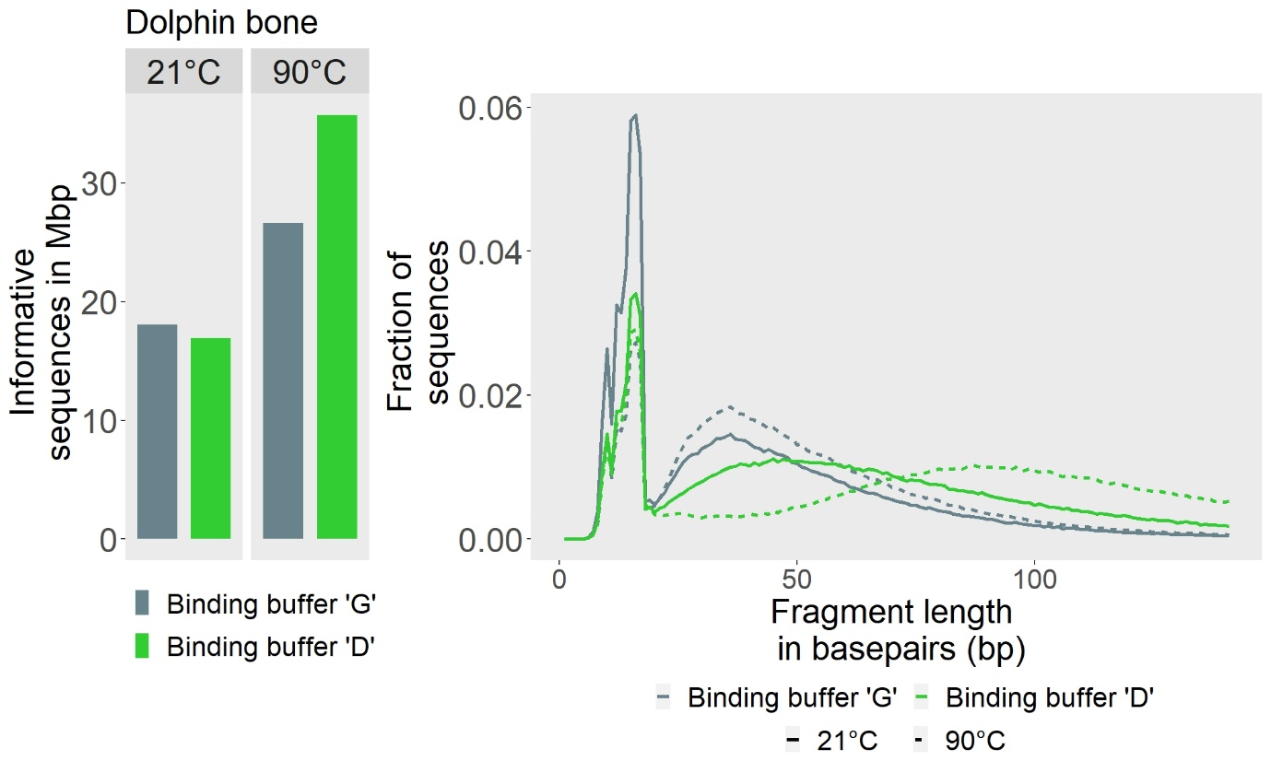
Supplementary Figure 1 Performance of two DNA extraction protocols for the purification of DNA from phosphate fractions obtained through incubation at room-temperature (21 °C) and 90 °C incubation. Phosphate fractions were obtained from the whale bone using the Supplementary Protocol. DNA was extracted from each fraction using two binding buffer options (‘G’ and ‘D’; [1]). Whereas both binding buffers yielded similar quantities of endogenous DNA (left panel), binding buffer ‘D’ resulted in a skew towards sequences from longer fragments (right panel), especially when applied to the 90 °C phosphate fraction, indicating a loss of short single-stranded DNA molecules. We therefore used binding buffer ‘G’ in all further experiments.

1. Glocke I, Meyer M. Extending the spectrum of DNA sequences retrieved from ancient bones and teeth. Genome Res. 27(7), 1230-1237 (2017).

