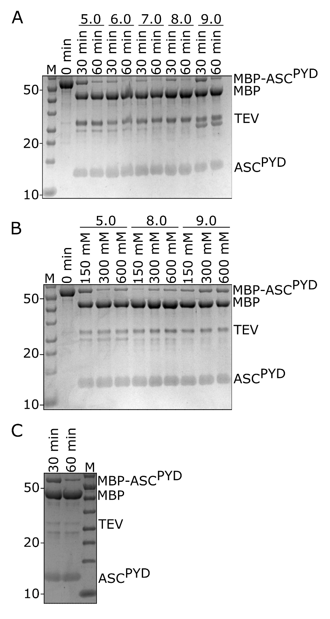

Supplementary Figure 1: TEV-Cleavage of MBP-ASC^{PYD}. (A) Proteolysis of 10 µM MBP-ASC^{PYD} with 2 µM TEV protease in buffers with 150 mM KCl and different pH values. (B) Proteolysis of 30 µM MBP-ASC^{PYD} with 2 µM TEV protease in buffers with different pHs and different KCl concentrations. (C) Proteolysis of 200 µM MBP-ASC^{PYD} with 2 µM TEV protease under standard conditions. The samples for B and C were diluted before applying to the gel to avoid overloading.
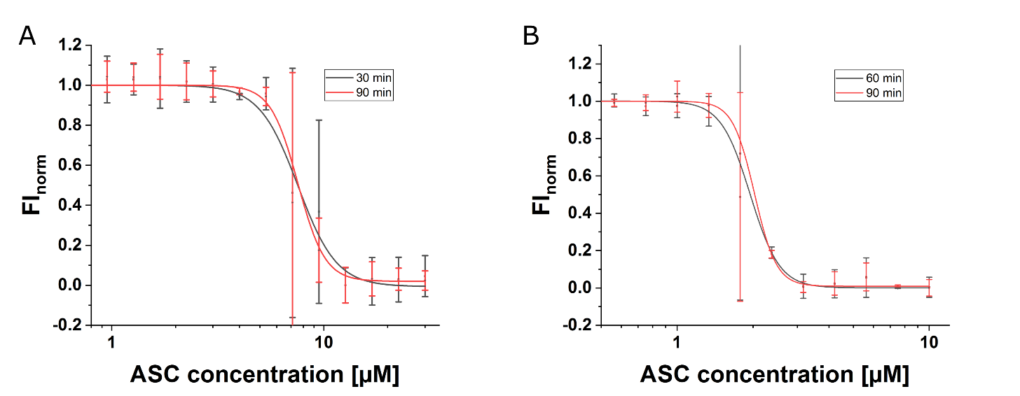

Supplementary Figure 2: Detection of the polymerization of ASC^{PYD} by MST at different time points: (A): ASC^{PYD} polymerization in solution with 600 mM KCl and a pH of 8.0 after an incubation time of 30 or 90 minutes at 37°C. (B): ASC^{PYD} polymerization in solution with 150 mM KCl and a pH of 5.0 after an incubation time of 60 or 90 minutes at 37°C. Each experiment was performed twice.

