**Supplementary Material – Progressive Exercises**

**1st EXERCISE**

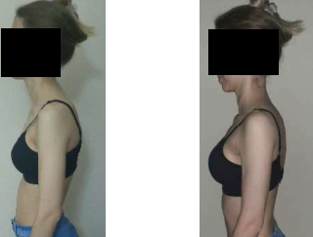

- Stand in a relaxed position.

- Try to keep your back straight, approaching the shoulder blades slowly.

- Stay in position for 5 deep breaths (for approximately 15 seconds). At the end, relax completely and return to the starting position.

- Repeat the exercise 3 times and rest for about 30 seconds between repetitions

- If you feel pain, adjust the movement so that there is mild pain (maximum 5 in VAS) and decrease immediately after exercise

**2nd EXERCISE**

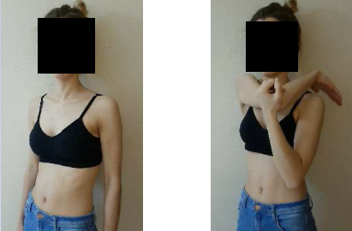

- Stand with the scapula on the side involved against the wall.

- Hold the other arm at the back of the arm / elbow and move the arm towards the sternum, so that the elbow goes towards the opposite shoulder.

- Keep your elbow at shoulder level, if there is pain, adjust to improve.

- Stay in position for 5 deep breaths (for approximately 15 seconds). At the end, relax completely and return to the starting position.

- Repeat the exercise 3 times and rest for about 30 seconds between repetitions

- If you feel pain, adjust the movement so that there is mild pain (maximum 5 in VAS) and decrease immediately after exercise

**3rd EXERCISE**

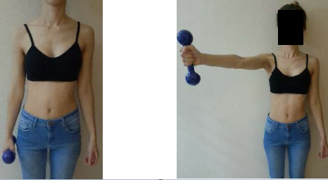

- Stand with your back straight, similar to the first exercise. Hold the dumbbell so that the palm of your hand is facing forward with your thumb pointing away from your body.

- Raise the dumbbell towards the horizontal plane at a 45º angle and slowly return to the starting position.

- The exercise will be carried out in this way:

15 repetitions in week 1

12 repetitions in weeks 2 + 3

10 repetitions in weeks 4 + 5

8 repetitions in weeks 6 + 7 + 8

6 repetitions in weeks 9 + 10 + 11 + 12

- The exercise is carried out for 4 sets and rest 30 seconds between sets. If the load is too easy (you can make 2 repetitions more than the proposed), increase the load.

- If you feel pain, adjust the movement so that there is mild pain (maximum 5 in VAS) and decrease immediately after exercise

**4th EXERCISE**

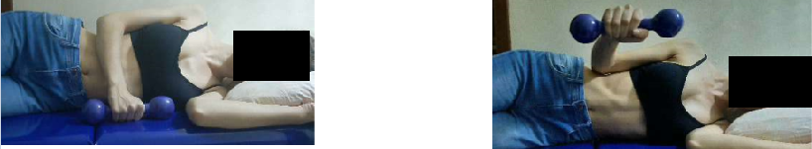

- Lie on your side, with the shoulder to be treated upwards so that the elbow is between the ribs and the hips. Leave your elbow bent at 90º so that your hand is placed in front of your navel. Try to approach the shoulder blades during exercise.

- Hold the dumbbell and lift towards the ceiling, making an external rotation on the shoulder. The movement is done as far as you can or as long as your forearm is kept as upright as possible. Perform the movement slowly. Make sure your elbow stays between your ribs and your hips.

- The exercise will be carried out in this way:

15 repetitions in week 1

12 repetitions in weeks 2 + 3

10 repetitions in weeks 4 + 5

8 repetitions in weeks 6 + 7 + 8

6 repetitions in weeks 9 + 10 + 11 + 12

- The exercise is carried out for 4 sets and rest 30 seconds between sets. If the load is too easy (you can make 2 repetitions more than the proposed), increase the load.

- If you feel pain, adjust the movement so that there is mild pain (maximum 5 in VAS) and decrease immediately after exercise

**5th EXERCISE**

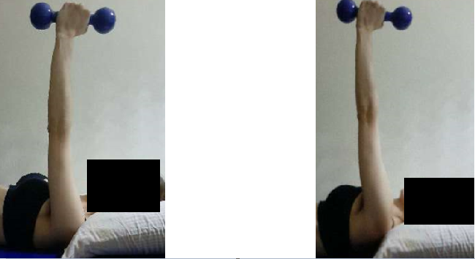

- Lie on your back in the most comfortable way possible. Take the dumbbell and raise it towards the ceiling, so that your elbow remains straight.

- Perform the reaching movement with the shoulder and scapula so that the dumbbell is raised towards the ceiling as high as possible.

- Then slowly lower your shoulder to the starting position. Stop the movement just before you feel you can relax.

- Perform 3 sets of 20 repetitions. Rest 30 seconds between sets. If you think the load is light or heavy, perform 5 more or less repetitions to adjust the quality of the exercise..

- If you feel pain, adjust the movement so that there is mild pain (maximum 5 in VAS) and decrease immediately after exercise

.

**6th EXERCISE**

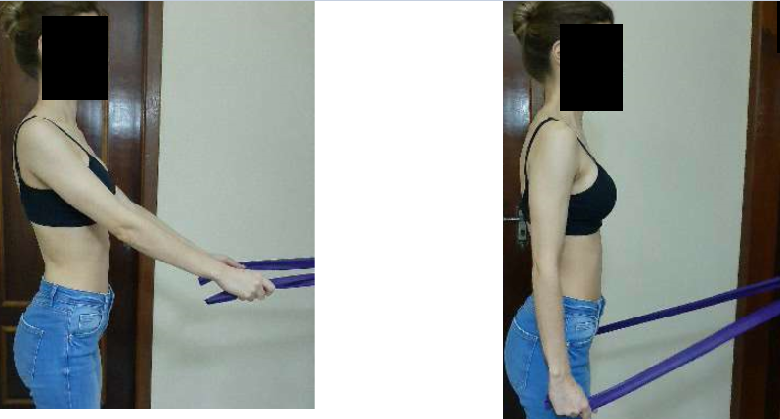

- Tie the elastic to a fixed point, such as a handrail or door handle. Hold the ends of the rubber band with both hands in pre-defined markings by the physiotherapist.

- Stand with arms straight, pull slowly until your hands are moved behind the hip line. Keep your back straight and your shoulders back throughout the exercise.

- Perform 3 sets of 20 repetitions. Rest 30 seconds between sets. If you think the load is light or heavy, perform 5 more or less repetitions to adjust the quality of the exercise..

- If you feel pain, adjust the movement so that there is mild pain (maximum 5 in VAS) and decrease immediately after exercise.