***Supporting Information***

**Development and *in vivo* evaluation of fused benzazole analogues of anti-melanoma agent HA15**

***Table of content***

|  |  |
| --- | --- |
| Spectra Section………………………………………………………………….............. | 2 |
| Biology………………………………………………………………………………….. | 30 |

**Spectra Section**

**7a**

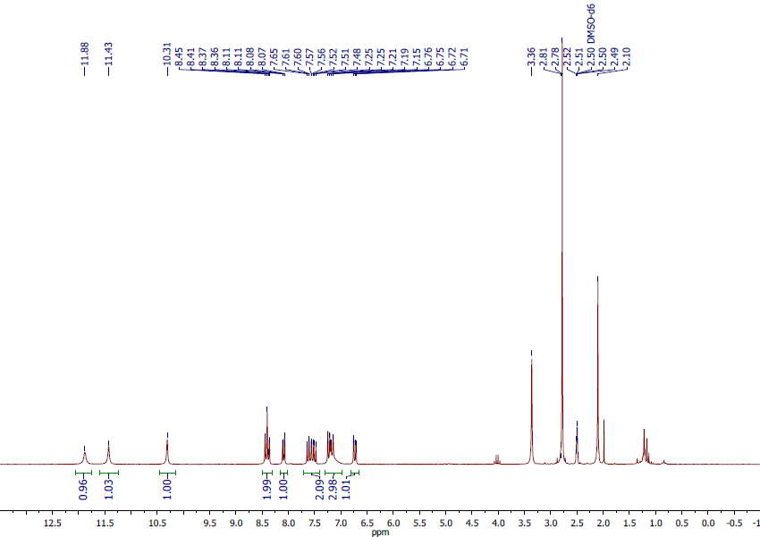

1H NMR spectra of **7a**

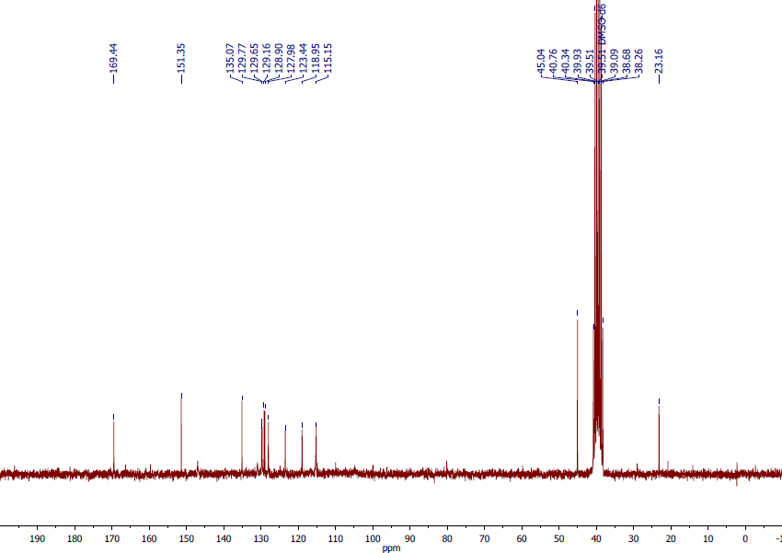

13C NMR spectra of **7a**

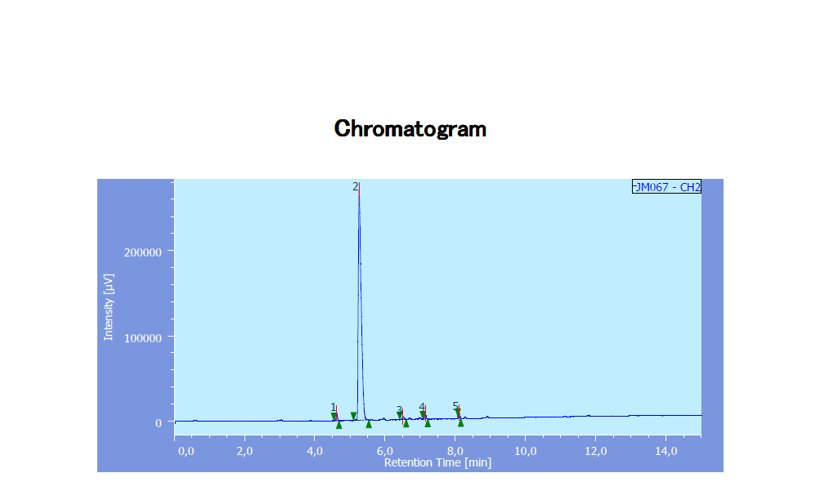

HPLC chromatogram of **7a**.



HRMS spectra of **7a**.

**7b**

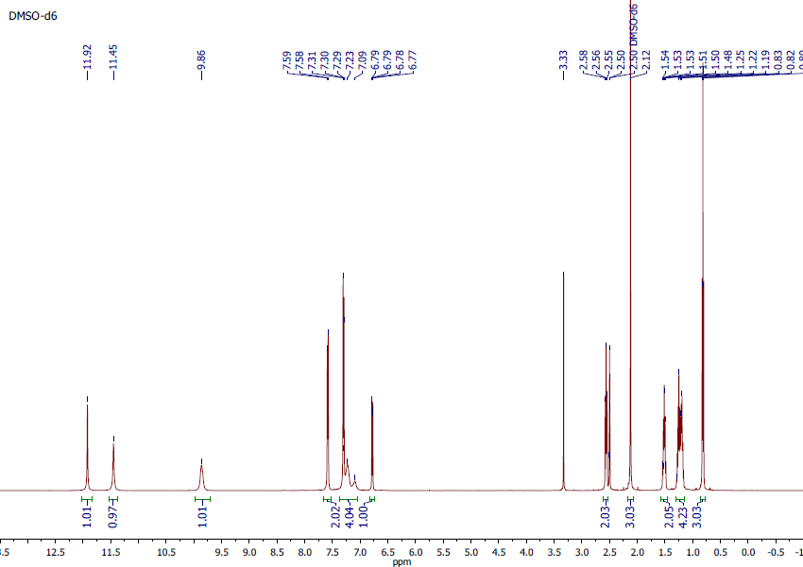

1H NMR spectra of **7b**

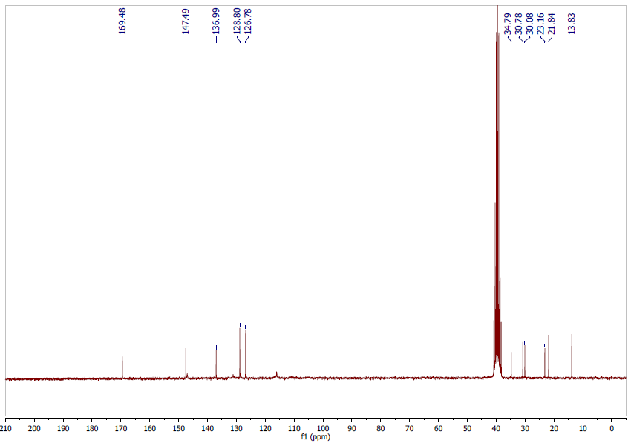

13C NMR spectra of **7b**

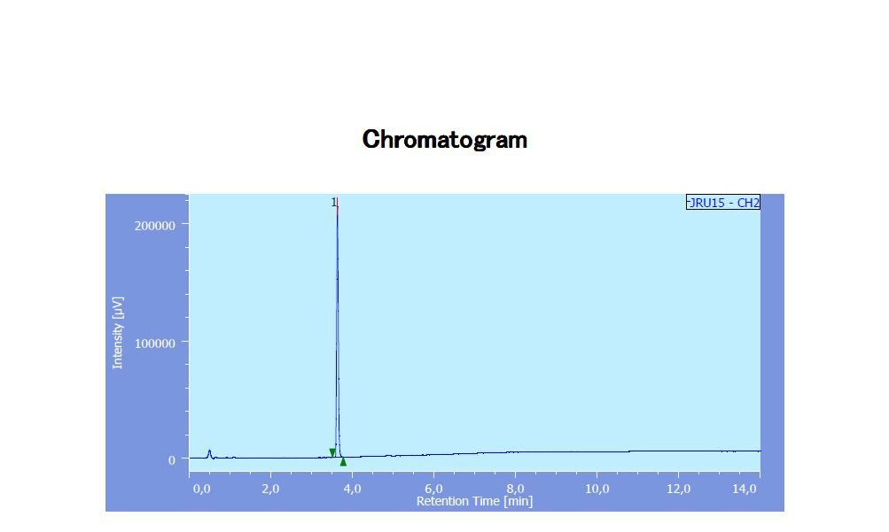

HPLC chromatogram of **7b**.



HRMS spectra of **7b**

**10a**

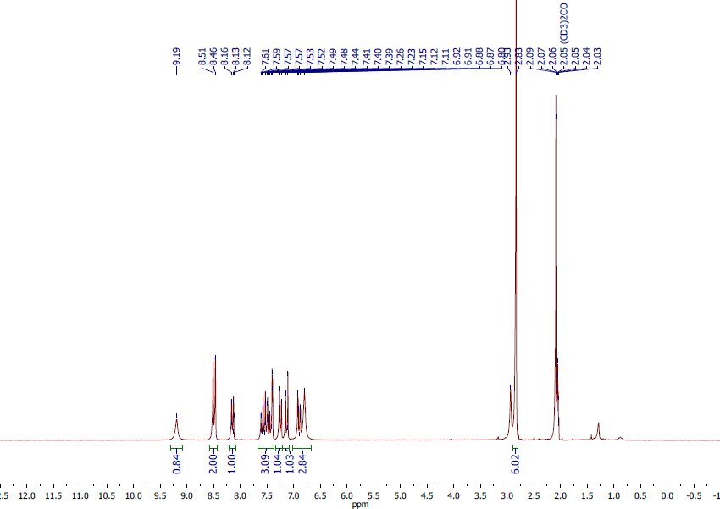

1H NMR spectra of **10a**

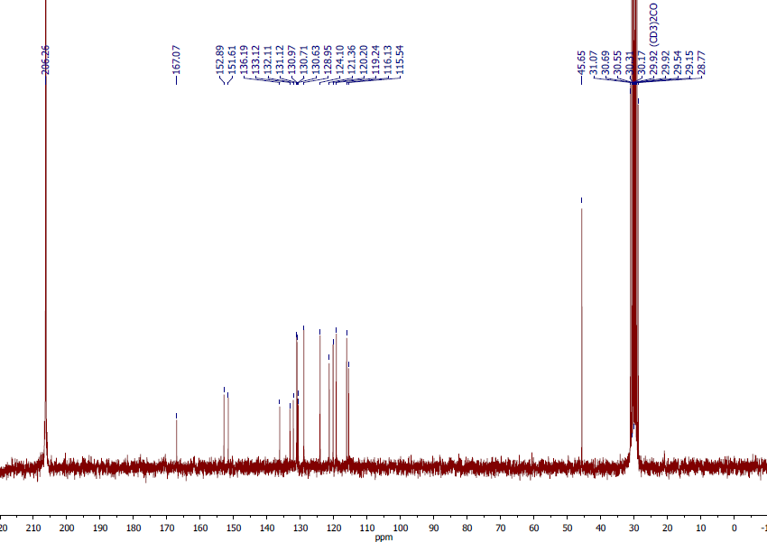

13C NMR spectra of **10a**

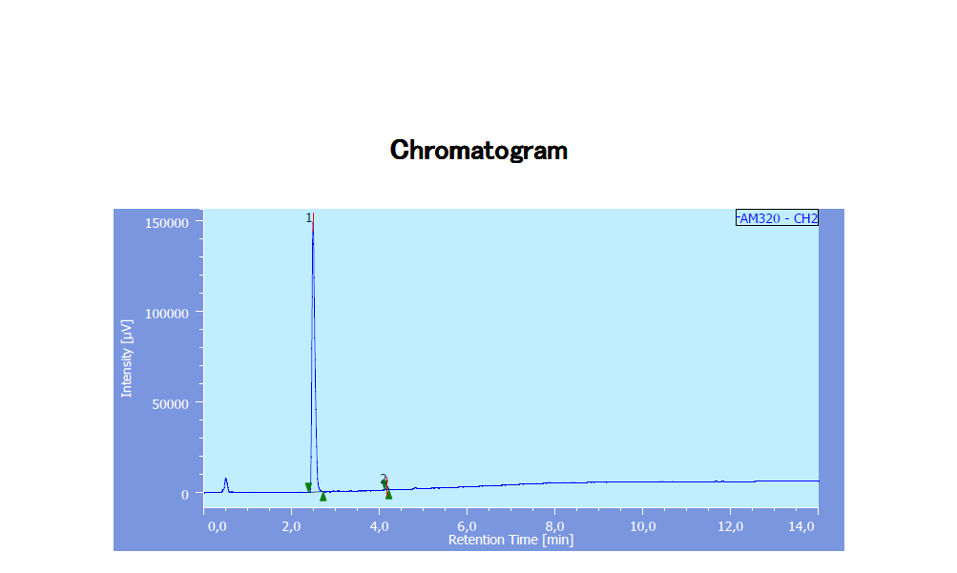

HPLC chromatogram of **10a**



HRMS spectra of **10a**.

**10b**

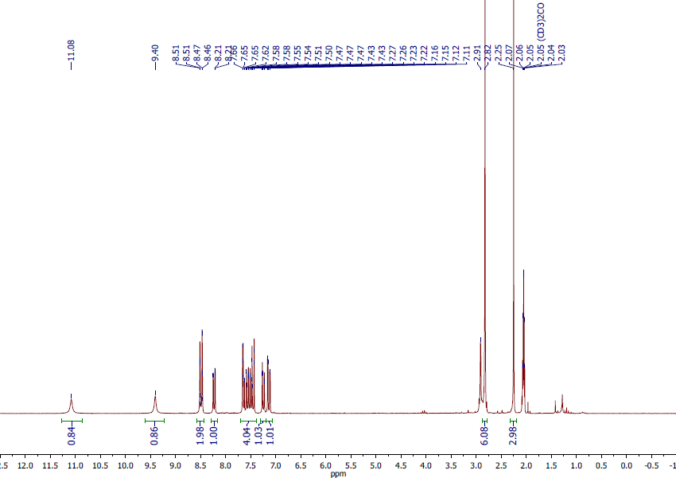

1H NMR spectra of **10b**

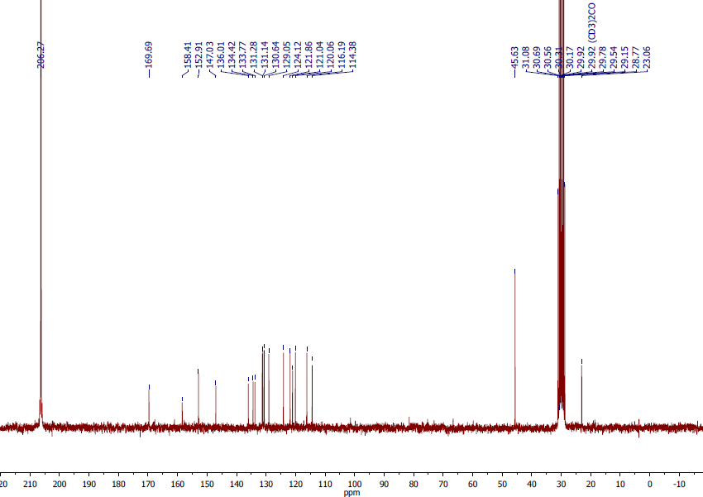

13C NMR spectra of **10b**

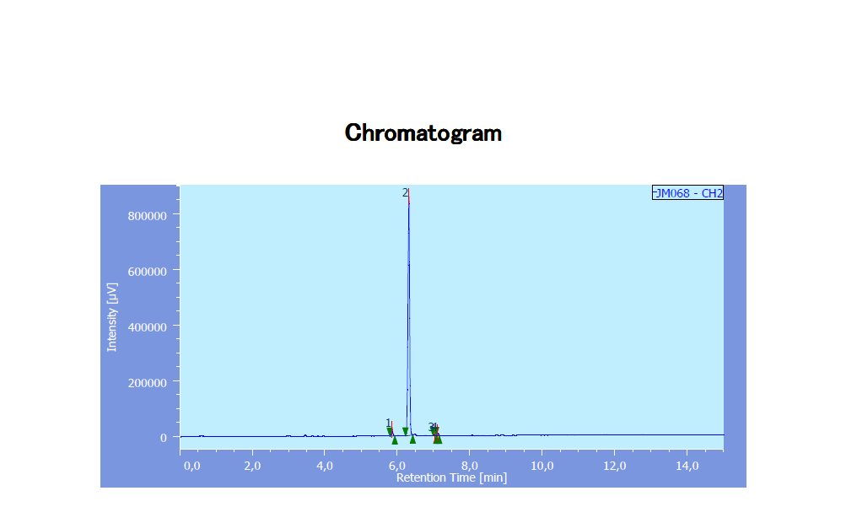

HPLC chromatogram of **10b**



HRMS spectra of **10b**.

**10c**

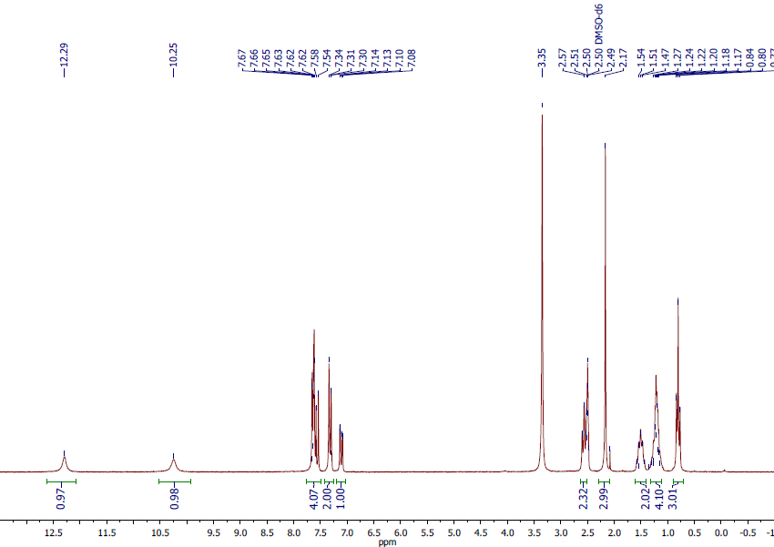

1H NMR spectra of **10c**

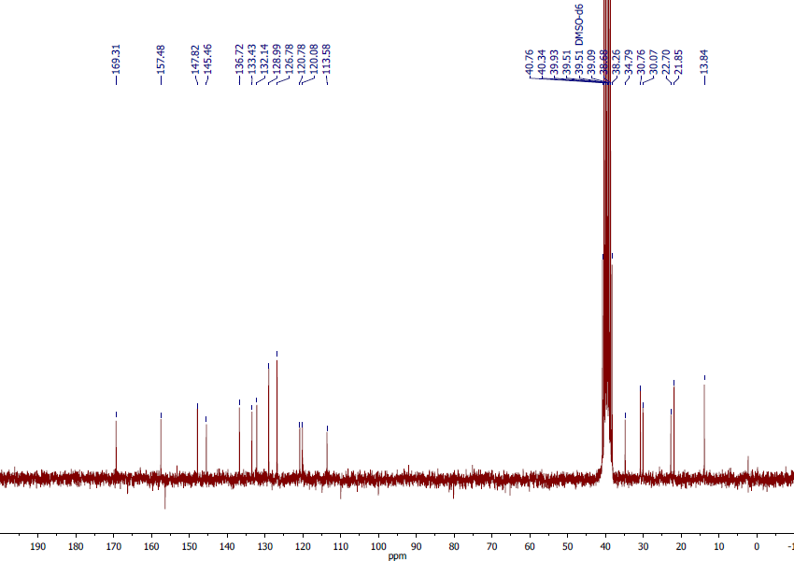

13C NMR spectra of **10c**

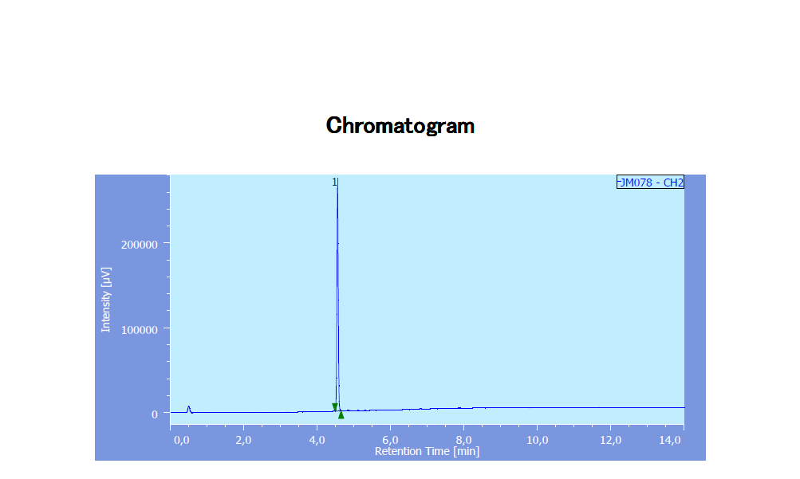

HPLC chromatogram of **10c**.



HRMS spectra of **10c**.

**14a**

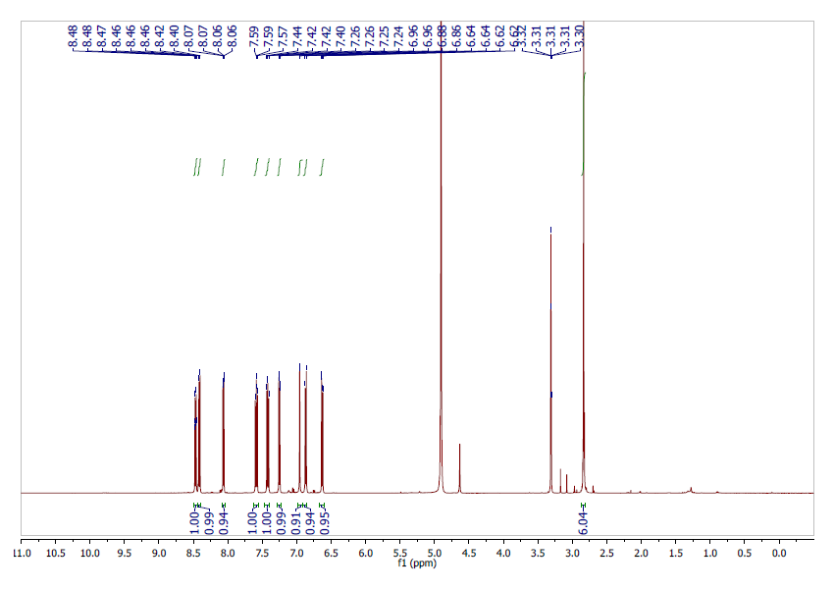

1H NMR spectra of **14a**

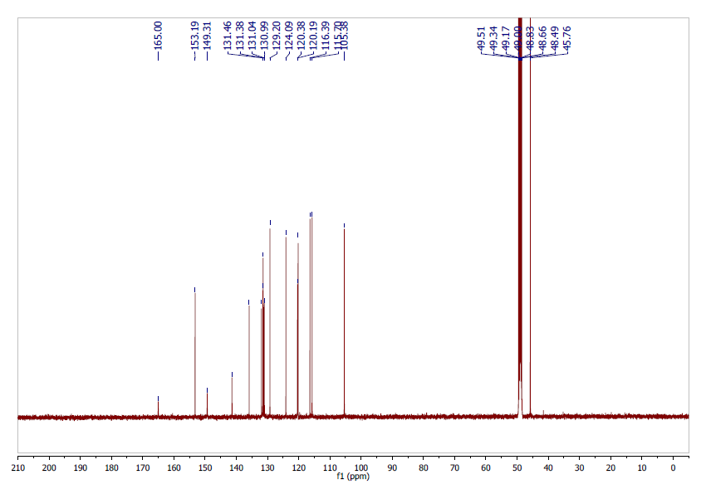

13C NMR spectra of **14a**

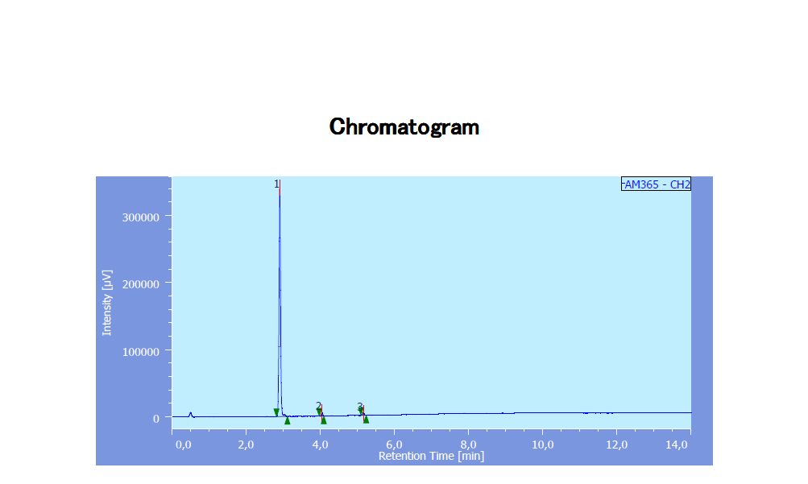

HPLC chromatogram of **14a**.



HRMS spectra of **14a**

**14b**

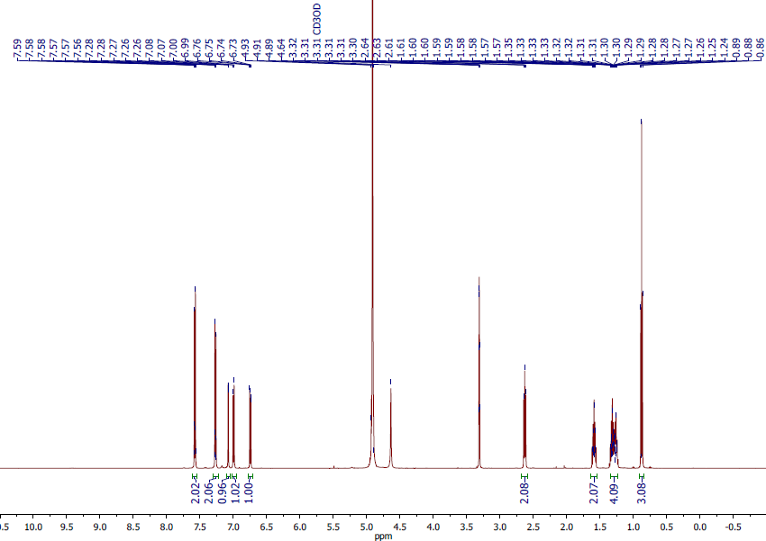

1H NMR spectra of **14b**

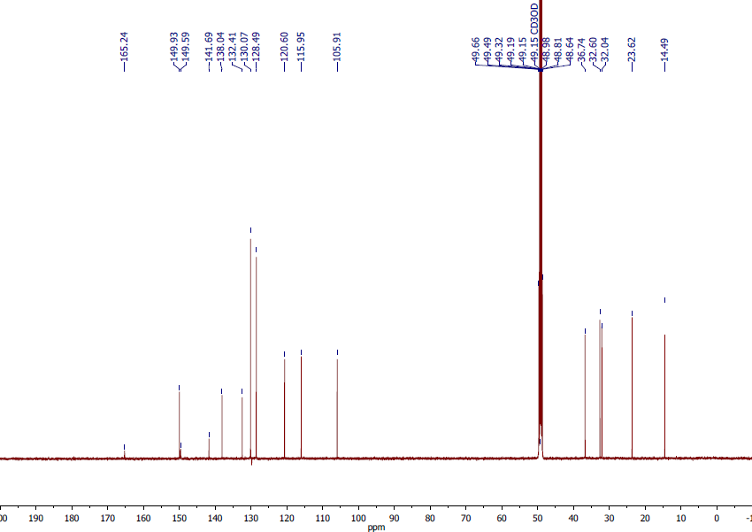

13C NMR spectra of **14b**

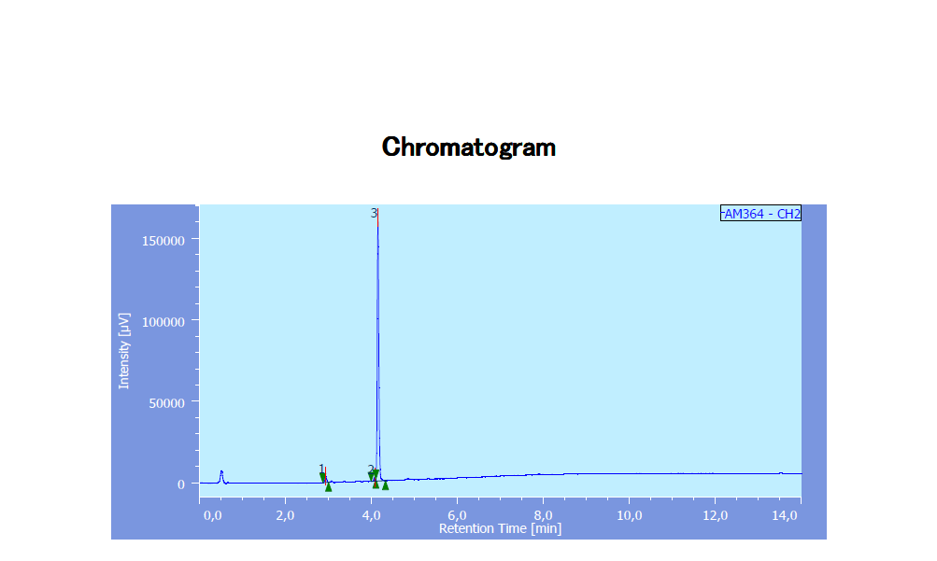

HPLC chromatogram of **14b**



HRMS spectra of **14b**

**15a**

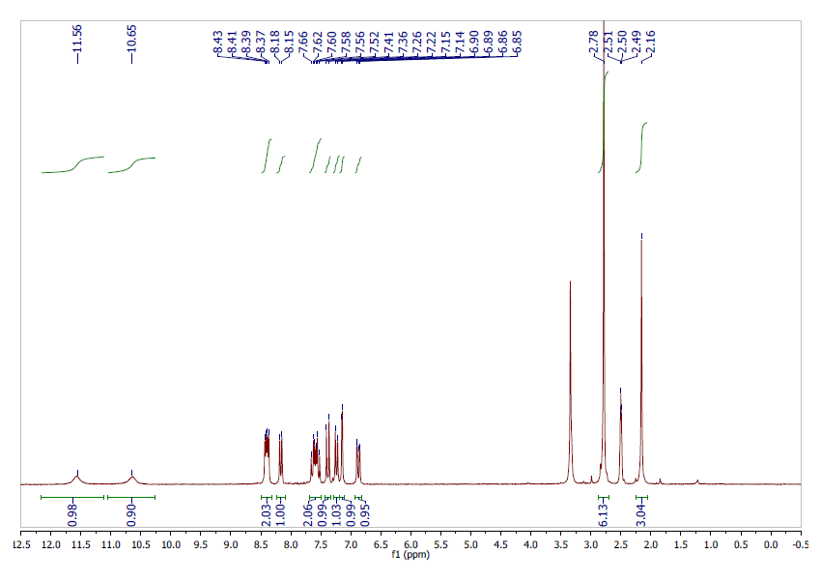

1H NMR spectra of **15a**

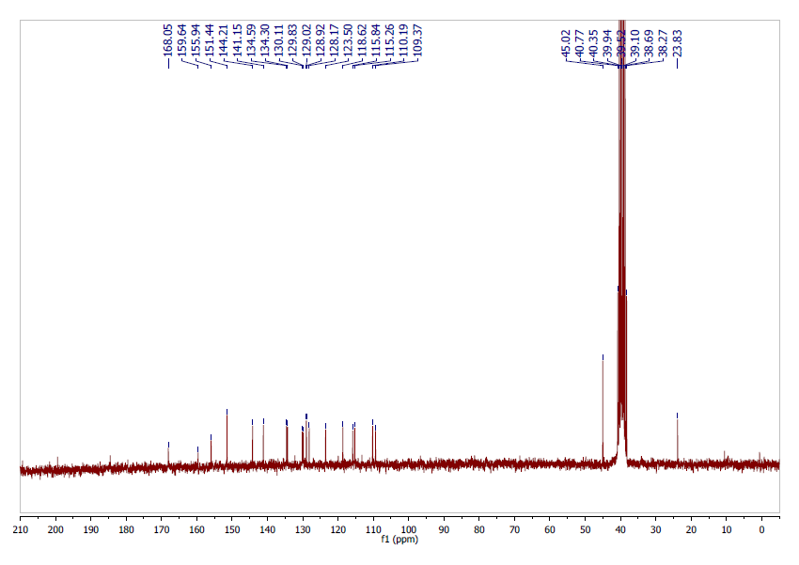

13C NMR spectra of **15a**

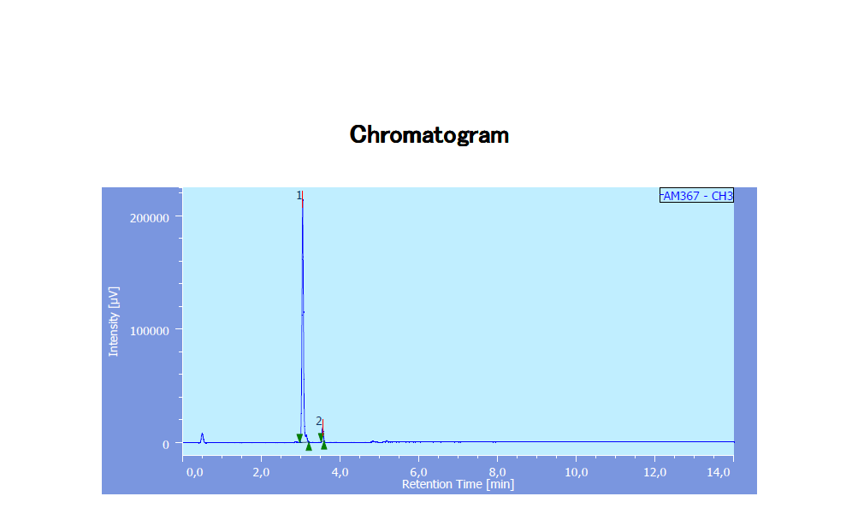

HPLC chromatogram of **15a**.



HRMS spectra of **15a**

**15b**

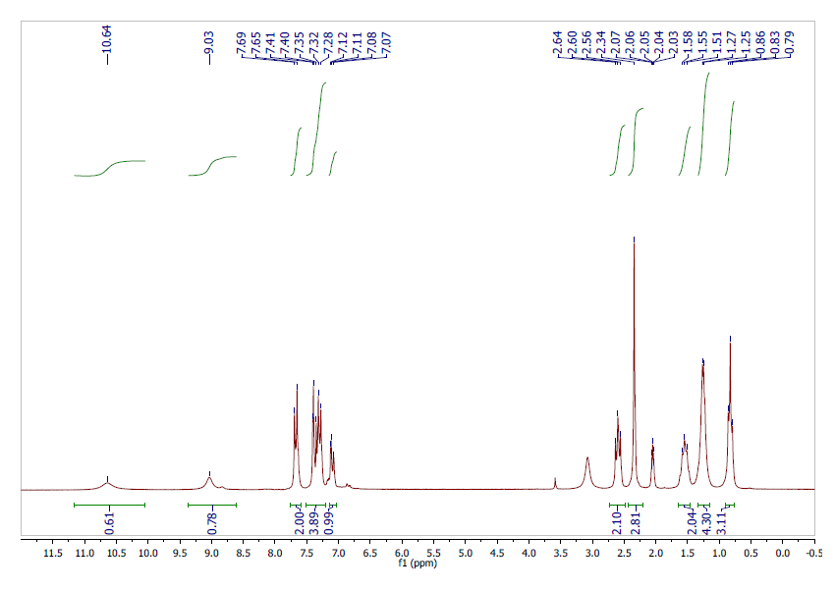

1H NMR spectra of **15b**

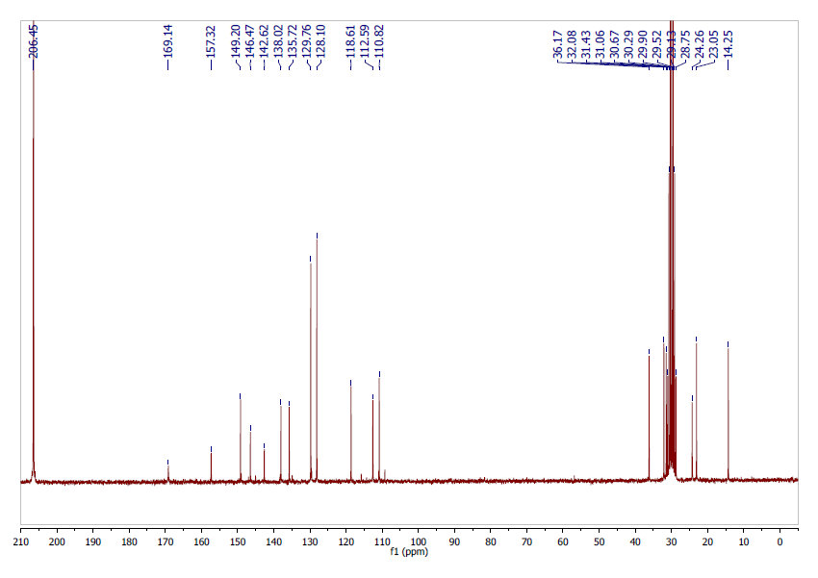

13C NMR spectra of **15b**

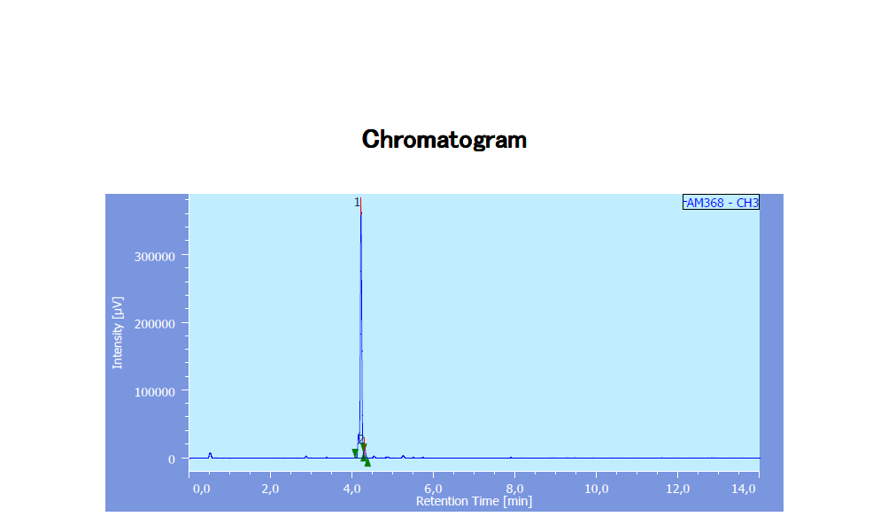

HPLC chromatogram of **15b**.



HRMS spectra of **15b**

**18a**

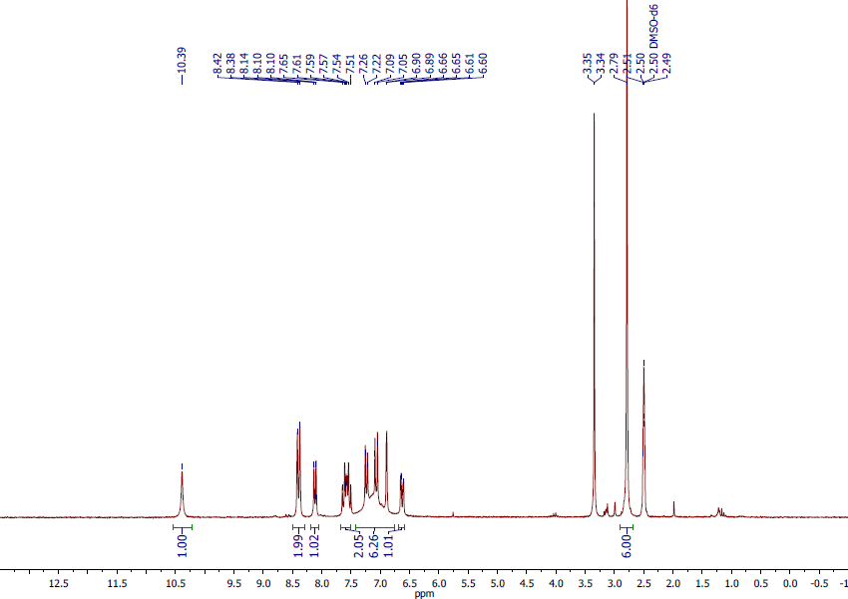

1H NMR spectra of **18a**

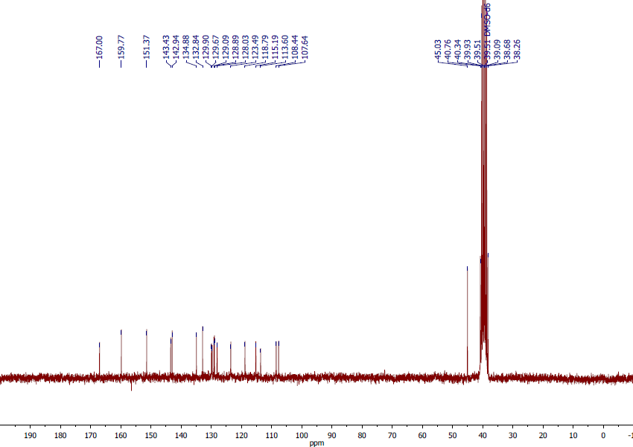

13C NMR spectra of **18a**

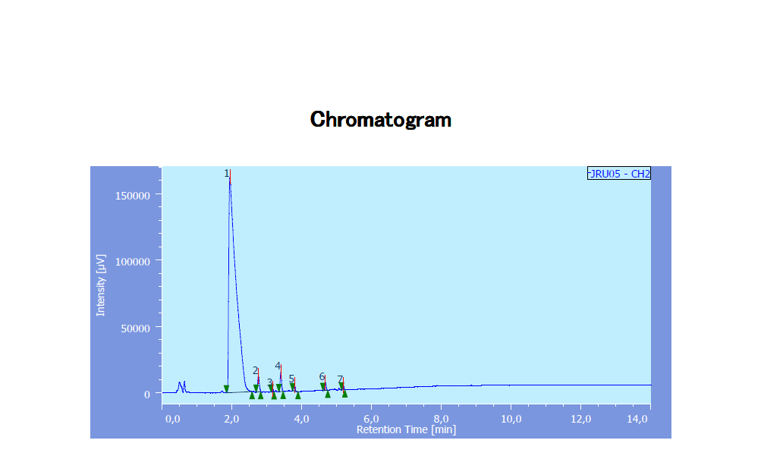

HPLC chromatogram of **18a**



HRMS spectra of **18a**

**18b**

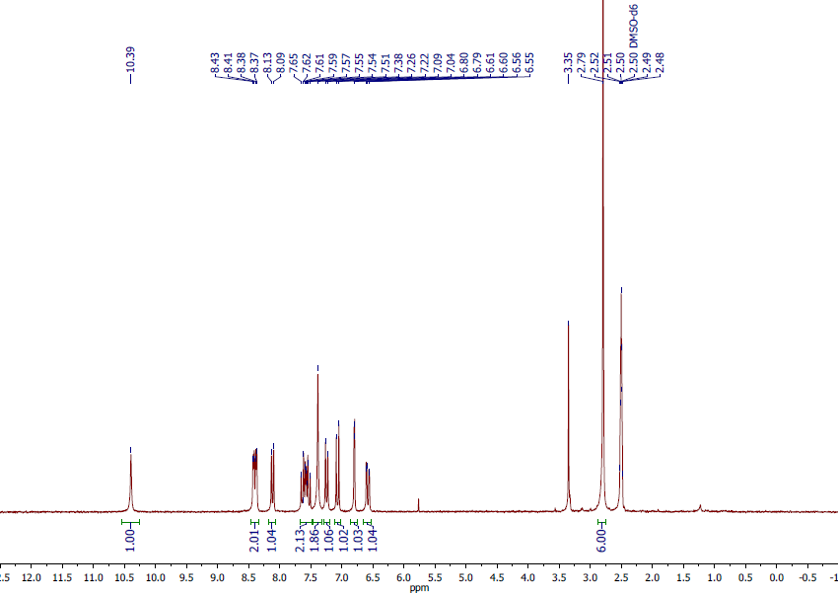

1H NMR spectra of **18b**

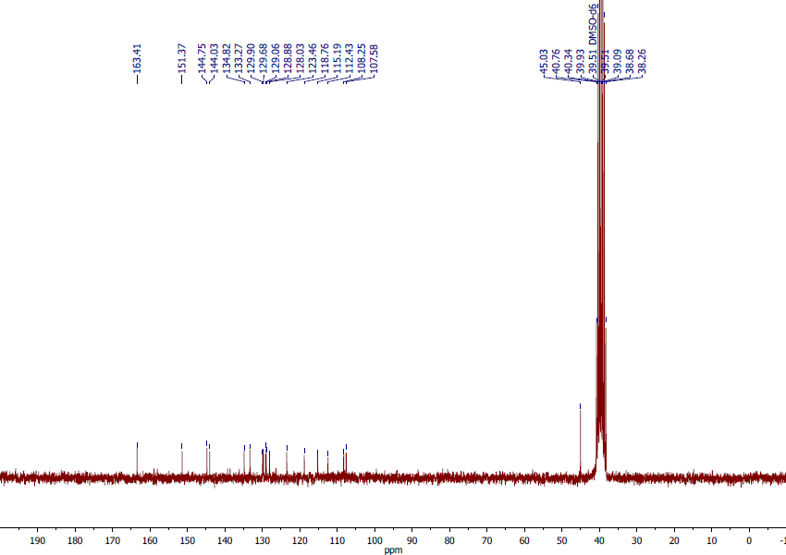

13C NMR spectra of **18b**

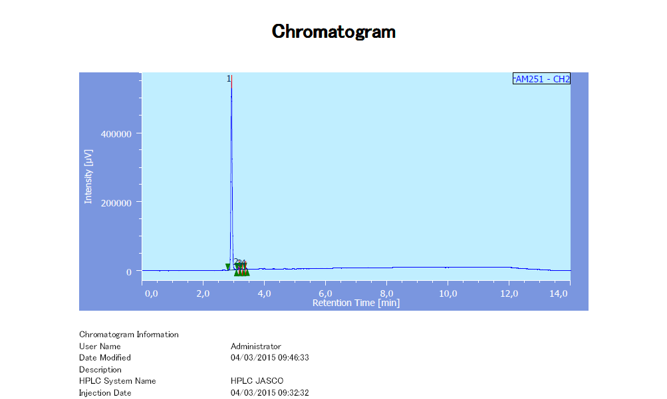

HPLC chromatogram of **18b**



HRMS spectra of **18b**

**18c**

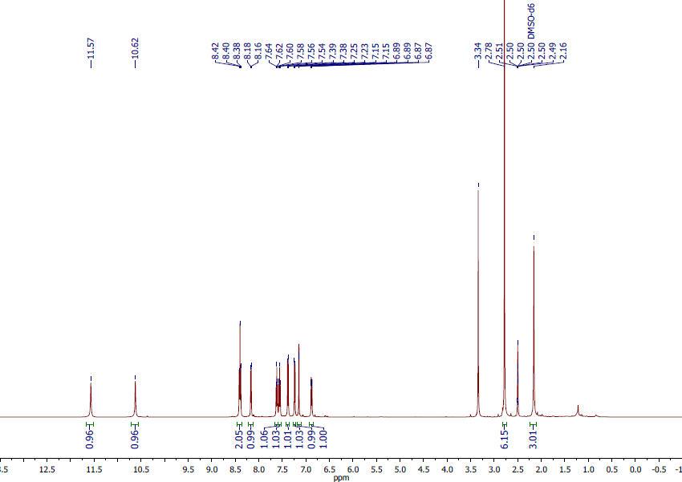

1H NMR spectra of **18c**

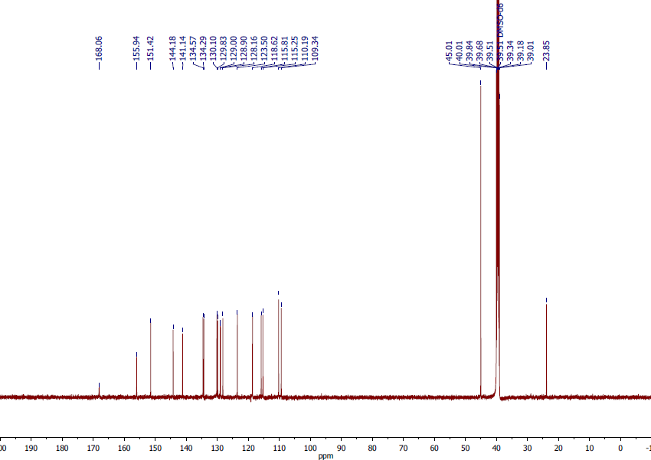

13C NMR spectra of **18c**

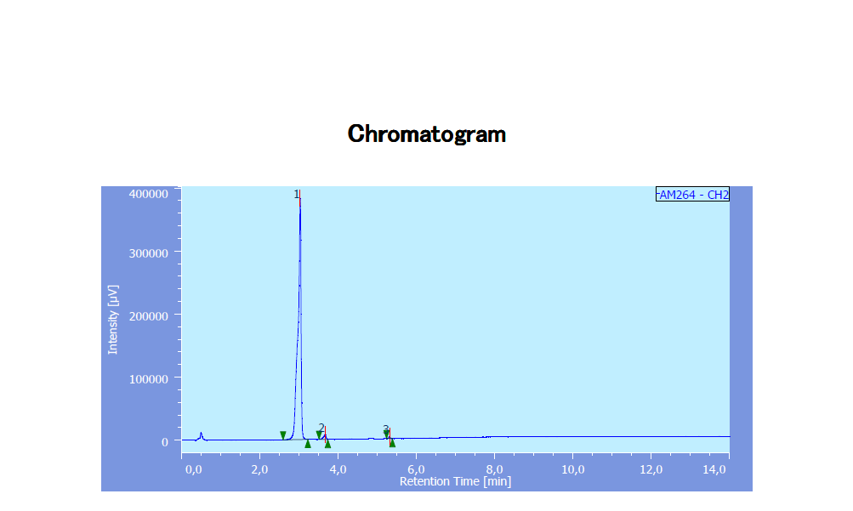

HPLC chromatogram of **18c**



HRMS spectra of **18c**

**22**

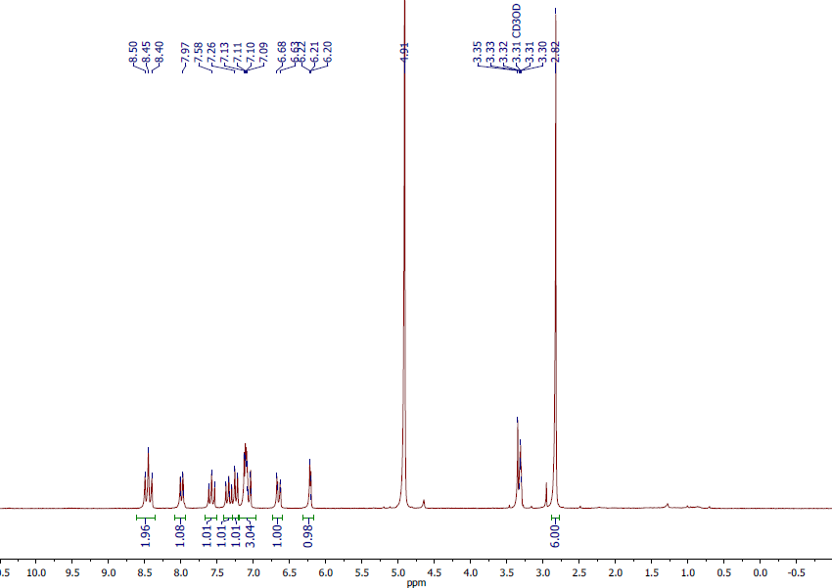

1H NMR spectra of **22**

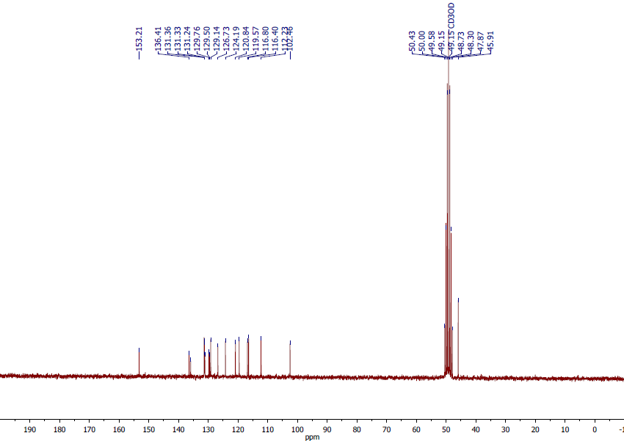

13C NMR spectra of **22**

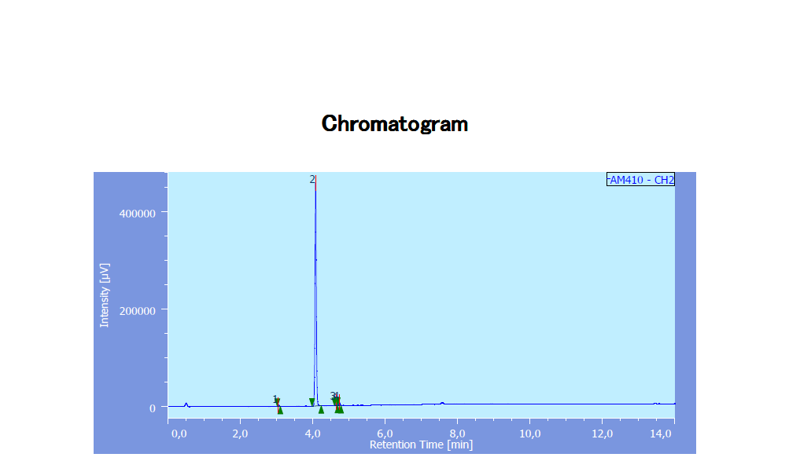

HPLC chromatogram of **22**



HRMS spectra of **22**

**23**

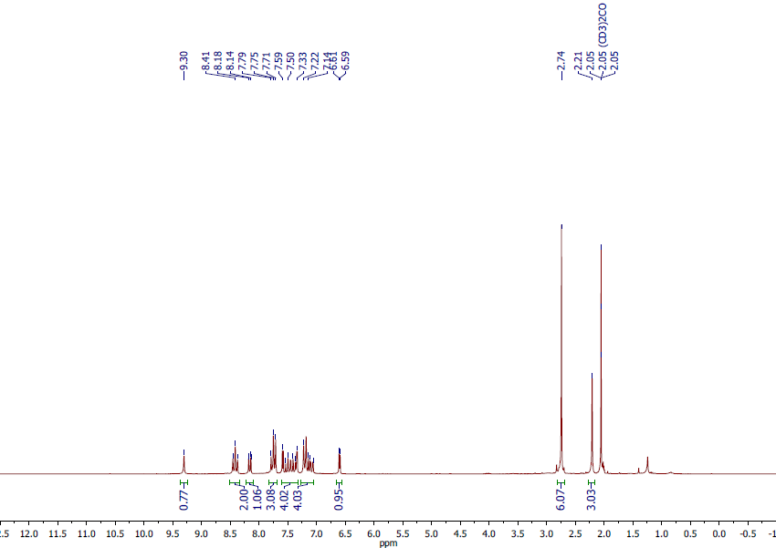

1H NMR spectra of **23**

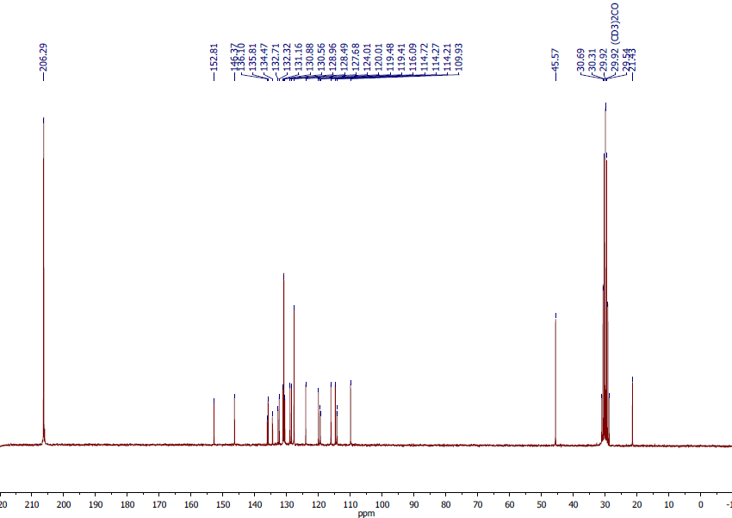

13C NMR spectra of **23**

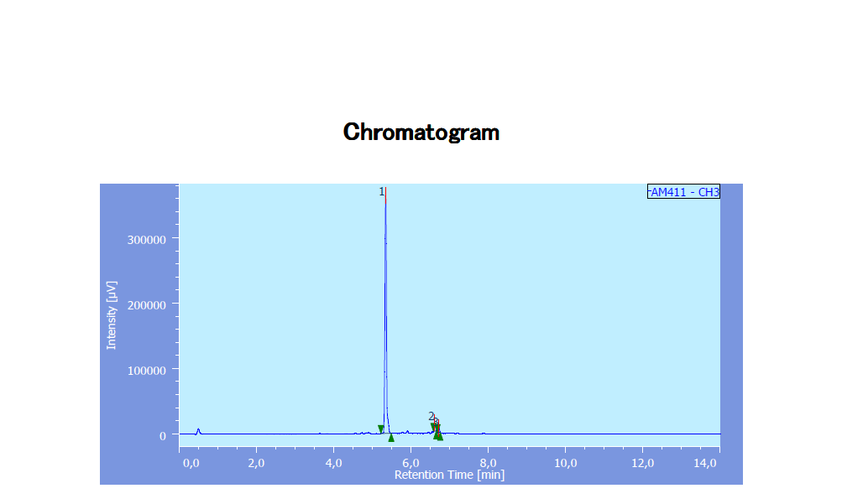

HPLC chromatogram of **23**



HRMS spectra of **23**

**Biological analysis**

|  |  |
| --- | --- |
|  |  |

**Figure S1**. Average tumor weight removed from euthanized mice after 31 days of treatment with vehicle (Labrafil) and compound **10b**. Adapted with permission from *ref 11* (main article) Copyright (2016), American Chemical Society.