Supplemental Tables
Supplemental Table A. CINAHL® (Cumulative Index of Nursing and Allied Health) Database Search String.
Supplemental Table B. Patient Participant Counts for Game Board Responses.
Supplemental Table C. Researcher Participant Counts for Game Board Responses.
Supplemental Table D. Other Stakeholder Participant Counts for Game Board Responses.
Supplemental Table E. Qualitative Summary – Concepts by Participant Group.

Supplemental Table A. CINAHL® (Cumulative Index of Nursing and Allied Health) Database Search String.
STEP | SEARCH STRING
1 | (AB "patient & public involvement" OR "patient and public involvement" OR "patient-centered outcomes research institute" OR pcori OR "james lind alliance")  OR  (TI "patient & public involvement" OR "patient and public involvement" OR "patient-centered outcomes research institute" OR pcori OR "james lind alliance")
2 | AB ((patient* OR caregiver* OR carer* OR citizen* OR community* OR communities OR consumer* OR lay* OR parent* OR partner* OR public* OR stakeholder* OR user* OR advoca* OR advisor* OR group* OR organi?ation* OR survivor* OR low-income OR women OR child* OR older OR elder* OR disabilit* OR disabl* OR "special need*" OR lesbian* OR gay OR bisexual* OR transgender* OR LGBT OR veteran* OR "armed forces") N2 (advis* OR advoca* OR ambassador* OR attitude* OR centered OR centred OR collaborat* OR "co research*" OR coresearch* OR deliberat* OR delphi OR engage* OR engaging OR "focus group*" OR forum* OR input* OR involv* OR participat* OR partner* OR perception* OR perspective* OR view* OR voice OR voices))  OR  TI ((patient* OR caregiver* OR carer* OR citizen* OR community* OR communities OR consumer* OR lay* OR parent* OR partner* OR public* OR stakeholder* OR user* OR advoca* OR advisor* OR group* OR organi?ation* OR survivor* OR low-income OR women OR child* OR older OR elder* OR disabilit* OR disabl* OR "special need*" OR lesbian* OR gay OR bisexual* OR transgender* OR LGBT OR veteran* OR "armed forces") N2 (advis* OR advoca* OR ambassador* OR attitude* OR centered OR centred OR collaborat* OR "co research*" OR coresearch* OR deliberat* OR delphi OR engage* OR engaging OR "focus group*" OR forum* OR input* OR involv* OR participat* OR partner* OR perception* OR perspective* OR view* OR voice OR voices))  OR  AB ((chronic OR genetic OR rare OR multiple) W2 (disease* OR condition*)) OR TI ((chronic OR genetic OR rare OR multiple) W2 (disease* OR condition*)) OR AB ((limited OR low*) W2 (English OR 'health literacy' OR numeracy OR proficien*)) OR TI ((limited OR low*) W2 (English OR 'health literacy' OR numeracy OR proficien*))
3 | #1 OR #2
4 | MH "Research" OR (AB "comparative effectiveness research" OR "card mapping" OR "health technology assessment") OR (TI "comparative effectiveness research" OR "card mapping" OR "health technology assessment") OR ((medicine* OR drug*) N2 develop*)
5 | ((AB "co research*" OR coresearch* OR CER OR HTA OR PCOR*) N2 (patient* OR caregiver* OR carer* OR citizen* OR community* OR communities OR consumer* OR lay* OR parent* OR partner* OR public* OR stakeholder* OR user* OR advoca* OR advisor* OR organi?ation* OR survivor*))  OR ((TI "co research*" OR coresearch* OR CER OR HTA OR PCOR*) N2 (patient* OR caregiver* OR carer* OR citizen* OR community* OR communities OR consumer* OR lay* OR parent* OR partner* OR public* OR stakeholder* OR user* OR advoca* OR advisor* OR organi?ation* OR survivor*))
6 | #4 OR #5
7 | #3 AND #6
8 | LIMIT 2005; ENGLISH; Humans
NOTE: The shaded steps indicate use of the Boolean operator, OR, with the results from the steps identified; this method yields the broadest search and retrieval of results.

Supplemental Table B. Patient Participant Counts for Game Board Responses.
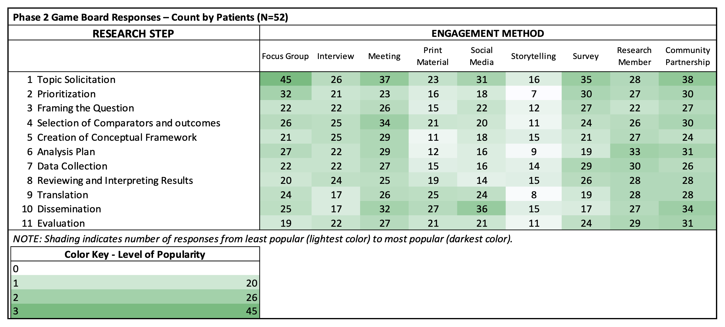

Supplemental Table C. Researcher Participant Counts for Game Board Responses.
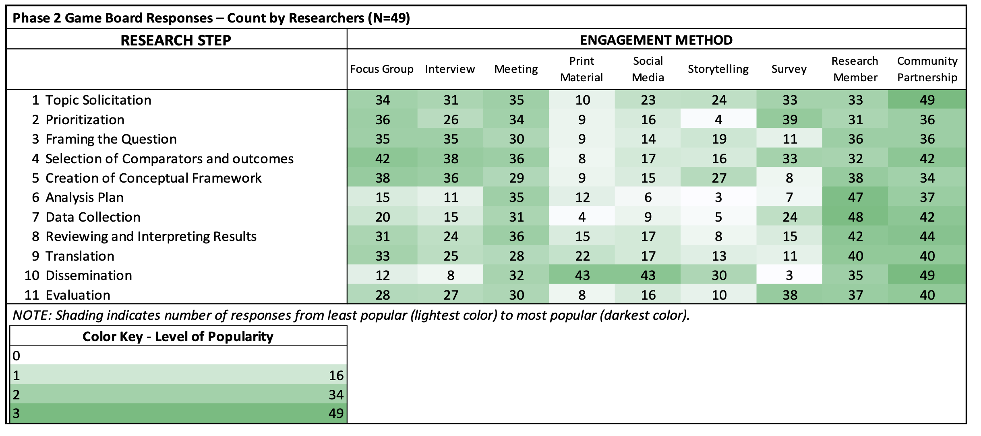

Supplemental Table D. Other Stakeholder Participant Counts for Game Board Responses.
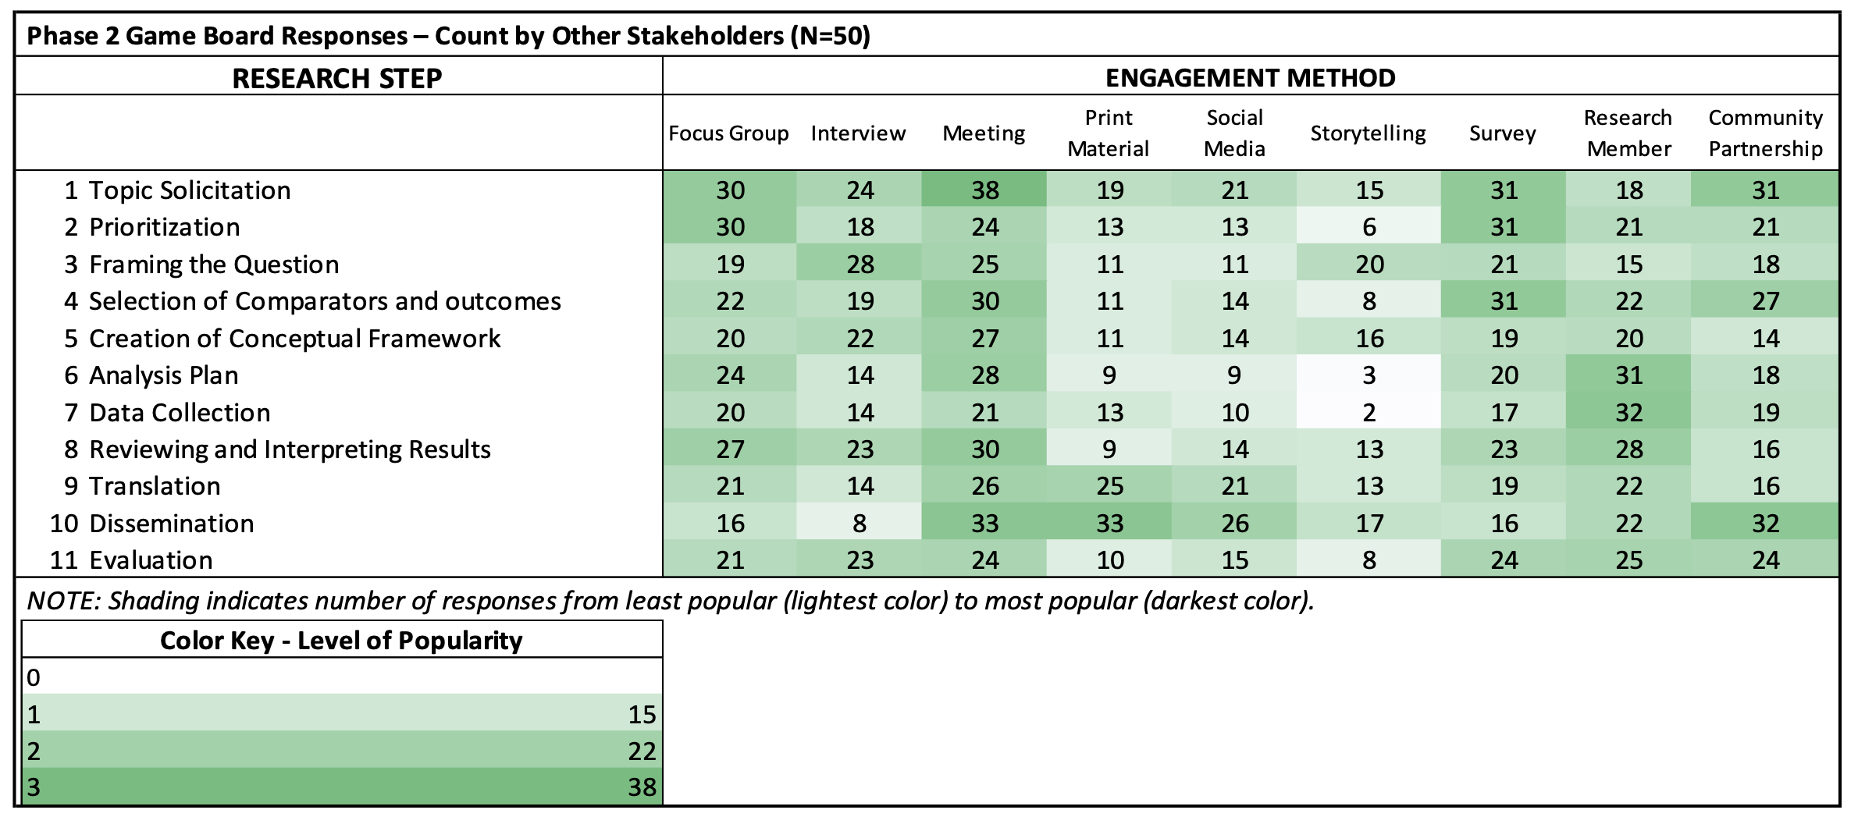

Supplemental Table E. Qualitative Summary – Concepts by Participant Group. | # Times Mentioned
 | Participant Group
General Concepts and Considerations | P/SH | R
- Take time for pre- and continuous engagement  - Lay a framework for partnership before data collection  - Provide resources/support for community before working on a study  - Build a network of people engaged over time  - Maintain a continuous presence in the community | N/A | 28
- Use a combination or variety of methods  - Every person is different and will require different engagement techniques  - Research questions will require different methods  - Each community context or culture is different  - Tailor methods and implementation techniques | 6 | 27
- Know your audience  - Immerse yourself on the community  - Exercise “cultural humility”  - Keep an open mind and accept that patient perspective may differ from researcher’s  - Determine the best way to contact the community | 9 | 22
Qualitative Summary – Concepts by Participant Group | # Times Mentioned
 | Participant Group
General Concepts and Considerations | P/SH | R
- Promote transparency between researcher and community  - Provide information and in ways the community can understand and relate to  - Be an active listener and a clear communicator  - Put patient first and consider their needs  - “Don’t let them feel like guinea pigs” | 5 | 20
- Use community representatives, partners, community navigators, and liaisons. | 2 | 12
- Offer monetary incentives (e.g., gift cards to big-box stores), refreshments* | 10 | 12
- Recognize the importance of patient engagement and build into funding and infrastructure* | N/A | 10
- Train or recruit researchers with necessary expertise* | N/A | 7
- Select locations that are accessible to community  - Host events in locations that offer services the community needs  - Meet people in locations that the community already uses | 5 | 4
- Be flexible with scheduling  - Schedule events at times that are convenient to community  - Researchers should make themselves readily available | 3 | 3
- Consider the historical context of research conduct in community | N/A | 3
- Confirm validity (e.g., cognitive debriefing) with community before starting work | 1 | 3
- Provide funding for staff* | N/A | 2
- Provide community resources (e.g. transportation, childcare, and/or translator/interpreter)* | 4 | 1
KEY – Participant Group: P = Patients, R = Researchers, SH = Other Shareholders
NOTES: 1. N/A means number is not applicable; 2. Concepts are listed in descending order of frequency by Researcher (R) response; 3. Asterisk (*) denotes concepts related to resources (time, staff, and/or financial).

