Supplementary data 1
Validation of the analytical technique
The analytical method was validated according to the FDA guidelines for the quantification of galantamine in 3 different biological matrices: rat plasma, cerebrospinal fluid (CSF) and brain homogenate. The obtained results met the required FDA limits. The linearity was acceptable for all analyzed biological matrices with acceptable correlation coefficient values. The results were accepted at four quality control levels. The specificity was performed using pooled samples from the three matrices and showed no significant interferences at the retention times of galantamine and nalbuphine. Figure 1 demonstrates exemplary chromatograms from rat plasma and brain homogenate.

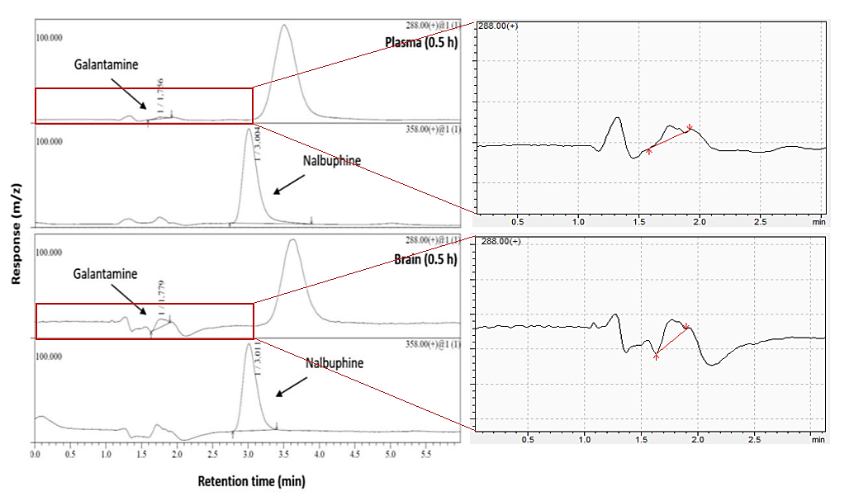
Figure 1: Chromatograms of galantamine in plasma and brain homogenate samples collected from rats 0.5 h following a single intranasal administration of G-NP equivalent to 3 mg/kg body weight and spiked with nalbuphine (internal standard)

