Supplementary Figure 4. Overall survival (a) and progression-free survival (b), stratified by prior anti-VGEF therapy.
(a)
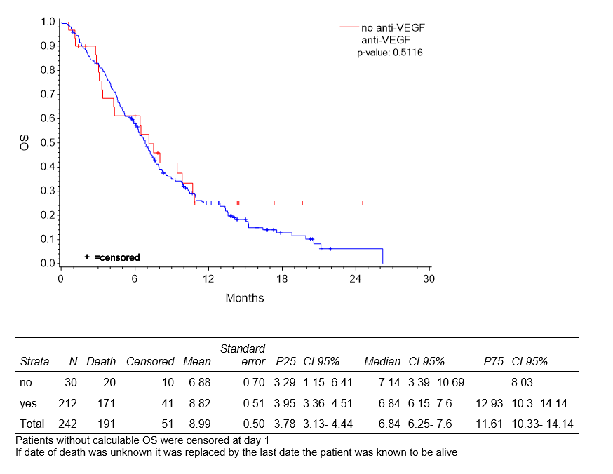
(b)
